Electronic Supplemental Materials
Table A1 Existing level models of fraction knowledge from literature
Fraction subconstructs  (Jiang et al., 2021) | Fraction subconstructs and fraction arithmetic  (Pantziara & Philippou, 2012) |  | Fraction knowledge  (Nicolaou & Pitta-Pantazi, 2016) | Summary
L6: Identifying fractions on less prestructured number lines |  |  | L3: Justifying and explaining about fractions, reflexive actions | Property of density, difficult numbers (e.g., unlike denominators), explanations beyond identifications
L5: Identifying fractions on prestructured number lines; alternating between differently prestructured models; measuring lengths; property of density (identification and explanation) | L6: Identifying property of density; adding two fractions (unlike denominators), before representing procedures and determining problems to given tasks; dealing with variable x in word problems
 | L5: Identifying fractions on prestructured number lines; describing two procedures for fraction comparing; alternating between differently prestructured models; identifying fractions out of given sets
L4: Alternating between different set models; determining parts of parts; estimating the result of fraction arithmetic tasks (addition) | L4: Determining wholes; alternating between differently prestructured models |  | L2: Alternating between different models; linking fractions to different representations | Alternating between different models and representations of fractions
L3: Alternating between area models and less prestructured models (unit fractions); determining wholes; comparing wholes of unit fractions in word problems; recognizing units of measures
L2: Determining shaded unit fractions on less prestructured area models | L3: Determining simple fractions on prestructured models; identifying ¼ out of differently prestructured area models; identifying fractions on prestructured number lines; adding two fractions (unlike denominators) |  | L1: Identifying and sorting fractions | (Partially) prestructured models, simple numbers (e.g., unit fractions, like denominators) and operations
L1: Determining simple fractions on prestructured models |  |  | L1: Identifying and sorting fractions
 | L2: Expanding unit fractions; comparing fractions (like denominators); identifying fractions on prestructured models |  | L1: Identifying and sorting fractions
 | L1: Adding fractions (like denominators)

Exemplary Items (Schadl & Ufer, 2023a)
Knowledge of Fraction Subconstructs
Part-Whole
Divide the rectangle into five equal parts. Color four of these parts. Which fraction is colored? Write down the correct fraction. (level FraCo1)

Mark the fraction $\frac{1}{6}$ in the rectangle. Justify your answer. (level FraCo2)
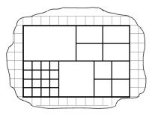Justification:

Ratio
A pack with gummy bears includes 12 gummy bears. The ratio of red to white bears is 1 : 3. How many bears are in the pack? (level FraCo4)

Operator
If you multiply a number with five and then divide by six, you get
□ $\frac{5}{6}$ of the number
□ the same result as if you multiply the number with $\frac{5}{6}$
□ the same result as if you divide the number by $\frac{5}{6}$
□ none of the other three results (level FraCo4)

Quotient
$\frac{2}{7}$ is the result of the division 7 divided by 2. (level FraCo2)
correct wrong I do not know

7 children eat 4 chocolate bars. The children share the chocolate bars fairly. Write down the fraction each child will get. (level FraCo3)

Measure
Mark the fraction $\frac{2}{5}$ on the number line. (level FraCo2)
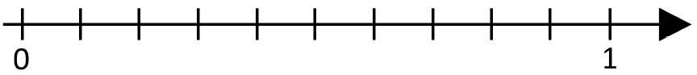

Write down a fraction that is between $\frac{1}{3}$ and $\frac{1}{2}$. (level FraCo4)
Fraction Arithmetic Skills
Equivalence
Fill in the box.
$5=\frac{□}{1}$ (level FrArit1)
$\frac{5}{35}=\frac{□}{14}$ (level FrArit4)

Addition / Subtraction
Calculate.
$\frac{3}{4}+\frac{1}{2}=$ (level FrArit1)
$\frac{5}{2}+\frac{5}{3}=$ (level FrArit2)
$\frac{4}{7}-\frac{3}{8}=$ (level FrArit3)
$\frac{8}{12}-\frac{6}{27}=$ (level FrArit4)

Multiplication / Division
Calculate.
$\frac{1}{2}⋅\frac{1}{4}=$ (level FrArit1)
$\frac{3}{6} : \frac{1}{6}=$ (level FrArit 2)
$7 : \frac{11}{7}=$ (level FrArit 3)

Fill in the missing fraction.
$9⋅\frac{□}{□}=15$ (level FrArit4)

Fraction Word Problems
Equivalence
The egg boxes contain white and brown eggs. Which box contains the larger share of brown eggs? Mark and justify your answer. (level FraWop2)
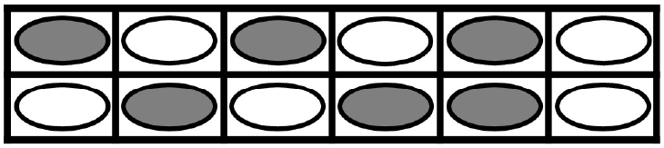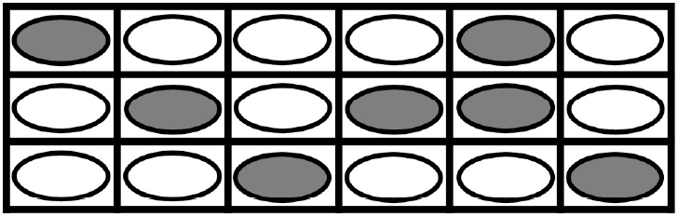
box 1 box 2
□ box 1 □ box 2 □ I do not know Justification:

Addition / Subtraction
A board is $\frac{7}{8}$ m long. Josef needs a board. The board should have a length of $\frac{3}{5}$ m. How much longer than needed is the board? Write down the result in meters. (level FraWop3)

Multiplication / Division
Maja gets €20 pocket money. She spends €15. Which fraction of her pocket money did she spend? (level FraWop1)
$\frac{1}{6}$ liter of water drips from a water tap in a quarter of an hour. How many litres are there in 24 hours? (level FraWop4)

There is $\frac{4}{5}$ left of a chocolate bar. Max eats $\frac{2}{3}$ of it. Which fraction of the whole chocolate bar has he eaten? (level FraWop5)

Description of Scaling and Linking Strategy
Throughout the whole project, the following scaling and linking strategy was applied: First, the scaling study data was analyzed. Based on this data, an initial level model was derived. Then, a second independent scaling of the main study data was performed. Item parameters were estimated freely. The stability of levels was investigated by comparing the empirical difficulty structure from this second scaling to the hierarchical structure expected based on the initial level model. This resulted in different cut-offs for the second dataset. Moreover, graphical plots were used to investigate the stability of level assignment for the items (Figure 5). Finally, a common scaling with both datasets was performed, combining all cases from the scaling and the main study. Again, item parameters were estimated freely. As for the main study, the empirical difficulty structure from this third scaling was compared to the hierarchical structure expected based on the initial level model, and cut-offs for the levels were determined for this joint scaling. The manuscript reports the Wright maps and level cut-offs from this common scaling. All scalings applied the one-dimensional, one-parameter Rasch model (1PL model).
Note. Based on the main dataset, the one- ($χ²$(44) = 139.96 (p < .001), CFI = .94, TLI = .93, RMSEA = .08, p = .001, SRMR = .04) and three-facet model ($χ²$(41) = 107.65, p < .001, CFI = .96, TLI = .95, RMSEA = .07, p = .035, SRMR = .04) showed largely acceptable fits. The three-facet model (see Figure A1, AIC = -728.77, BIC = -588.58) fitted data better than the one-facet model (AIC = -702.47, BIC = -573.95, $∆χ^{2}$ = 32.31, $∆df$= 3, p < .001).
Fig. A1 Three-facet model of fraction knowledge and skills based on the main dataset
Assignment of Students to Levels
IRT models allow it to align students’ ability parameters, item difficulties, and level cut-offs on a single numerical scale. This allows to assign students to an item. Traditionally, this is done by assigning a student to the highest level for which the student has a solution rate of at least p = 50% (other p values may be used, cf. Rolfes et al., 2022). This corresponds to checking if the person parameter is larger than the upper threshold of the level (plus an offset if p > 50%). However, this approach is prone to misclassification since it neglects the measurement error of person parameters. In the current study, we distributed each participant of the different levels by determining which share of the error distribution around the participant’s ability parameter falls between the level cut-offs.
To illustrate the difference, assume, for example, that a participant has a person parameter just a bit lower than the upper threshold of level 3. This student would be counted to level 3 in the traditional method. However, it is well possible that the student belongs to level 4, and only measurement error leads to the ability parameter ending below the applied limit. In our approach, this student will be distributed to some extent (say, 50%) to level 3 but also to some extent to level 4 (say, 40%). Since the error distribution is unbounded, the student will also have positive but small shares on levels 1 and 2.
The following diagrams present the "shares of a student" assigned to each level, depending on the student’s item parameter. In our case, the substantial overlap between the different curves indicates that an individual assignment with strict cut-offs must be taken with care. If individual reporting is desired in practice, it is reasonable to report at least an individual profile of the student’s share for each level (Ufer et al., 2024).

Note. Red = level 1; orange = level 2; yellow = level 3; green = level 4; dark green = level 5.
Fig. A2 Shares of a student’s assignment to levels

Fig. A3 Differences between adjacent levels

