Supplementary Material S1 – Definition of Resources
We define the resources examined in this study in reference to the work of Sommerhoff et al. (2025).
Concept: Topic Knowledge
Topic knowledge includes conceptual and procedural knowledge. Conceptual knowledge typically involves a network of general facts, concepts and principles, whereas procedural knowledge encompasses sequences of mental or concrete actions aimed at achieving a particular goal (Rittle-Johnson et al., 2015, Sommerhoff et al., 2025).

Concept: Strategic knowledge
We define strategic knowledge “as 'knowing when and why to use' specific pieces of conceptual or procedural knowledge”. From an information-processing perspective, mathematical strategic knowledge is defined as knowledge about which operator to apply in which situation. (Sommerhoff et al., 2025)

Concept: Meta-knowledge of proof
We define meta-knowledge of proof as knowledge, independent of the underlying mathematical content of a proof, about what constitutes an acceptable proof. The latter depends at least partially on the norms of the local mathematical community (Dawkins & Weber, 2017, Sommerhoff et al., 2025).

Concept: Problem Solving
We define as problem-solving skills as the “individual’s ability to solve non-routine tasks by applying heuristics”. (Sommerhoff et al., 2025).

Concept: Logical Reasoning
Logical Reasoning skills “comprise making multiple types of deductive inferences correctly based on if-then statements (conditionals), or evaluating such inferences” (Sommerhoff et al., 2025).

Concept: Self-regulation
Self-regulation “refers to self-generated thoughts, feelings, and actions that are planned and cyclically adapted to the attainment of personal goals” (Zimmermann, 2000, p. 14). In our context, we mostly refer to being able to monitor and control one’s own cognition.

Concept: Reading strategies
Reading strategies are understood to be “deliberate, goal-directed attempts to control and modify the reader’s efforts to decode text, understand words, and construct meanings of text” (Afflerbach et al., 2008, p. 368). We use the term domain-specific reading strategies to refer to reading strategies for mathematical texts, in particular proofs.

Supplementary Material 2 – Item Characteristics

Table S2.1 Item Characteristics
 | Mean | SD / Frequencies | Min | Max
PC 1 | 1.37 | 1.30 | 0 | 3
PC 2 | 0.64 | 0.77 | 0 | 3
PC 3 | 1.32 | 1.30 | 0 | 3
PC 4 | 1.21 | 1.32 | 0 | 3
PRV 1 | 0.59 | (1) 68 (0) 48 | 0 | 1
PRV 2 | 0.86 | (1) 100 (0) 16 | 0 | 1
PRV 3 | 0.83 | (1) 96 (0) 20 | 0 | 1
PRV 4 | 0.42 | (1) 49 (0) 67 | 0 | 1
PRC 1 | 0.96 | (1) 111 (0) 5 | 0 | 1
PRC 2 | 0.59 | (1) 68 (0) 48 | 0 | 1
PRC 3 | 0.78 | (1) 90 (0) 26 | 0 | 1
PRC 4 | 0.58 | (1) 67 (0) 49 | 0 | 1
PRC 5 | 0.32 | (1) 37 (0) 79 | 0 | 1
PRC 6 | 0.60 | (1) 70 (0) 46 | 0 | 1
PRC 7 | 0.47 | (1) 55 (0) 61 | 0 | 1
PRC 8 | 0.16 | (1) 19 (0) 97 | 0 | 1
PRC 9 | 0.48 | (1) 56 (0) 60 | 0 | 1
PRC 10 | 0.41 | (1) 48 (0) 68 | 0 | 1
PRC 11 | 0.24 | (1) 28 (0) 88 | 0 | 1
Note: RC1 to RC6 measure local aspects of proof comprehension and RC7 to RC11 measure global aspects of proof comprehension

Supplementary Material 3 – Item Examples and Coding
Below, we provide an example item of each of the proving activities that we measured, along with an explanation of our coding.

S3.1 Proof construction
To measure proof construction, participants had to prove four different propositions in elementary number theory. A translated version of one proposition is given below.
Figure S3.1. Item example for proof construction.
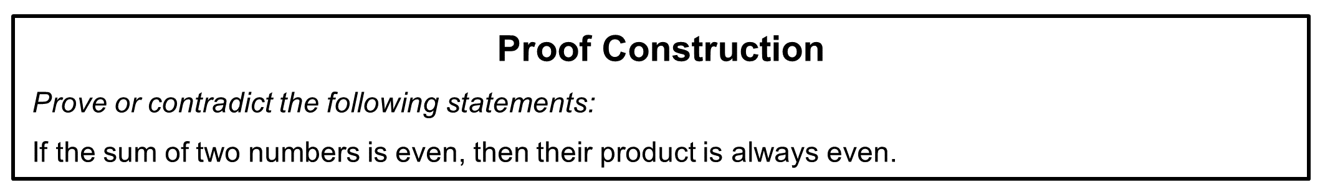
All answers to proof construction items were coded on a four-level scale (0-3) according to a coding scheme used in prior publications (e.g., Kollar et al., 2014). Lower levels differentiate by the degree to which relevant steps in the proof can be recognized (without necessarily referring explicitly to definitions or theorems in the mathematical framework theory). Higher levels include the presentation of the argument in terms of logical organization of the main ideas and providing adequate support from the mathematical framework theory for each step according to socio-mathematical norms of the context.
To guide coding, a large range of relevant possible proofs within the mathematical framework theory were analyzed before coding and sequenced into specified proof steps, including specifications which support from the framework would be expected (in the course context) for each step. The following table presents the code descriptions and illustrates them with exemplary answer types and a rough description of typical examples. Note that the intended level of coding was the 0-3 code, not the more specific answer type. In addition, after coding, code 9 (no answer) was combined with code 0, since sufficient time was provided to engage with all tasks (power test conditions).
Table S3.1 Coding scheme for proof construction
Code |  | Description |  | Exemplary answer types |  | Typical example(s)
0 |  | No relevant proof step recognizable |  | Irrelevant answers |  | Solutions not answering the question, mis-interpreting the to-be-proved statement or only re-formulating the statement.
 |  |  |  | Wrong approach |  | All recognizable arguments relate to a proof approach, that do cannot be used to prove the statement.
 |  |  |  | Example-based argument |  | Only one or few examples are used to investigate the validity of the statement.
1 |  | Some, but not all relevant proof steps included |  | Correct and incorrect steps in the argument |  | While some steps of a possible proof are included, the argument is based on invalid inferences at other points of the proof.
 |  |  |  | Correct steps at the start of the argument, but not argument complete at the end |  | The first steps of a possible proof can be recognized, but relevant steps are missing to prove the statement.
 |  |  |  | Gap in the argument |  | The recognizable argument leads from the provided assumptions to the to-be-proven statement largely along the lines of a possible proof. However, at least one relevant step is not recognizable, leading to unproven assumptions being used in the argument.
2 | All relevant proof steps included,  but flaws in organization or presentation |  | Coherently missing support from the framework theory |  | All steps of the argument can be recognized, they are presented in the correct sequence, including connections between consecutive steps. However, the reference to relevant support from the framework theory is not provided.
2 |  |  | Incorrect logical organization |  | All steps of the argument can be recognized, and relevant support by the framework theory is provided. However, the sequence and connections between the steps indicates errors in the logical organization of the argument.
2 |  |  | Widely correct line of argument, but technical errors |  | All steps of the argument can be recognized, they are presented in the correct logical organization, including support from the framework theory. There are, however technical errors, e.g. wrong algebraic transformations, that do not strongly influence the line of argument
3 | Acceptable proof |  | Locally missing support from the framework theory |  | All steps of the argument can be recognized, they are presented in the correct sequence, including connections between consecutive steps. Reference to relevant support from the framework theory is mostly provided, but still missing for at least one step.
3 |  |  | Complete proof |  | All steps of the argument can be recognized, they are presented in the correct sequence, including connections between consecutive steps. Reference to relevant support from the framework theory is mostly provided coherently.
9 | No answer |  | No answer |  | No answer, at all, was provided.
9 |  |  | Not codeable |  | The answer does not refer to the task in a recognizable way.

S3.2 Proof validation
To measure proof validation, participants were introduced to a proposition from elementary number theory and four different purported proofs that were presented as proofs by fellow students had to be validated. A translated version of the proposition and one purported proof item is given below (Sommerhoff & Ufer, 2019).
Figure S3.2. Item example for proof validation.
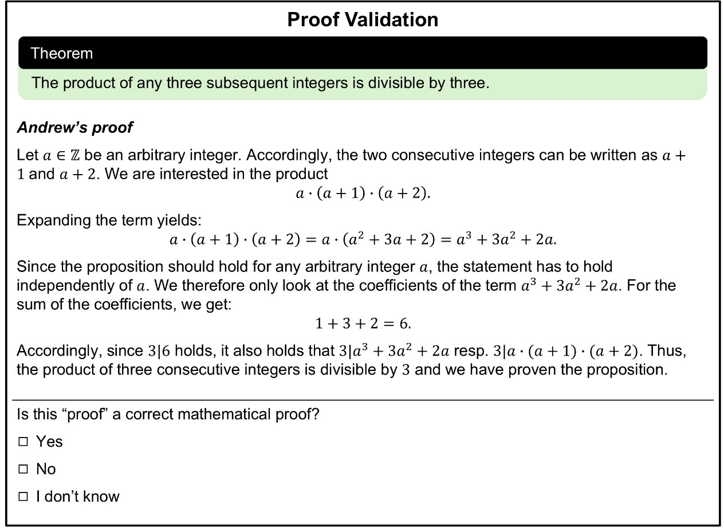
In this particular purported proof, the proof scheme is incorrect because it is based on empirical evidence rather than deductive reasoning. From the four presented purported proofs, three were unacceptable and one acceptable. To ensure that the proof attempts presented in this study could be 'rightfully seen' as acceptable or unacceptable, research mathematicians had been asked to judge them in an earlier study. The results showed that all the proof attempts could be seen as acceptable or unacceptable as intended. (Sommerhoff & Ufer, 2019)
After each proof attempt, the students were asked to rate if this proof attempt is correct / incorrect or if they do not know the answer. We coded 1 if the students answered correctly and 0 otherwise.

S3.3 Proof comprehension
The proof comprehension test included 10 multiple-choice and open-ended items and was based on the following elementary number theory proof and theorem (adapted from Exercise 1-29, Adler & Coury, 1995, p. 21).
Figure S3.3 Proposition and proof for proof comprehension test.
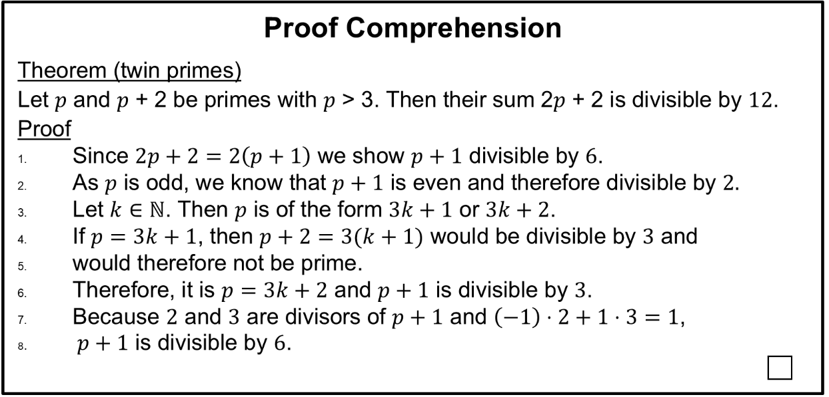
All answers to proof comprehension items were coded on a two-level scale (0-1) according to a coding scheme used in prior publications (Neuhaus-Eckhardt, 2022). A translated example of an open-ended item and its coding scheme are given below.
Figure S3.4 Item example for proof comprehension (questions 6).
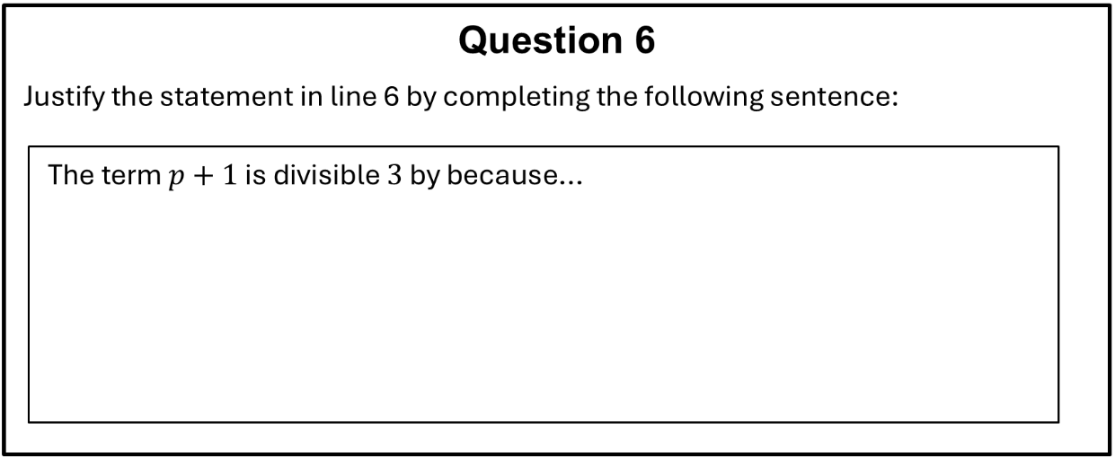
Table S3.2 Coding scheme for proof comprehension (questions 6)
Example Solution | Coding
- … $p+1=3k+3=3(k+1)$ which is why it is divisible by three. | 1 point
- … $p+1=3k+3$ and $3k$ as well as $3$ are divisible by three and therefore their sum is also divisible by three
- … $p,p+1,p+2$ are three consecutive integers. One of them must be divisible by $3$, $p$ and $p+2$ are prime, therefore $p+1$ must be divisible by $3$.
- … $p$ is divisble by three [wrong, because $p$ is > 3 and prime] | 0 points
- … $p=3k+2$ [reproduction of the proof without additional explanations]
- … $p=3k+1$ and $p+1=3k+1+1=3k+2$ [wrong term for $p$]
- … $p$ is odd, $p+1$ must be divisible by $3$ [no justification, incorrect, and unrelated]
- … $p = 5, p+1 = 6$ and therefore divisible by 3 [only examples]
- According to line 8, $p+1$ is divisible by $2$ and$3$. [Later information from the proof cannot be used at this point, as it is based on this line of argument.]
- $2p+2$ is divisible by 12 and therefore $p+1$ is divisible by $6$ which includes diversibility by $3$. [The statement $2p+2$ is divisibly by $12$ must be proved and therefore it cannot be used as an explanation here.]
- Explanation is incomprehensible

References for Supplementary Materials
Adler, A. & Coury, J. E. (1995). The Theory of Numbers: A text and source book of problems. Jones and Bartlett Boston Publisher.
Afflerbach, P., Pearson, P. D., & Paris, S. G. (2008). Clarifying differences between reading skills and reading strategies. The reading teacher, 61(5), 364-373.
Dawkins, P. C., & Weber, K. (2017). Values and norms of proof for mathematicians and students. Educational Studies in Mathematics, 95(2), 123–142.
Kollar, I., Ufer, S., Reichersdorfer, E., Vogel, F., Fischer, F., Reiss, K. (2014). Effects of Collaboration Scripts and Heuristic Worked Examples on the Acquisition of Mathematical Argumentation Skills of Teacher Students with Different Levels of Prior Achievement. Learning and Instruction 32, 22-36.
Neuhaus-Eckhardt, S. (2022). Beweisverständnis von Studierenden: Zusammenhänge zu individuellen Merkmalen und der Nutzung von Beweislesestrategien [Students‘ proof comprehension: Relations to individual characteristics and reading strategies for proofs]. Ph.D., Waxmann Verlag.
Rittle-Johnson, B., Schneider, M., & Star, J.!R. (2015). Not a one-way street: Bidirectional relations between procedural and conceptual knowledge of mathematics. Educational Psychology Review, 27, 198–208.
Sommerhoff, D., & Ufer, S. (2019). Acceptance Criteria for Validating Mathematical Proofs Used by Pupils, University Students, and Mathematicians in the Context of Teaching. ZDM, 51(5), 717-730.
Sommerhoff, D., Kollar, I., & Ufer, S. (2025). Undergraduate students’ mathematical proof skills. Examining the impact of six cognitive resources. In K. Weber & M. Savić (Eds.), Research in Mathematics Education. New Directions for Mathematics Education Research on Proving (pp. 45–71). Springer Nature Switzerland. https://doi.org/10.1007/978-3-031-85004-2_3
Zimmermann, B.J. (2000). Attaining Self-Regulation. In M. Boekaeris, P. R. Pintrich, M. Zeidner (Eds) Handbook of Self-Regulation. (pp. 13-39). Academic Press

