INVESTIGATING THE EVOLUTION OF CVS SUB-SKILLS ON HIGH SCHOOL STUDENTS THROUGH THE IMPLEMENTATION OF INQUIRY-BASED LEARNING EXPERIMENTAL ACTIVITIES IN PHYSICS

APPENDIX

One of the four assessments given to the students
Note: The correct answer is underlined each time. Possible choices were shuffled randomly by an online tool (https://www.random.org/lists/).

Below are some questions related to Physics experiments. Read each question carefully and answer or circle the correct answer each time.

1. (PLANNING item)
You have at your disposal the following materials:
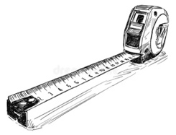 | 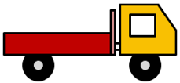 |  | 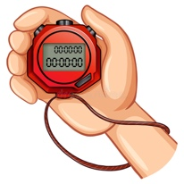 | 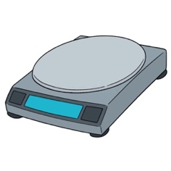
tape measure | a toy car | glass marbles | a stopwatch | a digital scale

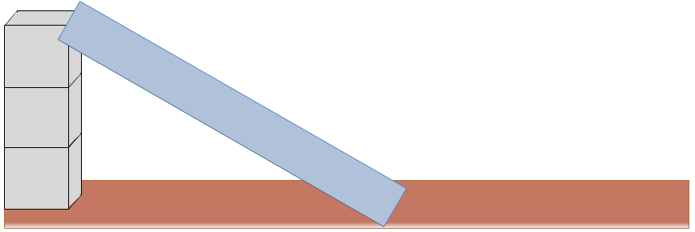 | 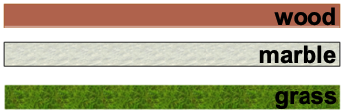
a ramp that you can lean on three boxes | various flat surfaces on which to place the ramp

You want to investigate whether the type of horizontal surfaces affects how far the toy car will go before it stops. What do you propose to do according to the materials you have at your disposal? (Note: You do not need to use all the ingredients).

2. (IDENTIFYING item)
You want to check if the weight of the load on the toy car affects the time it takes to go down the ramp. Which of the following series of experiments will help you check this?

A | 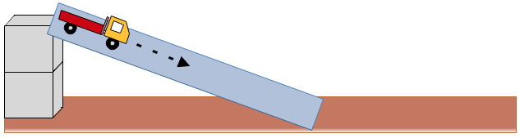 | 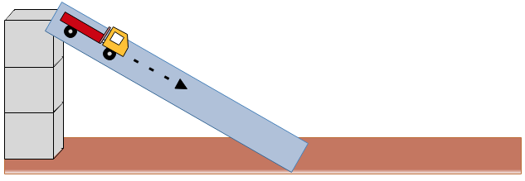
A | Test 1 | Test 2

B | 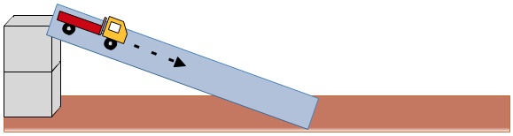 | 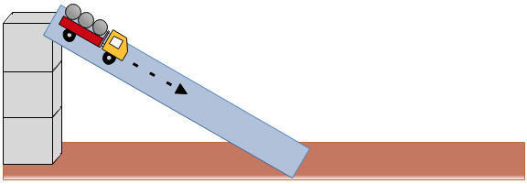
 | Test 1 | Test 2

C | 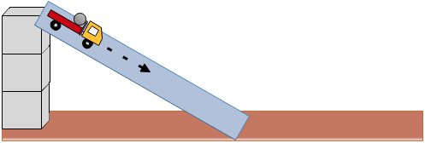 | 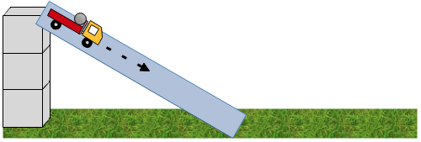
C | Test 1 | Test 2

D | 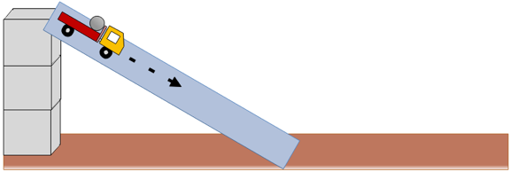 | 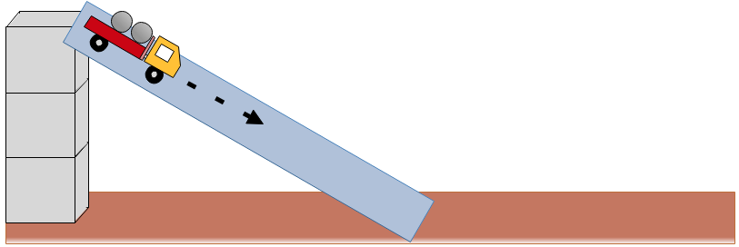
D | Test 1 | Test 2

Provide a brief explanation for the choice you made

3. (INTERPRETING item)
What do the following series of tests show?
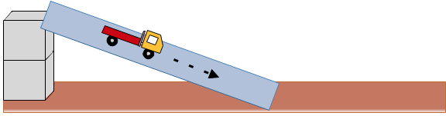 | 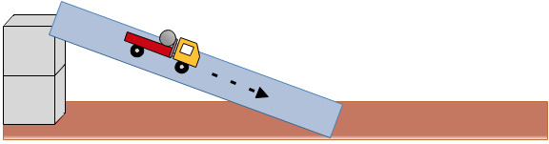
Test 1 | Test 2
A. No safe conclusion can be drawn.
B. The height from which the toy car is released affects the distance it will travel on the horizontal surface.
C. The ramp angle affects the distance the toy car will travel on the horizontal surface.
D. The weight of the load on the toy car affects the distance it will travel on the horizontal surface.

Provide a brief explanation for the choice you made
4. (UNDERSTANDING item)
What do the following series of tests show?
Test 1 | Test 2
A. The weight of the load on the toy car affects the distance it will travel on the horizontal surface.
B. The ramp height affects the distance the toy car will travel on the horizontal surface.
C. The weight of the load on the toy car and the height of the ramp affect the distance it will travel on the horizontal surface.
D. No safe conclusion can be drawn.

Provide a brief explanation for the choice you made

