Electronic Supplementary Material

Gesture Use in Communication Between Mothers and Offspring in Wild Orang-utans (Pongo pygmaeus wurmbii) from the Sabangau Peat-Swamp Forest, Borneo
Andrea Knox · Joey Markx · Emma How · Abdul Azis · Catherine Hobaiter · Frank J. F. van Veen · Helen Morrogh-Bernard

Table SI Video footage per individual in minutes

Individual | Total (min) | Coded (min)
Feb | 337.5 | 20.9
Fio | 406.8 | 115.1
Indy | 904.1 | 122.5
Icarus | 956.7 | 151.9
Cleo | 202.1 | 17.3
Chuck | 195.7 | 35.0
Joy | 19.9 | 9.4
Juno | 28.4 | 12.0
Georgia | 38.2
Gracia | 296.1 | 26.3
Gretel | 239.8 | 18.3
Indah | 316.7 | 26.3
Ima | 293.4 | 34.8
Isabella | 69.1 | 16.6
Teresia | 347.7 | 32.8
Trevor | 345.1 | 47.5
Total: the total length of the videos watched, per individual, to locate signals for coding. Coded: the total length of all videos from which signals were coded. Most signals were <2 s in duration; some individuals may be present in more than one video.

Table SII Definitions of the situational contexts

Context | Definition
Affiliating | One individual seeks social support or positive physical contact from another, for example, some greetings, when distressed, or during reconciliation.
Agonistic | One individual seeks to chase away or physically attack another; typically results in other individual leaving the party or engaging in physical fight.
Display | Social displays such as running through the group or toward another individual.
Feeding–individual | The location, preparation, and ingestion of food. Includes all food directed activity such as begging, foraging, and drinking with the exception of food sharing (see below).
Feeding–food sharing | One individual either actively gives another individual food, or passively allows cofeeding or tolerates pilfering.
Grooming | An individual participates in grooming or requests grooming from another.
Nesting | Construction of and resting within a day or night nest.
Nursing | Mother allows the infant to suck from nipples.
Play–social | Two or more individuals engaged in play behavior; may include both chasing-play and/or contact-play such as wrestling.
Play–solitary | Individual engages in play behavior alone; may include object-play.
Resting | Remains in a stationary position, without participation in self-directed or other-directed activity.
Sex | Includes copulation, inspection, and solicitation.
Moving | Movement within a tree, for example, to join another individual or to move feeding patch.
Other | Unusual behavior not listed under any other category.
Travel | Locomotion from one area to another, including movement between trees in a consistent direction. Does not include brief locomotion between individuals within a tree.
Unknown | It was not possible to determine individual’s context, typically because of poor visibility.
Contexts were coded separately for both the signaler and recipient before and after signal use, and were treated as mutually exclusive.

Table SIII Number of signals recorded by dyad

Signaler–recipient pair | # Total signals produced | # Gestural signals produced
Feb–Fio | 16 | 11
Gracia–Gretel | 10 | 9
Teresia–Trevor | 44 | 20
Cleo–Chuck | 30 | 21
Indy–Icarus | 158 | 111
Indah–Ima | 52 | 44
Juno–Joy | 2 | 2
Icarus–Isabella | 16 | 16
Fio–Icarus | 3 | 3
Dyads represent mother–infant pairs, except those in italics, which are siblings.

Table SIV GLMM of signal modality in response to recipient attention

Fixed effect type | Degree of freedom | Sum of squares | Mean Square | F-Value | P-Value
Recipient attention | 4 | 25.006 | 6.252 | 6.252 | 6.18e-05
Social relationship | 1 | 2.210 | 2.210 | 2.210 | 0.203
Signaler age class | 1 | 0.087 | 0.087 | 0.087 | 0.685
Signaler location | 1 | 1.333 | 1.333 | 1.333 | 3.89e-05
Social relationship (mother–offspring, other), signaler age class (adult, immature), and signaler location (ground, tree) were included as fixed control effects. Signaler and recipient identity and signaler and recipient behavioral contexts before the signal were included as random effects.

Table SV Analysis of variance of signal modality in response to recipient attention: Results of the χ² test analyzing the variance between the full and null models

Models | Degrees of freedom | AIC | BIC | Log link | Deviance | χ² | Pr(>χ²)
Null model | 8 | 450.28 | 480.79 | –217.14 | 434.28 | — | —
Full model | 12 | 433.72 | 479.49 | –204.86 | 409.72 | 24.56 | 6.177e-05

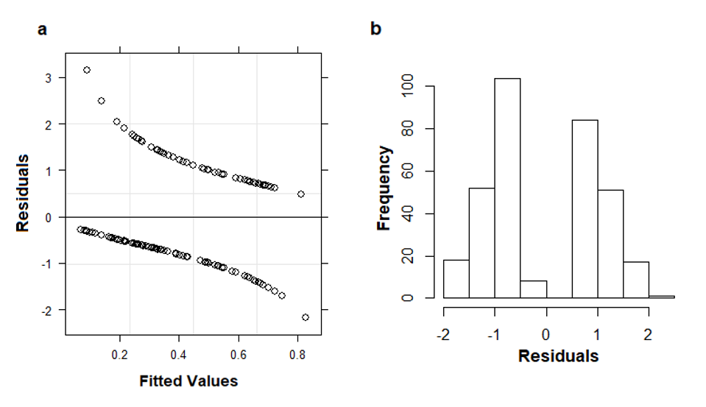
Fig. S1 Diagnostic residual plots for GLMM of signal intentionality in response to recipient attentional state with a binomial error distribution and a logarithmic link function. (a) Scatterplot of residuals vs. fitted values. The plot shows the systematic patterning typical of log link functions in GLMMs. (b) Histogram plotting the frequency of model residuals showing a normal distribution.

