Electronic Supplementary Material
Sleeping Site and Tree Selection by Bale Monkeys (Chlorocebus djamdjamensis) at Kokosa Forest Fragment in Southern Ethiopia

Table SI Habitat type classes and descriptions in the home range of Bale monkeys at Kokosa forest fragment in southern Ethiopia, February–July 2014
Habitat type | Description
Tree dominated forest | A habitat that consists of large trees (≥10 cm in DBH) accounting for ≥50% of the canopy cover and bamboo accounting for <10% of the stem density including Juniperus Forest
Mixed bamboo forest | A habitat that consists of 10%–49% bamboo as well as many large trees
Shrubland | A habitat that consists of ≥50% of shrubs, relatively few trees with dense ground vegetation cover, predominantly Rubus apetalus, Bothriocline schimperi and Jasminum abyssinicum
Grazing land | A habitat covered by graminoids and forbs and exploited by livestock
Cultivated land | A habitat used for cultivation, especially crops, enset (Ensete ventricosum), and home gardens

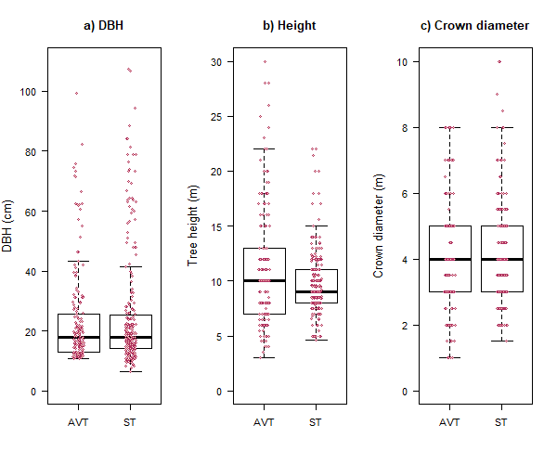 Fig. S1 Differences between available trees (AVT) and sleeping trees (ST) in the home range of the study group at Kokosa forest fragment, southern Ethiopia. (a) DBH. (b) Height. (c) Crown diameter. Dots represent the corresponding data set in category available trees and sleeping trees, the box shows the 25% and 75% interquartile and the line in the box indicates the median of the corresponding value. Vertical dotted lines denote the acceptable range with interquartile distance (IQD) multiplied by 1.5. Only height showed a significant difference (P < 0.01).

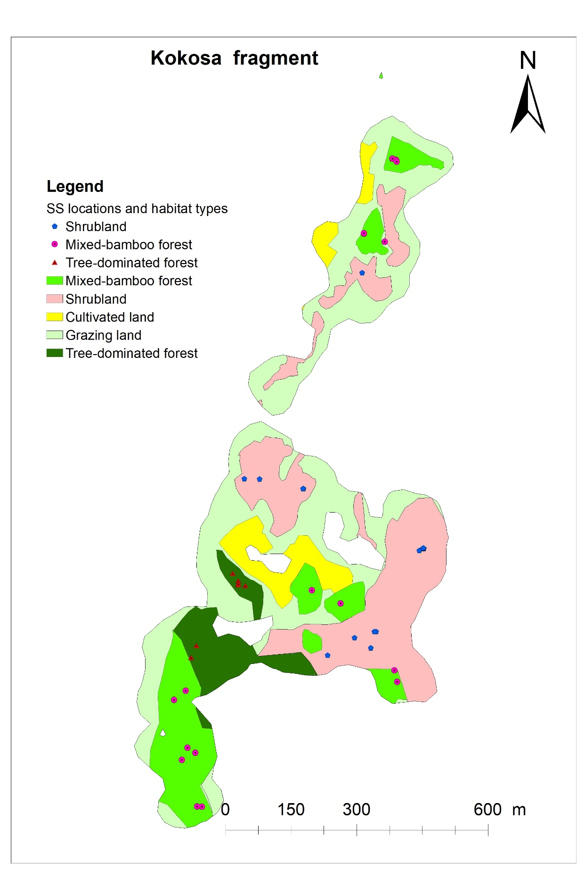
Fig. S2 Spatial distribution of sleeping sites (SS) with respect to habitat types in the 95% KDE home range of the Bale monkey group at Kokosa forest fragment in southern Ethiopia, February–July 2014.

