Foraging strategies of invasive Macaca fascicularis may promote plant invasion in Mauritius

Electronic Supplementary Material
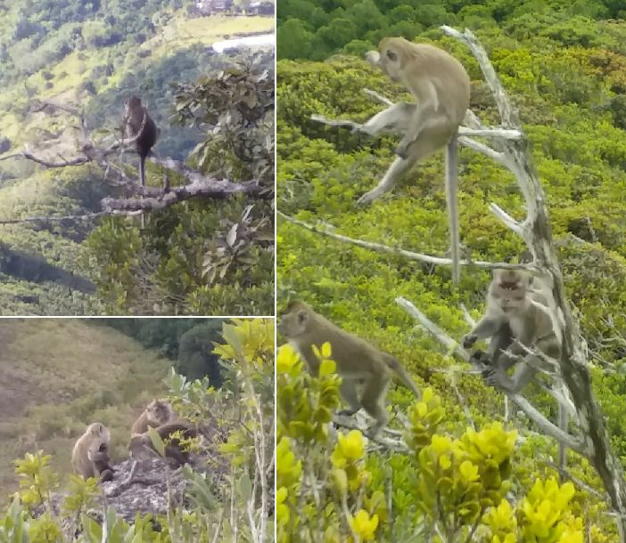
Figure S1: Members of our study group (long-tailed macaques, Macaca fascicularis) resting near their sleep site on the north-west facing slope of Mt. Calebasses, Mauritius.
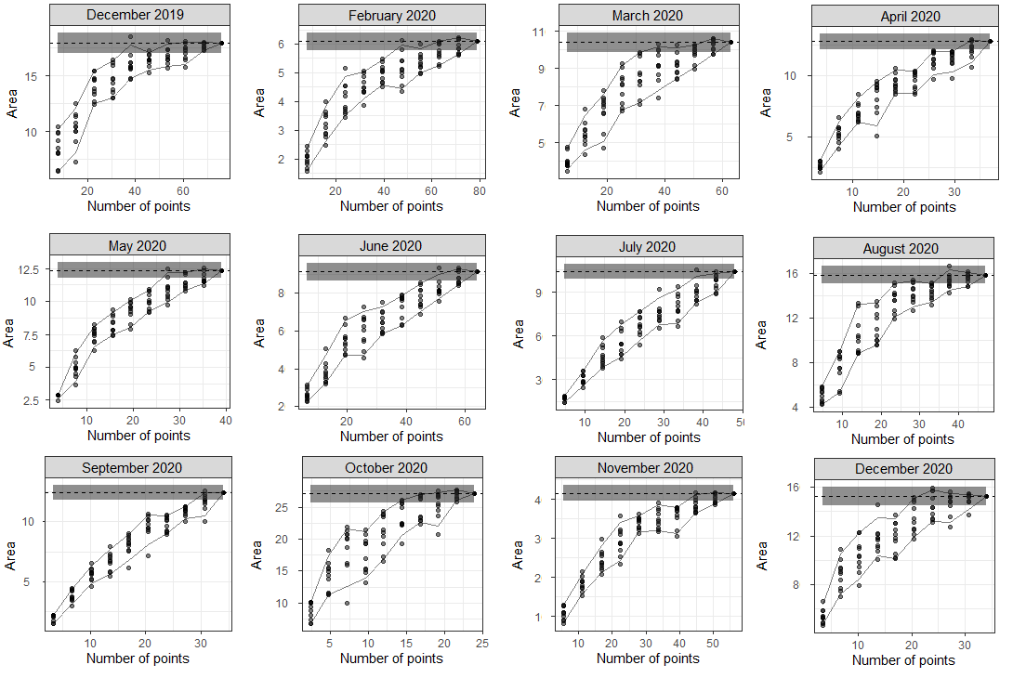
Figure S2: Bootstrapped home range estimates (area in hectares) of our long-tailed macaque (Macaca fascicularis) group plotted against sample size (number of GPS points) for every month (December 2019 – December 2020). For every sample size we randomly re-sampled all GPS points ten times to estimate home range size. We collected the GPS points in Mt. Calebasses, Mauritius.

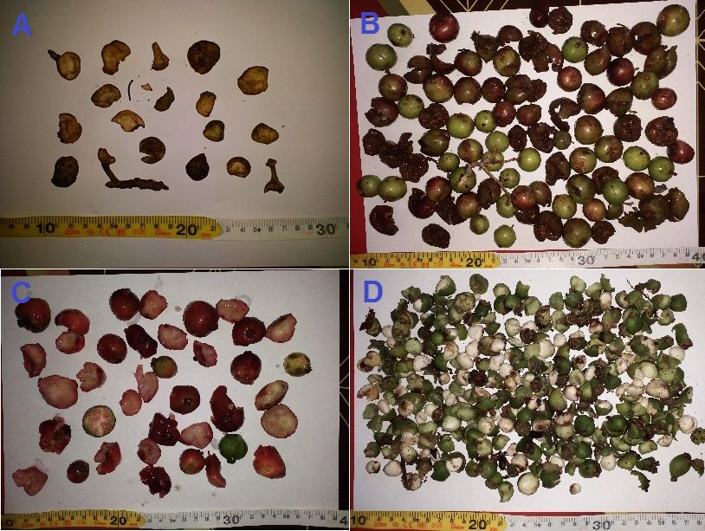
Figure S3: Intact and partly eaten fruits dropped by long-tailed macaques (Macaca fascicularis) during feeding observations: A) unripe partly eaten fruits of Ficus mauritiana, B) intact and partly eaten ripe and unripe fruits of Flacourtia indica, C) partly eaten ripe and unripe fruits of Psidium cattleyanum and D) intact and partly eaten fruits of Eugenia pyxidata. The fruits in picture A were dropped by a single individual in one minute, fruits in pictures B dropped by two individuals in 10 minutes, fruits in picture C by two individuals in 22 minutes and the fruits in picture D were dropped by two individuals in 16 minutes. We made these feeding observations during December 2019 – December 2020 in Mt. Calebasses, Mauritius.

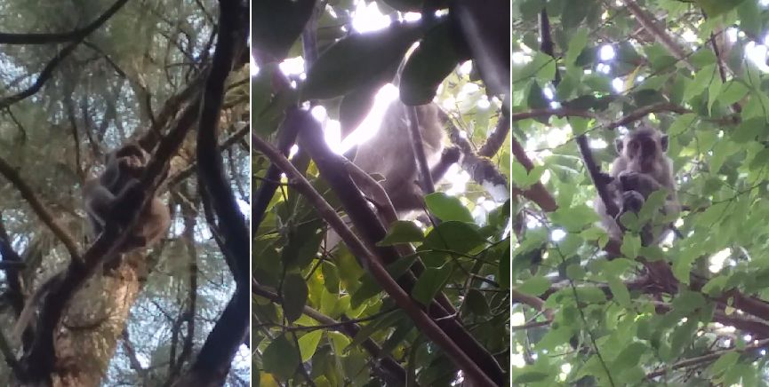
Figure S4: A long-tailed macaque (Macaca fascicularis) feeding on pine cone of Pinus elliotti (left), a macaque eating fruits of Psidium cattleyanum (middle) and a macaque chewing on fruits of Litsea sp. and Flacourtia indica stored in its cheek pouches (right). We observed these feeding individuals during December 2019 – December 2020 in Mt. Calebasses, Mauritius.

Table S1: Native and invasive (inv.) plant species recorded along our phenology transects in Mt. Calebasses, Mauritius. Status (native or inv.), total number of recorded stems (DBH ≥ 5 cm) across all four transects (N), percentage of stems that successfully fruited (% success), percentage of total Fruit Availability Index (% FAI), fruiting period and the month when ripe fruit developed (Ripe) are also provided for every species. A free-standing hyphen is used when a species did not produce fruit and/or ripe fruit. We collected data on fruiting phenology during December 2019 – December 2020.
Family and species | Status | N | % success | % FAI | Fruiting period | Ripe
Achariaceae
Erythrospermum monticolum | Native | 28 | 35 | 2.43 | 12/19 - 12/20 | 07/20
Aphloiaceae
Aphloia theiformis | Native | 12 | 22 | 0.12 | 05/20 - 07/20 | -
Apocynaceae
Tabernaemontana persicariifolia | Native | 9 | - | - | - | -
Burseraceae
Canarium paniculatum | Native | 2 | 100 | 5.44 | 12/19 - 12/20 | 03/20
Calophyllaceae
Calophyllum tacamahaca | Native | 8 | - | - | - | -
Ebenaceae
Diospyros boutoniana* | Native | 1 | 100 | 0.06 | 12/19 | -
Diospyros neraudii | Native | 1 | - | - | - | -
Euphorbiaceae
Claoxylon sp. | Native | 2 | - | - | - | -
Securinega durissima | Native | 23 | - | - | - | -
Lamiaceae
Premna serratifolia | Native | 1 | 50 | 0.02 | 02/20 | -
Rotheca serrata | Inv. | 3 | 100 | 0.07 | 12/19 - 03/20 | 02/20
Lauraceae
Cinnamomum camphora | Inv. | 1 | - | - | - | -
Litsea sp. | Inv. | 143 | 46 | 14.73 | 12/19 - 05/20 + 12/20 | 12/19
Loganiaceae
Geniostoma borbonicum | Native | 6 | 17 | 0.28 | 09/20 - 12/20 | -
Malpighiaceae
Hiptage benghalensis | Inv. | 19 | 100 | 0.79 | 05/20 - 07/20 + 11/20 - 12/20 | 10/20
Melastomataceae
Memecylon cordatum | Native | 1 | 100 | 0.01 | 03/20 - 04/20 | 03/20
Moraceae
Ficus mauritiana | Native | 4 | 50 | 0.46 | 12/19 - 03/20 + 05/20 - 09/20 | -
Myrtaceae
Eugenia elliptica | Native | 3 | - | - | - | -
Eugenia pyxidata | Native | 26 | 58 | 0.88 | 12/19 - 04/20 | 04/20
Psidium cattleyanum | Inv. | 534 | 48 | 15.28 | 12/19 - 10/20 | 03/20
Syzygium commersonii | Native | 3 | 50 | 0.08 | 11/20 - 12/20 | -
Syzygium dupontii | Native | 3 | 50 | 0.31 | 11/20 - 12/20 | -
Syzygium glomeratum | Native | 18 | 36 | 2.72 | 04/20 - 12/20 | 06/20
Syzygium jambos | Inv. | 112 | 14 | 0.55 | 12/19 + 07/20 + 11/20 | -
Syzygium mauritianum | Native | 4 | 75 | 0.14 | 02/20 - 03/20 | -
Oleaceae
Ligustrum robustum | Inv. | 76 | 58 | 4.81 | 12/19 - 09/20 | 04/20
Phyllantaceae
Margaritaria anomala | Native | 1 | 100 | 1.04 | 02/20 - 08/20 | 04/20
Phyllanthus sp. | Native | 1 | - | - | - | -
Pittosporaceae
Pittosporum senacia | Native | 5 | 33 | 0.06 | 12/19 - 02/20 | 02/20
Primulaceae
Ardisia elliptica | Inv. | 8 | 100 | 1.33 | 03/20 - 12/20 | 05/20
Psiloxylaceae
Psiloxylon mauritianum | Native | 7 | 80 | 15.82 | 02/20 - 10/20 | 05/20
Rhamnaceae
Rhamnus nepalensis | Inv. | 14 | - | - | - | -
Salicaceae
Casearia coriacea | Native | 2 | - | - | - | -
Flacourtia indica | Inv. | 180 | 59 | 32.59 | 12/19 - 09/20 + 12/20 | 03/20
Sapindaceae
Molinaea alternifolia | Native | 1 | - | - | - | -
Sapotaceae
Labourdonnaisia glauca | Native | 1 | - | - | - | -
Mimusops maxima | Native | 4 | - | - | - | -
Sideroxylon puberulum | Native | 3 | - | - | - | -
Stilbaceae
Nuxia verticillata | Native | 2 | - | - | - | -

Table S2: Family and species name of every invasive (inv.) and native plant species in the long-tailed macaque’s (Macaca fascicularis) diet and the percentage of total plant feeding time macaques fed on any of their plant parts (% plant diet) and percentage of total fruit feeding time that macaques fed on their fruits (% fruit diet) during December 2019 – December 2020 in Mt. Calebasses, Mauritius. A hyphen indicates that no fruits of this plant species were eaten by macaques. The plant parts macaques consumed are also provided for every species: ripe (r) and unripe (u) fruit (Fr), seed (Se), flower (Fl), leaf (L), stem (St), bark (B) and male and female pine cone (Pc). Finally, the fruit preference index is provided for every species (FPI_{i}). For some species in the macaque’s fruit diet, we could not measure fruit availability because the species was either extremely rare in the study site or restricted to one particular forest area (Olea lancea and Mangifera indica).
Family | Species | Status | Parts consumed | % plant diet | % fruit diet | FPI_{i}
Acanthaceae | Justicia gendarussa | Inv. | L | 4.4*10⁻² | - | -
Anacardiaceae | Mangifera indica | Inv. | Fr (r/u), Se | 2.2 | 4.9 | -
Arecaceae | Livistona chinensis | Inv. | Fl, L, S | 0.8 | - | -
Bignoniaceae | Tabebuia pallida | Inv. | L | 0.2 | - | -
Caprifoliaceae | Lonicera sp. | Inv. | L | 4.4*10⁻² | - | -
Fabaceae | Fabaceae sp. | Inv. | L | 0.3 | - | -
Lauraceae | Litsea sp. | Inv. | Fr (r/u), L, Fl, St | 25.0 | 40.2 | 4.0
Malpighiaceae | Hiptage benghalensis | Inv. | Fr (r/u), Se, L, Fl | 6.4 | 0.7 | 0.1
Malvaceae | Ruizia blackburniana | Native | L | 4.4*10⁻² | - | -
Melastomataceae | Clidemia hirta | Inv. | S | 4.4*10⁻² | - | -
 | Ossaea marginata | Inv. | L | 8.7*10⁻² | - | -
Moraceae | Ficus mauritiana | Native | Fr (u), L | 0.3 | 0.4 | 0.8
 | Ficus reflexa | Native | Fr (r/u), L | 0.4 | 0.3 | -
 | Ficus rubra | Native | Fr (r/u) | 0.3 | 0.6 | -
Myrtaceae | Eugenia pyxidata | Native | Fr (u), Se, L | 0.4 | 0.7 | 0.1
 | Psidium cattleyanum | Inv. | Fr (r/u), L, B | 17.6 | 39.3 | 1.1
 | Syzygium dupontii | Native | Fr (u), Se | 0.1 | 0.3 | 0.6
 | Syzygium glomeratum | Native | L | 0.2 | - | -
 | Syzygium jambos | Inv. | Fr (u), Se, L, Fl | 1.2 | 1.0 | 1.2
Oleaceae | Ligustrum robustum | Inv. | Fr (r/u), Se, L, Fl | 3.7 | 0.7 | 0.1
 | Noronhia broomeana | Native | Fr (u), Se | 4.4*10⁻² | 0.1 | -
 | Olea lancea | Native | Fr (u), Se, L | 8.7*10⁻² | 0.1 | -
Phyllanthaceae | Securinega durissima | Native | L | 0.1 | - | -
Pinaceae | Pinus elliotii | Inv. | Pc, B, St | 28.8 | - | -
Piperaceae | Piper borbonense | Native | L | 4.4*10⁻² | - | -
Pittosporaceae | Pittosporum senacia | Native | Fr (u), L | 0.2 | 0.3 | 0.7
Poaceae | Bambusoideae sp. | Inv. | L | 0.1 | - | -
 | Poaceae sp. | Unknown | L | 0.3 | - | -
Primulaceae | Ardisia elliptica | Inv. | L | 4.4*10⁻² | - | -
Psiloxylaceae | Psiloxylon mauritianum | Native | Fr (r) | 8.7*10⁻² | 0.1 | 0.1
Rutaceae | Citrus sp. | Inv. | Fr (r/u) | 0.4 | 0.8 | -
Salicaceae | Flacourtia sp. | Native | Fr (r/u), L | 5.6 | 9.5 | 0.5
Sapotaceae | Mimusops maxima | Native | L | 8.7*10⁻² | - | -
 | Sideroxylon puberulum | Native | L | 0.1 | - | -
Verbenaceae | Stachytarpheta jamaicensis | Inv. | L | 8.7*10⁻² | - | -
Unknown | Unknown | Unknown | L | 4.5 | - | -

Table S3: Regression coefficients and standard errors (SE) for all predictors included in our top-ranked GLM’s explaining the effects of monthly Fruit Availability Index (FAI) scores and ‘Species’ on the proportion of ripe vs. unripe fruits consumed by long-tailed macaques (Macaca fascicularis) per feeding bout and the effects of monthly FAI, ‘Species’ and ‘Maturity’ (ripe or unripe) on the proportion of fruits consumed vs. dropped by macaques per feeding bout. Predictor ‘Species’ has two categories: ‘main inv. plants’ (consisting of invasive Flacourtia indica, Litsea sp. and Psidium cattleyanum) and ‘other’ (consisting of other native and invasive plant species). For the first model, we added regression coefficients and SEs for the simple slopes of FAI for the two levels of ‘Species’. For the second model, we added coefficient and SEs for the pairwise comparisons between predicted marginal means of levels of predictor Maturity (ripe/unripe) for low (-1 SD), intermediate (mean) and high (+1 SD) FAI values. We collected the data used for the GLM’s during December 2019 – December 2020 in Mt. Calebasses, Mauritius.
Model | Predictor | Coefficient | SE
Prop. ripe vs. unripe cons. | FAI | 3.45*10⁻⁴ | 9.51*10⁻⁵
Prop. ripe vs. unripe cons. | Species | 3.49 | 2.01
Prop. ripe vs. unripe cons. | FAI: Species | 5.53*10⁻⁴ | 3.39*10⁻⁴
 | FAI: Species – Main inv. plant slope | 3.45*10⁻⁴ | 9.51*10⁻⁵
 | FAI: Species – Other slope | -2.09*10⁻⁴ | -8.46*10⁻⁴
Prop. cons. vs. drop | Maturity | 1.99 | 9.58*10⁻¹
Prop. cons. vs. drop | FAI | 3.15*10⁻⁴ | 6.39*10⁻⁵
Prop. cons. vs. drop | Species | 3.11 | 7.11*10⁻¹
Prop. cons. vs. drop | FAI: Maturity | 2.39*10⁻⁴ | 5.94*10⁻⁵
 | FAI -1 SD: ripe – unripe pairwise | 1.57*10⁻² | 5.18*10⁻¹
 | FAI mean: ripe – unripe pairwise | 1.49 | 3.25*10⁻¹
 | FAI +1 SD: ripe – unripe pairwise | 2.96 | 4.60*10⁻¹

Table S4: Predictors (and their two-way and three-way interactions) in our generalized linear models (GLM’s) explaining a) the variation in the proportion of ripe vs. unripe fruits consumed by long-tailed macaques (Macaca fascicularis) per feeding bout and b) the proportion fruits consumed vs. dropped by macaques per feeding bout. The predictors have been ranked by summed predictor weights, which were obtained by summing the Akaike weights for each model in which that predictor or interaction appeared. A summed weight close to 1 means that the predictor is highly likely to be part of the model best explaining variation in the response variables. We collected the data used in the GLM’s during December 2019 – December 2020 in Mt. Calebasses, Mauritius.
Response variable and predictors | Summed predictor weights
- Prop. ripe vs. unripe consumed
FAI | 1.00
Species | 0.95
FAI*Species | 0.87
- Prop. consumed vs. intact
FAI | 1
Species | 1
Maturity | 1
FAI*Maturity | 0.98
FAI*Species | 0.48
Maturity*Species | 0.43
FAI*Maturity*Species | 0.12

Figure S5: Black and white version of figure 2 from main text. 