Appendix Table 1. Ethogram used for data collection
Behavior | Description | Type
Affiliative
Groom C | Continue grooming session which started before the focal session | State
Groom S | Grooming session started during the focal session | State
Groom T | Grooming session terminated during the focal session | State
Hug C | Hug session continued before the focal session | State
Hug S | Hug session started during the focal session | State
Hug T | Hug session terminated during the focal session | State
Aggressive
Approach | Initiator is moving towards recipient aggressively | Point
Avoid contact | Avoidant behavior of recipient towards initiator where the recipient moves away from the initiator to  prevent any potential interaction | Point
Bite | Aggressive behavior when the individual bites another one | Point
Chase | Intensively running towards a fleeing recipient | Point
Displacement | Forced movement or change of place by a subordinate in presence of dominant individual | Point
Display | Focal individual shakes branch or roof to show dominance to other individual | Point
Flee | Recipient running away from a chasing initiator | Point
Approach | Initiator is moving towards recipient aggressively | Point
Avoid contact | Avoidant behavior of recipient towards initiator where the recipient moves away from the initiator to  prevent any potential interaction | Point
Bite | Aggressive behavior when the individual bites another one | Point
Chase | Intensively running towards a fleeing recipient | Point
Displacement | Forced movement or change of place by a subordinate in presence of dominant individual | Point
Display | Focal individual shakes branch or roof to show dominance to other individual | Point
Flee | Recipient running away from a chasing initiator | Point
Vocal
Contact rattle | If an individual looks at another individual and gives a contact rattle | Point
Contact woo | Woo call to ascertain presence of individuals | Point
Isolation coo | Contact call (coo) given by individual far from the rest | Point
Activity
Affiliative | All interactions listed under affiliative category
Aggression | All interactions listed under aggressive category
Feed | Individual eating food | Point
Move | Movement of the infant going from one place to other without exploring | State
Sit | Focal in sitting position | State
Rest | Focal lays down with open eyes | State
Sleep | Focal sleeping | State

Appendix Table 2. Mean values of observed behavior of individual females before and after the loss of their infants.

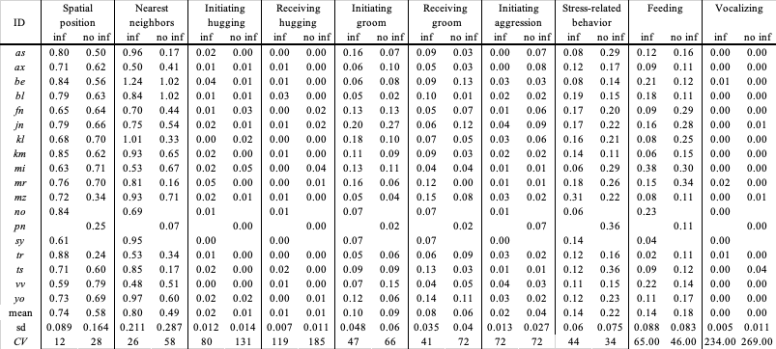

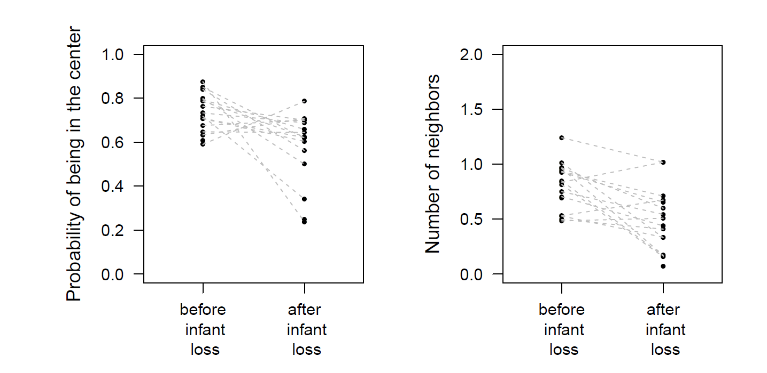

Appendix Fig. 1 Probability of being in the center of the group and the number of neighbors within 3 m for individual bonnet macaque females before and after their infants died.
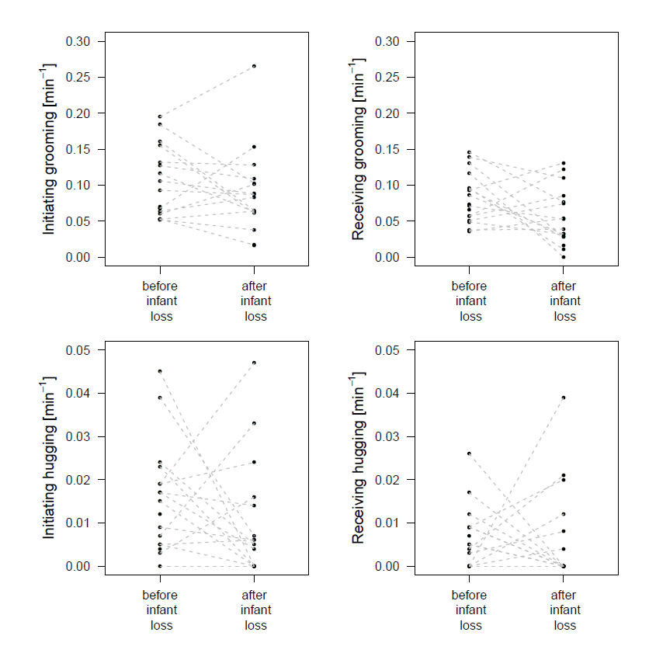
Appendix Fig. 2 Initiating and receiving affiliative behaviors by individual bonnet macaque females before and after their infants died.

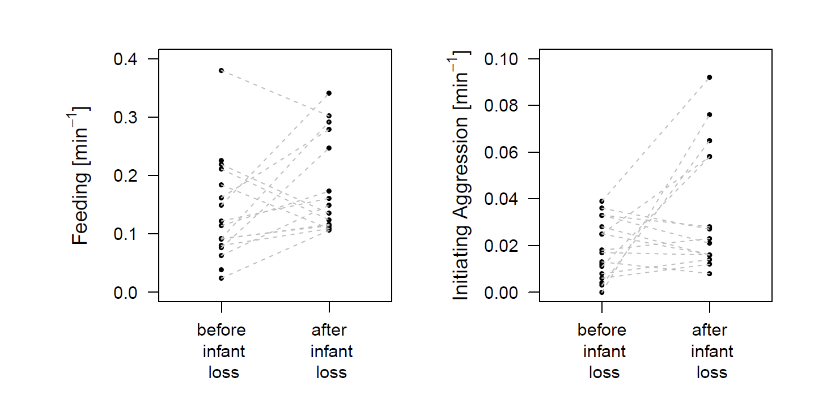
Appendix Fig. 3 Feeding and aggressive behavior of individual bonnet macaque females before and after their infant loss.
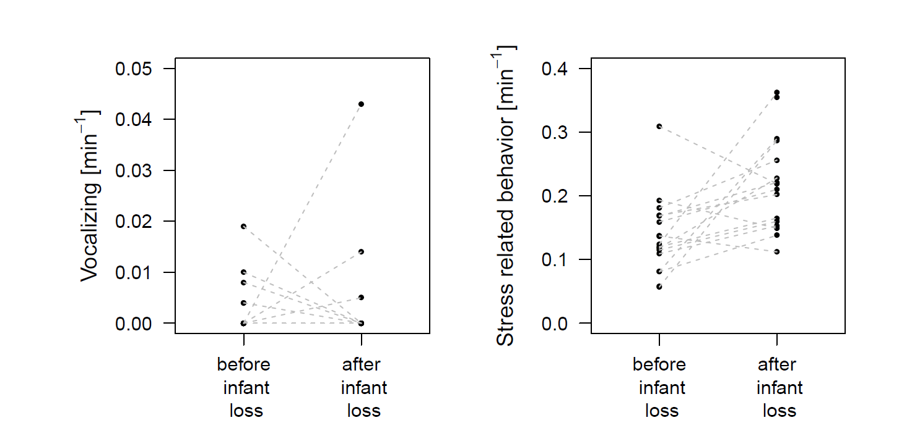
Appendix Fig. 4 Vocalization and feeding by individual bonnet macaque females before and after their infant loss.
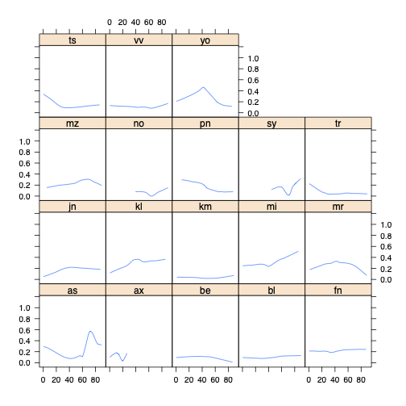
Appendix Fig. 5 Example of individual variation in the duration of the grieving period for stress related behavior levels. Compare with Appendix Fig. 4 to see that while the increase in stress-related behavior levels seems very common for females after infant loss; for some females (e.g., jn, kl, mi), there seems to be no evidence of the decrease of the levels even 90 days after infant loss.

