Figure 2 Proximity network for a white-fronted lemur group at Faunia Zoo, Spain (2023). Males are shown as circles and females as squares; individuals in green and orange represent mother-offspring pairs; the width of the lines represents the strength of the relationships. We removed relationships below the mean to facilitate visualization.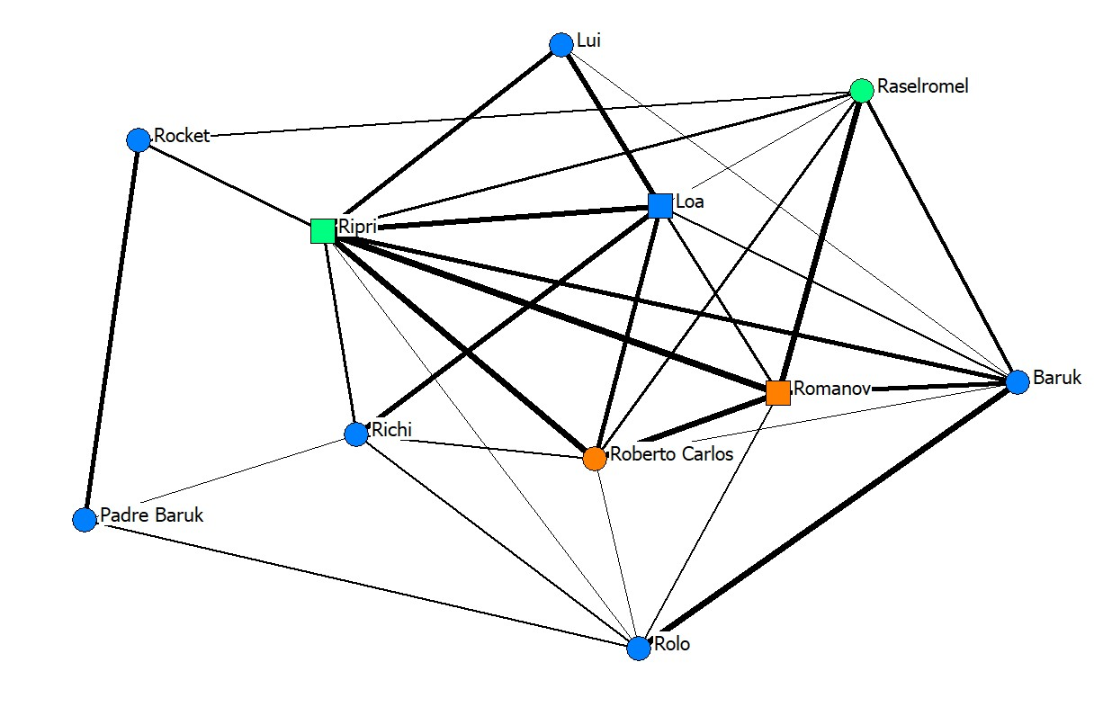
Figure 3 Chasing network for a white-fronted lemur group at Faunia Zoo, Spain (2023). Males are shown as circles and females as squares; individuals in green and orange represent mother-offspring pairs; the width of the lines represents the strength of the relationships and arrowheads represent direction and strength. 