Supplementary Material
Figure S1: Field team on Marambaia Island performing the main steps of the capture, biological sample collection, and release procedures for Sapajus nigritus. (a) Traps on bamboo platforms in the trees using a rope-and-pulley system; (b) Trap placed on the ground and covered with a black cloth to reduce visual stimuli and minimize stress; (c) Restraint of the primates using iron rods attached to wooden supports to facilitate sedation; (d) Subcutaneous microchip insertion into the interscapular region for subsequent identification; (e) Whole blood collection from the femoral vein after asepsis of the site with 70% alcohol; (f) Release of the primates at the capture site after recovery of reflexes and muscle tone. Photographs from the DiGA archive.
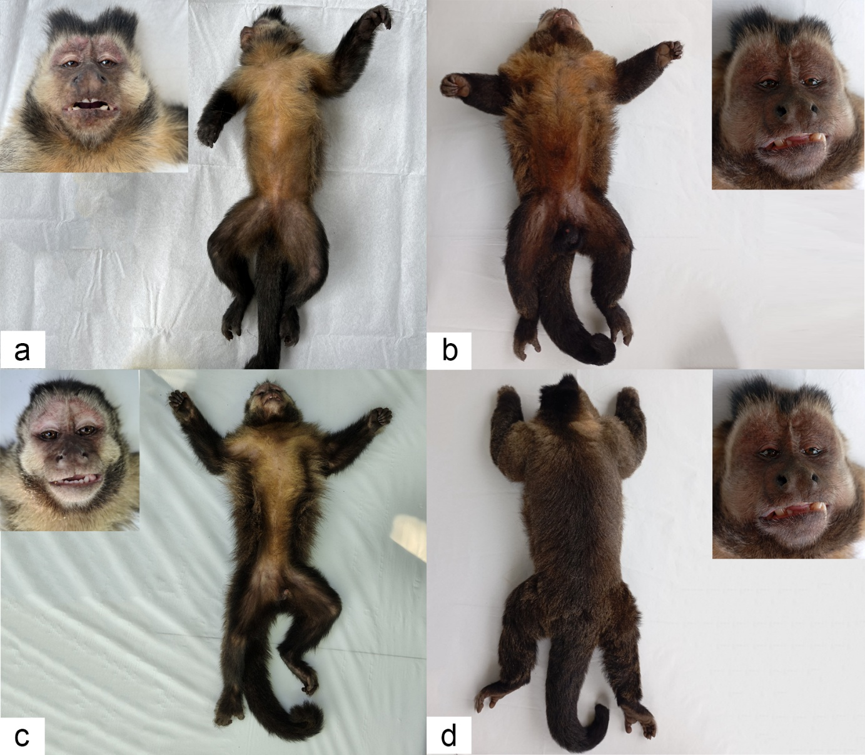
Figure S2: Sapajus nigritus individuals from Marambaia Island, Rio de Janeiro, Brazil. (a) Adult female; (b) Adult male, ventral view; (c) Juvenile male, ventral view; (d) Adult male, dorsal view. Photographs from the DiGA archive.

