Supplementary Material
Surface Tension and Viscosity of Binary Mixtures of the Fluorinated and
Non-Fluorinated Ionic Liquids [PFBMIm][PF₆] and [C₄C₁Im][PF₆] by
the Pendant Drop Method and Surface Light Scattering
Thomas M. Koller,^{*,a} Frances D. Lenahan,ª Patrick S. Schmidt,ª Tobias Klein,ª
Julian Mehler,^{b} Florian Maier,^{c} Michael H. Rausch,ª Peter Wasserscheid,^{b,d}
Hans-Peter Steinrück,^{c} and Andreas P. Fröbaª
ªInstitute of Advanced Optical Technologies ‒ Thermophysical Properties (AOT-TP),
Department of Chemical and Biological Engineering (CBI) and Erlangen Graduate School in Advanced Optical Technologies (SAOT), Friedrich-Alexander-University
Erlangen-Nürnberg (FAU), Paul-Gordan-Straße 8, 91052 Erlangen, Germany
^{b}Institute of Chemical Reaction Engineering (CRT), Department of Chemical and Biological Engineering (CBI), Friedrich-Alexander-University Erlangen-Nürnberg (FAU),
Egerlandstraße 3, 91058 Erlangen, Germany
^{c}Chair of Physical Chemistry II, Department of Chemistry and Pharmacy,
Friedrich-Alexander-University Erlangen-Nürnberg (FAU), Egerlandstraße 3,
91058 Erlangen, Germany
^{d}Forschungszentrum Jülich, Helmholtz-Institute Erlangen-Nürnberg for Renewable Energy
(IEK 11), Egerlandstraße 3, 91058 Erlangen, Germany

__________________________
* Author to whom correspondence should be addressed. Tel. +49-9131-85-25809, fax +49-9131-85-25878, email thomas.m.koller@fau.de, ORCID number 0000-003-4917-3079.
A Measurement Methods
A.1 Vibrating Tube Densimeter – Density
Instruments from Anton Paar based on the vibrating-tube method were used for measuring the liquid density ρ at atmospheric pressure of 0.1 MPa. The uncertainty specified for the temperature measurement of the densimeters used is 0.01 K. Both instruments DMA 5000 M and DMA 5000 were checked successfully with air as well as with degassed and deionized water before and after each measurement series. After their preparation, all samples were injected into the densimeters via syringes, where the pure [PFBMIm][PF₆] was liquefied at about 363 K in a beaker in an argon atmosphere before filling it into a preheated syringe. Due to the small amount of the fluorinated IL available, only one fill of the U-tube was investigated, where the temperature range stated was studied three times. For the samples studied with the DMA 5000 M, the U-tube was filled two times with the individual samples, and two temperature scans were performed for each fill. Considering the complete experimental procedures, expanded relative uncertainties (k = 2) of 0.01% for the results obtained from the DMA 5000 M and 0.02% for those from the DMA 5000 were estimated. The agreement between the different data sets measured for each substance was within the stated uncertainties. The temperature and density data reported represent the averages of the measurement data collected during the individual runs for a given sample.
After the measurements reported in the main manuscript, further experiments were started with the DMA 5000 M for a mixture of [C₄C₁Im][PF₆] with a [PFBMIm][PF₆] mole fraction of 0.090. During the first temperature scan starting from 293 K, the formation of particles accompanied by a distinct shift in the recorded density data was observed at about 338 K. As the U-tube material was obviously affected irreversibly by this process, the measurement series was stopped and no corresponding data are reported.

A.2 Pendant Drop Method – Surface Tension
For the measurement of the surface tension σ of the two pure ILs and their mixtures with [PFBMIm][PF₆] mole fractions of 0.029 and 0.090 of the fluorinated IL in an argon atmosphere at about 0.11 MPa, the pendant drop (PD) method was used. Liquid samples of pure [C₄C₁Im][PF₆] as well as of its mixtures with [PFBMIm][PF₆] with mole fractions of 0.029 and 0.090 of the fluorinated IL were filled into a syringe connected to a capillary made of stainless steel and specified with an outer diameter of 1/16" and an inner diameter of 0.12 mm. The capillary reached into a temperature-controlled measurement cell with optical accesses which was flushed with argon before producing the pendant drops. The mentioned samples were studied at room temperature of about 298 K as well as at controlled temperatures of (308, 338, and 368) K. In the case of pure [PFBMIm][PF₆], a syringe containing the solid IL was connected to the capillary and carefully heated by an air gun as soon as the measurement cell reached the desired temperature of 368 K, which is above the melting point of the sample. The temperature control of the sample cell having an inner volume of about 45 mL was realized by resistance heating. The temperature of the gas atmosphere close to the capillary outlet was measured with a calibrated Pt100 Ω resistance probe with an expanded (k = 2) uncertainty of 0.02 K. For each sample and temperature, between 3 and 5 pendant drops were produced. After a temperature equilibration time of several minutes, a photograph of the drop was taken and the corresponding temperature was recorded. The temperature stability during the production of all evaluated droplets for a given sample and temperature was better than (±0.49, ±0.14, and ±0.07) K for the measurements for [PFBMIm][PF₆], at room temperature, and at the controlled temperatures studied for the samples being liquid at room temperature, respectively. For each sample and temperature, the average of the temperatures recorded when the pictures were taken are reported in Table S2 together with the corresponding expanded (k = 2) uncertainties. The latter consider both the uncertainty of the resistance probe and the temperature stabilities within the individual measurement series.

A.3 Surface light scattering – Dynamics of surface fluctuations and viscosity
For the surface light scattering (SLS) experiments, the sample cell made of aluminum was filled with about 30 mL of the degassed IL samples and flushed by argon to avoid any external contamination. After closing the cell, an argon gas atmosphere with a pressure of about 0.1 MPa was adjusted. For such low pressures, a negligible effect of argon on the properties of the IL systems is assumed. Using resistance heating in direct contact with the sample cell, its temperature T was regulated. For the temperature measurement, a calibrated 100 Ω platinum resistance probe with an expanded uncertainty (k = 2) of U(T) = 20 mK was placed in the main body of the sample cell in close vicinity to the IL surface. During each experimental run, the temperature stability was better than ±1 mK. For each temperature point, six independent measurements at different and relatively high moduli of the wave numbers of the studied surface fluctuations on the order of 6 × 10⁵ m^{–1} were performed, where line broadening effects are suppressed [1,2]. Temperatures of (293, 308, 338, and 368) K were investigated, where the temperature was stepwise increased. For all samples investigated, repetition measurements at 308 K showed within combined uncertainties the same results as the initial measurements.

B Summary of Experimental Results
The experimental results for the liquid density, liquid dynamic viscosity, and surface tension of the binary mixtures of [C₄C₁Im][PF₆] and [PFBMIm][PF₆] obtained in this work are summarized in the following Tables S1, S2, and S3, respectively.

Table S1 Liquid density ρ of the studied IL systems obtained by vibrating tube densimeters at temperature T and 0.1 MPaª
T / K | ρ / (kg m⁻³) | 100 U_{r}(ρ) | T / K | ρ / (kg m⁻³) | 100 U_{r}(ρ)
[C₄C₁Im][PF₆], x_{F,B} = 0 (DMA 5000 M)
293.15 | 1371.58 | 0.01 | 333.15 | 1338.30 | 0.01
298.15 | 1367.38 | 0.01 | 338.15 | 1334.23 | 0.01
303.15 | 1363.19 | 0.01 | 343.15 | 1330.16 | 0.01
308.15 | 1359.00 | 0.01 | 348.15 | 1326.12 | 0.01
313.15 | 1354.82 | 0.01 | 353.15 | 1322.09 | 0.01
318.15 | 1350.66 | 0.01 | 358.15 | 1318.07 | 0.01
323.15 | 1346.52 | 0.01 | 363.15 | 1314.07 | 0.01
328.15 | 1342.40 | 0.01
[C₄C₁Im][PF₆] + [PFBMIm][PF₆], x_{F,B} = 0.028 (DMA 5000 M)
293.15 | 1379.31 | 0.01 | 333.15 | 1345.83 | 0.01
298.15 | 1375.10 | 0.01 | 338.15 | 1341.72 | 0.01
303.15 | 1370.88 | 0.01 | 343.15 | 1337.63 | 0.01
308.15 | 1366.66 | 0.01 | 348.15 | 1333.55 | 0.01
313.15 | 1362.45 | 0.01 | 353.15 | 1329.50 | 0.01
318.15 | 1358.26 | 0.01 | 358.15 | 1325.45 | 0.01
323.15 | 1354.10 | 0.01 | 363.15 | 1321.42 | 0.01
328.15 | 1349.95 | 0.01
[PFBMIm][PF₆], x_{F,B} = 1 (DMA 5000)
340.65 | 1597.96 | 0.02 | 353.15 | 1585.58 | 0.02
343.15 | 1595.43 | 0.02 | 355.65 | 1583.11 | 0.02
345.65 | 1592.93 | 0.02 | 358.15 | 1580.79 | 0.02
348.15 | 1590.37 | 0.02 | 360.65 | 1578.48 | 0.02
350.65 | 1587.91 | 0.02 | 363.15 | 1576.16 | 0.02
ªThe expanded uncertainties (k = 2) U are U(T) = 0.01 K, U(p) = 3 kPa, and U(x_{F,B}) = 0.001 for the mixture. For the density, the relative expanded uncertainties (k = 2) U_{r}(ρ) are given in the table.

Table S2 Liquid dynamic viscosity η of the studied IL systems obtained by surface light scattering at temperature T and 0.1 MPa using correlations for the measured data for the liquid density ρ and the surface tension σ ª
T / K | η / (mPa s) | 100 U_{r}(η) | T / K | η / (mPa s) | 100 U_{r}(η)
[C₄C₁Im][PF₆], x_{F} = 0
293.20 | 342.7 | 4.1 | 338.16 | 39.54 | 4.2
308.19 | 144.0 | 4.1 | 368.13 | 16.34 | 4.3
[C₄C₁Im][PF₆] + [PFBMIm][PF₆], x_{F} = 0.028
293.20 | 370.4 | 4.4 | 338.16 | 40.93 | 4.1
308.19 | 153.0 | 4.2 | 368.13 | 16.38 | 4.3
[C₄C₁Im][PF₆] + [PFBMIm][PF₆], x_{F} = 0.090
293.20 | 429.6 | 5.3 | 338.16 | 46.18 | 4.7
308.19 | 171.4 | 4.7 | 368.13 | 17.60 | 4.4
ªDirectly measured values for damping Γ at a defined wave vector q of surface fluctuations were combined with correlations for liquid density ρ and surface tension σ described in the main text to determine the liquid dynamic viscosity η by an exact numerical solution of the dispersion relation [3,4]. The expanded uncertainties (k = 2) U are U(T) = 0.02 K and U(p) = 10 kPa. For the viscosity, the relative expanded uncertainties U_{r}(η) are given in the table (k = 2).

Table S3 Surface tension σ of the studied IL systems obtained by pendant drop method at temperature T in argon atmosphere using correlations for the measured data for the liquid density ρ ª
T / K | p / MPa | σ / (mN m⁻¹) | T / K | p / MPa | σ / (mN m⁻¹)
[C₄C₁Im][PF₆], x_{F} = 0 |  |  | [C₄C₁Im][PF₆] + [PFBMIm][PF₆], x_{F} = 0.090
295.33 ± 0.05 | 0.111 | 41.58 | 298.56 ± 0.10 | 0.111 | 39.40
308.14 ± 0.03 | 0.111 | 41.28 | 308.11 ± 0.04 | 0.111 | 39.06
338.10 ± 0.07 | 0.111 | 39.81 | 338.13 ± 0.03 | 0.111 | 37.19
368.09 ± 0.06 | 0.111 | 38.28 | 368.12 ± 0.05 | 0.111 | 35.92
[C₄C₁Im][PF₆] + [PFBMIm][PF₆], x_{F} = 0.029 |  |  | 338.17 ± 0.03^{b} | 0.111^{b} | 37.09^{b}
299.24 ± 0.14 | 0.110 | 40.25 | 298.81 ± 0.08^{b} | 0.111^{b} | 39.19^{b}
308.13 ± 0.03 | 0.110 | 40.22 | [PFBMIm][PF₆], x_{F} = 1
338.13 ± 0.02 | 0.110 | 38.27 | 368.18 ± 0.49 | 0.110 | 29.78
368.11 ± 0.04 | 0.110 | 36.65
ªThe expanded uncertainties (k = 2) for the pressure and the mole fraction of [PFBMIm][PF₆] in mixtures are U(p) = 3 kPa and U(x_{F,B}) = 0.001. The expanded uncertainties (k = 2) for the temperature U(T) considering both the uncertainty of the temperature probe and the temperature stability are given in the table. For the interfacial tension, the relative expanded uncertainties (k = 2) are U_{r}(σ) = 4%. ^{b}Repetition measurement and not used for the fit according to Eq. 4.

C Data Comparison for Pure [C₄C₁Im][PF₆]
For pure [C₄C₁Im][PF₆], a comparison of the experimental data obtained in this work with literature data was performed. All experimental literature data associated with a pressure at or close to 0.1 MPa were accessed through the "NIST Ionic Liquids Database - ILThermo", Version 2.0 [5] and are not differentiated regarding the source. In the following figures, the absolute data (upper part) and the relative deviation of the literature data from the correlations (lower part) for the liquid density ρ, liquid dynamic viscosity η, and surface tension σ based on Eqs. (2), (3), and (4), respectively, discussed in the main text are shown as a function of temperature in the relevant range between (280 and 380) K. For this range, all available 238 viscosity and 96 surface tension data are shown, while the in total 213 depicted density data points refer to literature published between the years 2009 until today. As can be seen from Figs. S1 and S2, the literature data for the density and the liquid viscosity scatter around the present correlations which seem to form the center of the datasets. For the surface tension shown in Fig. S3, most of the literature data show positive deviations from the present data. These deviations are often within combined expanded uncertainties of the datasets.
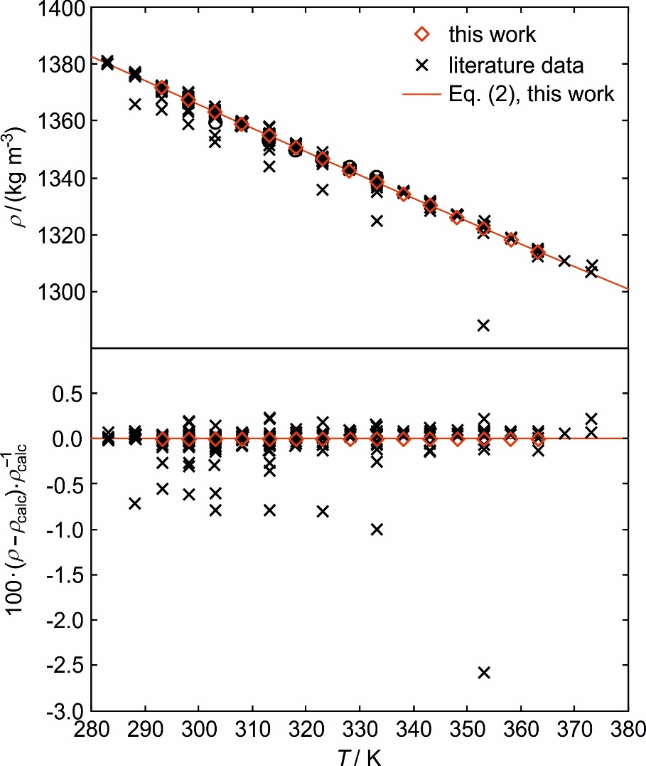
Fig. S1 Data comparison for the liquid density ρ of [C₄C₁Im][PF₆] at or close to 0.1 MPa as a function of temperature T in form of an absolute plot (upper part) and a deviation plot (lower part). The solid line represents the correlation, Eq. (2), developed in this work based on the experimental data.
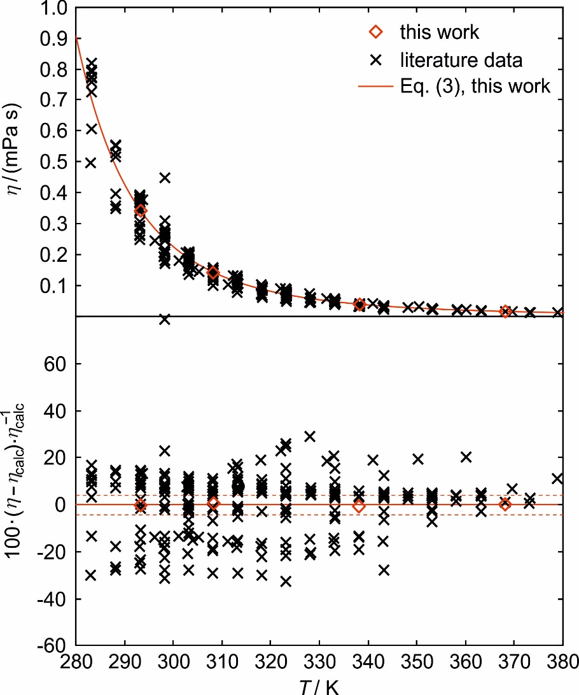
Fig. S2 Data comparison for the liquid dynamic viscosity η of [C₄C₁Im][PF₆] at or close to 0.1 MPa as a function of temperature T in form of an absolute plot (upper part) and a deviation plot (lower part). The solid line represents the correlation, Eq. (3), developed in this work based on the experimental data, while the dashed lines in the lower part of the figure indicate the average expanded uncertainty (k = 2) of the experimental data obtained in this work.

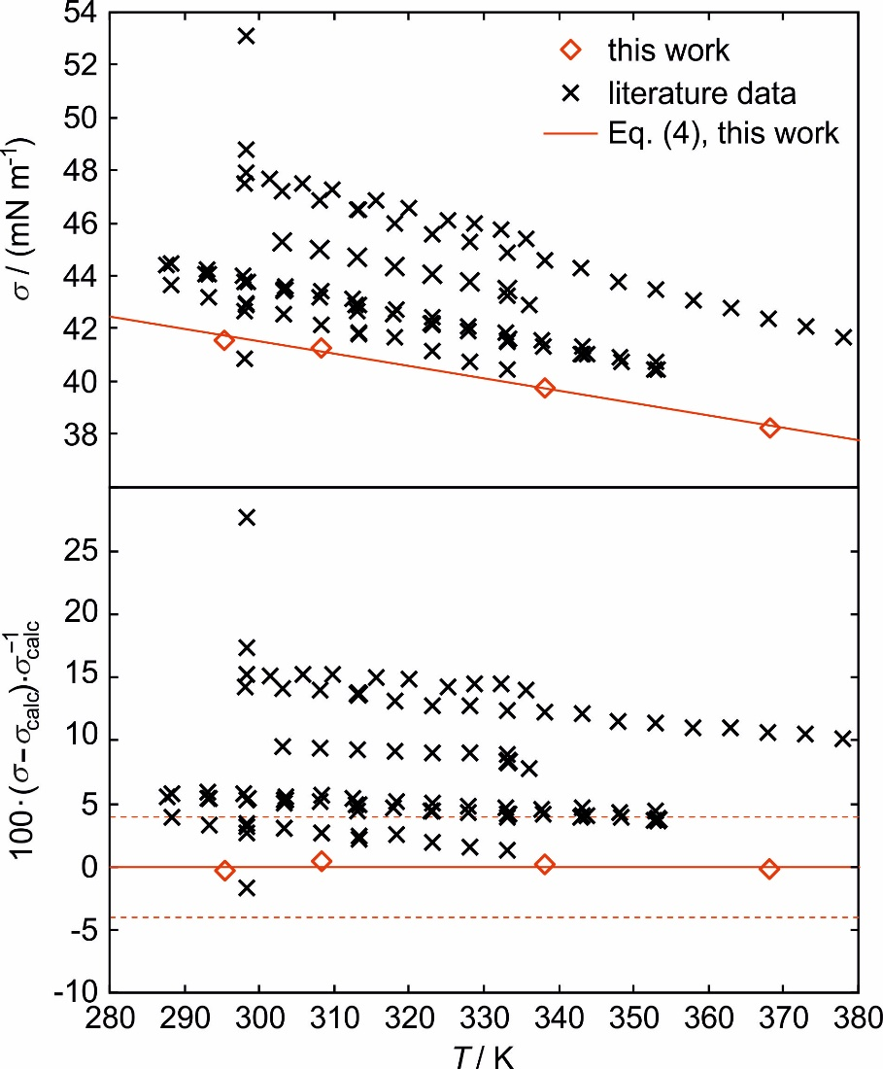
Fig. S3 Data comparison for the surface tension σ of [C₄C₁Im][PF₆] at or close to 0.1 MPa as a function of temperature T in form of an absolute plot (upper part) and a deviation plot (lower part). The solid line represents the correlation, Eq. (4), developed in this work based on the experimental data, while the dashed lines in the lower part of the figure indicate the average expanded uncertainty (k = 2) of the experimental data obtained in this work.

References
[1] A.P. Fröba, A. Leipertz, Int. J. Thermophys. 22, 41-59 (2001)
[2] A.P. Fröba, S. Will, Light Scattering by Surface Waves - Surface Light Scattering, in: Experimental Thermodynamics, Vol. IX: Advances in Transport Properties of Fluids, M.J. Assael, A.R.H. Goodwin, V. Vesovic, W.A. Wakeham, Eds. (Royal Society of Chemistry, Cambridge, 2014, pp. 22-35)
[3] D. Langevin, Light Scattering by Liquid Surfaces and Complementary Techniques (Marcel Dekker, New York, 1992)
[4] E.H. Lucassen-Reynders, J. Lucassen, Adv. Colloid Interface Sci. 2, 347-395 (1970)
[5] A. Kazakov, J.W. Magee, R.D. Chirico, E. Paulechka, V. Diky, C.D. Muzny, K. Kroenlein, M. Frenkel, "NIST Standard Reference Database 147: NIST Ionic Liquids Database - (ILThermo)", Version 2.0, National Institute of Standards and Technology, Gaithersburg MD, http://ilthermo.boulder.nist.gov (accessed March 26, 2020)

