Supplementary Material of the paper:
An accurate thermodynamic model to characterise dissociating N₂O₄ at vapour-liquid equilibrium states

Konstantin Samukov†, David Vega-Maza‡, Eric W. Lemmon§,, Vladimir Diky^{§,1}
and Silvia Lasala†,*
† Université de Lorraine, CNRS, LRGP, F-54000 Nancy, France.
‡ Group of Energy, Economy and Systems Dynamics (GEEDS), Bioeconomy Research Institute BioEcoUVa, University of Valladolid, Paseo del Cauce 59, 47011 Valladolid, Spain.
§ Applied Chemicals and Materials Division, National Institute of Standards and Technology, Boulder, Colorado 80305-3337, USA.
* E-mail: silvia.lasala@univ-lorraine.fr
S1. Ideal gas properties
Table S1. Available experimental data on standard molar enthalpy of formation and standard molar entropy for pure N₂O₄ and NO₂ at 298.15 K.
Source | , kJ/mol |  | , J/mol/K
Source | N₂O₄ | NO₂ | N₂O₄ | NO₂
Chao [1] | 9.16 | 33.18 | 304.64 | 240.25
Hisatsune [2] | 10.63 | − | 304.30 | −
Altshuller [3] | − | − | − | 239.83
Gordon [4] | − | − | − | 239.94
Lasala et al. [5] | 9.99 | 34.20 | 297.65 | 240.03
Gurvich et al. [6] | 11.11 | 34.19 | 304.35 | 240.06
NIST-JANAF [7] | 9.080 | 33.100 | 304.376 | 240.034

Table S2. Available experimental data on standard molar enthalpy and standard molar entropy for the reaction N₂O₄ ⇄ 2NO₂ at 298.15 K.
Source | , kJ/mol | , J/mol/K
Chao [1] | 57.20 | 175.86
Hisatsune [2] | 57.07 | 175.35
Lasala et al. [5] | 58.41 | 182.41
Gurviĉ et al. [6] | 57.27 | 175.71
NIST-JANAF [7] | 57.12 | 175.68
Blend [8] | 57.11 | −
Harris and Churney [9] | 57.07 | −
Mišina et al. [10] | 57.57 | −
Vosper [11] | 57.11 | 175.39
Glendening and Halpern [12] | 58.40 | 176.45
S2. Available experimental data for the reactive system N₂O₄ ⇄ 2NO₂ ⇄ 2NO+O₂
Table S3. Available experimental critical properties of the reactive system N₂O₄ ⇄ 2NO₂ ⇄ 2NO+O₂.
Source | , K | , bar | , kg/m³
Bennewitz and Windisch [13] | 431.34 ± 0.7 | − | 570 ± 18
Greben’kov et al. [14] | 430.91 | 101.4 | −
Nadejdine [15] | 444.34 | − | −
Polikhronidi et al. [16] | 431.07 ± 0.1 | − | 551.7 ± 4.33
Scheffer and Treub [17–19] | 431.35 ± 0.2 | 101.33 | −
Reamer and Sage [20] / Schlinger and Sage [21] | 431.36 | 101.28 | 550.5
Scheuer [22] | 430.1 | − | 566.7
Curbelev [23,24] | 430.91 ± 0.61 | − | 556.2
Veržinskaâ et al. [25] | 430.91 ± 0.1 | − | 555 ± 6
Table S4. Available P-T experimental data of the reactive system N₂O₄ ⇄ 2NO₂ ⇄ 2NO+O₂ at vapour-liquid equilibrium conditions. Data indicated with (*) have not been used as justified in the main text.
Source | Number of points | Temperature range, K | Pressure range, bar
Greben’kov et al. [14] | 42 | 352-431 | 10-101
Scheffer and Treub [17–19] | 72 | 262-431 | 0.2-1
Reamer and Sage [20] | 25 | 294-428 | 1-92
Schlinger and Sage [21] | 26 | 294-428 | 1-92
Scheuer [22] | 13(*) | 263-288 | 0.2-0.8
Nesterenko [26] | 53 | 292-427 | 1-91
Giauque and Kemp [27] | 24 | 262-295 | 0.1-1
Addison and Sheldon [28] | 6 | 263-293 | 0.2-1
Baume and Robert [29,30] | 25 | 265-311 | 0.2-2.2
Guye and Drouginine [31] | 8(*) | 263-285 | 0.2-0.8
Mittasch et al. [32] | 34 | 276-333 | 0.4-5.2
Ramsay and Young [33] | 17 | 263-295 | 0.2-1
Selleck et al. [34] | 1 | 278 | 0.45
Stoddart [35] | 8 | 273-293 | 0.3-1
Thorpe [36] | 1 | 295 | 1
Cymarnyj [37] | 9 | 363-428 | 14-94
Table S5. Features of available saturated liquid density data for the reactive system N₂O₄ ⇄ 2NO₂ ⇄ 2NO+O₂. Data indicated with (*) have not been used as justified in the main text.
Source | Number of points | Temperature range, K | Density range, kg/m³
Bennewitz and Windisch [13] | 19(*) | 293-431 | 738-1447
Polikhronidi et al. [16] | 15 | 301-431 | 562-1427
Reamer and Sage [20] | 26 | 294-431 | 550-1439
Scheuer [22] | 15(*) | 283-429 | 730-1468
Curbelev [24] | 4 | 430-431 | 538-682
Veržinskaâ et al. [25] | 7 | 406-431 | 589-1033
Mittasch et al. [32] | 28 | 276-329 | 1356-1484
Pascal and Garnier [38] | 19 | 268-294 | 1444-1500
Greben’kov et al. [39] | 23 | 400-431 | 556-1080
Amirhanov [40] | 5 | 301-427 | 804-1427
Table S6. Available saturated vapour density data of the reactive system N₂O₄ ⇄ 2NO₂. Data indicated with (*) have not been used as justified in the main text.
Source | Number of points | Temperature range, K | Density range, kg/m³
Bennewitz and Windisch [13] | 19(*) | 293-431 | 3.4-488
Polikhronidi et al. [16] | 11 | 417-431 | 201-550
Reamer and Sage [20] | 26 | 294-431 | 3-550
Schlinger and Sage [21] | 9 | 294-428 | 3.5-306
Scheuer [22] | 15(*) | 283-429 | 3.4-405
Curbelev [24] | 6 | 430-431 | 429-519
Veržinskaâ et al. [25] | 19 | 370-431 | 46-556
Mittasch et al. [32] | 7 | 273-333 | 1.4-15.2
Veržinskaâ and Curbelev [41] | 9 | 370-431 | 45-556
Table S7. Used in this work experimental data on equilibrium constants in the liquid phase of the reactive system N₂O₄ ⇄ 2NO₂.
Source | Number of points | Temperature range, K
Gray and Rathbone [42] | 6 | 262-294
James and Marshall [43] | 4 | 266-296
Vosper [44] | 16 | 263-333
Table S8. Used in this work experimental data on liquid phase density of the reactive system N₂O₄ ⇄ 2NO₂.
Source | Number of points | Temperature range, K | Pressure range, bar | Density range, kg/m³
Reamer and Sage [20] | 98 | 294-428 | 34-414 | 956-1487
Thorpe [36] | 1 | 273 | 1 | 1490
Cymarnyj [37] | 117 | 299-511 | 26-594 | 800-1441
Addison and Smith [45] | 23 | 263-293 | 1 | 1447-1515
Ramsay and Shields [46] | 2 | 275-293 | 1 | 1444-1487
Bousfield [47] | 20 | 277-293 | 1 | 1450-1484
Vitûk [48] / Vitûk and Golovskij [49] / Vitûk et al. [50] | 52 | 262-343 | 23-596 | 1402-1540
Table S9. Used in this work experimental data on enthalpy increment of the liquid phase of the reactive system N₂O₄ ⇄ 2NO₂.
Source | Number of points | Temperature range, K | Pressure range, bar | Enthalpy increment range, kJ/kg
Sarumov [51] | 38 | 283-429 | 49-294 | 101-402
Šejndlin et al. [52,53] | 45 | 283-438 | 49-294 | 100-430
Šejndlin et al. [54] | 41 | 283-431 | 49-294 | 100-430
Šejndlin et al. [55] | 20 | 283-468 | 49-294 | 35-522
Šejndlin et al. [56] / Simonov [57] | 69 | 283-482 | 118-294 | 44-654
S3. Sensibility analysis plots
This section introduces the results of the sensibility analysis, applied to the variables of the optimisation problem and presented in Figures S1 – S4. Pink solid curves represent results of calculations in the case of non-perturbed input parameters (thus coincident with calculations shown in Figure 1 of the main manuscript); green dashed and black dashed curves portray the results of calculations at perturbed values of the variable parameter: values of the parameter were increased or reduced by 10%, respectively. Blue curves represent the results of calculations in the case of coincidence between the results of calculations for non-perturbed and perturbed values of parameters. The red line corresponds to the triple temperature point of the reactive system.
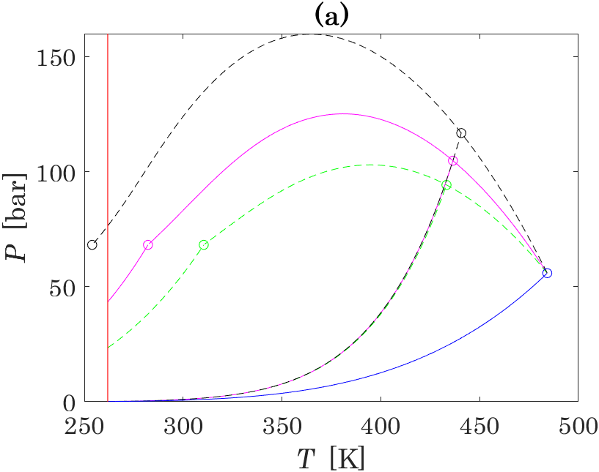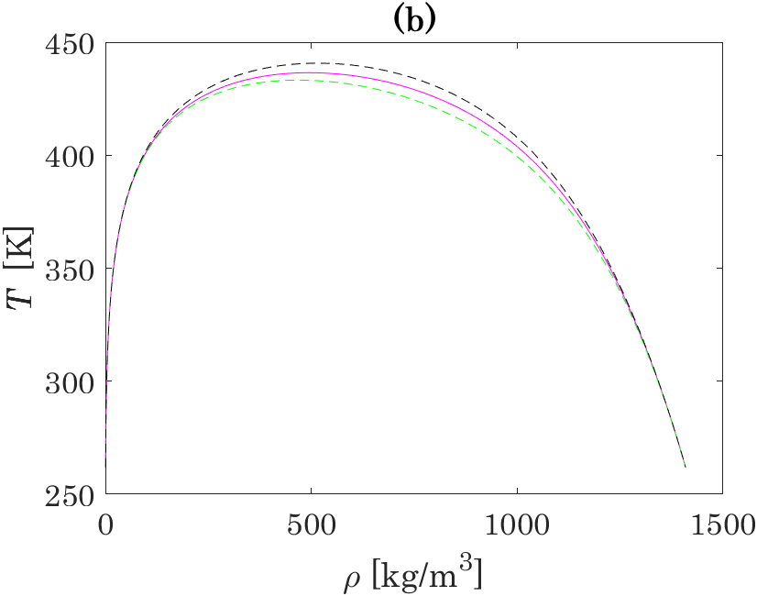
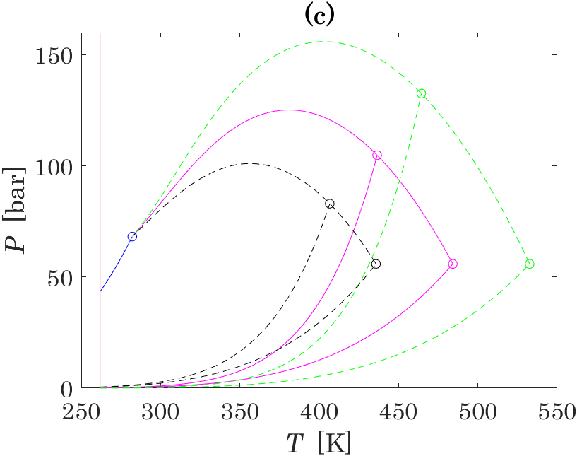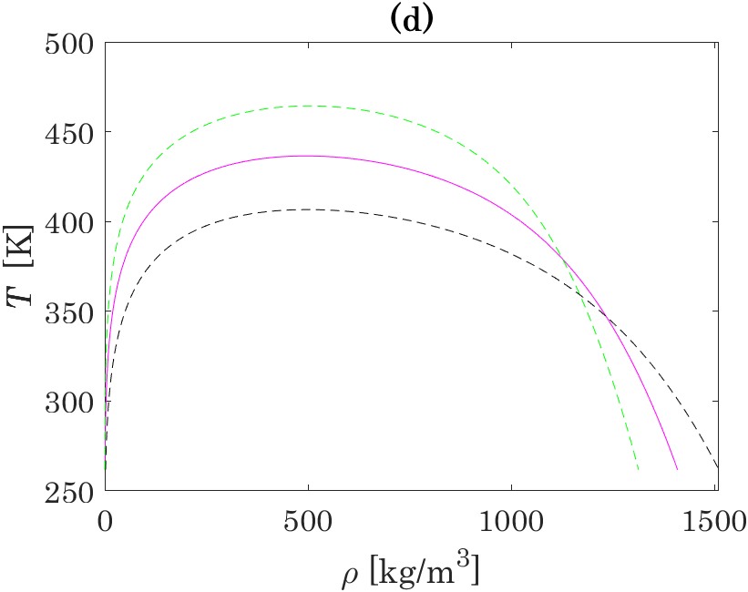
Figure S1. Results of sensitivity analysis performed for critical temperatures: (a) and (b) – for T_{c}(NO₂), (c) and (d) – for T_{c}(N₂O₄).

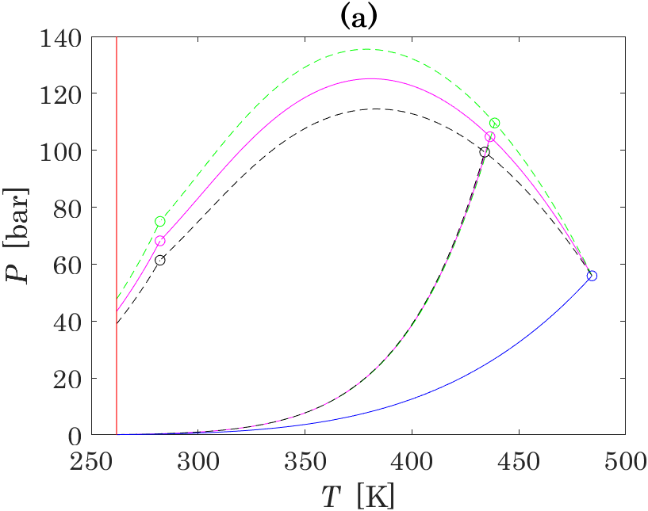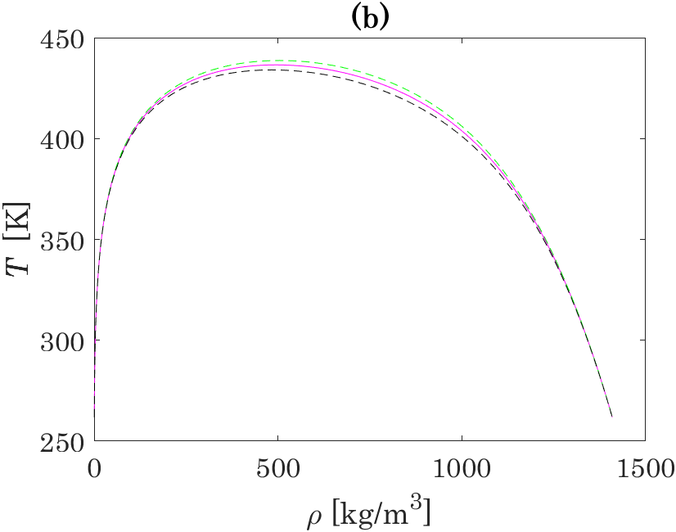
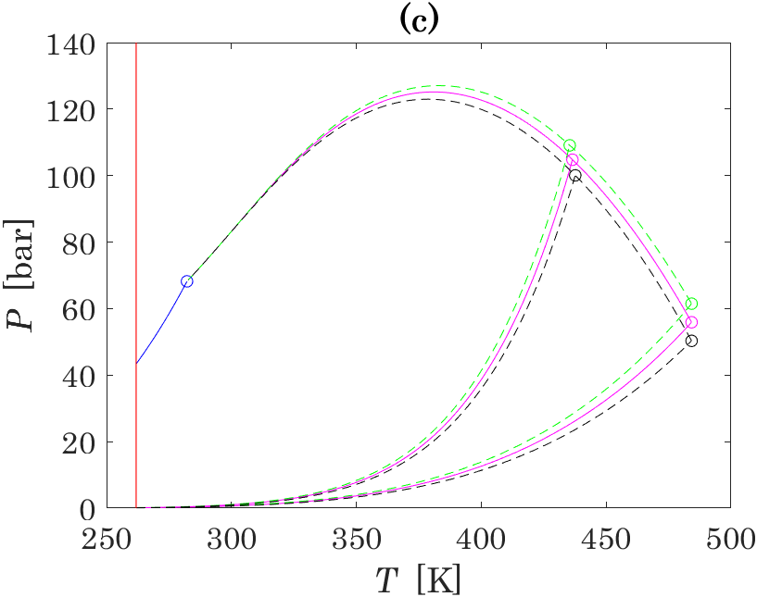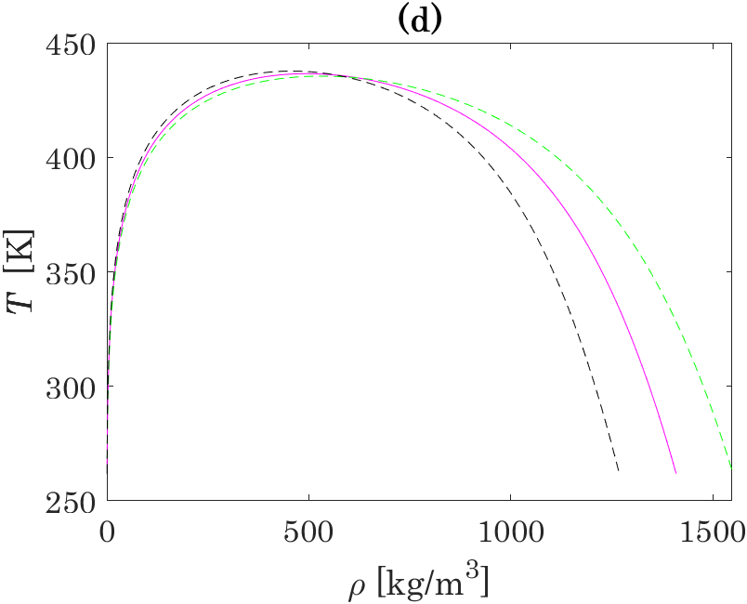
Figure S2. Results of sensitivity analysis performed for critical pressures: (a) and (b) – for P_{c}(NO₂), (c) and (d) – for P_{c}(N₂O₄).

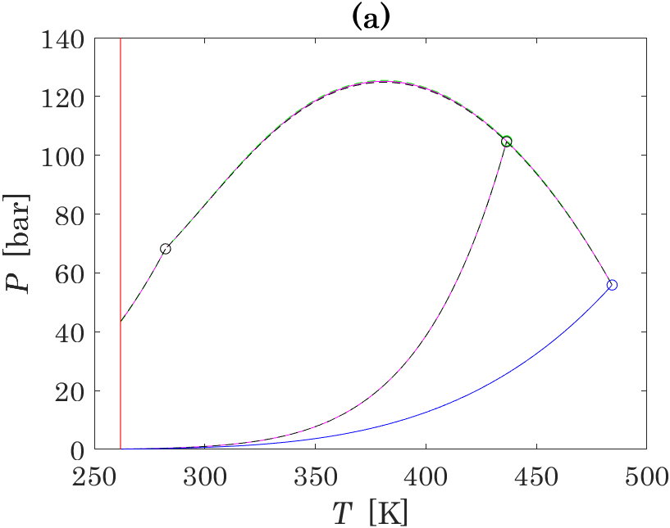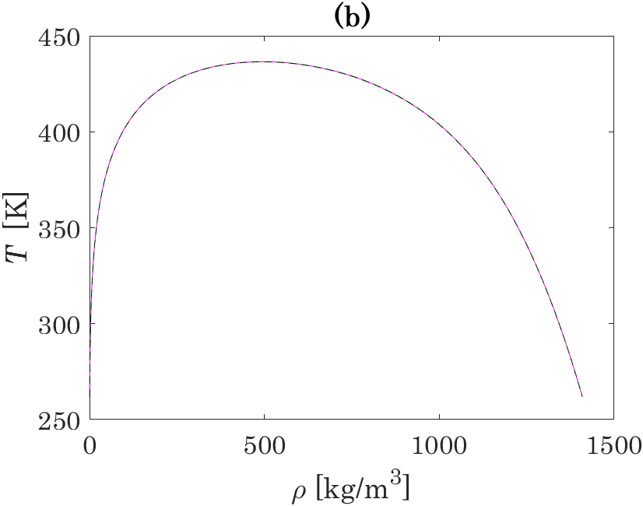
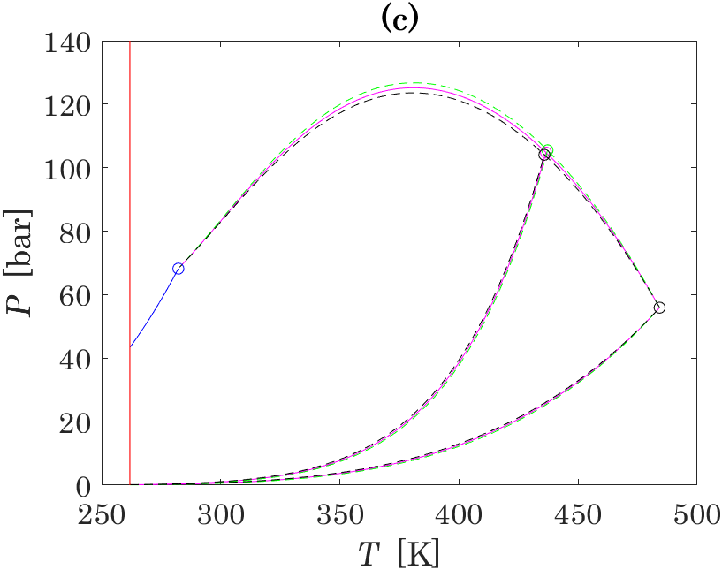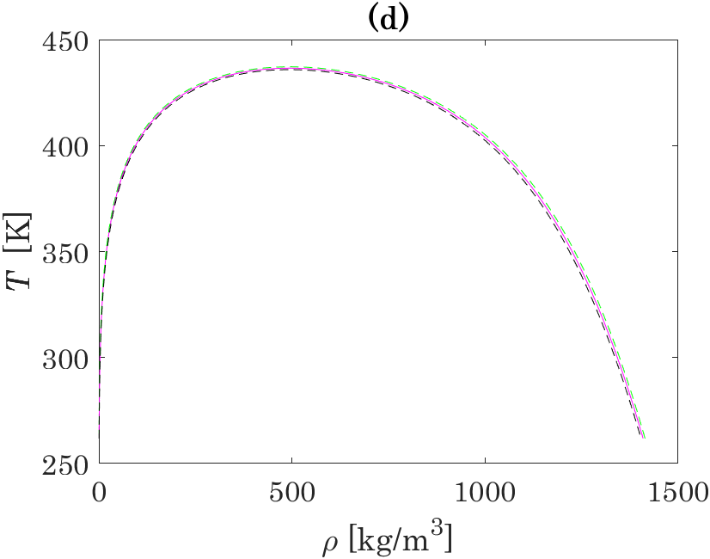
Figure S3. Results of sensitivity analysis performed for acentric factors: (a) and (b) – for ω(NO₂), (c) and (d) – for ω(N₂O₄).

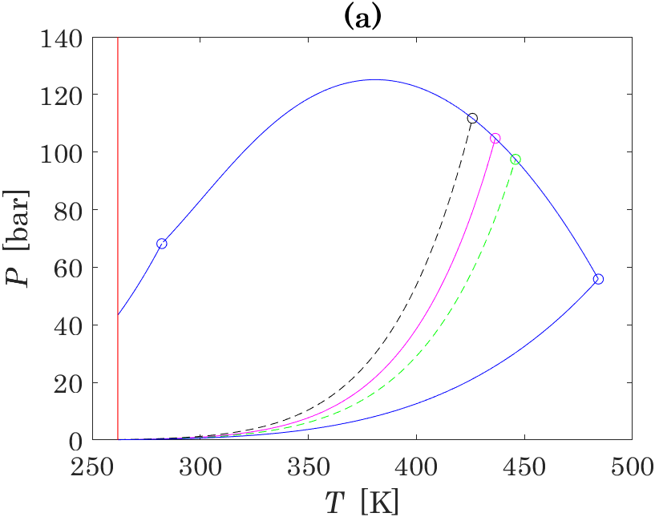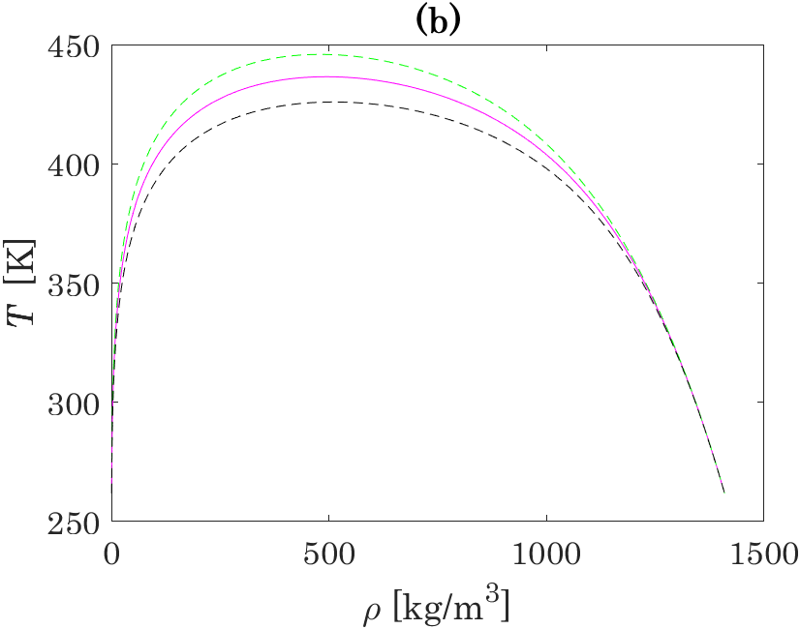
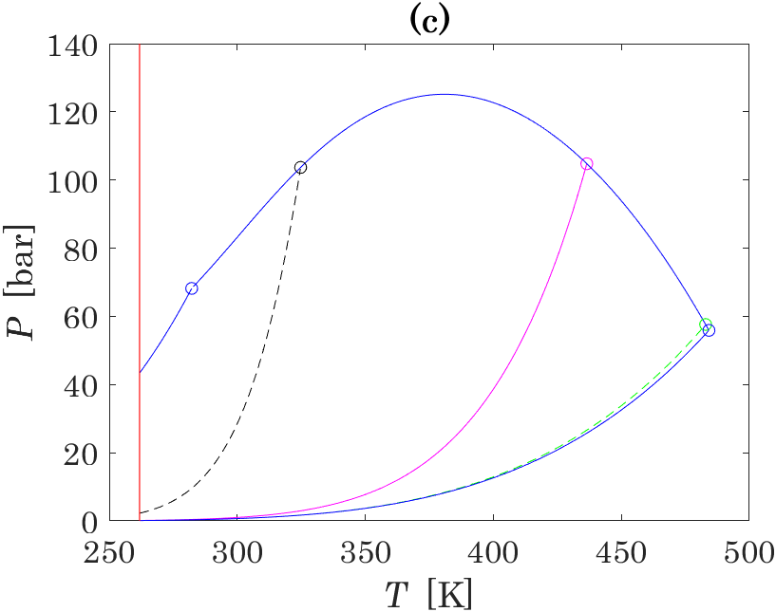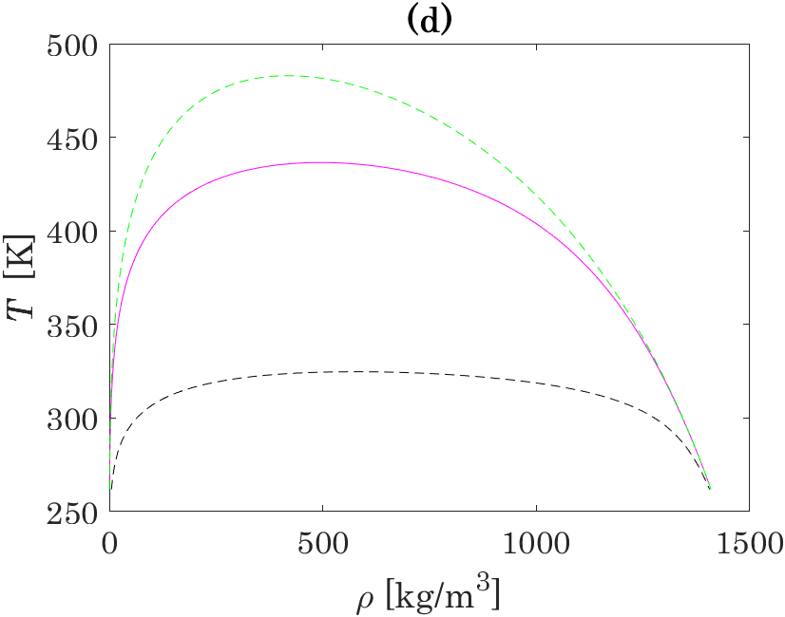
Figure S4. Results of sensitivity analysis performed for standard molar properties of the N₂O₄ ⇄ 2NO₂ reaction: (a) and (b) – for , (c) and (d) – for .
S4. Validity of the Clapeyron equation for reactive systems with congruent material transfer between phases
Consider the change of the extensive Gibbs energy in the reactive system:
In the case of the phase equilibrium between liquid and vapor phases, we can write
Since at chemical equilibrium the Gibbs energies of the reaction of vapor and of liquid are both equal to zero, we obtain:
Thus, the Clapeyron equation is still valid for reactive systems. However, we can not rewrite eq. in terms of molar properties as in the case of inert fluids, since the composition of the system changes during the process of evaporation ():
Since mass of the system does not change during the evaporation process (), we can use the Clapeyron equation in terms of mass properties:
References
[1] J. Chao, R.C. Wilhoit, B.J. Zwolinski, Gas Phase Chemical Equilibrium in Dinitrogen Trioxide and Dinitrogen Tetroxide, Thermochim. Acta 10 (1974) 359–371. https://doi.org/10.1016/0040-6031(74)87005-X.
[2] I.C. Hisatsune, Thermodynamic Properties of Some Oxides of Nitrogen, J. Phys. Chem. 65 (1961) 2249–2253. https://doi.org/10.1021/j100829a037.
[3] A.P. Altshuller, Thermodynamic Functions for Nitrogen Dioxide and Nitrous Acid, J. Phys. Chem. 61 (1957) 251–253. https://doi.org/10.1021/j150548a026.
[4] J.S. Gordon, Thermodynamic Functions of the Gaseous Dioxides of Carbon, Nitrogen, Sulfur, and Chlorine, and of Carbon Disulfide and Oxysulfide, J. Chem. Eng. Data 6 (1961) 390–394. https://doi.org/10.1021/je00103a022.
[5] S. Lasala, K. Samukov, H. Mert Polat, V. Lachet, O. Herbinet, R. Privat, J.-N. Jaubert, O. Moultos, K. de Ras, T. J. H. Vlugt, Application of Thermodynamics at Different Scales to Describe the Behaviour of Fast Reacting Binary Mixtures in Vapour-Liquid Equilibrium, Chem. Eng. J. 483 (2024) 148961. https://doi.org/10.1016/j.cej.2024.148961.
[6] L.V. Gurvič, I.V. Vejc, A.V. Medvedev, Termičeskie Konstanty Veŝestv [Thermal Constants of Substances]. Volume 1: Elements O, H(D,T), F, Cl, Br, I, He, Ne, Ar, Kr, Xe, Rn, S, N, P and Their Compounds. Book 2: Tables of Thermodynamic Properties, 3rd ed., Nauka, Moscow, 1978.
[7] NIST-JANAF Thermochemical Tables, (2013). https://janaf.nist.gov/ (accessed November 1, 2024).
[8] H. Blend, Study of Equilibria in Nitrogen Dioxide, J. Chem. Phys. 53 (1970) 4497–4499. https://doi.org/10.1063/1.1673979.
[9] L. Harris, K.L. Churney, Evaluation of the Equilibrium Constant for the N₂O₄ (g) = 2NO₂ (g) Reaction at 298.16°K from Light-Transmission Measurements, J. Chem. Phys. 47 (1967) 1703–1709. https://doi.org/10.1063/1.1712153.
[10] L.V. Mišina, G.Z. Serebrânyj, S.A. Šalygin, Calculation of the Equilibrium Constant of the Reaction N₂O₄ ⇄ 2NO₂ Based on the Molecular Constants of the Components, Vescì Akad. Navuk BSSR Seryâ Fiz.-Teh. Navuk (1967) 23–28.
[11] A.J. Vosper, Dissociation of Dinitrogen Tetroxide in the Gas Phase, J. Chem. Soc. Inorg. Phys. Theor. (1970) 625–627. https://doi.org/10.1039/j19700000625.
[12] E.D. Glendening, A.M. Halpern, Ab Initio Calculations of Nitrogen Oxide Reactions: Formation of N₂O₂, N₂O₃, N₂O₄, N₂O₅, and N₄O₂ from NO, NO₂, NO₃, and N₂O, J. Chem. Phys. 127 (2007) 164307. https://doi.org/10.1063/1.2777145.
[13] K. Bennewitz, J.J. Windisch, Eine neue Methode zur Bestimmung der Dichte von aggressiven Flüssigkeiten unter hohem Druck, im besonderen der kritischen Dichte von Stickstofftetroxyd, Z. Für Phys. Chem. 166A (1933) 401–415. https://doi.org/10.1515/zpch-1933-16640.
[14] A.Ž. Greben’kov, V.P. Curbelev, S.V. Limarenko, Phase Equilibrium Parameters of Nitrogen Tetroxide and Their Asymptotic Behavior in the Critical Point Region. I. Vapour Pressure, Vescì Akad. Navuk BSSR Seryâ Fiz.-Energ. Navuk (1985) 56–60.
[15] A. Nadejdine, La Détermination de la Température Critique dans les Tubes Opaques, Bull. Acad. Imp. Sci. St-Petersbourg 30 (1886) 327–330. https://www.biodiversitylibrary.org/bibliography/49351.
[16] N.G. Polikhronidi, R.G. Batyrova, I.M. Abdulagatov, Isochoric Heat Capacity Measurements of Nitrogen Tetroxide System at Temperatures Between 410 and 484 K and Pressures Up to 35 MPa, Fluid Phase Equilibria 175 (2000) 153–174. https://doi.org/10.1016/S0378-3812(00)00457-X.
[17] F.E.C. Scheffer, J.P. Treub, Determinations of Vapour Tensions of Nitrogen Tetroxide, Proc. KNAW 14 (1911) 536–549. https://dwc.knaw.nl/toegangen/digital-library-knaw/?pagetype=publDetail&pId=PU00013111.
[18] F.E.C. Scheffer, J.P. Treub, Determinations of the Vapour Tension of Nitrogen Tetroxide, Proc. KNAW 15 (1912) 166–178. https://dwc.knaw.nl/toegangen/digital-library-knaw/?pagetype=publDetail&pId=PU00012961.
[19] F.E.C. Scheffer, J.P. Treub, Die Dampfdruckkurve des Stickstofftetroxyds, Z. Für Phys. Chem. 81U (1913) 308–332. https://doi.org/10.1515/zpch-1913-8116.
[20] H.H. Reamer, B.H. Sage, Volumetric Behavior of Nitrogen Dioxide in the Liquid Phase, Ind. Eng. Chem. 44 (1952) 185–187. https://doi.org/10.1021/ie50505a052.
[21] W.G. Schlinger, B.H. Sage, Volumetric Behavior of Nitrogen Dioxide, Ind. Eng. Chem. 42 (1950) 2158–2163. https://doi.org/10.1021/ie50490a042.
[22] O. Scheuer, Preliminary Report of the Examination of the Physical and Chemical Properties of Pure Gases and Binary Mixtures, Anz. Österr. Akad. Wiss. 48 (1911) 304–307. https://www.zobodat.at/publikation_volumes.php?id=32597.
[23] V.P. Curbelev, Determination of the Critical Temperature of Dissociating Nitrogen Tetroxide, Vescì Akad. Navuk BSSR Seryâ Fiz.-Energ. Navuk (1984) 58–60.
[24] V.P. Сurbelev, Temperature Dependency of Density on the Liquid-Gas Coexistence Curve for NO₂-NO Solutions in the Extended Critical Region (Experimental Determination and Tables of Thermodynamic Properties), Abstract of a PhD thesis in Technical Sciences, Institute of Nuclear Energy of the Belarus Academy of Sciences, 1986.
[25] A.B. Veržinskaâ, V.P. Curbelev, P.M. Klepatskij, Impact of Nitrogen Monoxide on the Shape of the Coexistence Curve of N₂O₄ in the Vicinity of the Critical Point Liquid-Vapour, in: 5th -Union Sch. Appl. Math. Methods Descr. Stud. Phys.-Chem. Equilibria Ext. Abstr. Rep. Part II, Novosibirsk, 1985: pp. 120–123.
[26] V.B. Nesterenko, Ed. Teplofizičeskie Svojstva Četyrekhokisi Azota [Thermophysical Properties of Nitrogen Tetroxide], Nauka i Tehnika, Minsk, 1982.
[27] W.F. Giauque, J.D. Kemp, The Entropies of Nitrogen Tetroxide and Nitrogen Dioxide. The Heat Capacity from 15°K to the Boiling Point. The Heat of Vaporization and Vapor Pressure. The Equilibria N₂O₄=2NO₂=2NO+O₂, J. Chem. Phys. 6 (1938) 40–52. https://doi.org/10.1063/1.1750122.
[28] C.C. Addison, J.C. Sheldon, 373. Vapour Pressures of Mixtures of Dinitrogen Tetroxide with Donor and with Non-Donor Organic Solvents: Comparison with Some Nitrosyl Chloride Systems, J. Chem. Soc. (1957) 1937–1945. https://doi.org/10.1039/JR9570001937.
[29] G. Baume, M. Robert, Some Properties of Pure Dinitrogen Trioxide and of its Solution in Nitrogen Peroxide, Comptes Rendus Hebd. Séances Académie Sci. 169 (1919) 968–970. https://doi.org/10.1259/jrs.1912.0009.
[30] G. Baume, M. Robert, A Glass Manometer with Elastic Walls, Comptes Rendus Hebd. Séances Académie Sci. 168 (1919) 1199–1201. https://doi.org/10.1259/jrs.1912.0009.
[31] Ph.-A. Guye, G. Drouginine, Nouvelle Révision du Poids Atomique de l’Azote. Analyse Exacte du Peroxyde d’Azote, J. Chim. Phys. 8 (1910) 473–514. https://doi.org/10.1051/jcp/1910080473.
[32] A. Mittasch, E. Kuss, H. Schlueter, Dichten und Dampfdrucke von wäßrigen Ammoniaklösungen und von flüssigem Stickstofftetroxyd für das Temperatur-gebiet 0° bis 60°, Z. Für Anorg. Allg. Chem. 159 (1927) 1–36. https://doi.org/10.1002/zaac.19261590102.
[33] W. Ramsay, S. Young, On Evaporation and Dissociation. Part I, Philos. Trans. R. Soc. Lond. 177 (1886) 71–122. https://doi.org/10.1098/rstl.1886.0003.
[34] F.T. Selleck, H.H. Reamer, B.H. Sage, Volumetric and Phase Behavior of Mixtures of Nitric Oxide and Nitrogen Dioxide, Ind. Eng. Chem. 45 (1953) 814–819. https://doi.org/10.1021/ie50520a046.
[35] E.M. Stoddart, The Effect of Drying on the Vapour Pressure of Dinitrogen Tetroxide and the Vapour Density of Dinitrogen Trioxide, J. Chem. Soc. Resumed (1945) 448. https://doi.org/10.1039/jr9450000448.
[36] T.E. Thorpe, On the Relation Between the Molecular Weights of Substances and Their Specific Gravities When in the Liquid State, J. Chem. Soc. Trans. 37 (1880) 141–225. https://doi.org/10.1039/CT8803700141.
[37] V.A. Cymarnyj, Density of Liquid Nitrogen Tetroxide at Temperatures 300-500 K and Pressures Up to 600 Bar, N. 2165-70, Deposited in VINITI, Odessa, 1970.
[38] P. Pascal, M. Garnier, Relations Between Nitrogen Peroxide and Nitric Acid, Bull. Société Chim. Fr. 25 (1919) 309–321.
[39] A.Ž. Greben’kov, V.P. Curbelev, A.B. Veržinskaâ, V.B. Nesterenko, Study of the Thermodynamic Properties of Nitrogen Dioxide in the Wide Range of the Critical Point, Teplofiz. Svojstva Veŝestv Mater. 27 (1989) 41–53.
[40] H.I. Amirhanov, N.G. Polihronidi, B.G. Alibekov, R.G. Batyrova, Isochoric Heat Capacity of Nitrogen Tetroxide and the Effect of Dissociation on the Form of C_{v}(T), Vescì Akad. Navuk BSSR Seryâ Fiz.-Energ. Navuk (1981) 113–118.
[41] A.B. Veržinskaâ, V.P. Curbelev, Experimental Study of T_{s}-ρ_{s} Parameters of Dissociated Heat-Transport Medium on the Basis of N₂O₄ by the Method of Quasi-Static Thermogram’s in the Range of Temperature 373 K to T_{c}, Vescì Akad. Navuk BSSR Seryâ Fiz.-Energ. Navuk (1982) 43–46.
[42] P. Gray, P. Rathbone, Dissociation of Liquid Dinitrogen Tetroxide; Henry’s Law Coefficients, Heats and Entropies of Solution, and the Thermodynamics of Homolytic Dissociation in the Pure Liquid, J. Chem. Soc. (1958) 3550. https://doi.org/10.1039/jr9580003550.
[43] D.W. James, R.C. Marshall, Electron Spin Resonance Study of the Dinitrogen Tetroxide-Nitrogen Dioxide System, J. Phys. Chem. 72 (1968) 2963–2966. https://doi.org/10.1021/j100854a048.
[44] A.J. Vosper, The Dissociation of Dinitrogen Tetroxide in the Liquid Phase, J. Chem. Soc. Inorg. Phys. Theor. (1970) 2191–2193. https://doi.org/10.1039/j19700002191.
[45] C.C. Addison, B.C. Smith, Volume Changes on Mixing Organic Liquids with Dinitrogen Tetroxide: Comparison with Sulphur Dioxide Systems, J. Chem. Soc. Resumed (1958) 3664. https://doi.org/10.1039/jr9580003664.
[46] W. Ramsay, J. Shields, LXXXI.—The Molecular Complexity of Liquids, J. Chem. Soc. Trans. 63 (1893) 1089–1109. https://doi.org/10.1039/CT8936301089.
[47] W.R. Bousfield, III.—Mixtures of Nitrogen Peroxide and Nitric Acid, J. Chem. Soc. Trans. 115 (1919) 45–55. https://doi.org/10.1039/CT9191500045.
[48] L.S. Vitûk, Èksperimental’naâ Metodika i Rezul’taty Issledovaniâ Termodinamičeskih Svojstv Agressivnyh i Vâzkih Veŝestv Kak Rabočih Tel Ènergetičeskih Ustanovok [Experimental Methodology and Results of the Determination of Thermodynamic Properties of Aggressive and Viscous Compounds as Working Fluids of Power Plants, Abstract of a PhD thesis in Technical Sciences, Odessa Technological Institute of Refrigeration Industry, 1982.
[49] L.S. Vitûk, E.A. Golovskij, Experimental Investigation of Density and Isobaric Heat Capacity of Nitrogen Tetroxide and Solutions Based on It, Teplofiz. Svojstva Veŝestv Mater. (1988) 40–48.
[50] L.S. Vitûk, E.A. Golovskij, A.G. Tabačnikov, Experimental Study of Thermodynamic Properties of Nitrogen Tetroxide at 230-330 K, Deposited in ONIITEKHim, SPSTL 39 Khp-D80, (1980).
[51] Û.A. Sarumov, Issledovanie Èntalʹpii Azotnogo Tetraksida v Širokoj Oblasti Parametrov Sostoâniâ [Investigation of Enthalpy of Nitrogen Tetroxide in a Wide Range of State Parameters], Abstract of a PhD thesis in Technical Sciences, Moscow Energy Institute of the Order of Lenin, 1969.
[52] А.Е. Šejndlin, N.I. Gorbunova, Û.A. Sarumov, Experimental Investigation of Enthalpy of Chemically Reacting System N₂O₄ ⇆ 2NO₂ ⇆ 2NO + O₂, Dokl. Akad. Nauk SSSR 186 (1969) 817–819. https://www.mathnet.ru/links/b618abf372d953d4811aeb9a595d0417/dan34675.pdf.
[53] А.Е. Šejndlin, N.I. Gorbunova, Û.A. Sarumov, Corrections to the Article “Experimental Investigation of Enthalpy of Chemically Reacting System N₂O₄ ⇆ 2NO₂ ⇆ 2NO + O₂” (Doklady Akademii Nauk SSSR, 186(4), 1969), Dokl. Akad. Nauk SSSR 188 (1969) 8. https://www.mathnet.ru/links/ee8d87bbf438cbdfad446aa19d314cd0/dan34919.pdf.
[54] А.Е. Šejndlin, N.I. Gorbunova, Û.A. Sarumov, Enthalpy of Nitrogen Tetroxide in the near-Critical Region of the Parameters of State, Teplofiz. Vysok. Temp. 11 (1973) 1192–1197. https://www.mathnet.ru/links/ad86d58a9bd82c9671a4d585c4eb8611/tvt9976.pdf.
[55] А.Е. Šejndlin, N.I. Gorbunova, V.M. Simonov, Experimental Enthalpy Data of Nitrogen Tetroxide, Teplofiz. Vysok. Temp. 12 (1974) 666–669. https://www.mathnet.ru/links/392bc0b823e30348eaf9121a2d4d64b6/tvt9397.pdf.
[56] А.Е. Šejndlin, N.I. Gorbunova, V.M. Simonov, Enthalpy of Dissociating Nitrogen Tetroxide at Pressures Up to 30 MPa and Temperatures Up to 782 K, Teplofiz. Vysok. Temp. 15 (1977) 767–771. https://www.mathnet.ru/links/125b26aa45934caf22230266a7698229/tvt7139.pdf.
[57] V.M. Simonov, Èksperimentalʹnoe Issledovanie Kaloričeskih Svojstv Četyrehokisi Azota i Difenilʹnoj Smesi [Experimental Investigation of Caloric Properties of Nitrogen Tetroxide and Diphenyl Mixture], Abstract of a PhD thesis in Technical Sciences, Institute of High Temperatures, Academy of Sciences of the USSR, 1977.

Any mention of commercial products within this article is for information only; it does not imply recommendation or endorsement by NIST. These opinions, recommendations, findings, and conclusions do not necessarily reflect the views or policies of NIST or the United States Government.

