Supplementary Material for
“Classical Ideal Curves of Fluid Mixtures and their Role for the Development of Equations of State”

International Journal of Thermophysics

Jessica Buchenfeld¹ ∙ Monika Thol¹ ∙ Roland Span¹

¹Thermodynamics, Ruhr University Bochum, Bochum, 44801, Germany

E-Mail: Jessica.Buchenfeld@thermo.ruhr-uni-bochum.de

Classical Ideal Curves: reduced p,T-diagrams
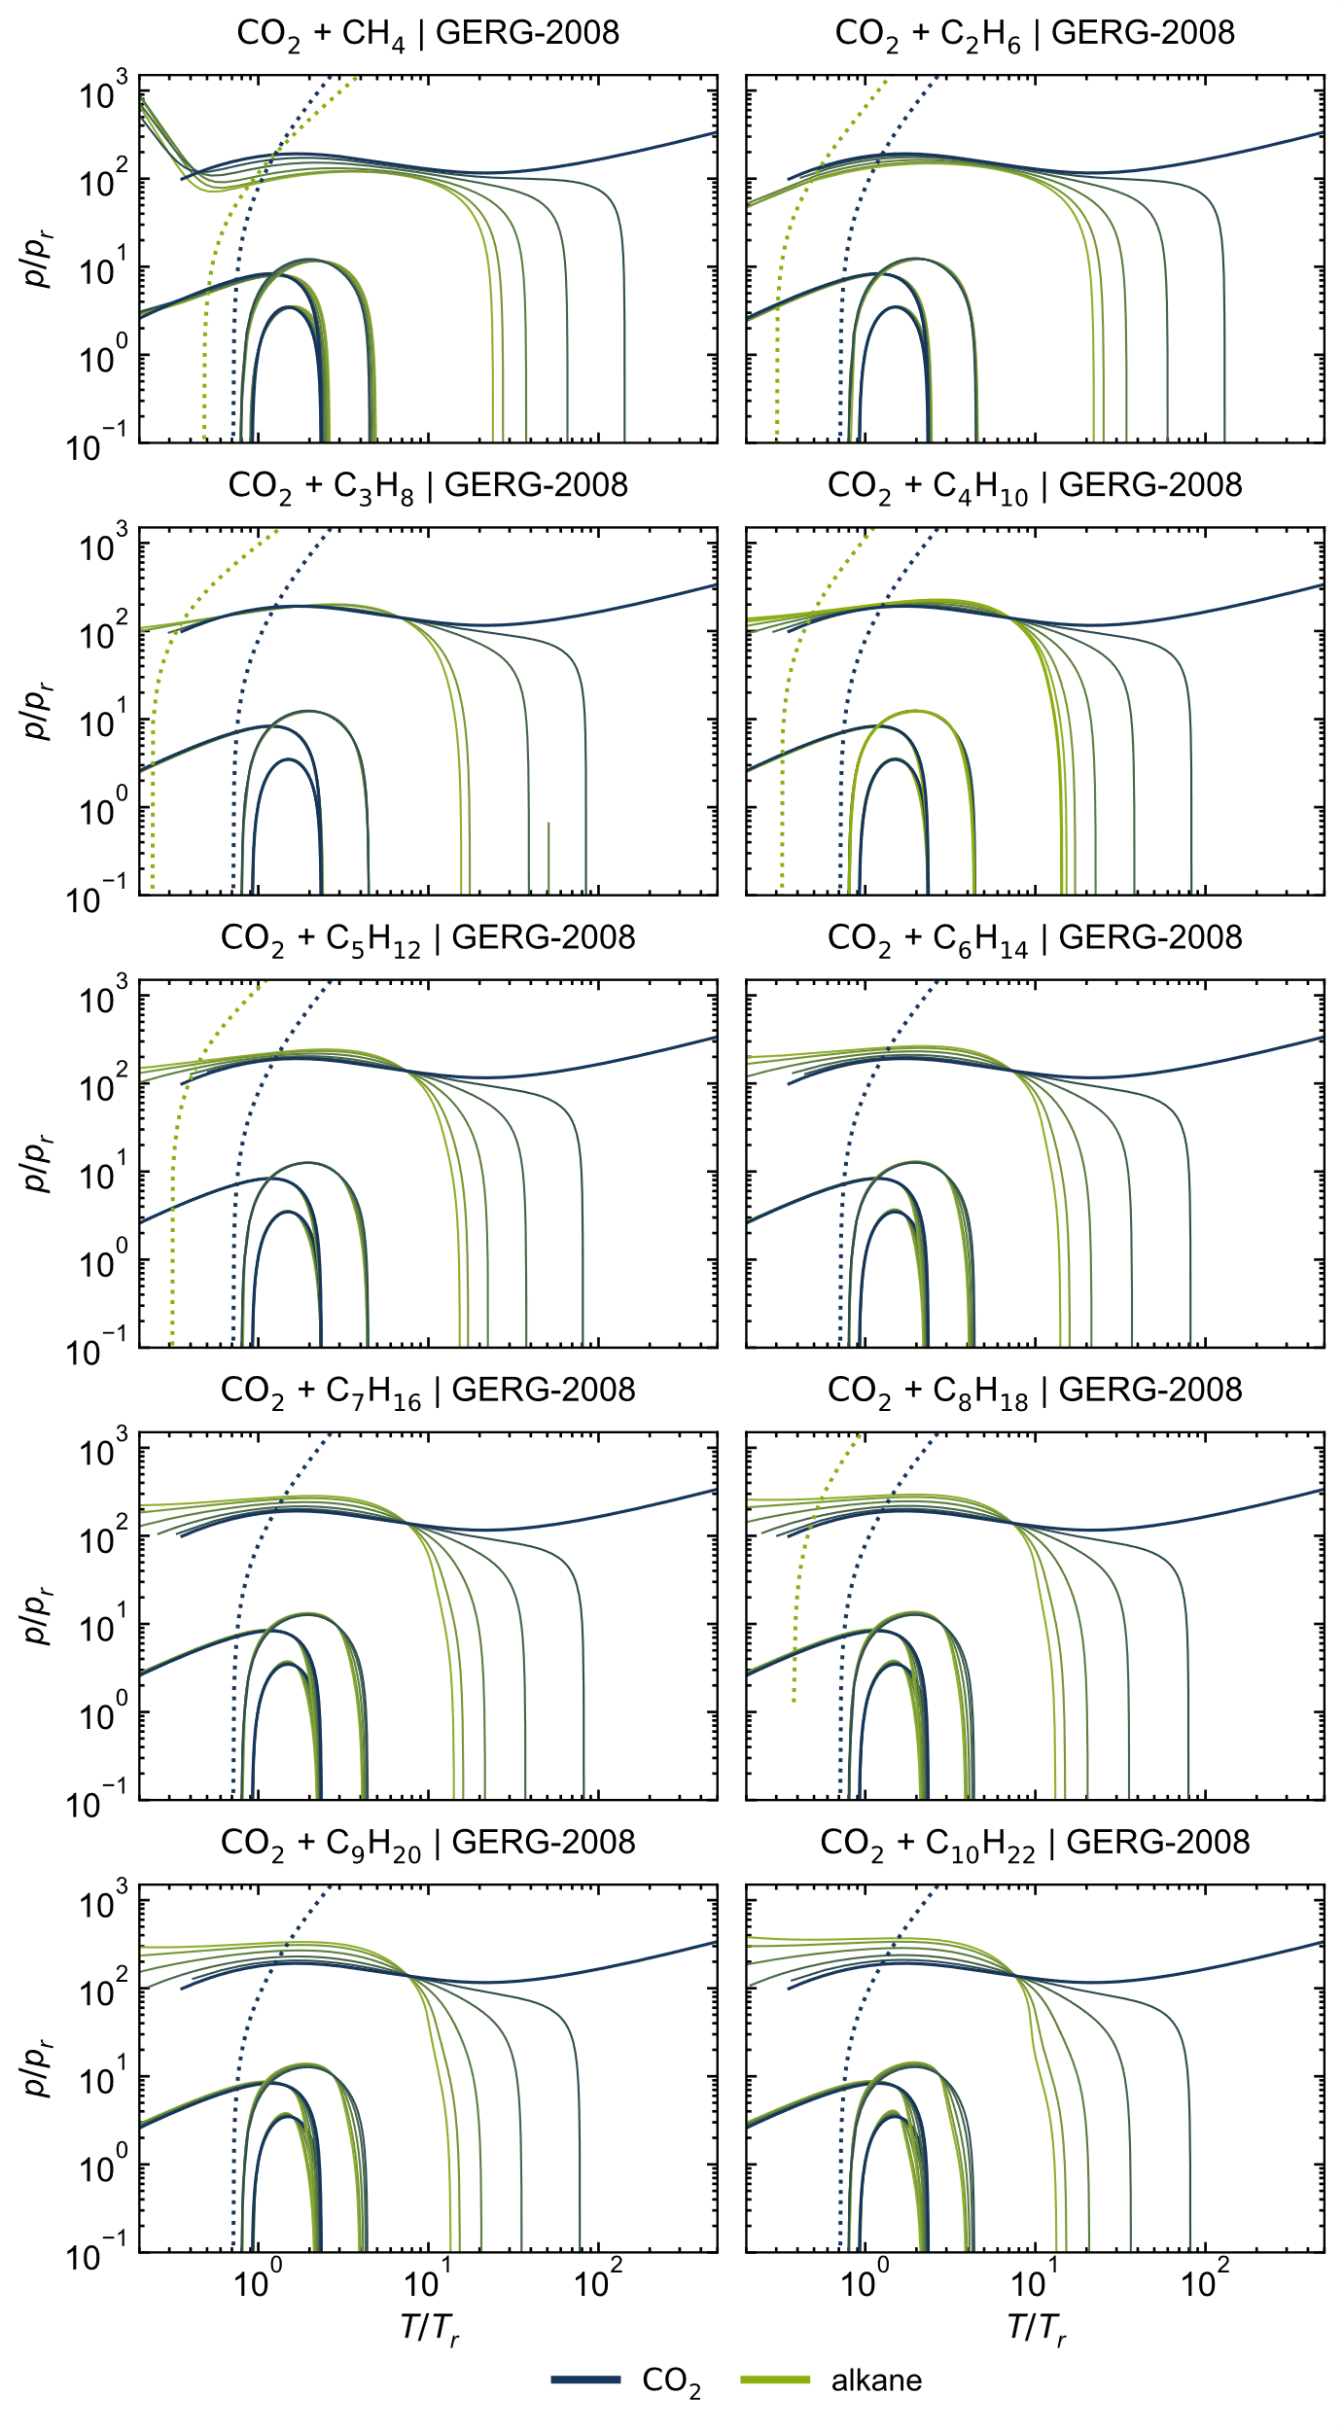
Figure S 1: Ideal curves of all considered CO₂ + alkane mixtures, calculated with the GERG-2008 model [1].
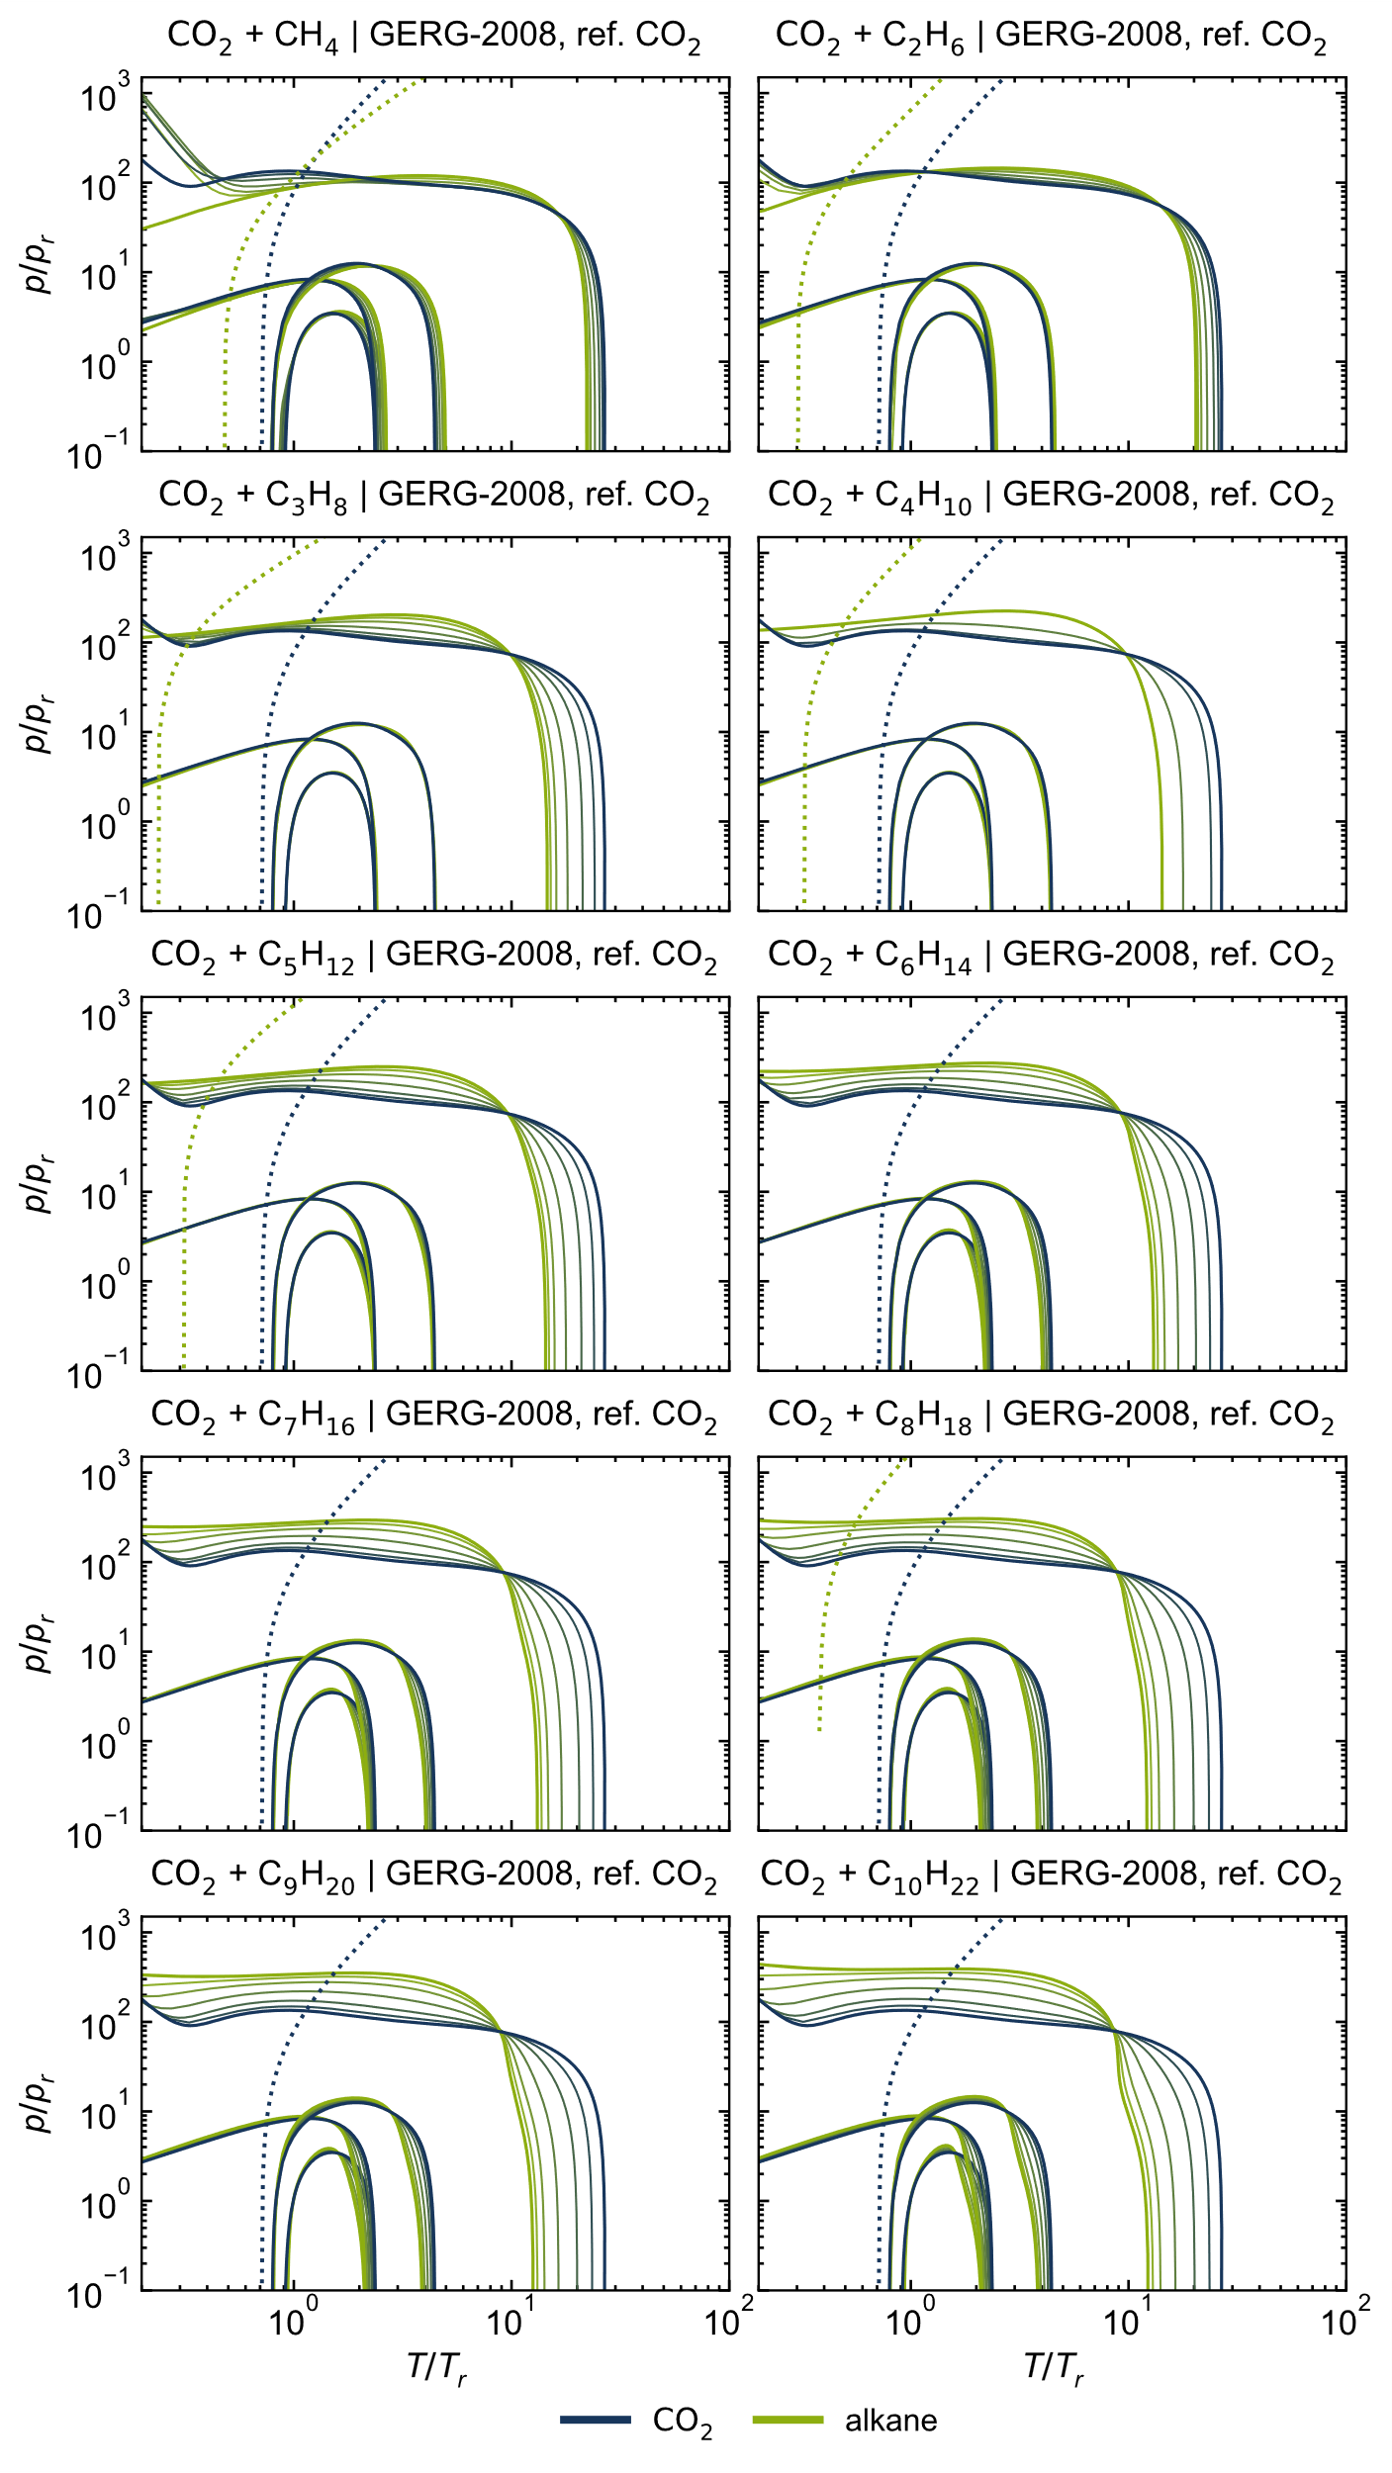
Figure S 2: Ideal curves of all considered CO₂ + alkane mixtures, calculated with the GERG-2008 model [1] and the reference EOS for CO₂ [2].

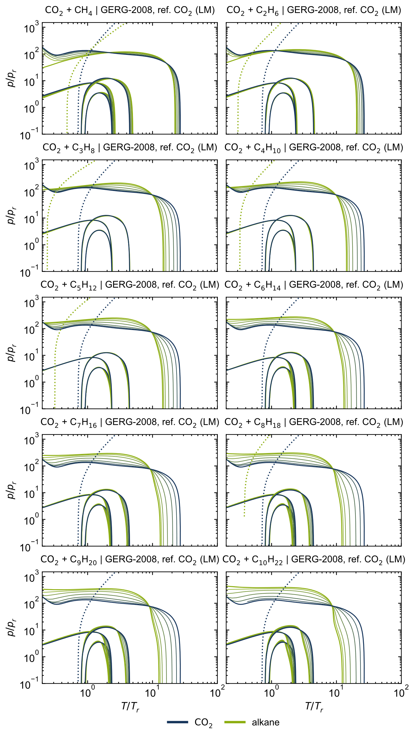
Figure S 3: Ideal curves of all considered CO₂ + alkane mixtures, calculated with the GERG-2008 model [1] and the reference EOS for CO₂ [2] using the linear mixing rule (LM).

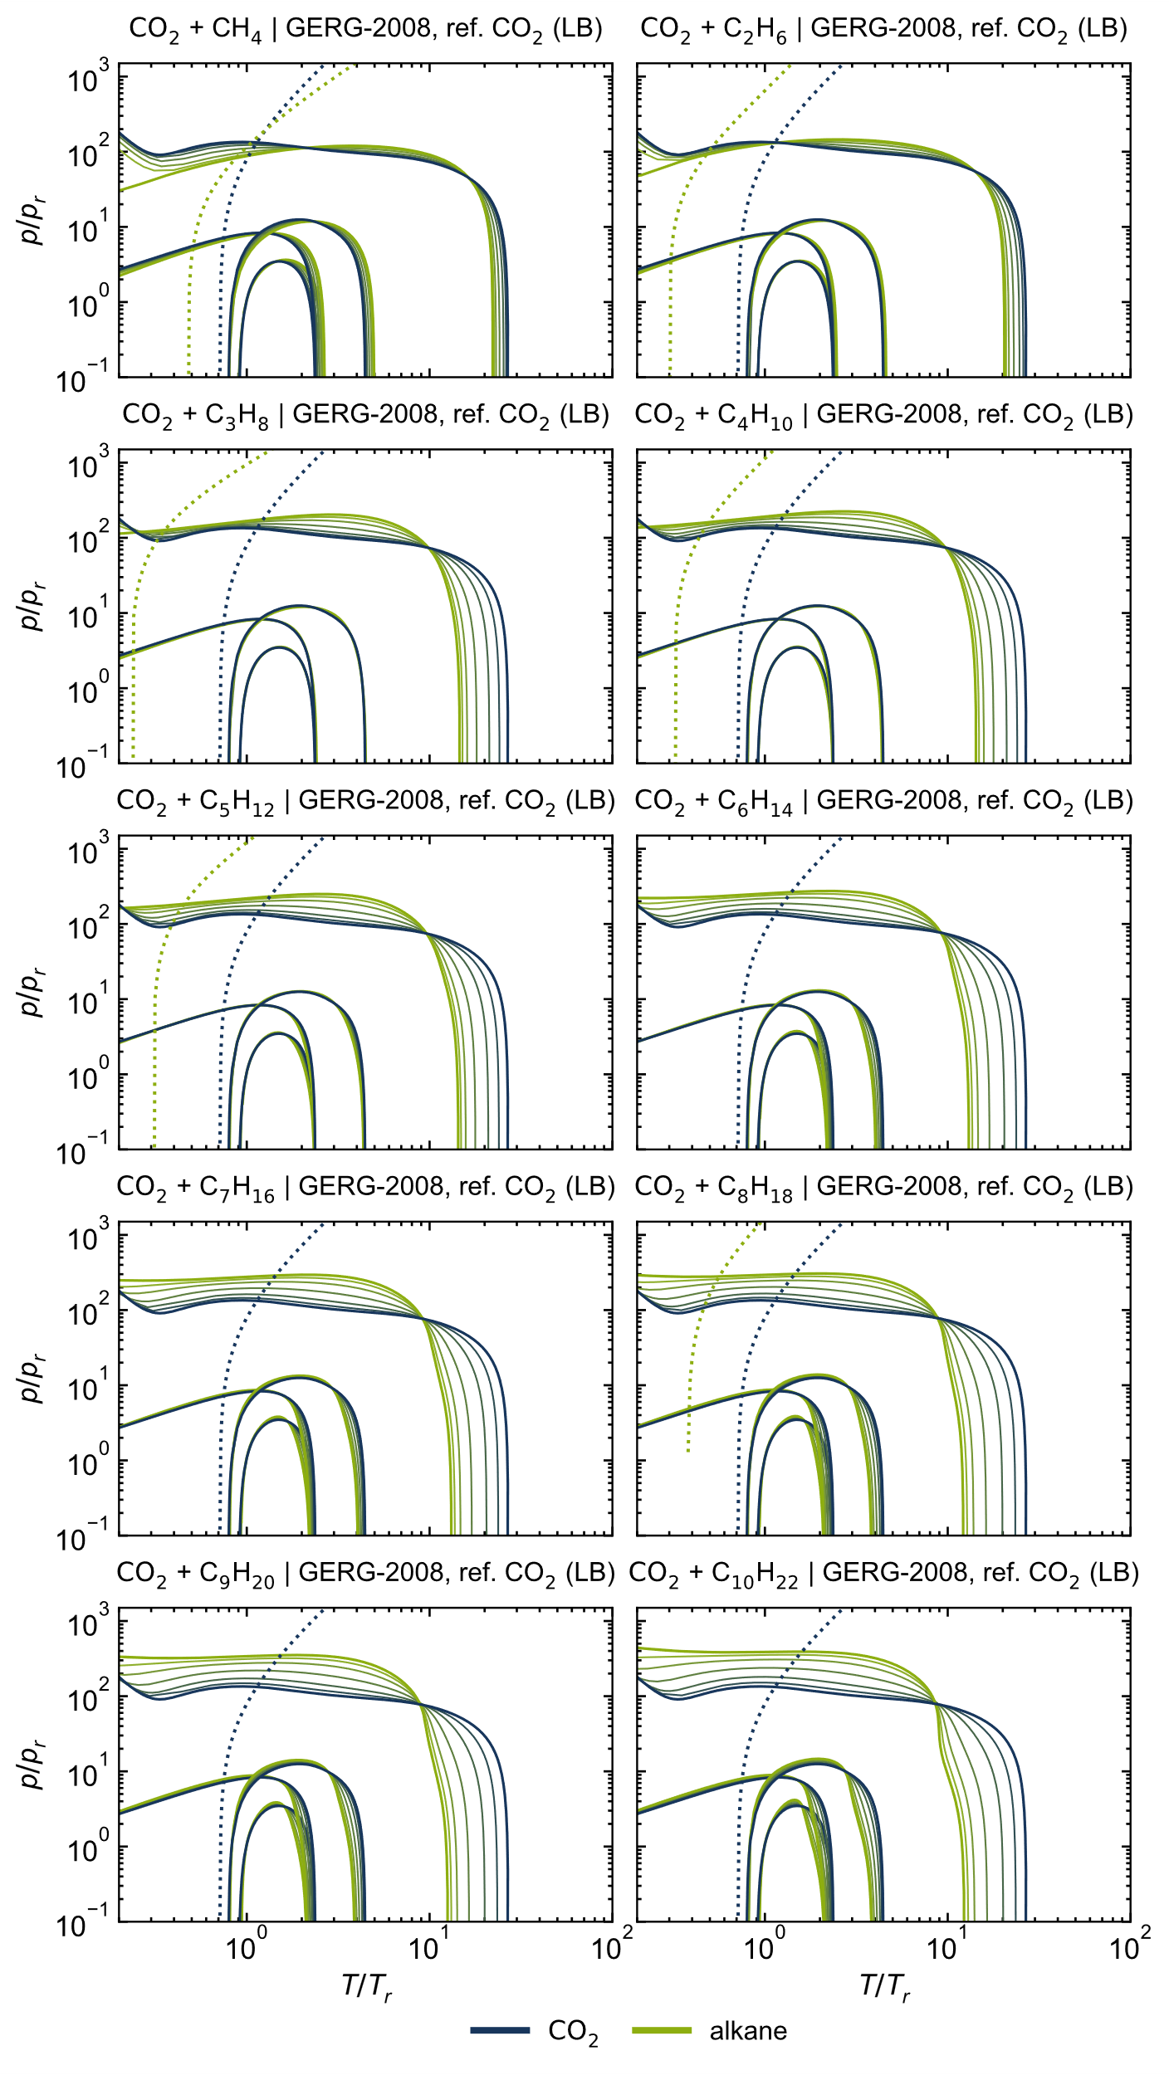
Figure S 4: Ideal curves of all considered CO₂ + alkane mixtures, calculated with the GERG-2008 model [1] and the reference EOS for CO₂ [2] using the Lorentz-Berthelot mixing rule (LB).

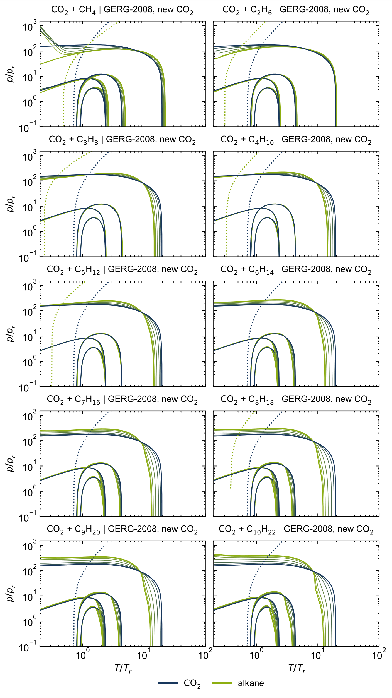
Figure S 5: Ideal curves of all considered CO₂ + alkane mixtures, calculated with the GERG-2008 model [1] and the new preliminary EOS for CO₂ [3].
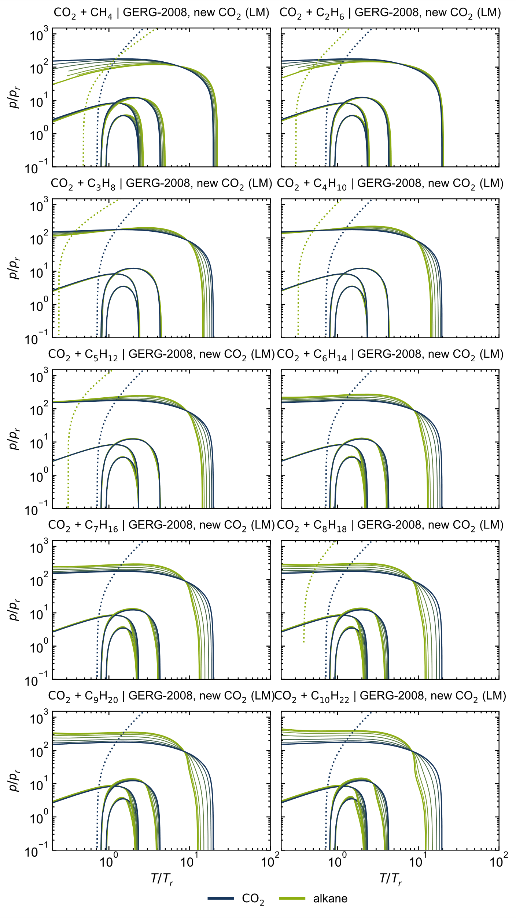
Figure S 6: Ideal curves of all considered CO₂ + alkane mixtures, calculated with the GERG-2008 model [1] and the new preliminary EOS for CO₂ [3] using the linear mixing rule (LM).
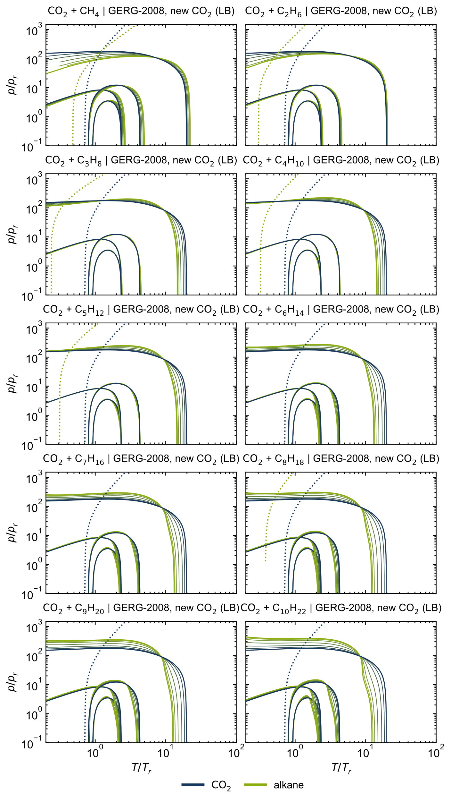
Figure S 7: Ideal curves of all considered CO₂ + alkane mixtures, calculated with the GERG-2008 model [1] and the new preliminary EOS for CO₂ [3] using the Lorentz-Berthelot mixing rule (LB).

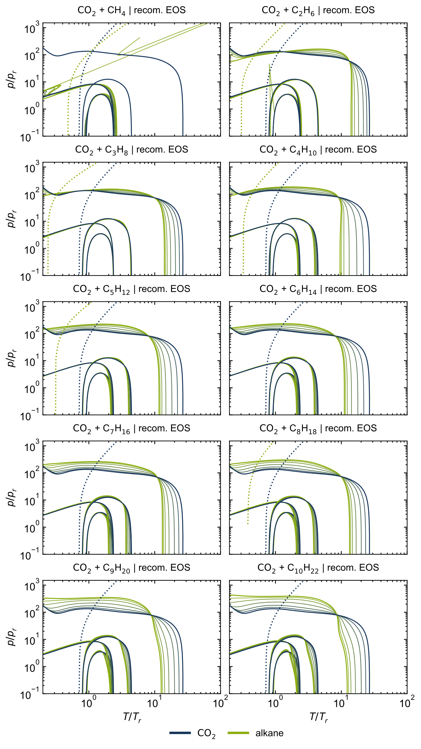
Figure S 8: Ideal curves of all considered CO₂ + alkane mixtures, calculated with the recommended EOS [2, 4–12].
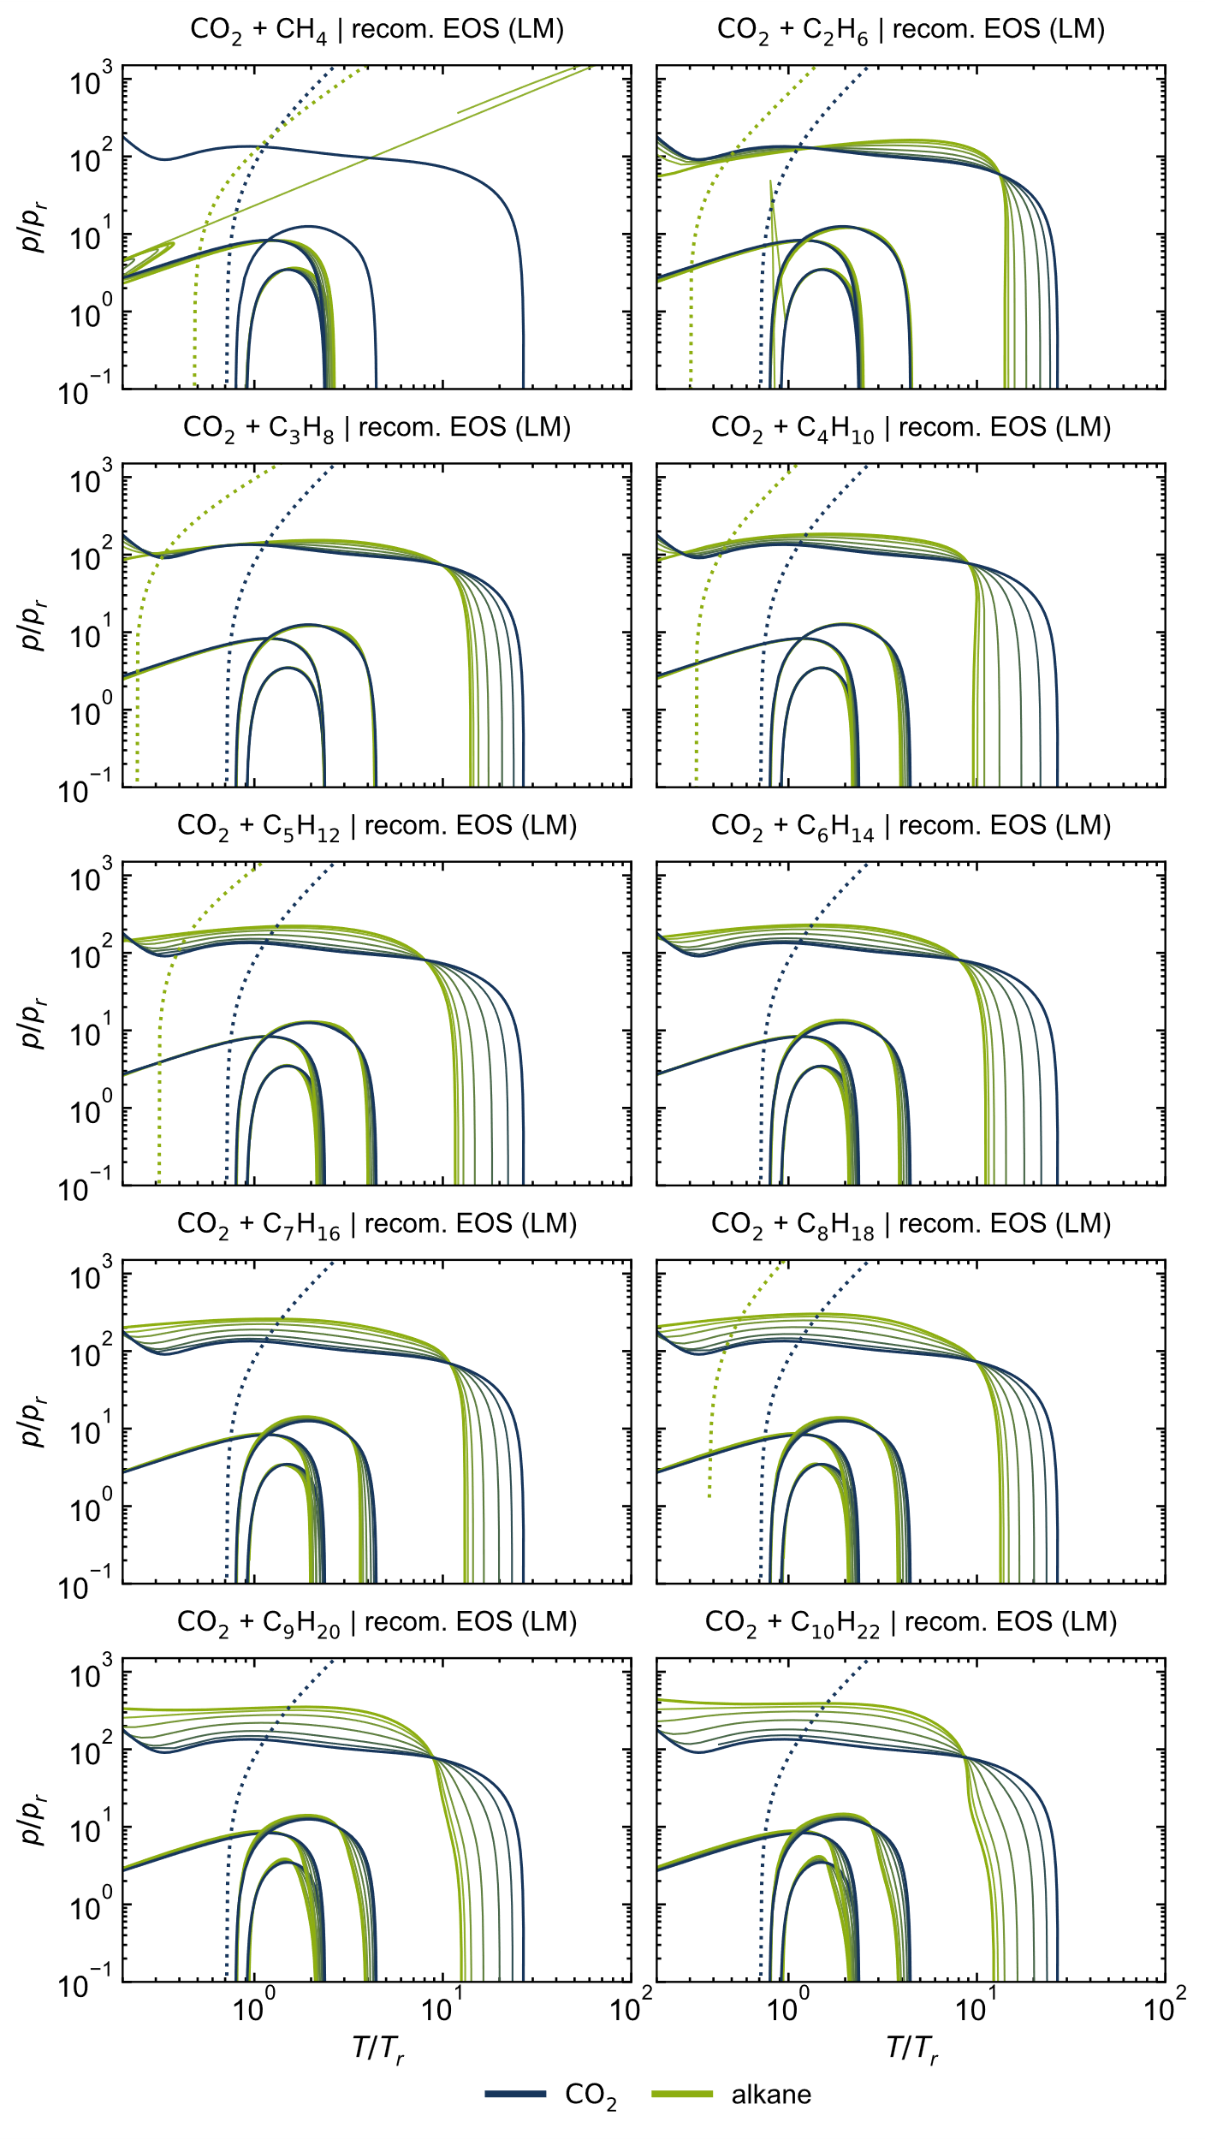
Figure S 9: Ideal curves of all considered CO₂ + alkane mixtures, calculated with the recommended EOS [2, 4–12] using the linear mixing rule (LM).
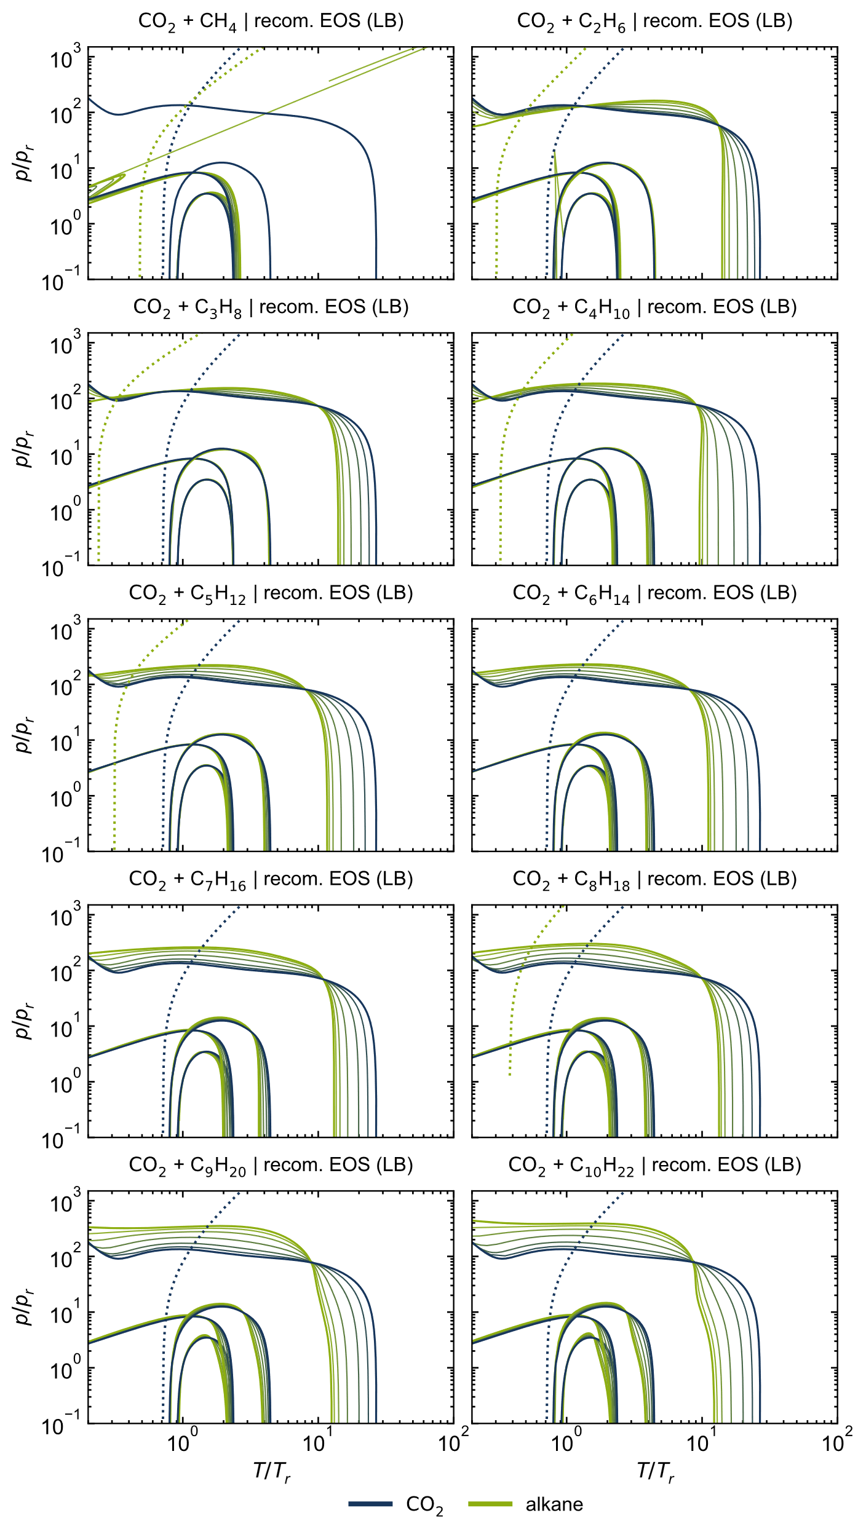
Figure S 10: Ideal curves of all considered CO₂ + alkane mixtures, calculated with the recommended EOS [2, 4–12] using the Lorentz-Berthelot mixing rule (LB).

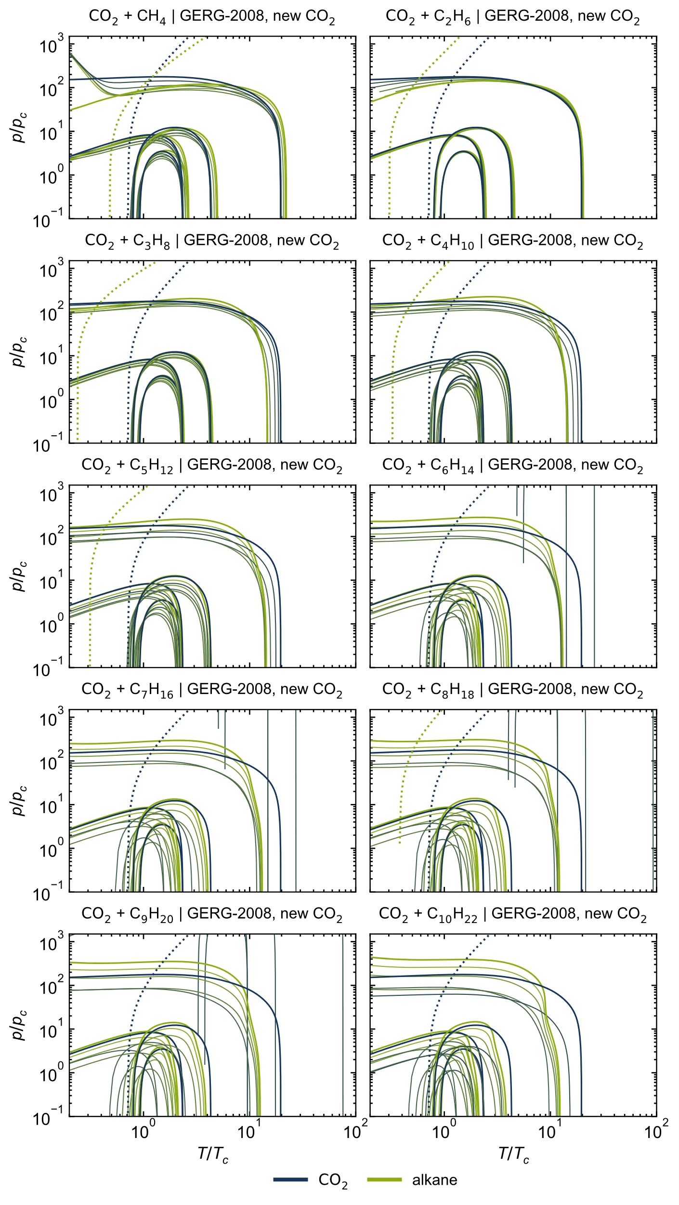
Figure S 11: Ideal curves of all considered CO₂ + alkane mixtures, calculated with the GERG-2008 model [1] and the new preliminary EOS for CO₂ [3], normalized with the calculated critical values.

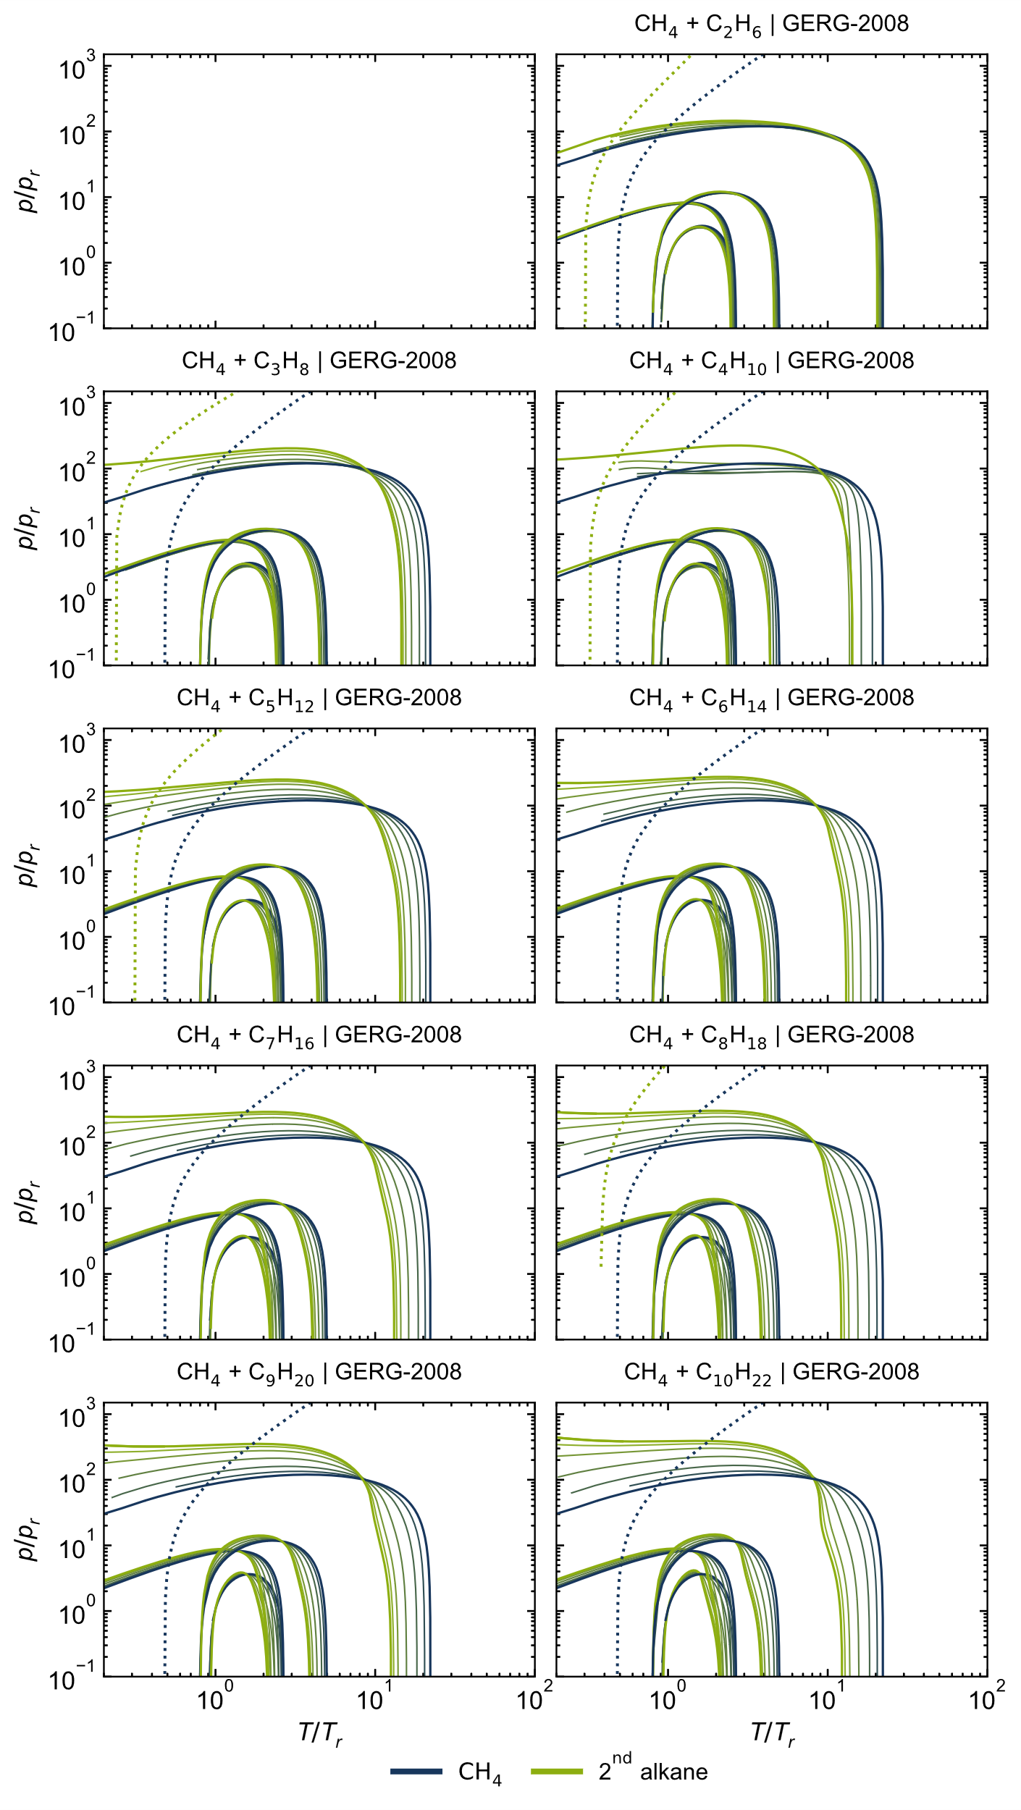
Figure S 12: Ideal curves of all considered CH₄ + alkane mixtures, calculated with the GERG-2008 model [1].
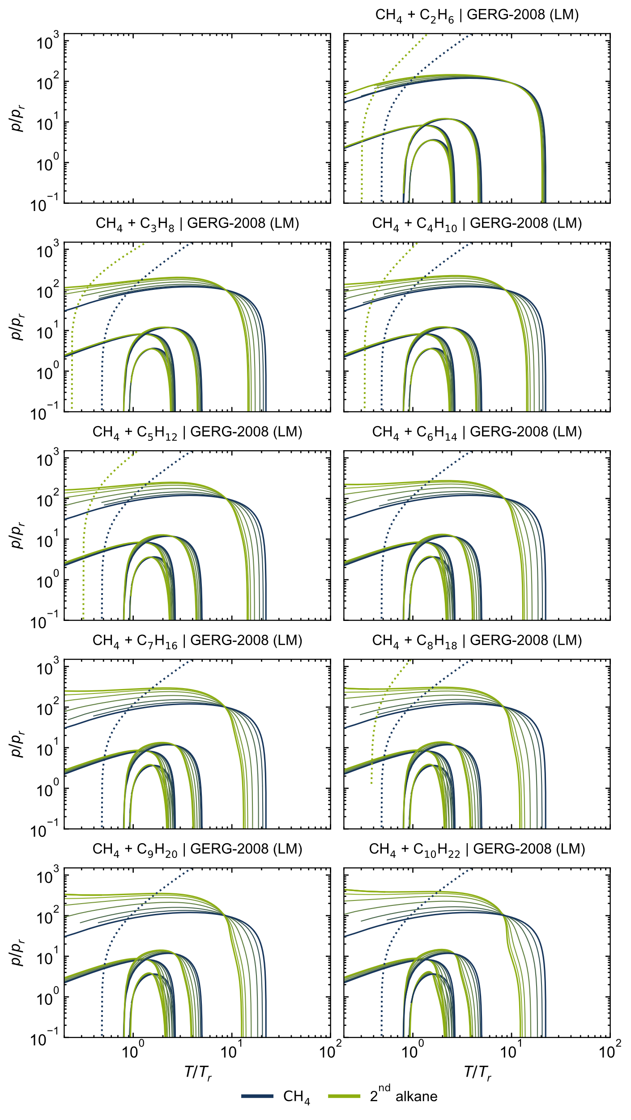
Figure S 13: Ideal curves of all considered CH₄ + alkane mixtures, calculated with the GERG-2008 model [1] using the linear mixing rule (LM).
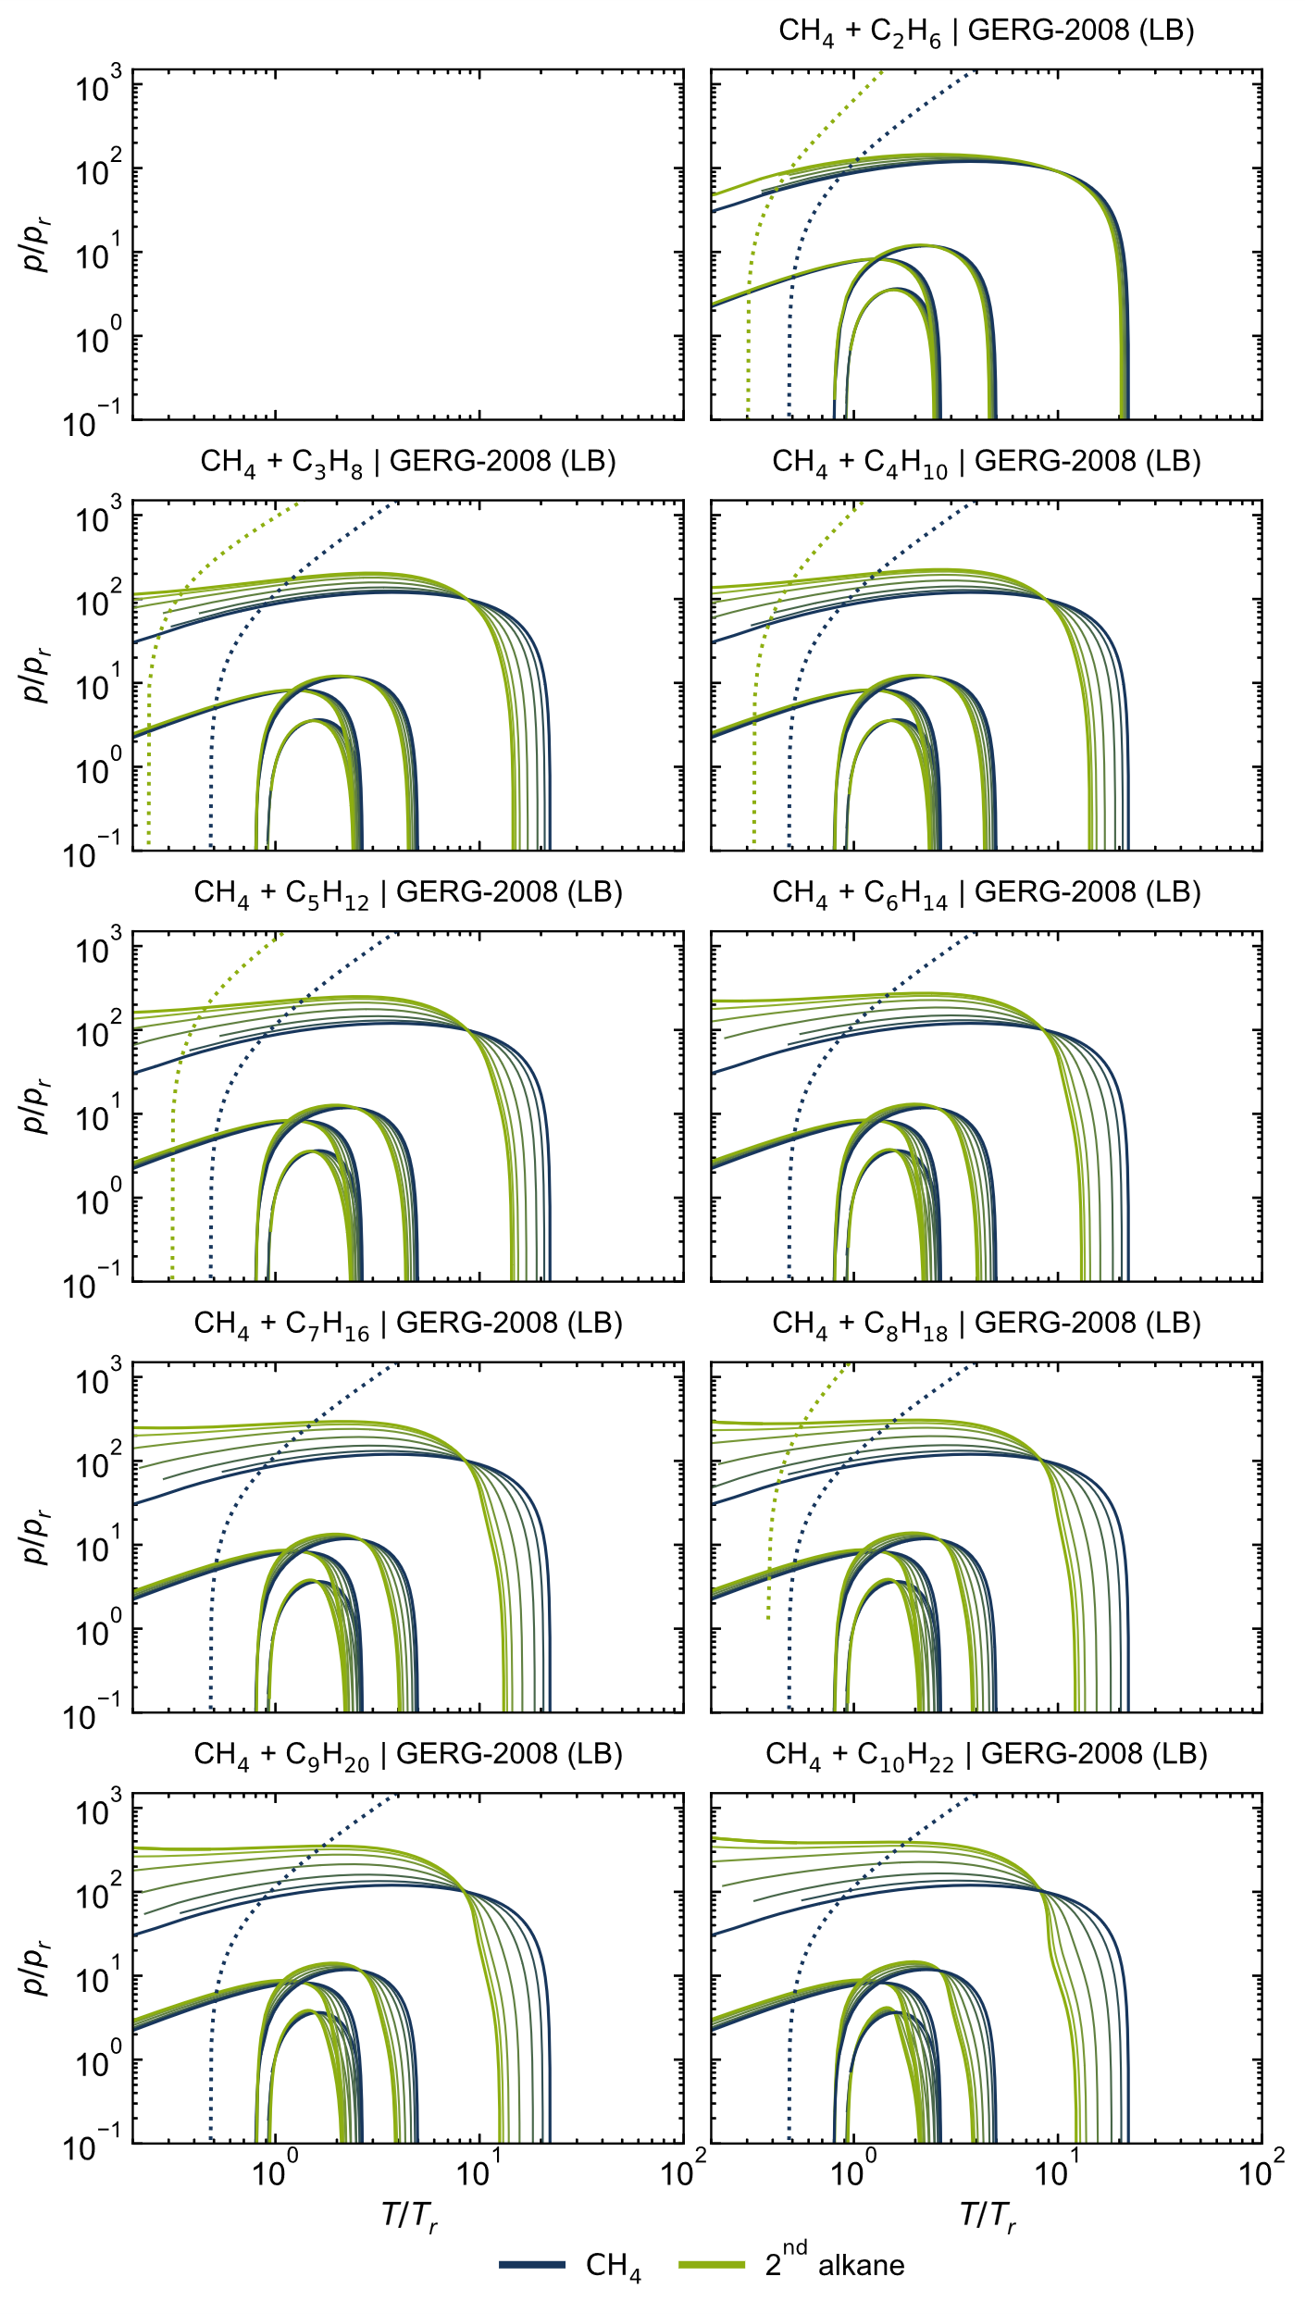
Figure S 14: Ideal curves of all considered CH₄ + alkane mixtures, calculated with the GERG-2008 model [1] using the Lorentz-Berthelot mixing rule (LB).

Classical Ideal Curves: reduced T, ρ diagrams
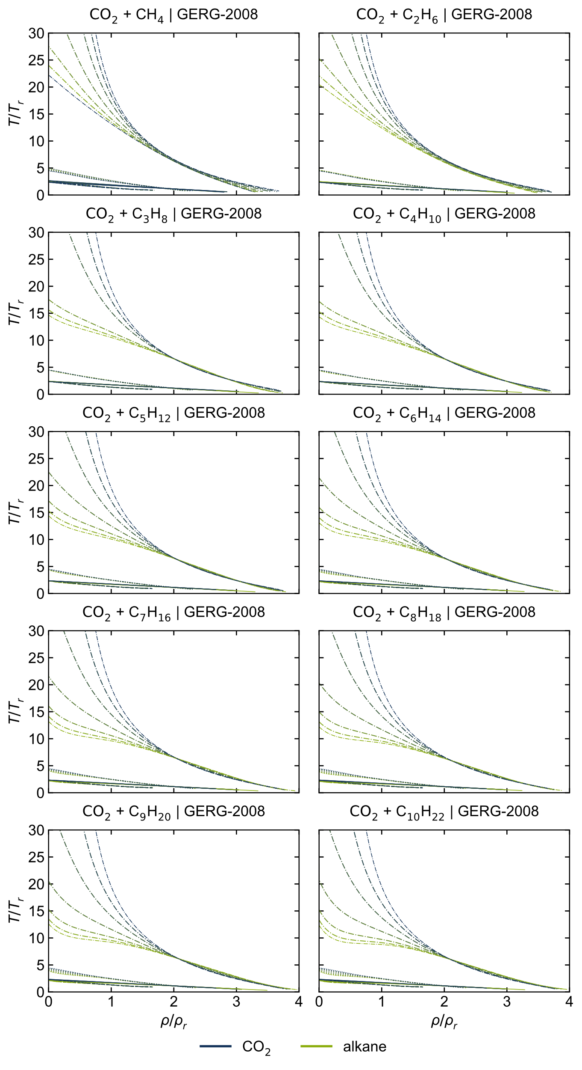
Figure S 15: T,ρ-curves of all considered CO₂ + alkane mixtures, calculated with the GERG-2008 model [1].
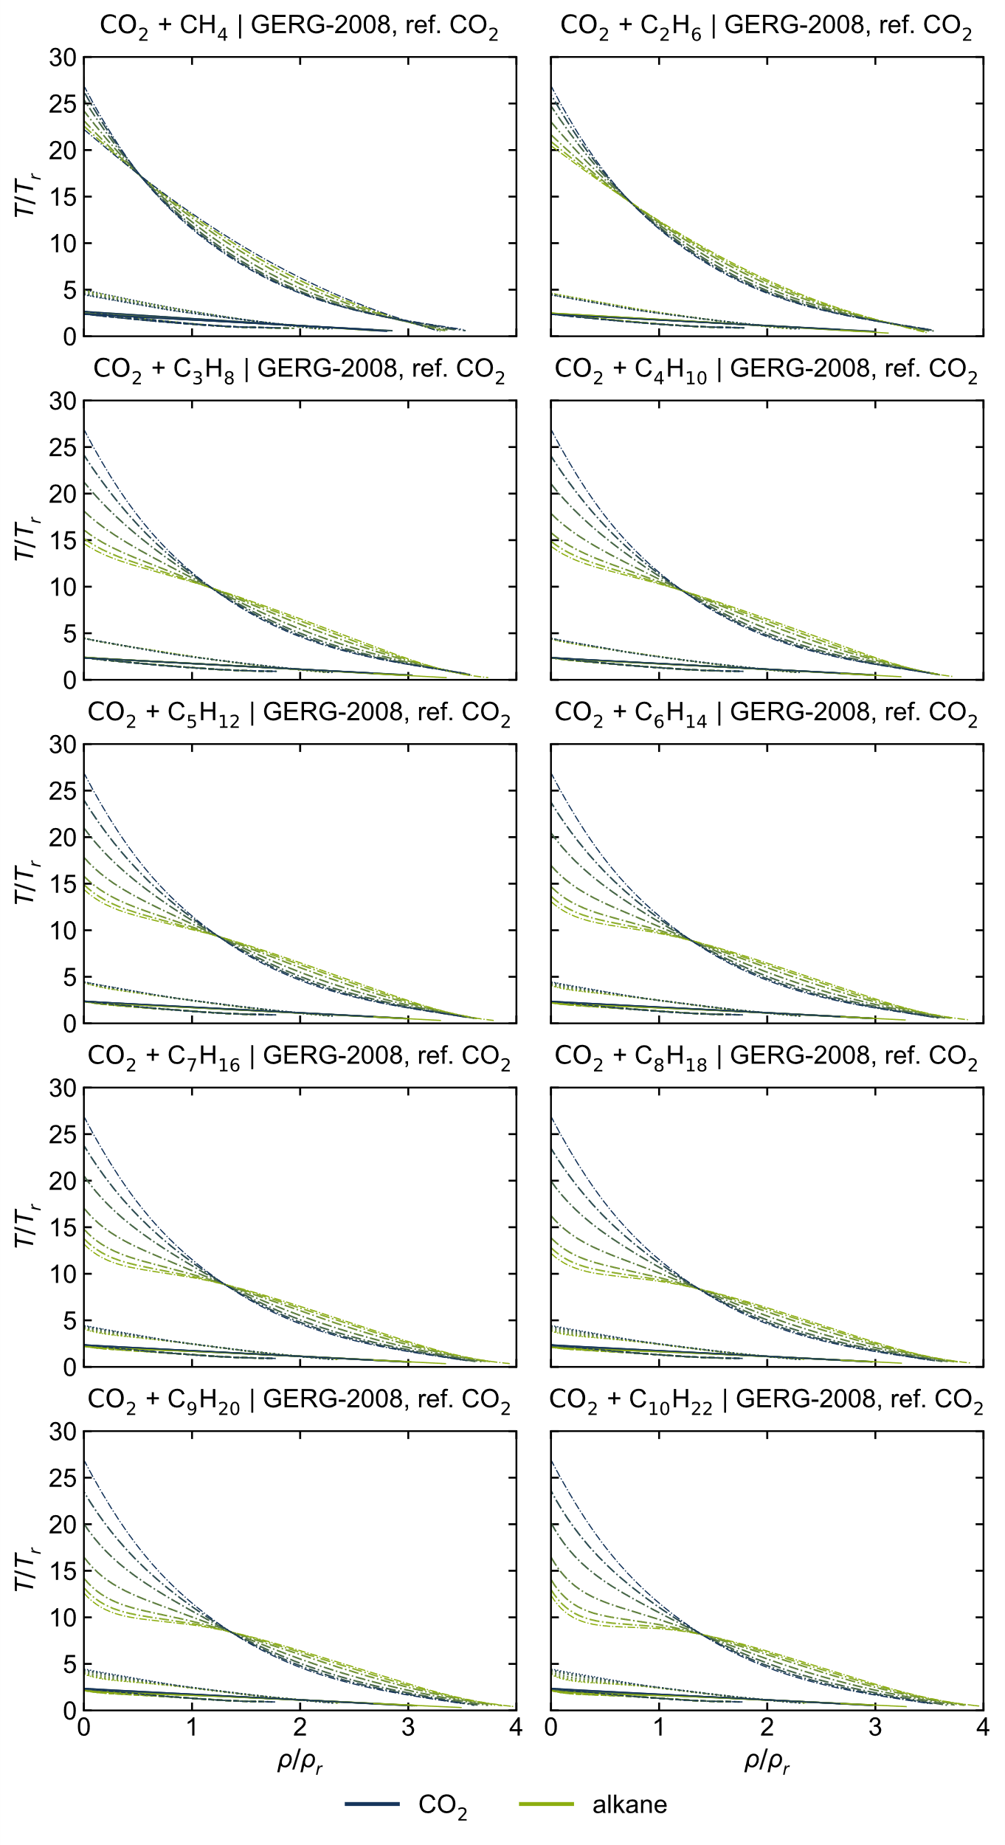
Figure S 16: T,ρ-curves of all considered CO₂ + alkane mixtures, calculated with the GERG-2008 model [1] with the reference CO₂-EOS [2].
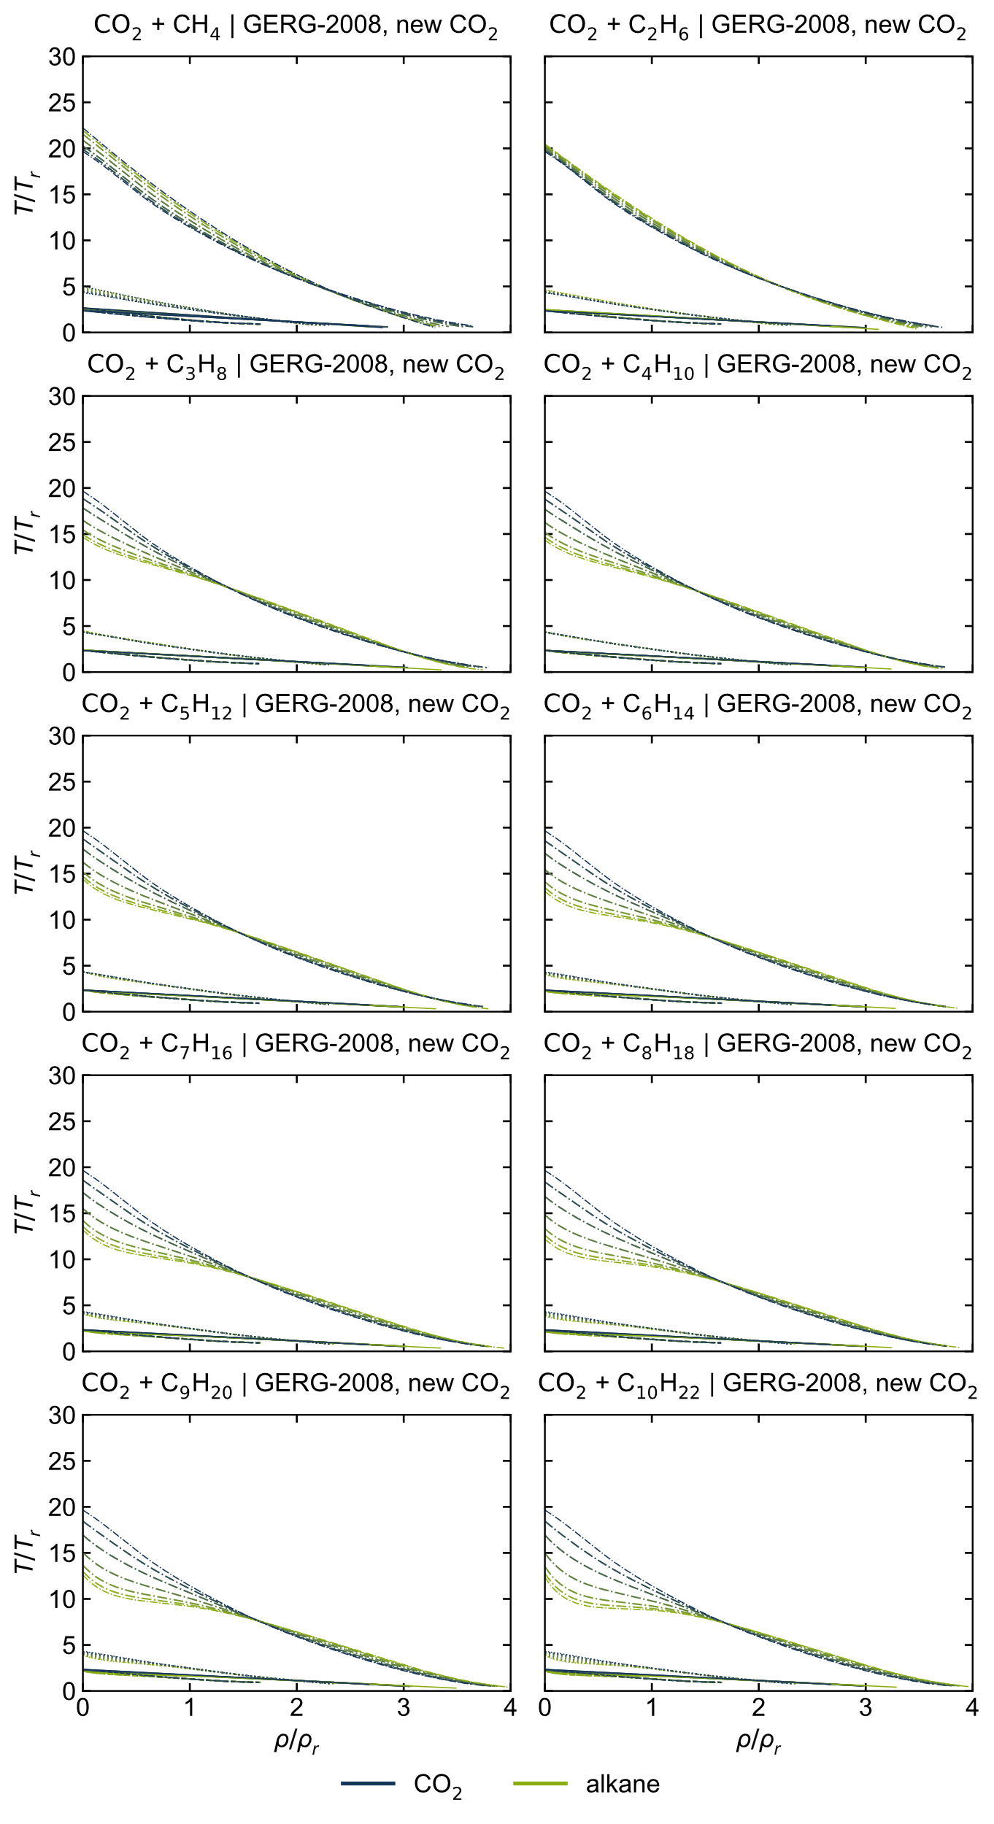
Figure S 17: T,ρ-curves of all considered CO₂ + alkane mixtures, calculated with the GERG-2008 model [1] with the new preliminary CO₂-EOS [3].
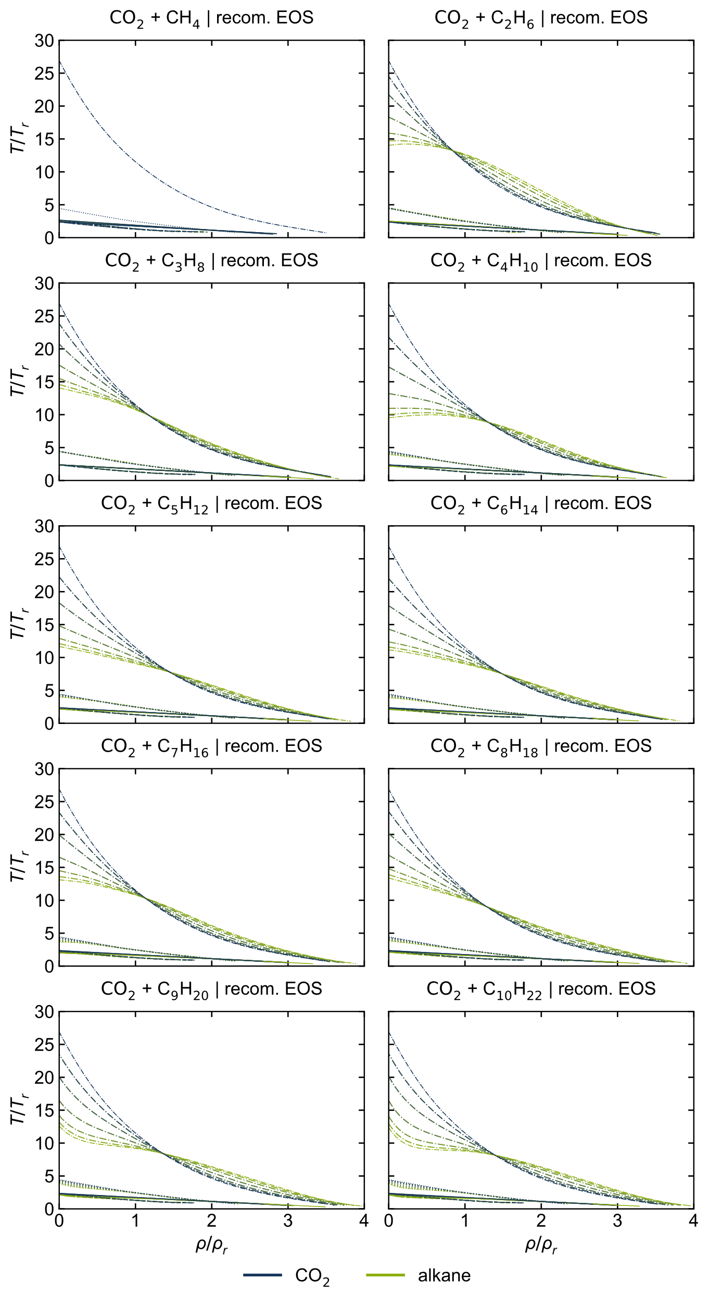
Figure S 18: T,ρ-curves of all considered CO₂ + alkane mixtures, calculated with the recommended EOS [2, 4–12].

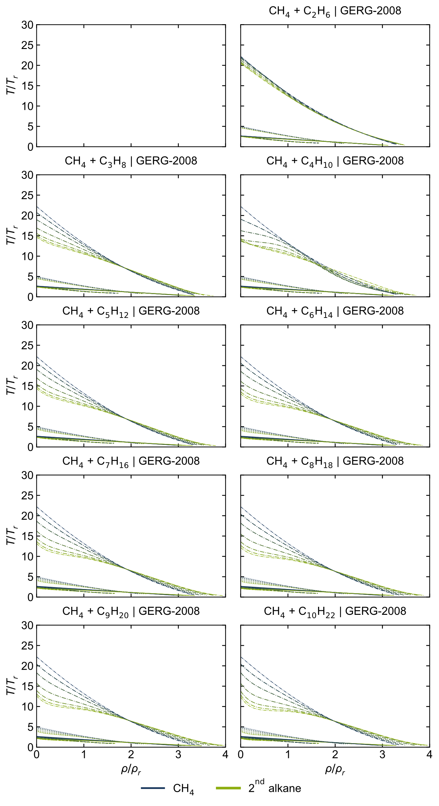
Figure S 19: T,ρ-curves of all considered CH₄ + alkane mixtures, calculated with the GERG-2008 model [1].

VLE data: p,x diagrams
Using the linear mixing rule and the Lorentz-Berthelot mixing rule instead of adjusted reducing and departure functions yields in lower accuracies in other properties, here shown for vapor-liquid-equilibria (VLE) in p,x diagrams. As illustrated in Figure S 20, the phase equilibria using the GERG-2008 model with the linear and the Lorentz-Berthelot mixing rule instead of the adjusted functions are described poorly. While observing some differences between both combining rules in the p,x-diagrams, no significant differences can be seen in the ideal curves (see Figure S 3 and Figure S 4).
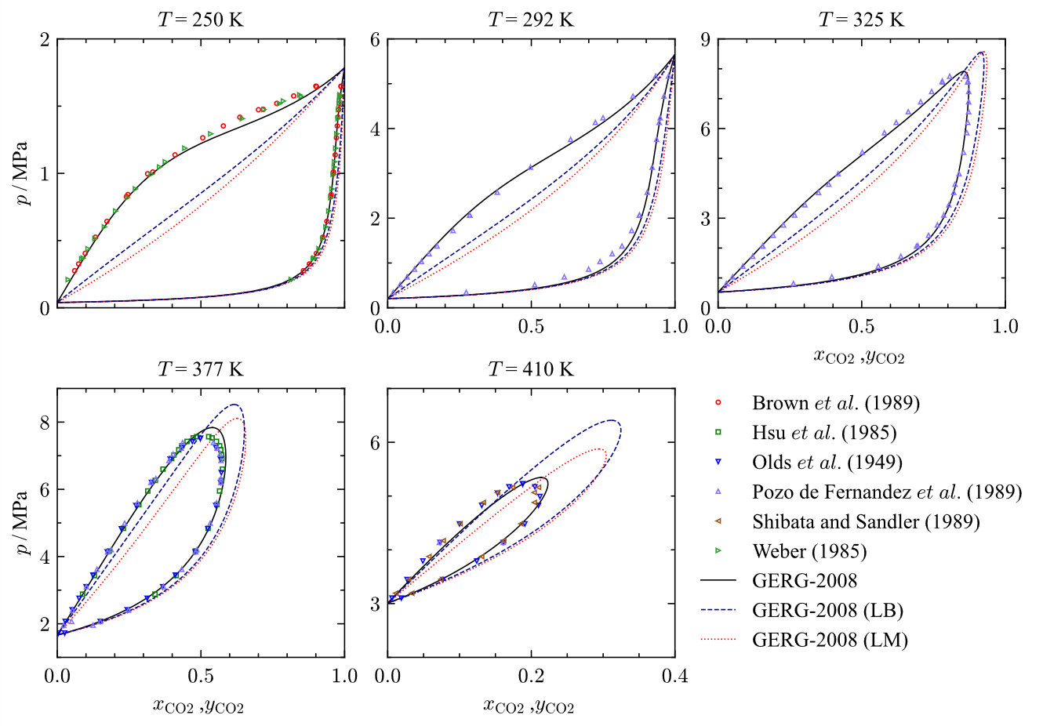
Figure S 20: p,x-diagrams representing selected experimental data [13–18] of vapor-liquid-equilibria (VLE) for the binary system CO₂ + C₄H₁₀ at 250 K, 292 K, 325 K, 377 K and 410 K in comparison to VLEs calculated with the original GERG-2008 model [1] and modified model versions using the linear mixing rule (LM) and the Lorent-Berthelot mixing rule (LB).

The impact of the interaction parameter on the calculated vapor-liquid-equilibria is apparent (see Figure S 21). The overall best representation of the experimental VLE data is obtained using the average interaction parameter, while the results simultaneously indicate a clear temperature dependence of the interaction parameter.
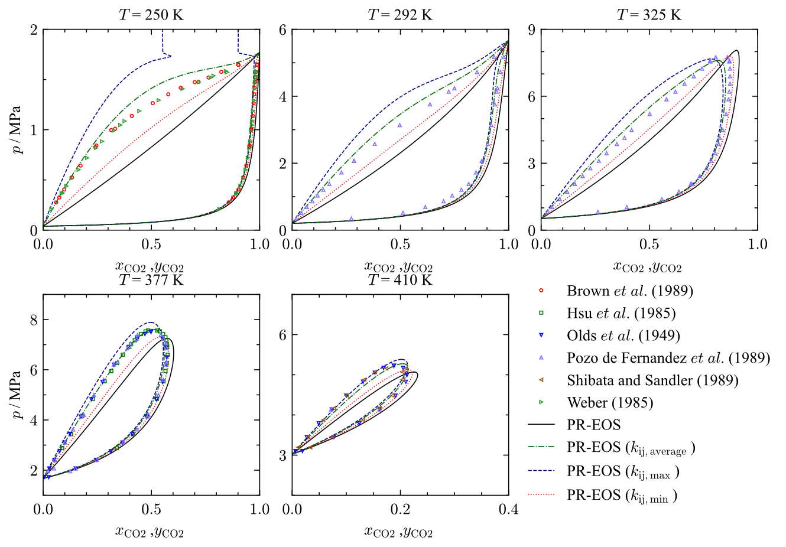
Figure S 21: p,x-diagrams representing selected experimental data [13–18] of vapor-liquid-equilibria (VLE) for the binary system CO₂ + C₄H₁₀ at 250 K, 292 K, 325 K, 377 K and 410 K in comparison to VLEs calculated using the PR-EOS [19] with different interaction parameters k_{ij} from Table 5.

Characteristic values
Table S 1: Overview of the characteristic values from Span and Wagner [20] of all components, CO₂ mixtures and mixture models considered.
 | $θ_{BL}$, $θ_{ID}$ | $$θ_{JT}$$ | $$θ_{JI}$$ | $$δ_{BL|T=T_{r}}$$ | $$δ_{ID|T=T_{r}}$$ | $π_{max,JT}$ | $θ_{max,JT}$
Predicted for pure fluids [20]: | 2.66 | 5 | 19.5 | 1.435 | 2.2235 | 11.8 | 2.25
system | GERG-2008 [1]
CO₂ | 2.3511 | 4.4533 | 89.7040 | 1.4410 | 2.2309 | 12.5290 | 1.9377
C1 | 2.6720 | 4.9894 | 22.2147 | 1.4277 | 2.2032 | 11.8196 | 2.2643
C2 | 2.4830 | 4.6213 | 20.4638 | 1.4303 | 2.1940 | 12.1023 | 2.1125
C3 | 2.4215 | 4.4967 | 14.6510 | 1.4336 | 2.1947 | 12.0989 | 2.0563
C4 | 2.3658 | 4.3884 | 14.3410 | 1.4448 | 2.2013 | 12.3293 | 1.9995
C5 | 2.3564 | 4.3732 | 14.3829 | 1.4435 | 2.1991 | 12.7175 | 1.9606
C6 | 2.2067 | 4.0490 | 13.0851 | 1.4643 | 2.2114 | 13.0722 | 1.9699
C7 | 2.2191 | 4.0683 | 13.1894 | 1.4549 | 2.2373 | 13.4027 | 1.9559
C8 | 2.1093 | 3.8314 | 12.1951 | 1.4340 | 2.2170 | 13.8698 | 1.9281
C9 | 2.1368 | 3.8993 | 12.6051 | 1.4681 | 2.2297 | 14.1518 | 1.9077
C10 | 2.1351 | 3.8643 | 12.3639 | 1.4442 | 2.2136 | 14.6909 | 1.9706
 | recommended EOS (TREND 6 [21]), used in This work [2, 4–12]
CO₂ | 2.3744 | 4.4513 | 26.5436 | 1.4415 | 2.2318 | 12.5362 | 1.9369
C1 | 2.6697 | + | + | 1.4278 | 2.2028 | 5.3000 | +
C2 | 2.5057 | 4.5365 | 14.0155 | 1.4341 | 2.1999 | 12.0777 | 2.1100
C3 | 2.3588 | 4.3494 | 14.0677 | 1.4354 | 2.1953 | 12.1050 | 2.0598
C4 | 2.1953 | 3.9444 | 9.5370 | 1.4472 | 2.2021 | 12.8618 | 1.9704
C5 | 2.1570 | 4.0052 | 11.6686 | 1.4474 | 2.2063 | 12.9816 | 2.0125
C6 | 2.0984 | 3.8794 | 11.1520 | 1.4441 | 2.2091 | 13.6075 | 1.9001
C7 | 1.9881 | 3.6499 | 13.1122 | 1.4525 | 2.2193 | 14.3209 | 1.8565
C8 | 2.0886 | 3.8131 | 13.3792 | 1.4574 | 2.2283 | 13.9759 | 1.8530
C9 | 2.1368 | 3.8993 | 12.6051 | 1.4681 | 2.2297 | 14.1518 | 1.9077
C10 | 2.1351 | 3.8643 | 12.3639 | 1.4442 | 2.2136 | 14.6909 | 1.9706
 | new CO₂-EOS [3]
CO₂ | 2.344 | 4.3083 | 19.6385 | 1.4409 | 2.2307 | 12.2759 | 1.9833

Table S 1 continued
 | Peng-Robinson EOS [19]
CO₂ | 2.3256 | 3.8396 | 5.8336 | 1.5602 | 2.7981 | 13.6491 | 1.8711
C1 | 2.9952 | 5.3550 | 12.6295 | 1.5602 | 2.7982 | 13.0850 | 2.3188
C2 | 2.6435 | 4.5613 | 8.4131 | 1.5601 | 2.7982 | 13.2742 | 2.0701
C3 | 2.4921 | 4.2180 | 7.0695 | 1.5601 | 2.7982 | 13.4194 | 1.9647
C4 | 2.3743 | 3.9503 | 6.1716 | 1.5601 | 2.7982 | 13.5732 | 1.8983
C5 | 2.2731 | 3.7201 | 5.4885 | 1.5601 | 2.7982 | 13.7394 | 1.8506
C6 | 2.1902 | 3.5314 | 4.9821 | 1.5601 | 2.7982 | 13.9080 | 1.7951
C7 | - | - | - | - | - | - | -
C8 | - | - | - | - | - | - | -
C9 | - | - | - | - | - | - | -
C10 | - | - | - | - | - | - | -
 | GERG-2008 [1]
CO₂+C1 | 2.6369 - 2.3809 | 4.9323 - 4.5045 | 24.0468 - 145.7370 | 1.4161 - (1.3966) - 1.4270 | 2.1981 - (2.1937) - 2.2203 | 11.7006 - (11.5956) - 12.2363 | 2.2610 - 1.9924
CO₂+C2 | 2.4691 - 2.3633 | 4.6038 - 4.4696 | 22.9289 - 134.9980 | 1.4312 - 1.4399 | 2.1975 - 2.2269 | 12.1365 - 12.4770 | 2.0969 - 1.9466
CO₂+C3 | 2.4144 - 2.3580 | 4.4926 - 4.4580 | 15.6304 - 90.7700 | 1.4343 - 1.4408 | 2.1981 - 2.2270 | 12.1362 - 12.4806 | 2.0333 - (1.9412) - 1.9646
CO₂+C4 | 2.3643 - 2.3525 | 4.3945 - 4.4464 | 15.3037 - 89.4285 | 1.4444 - 1.4416 | 2.2040 - 2.2277 | 12.3445 - 12.5021 | 1.9981 - 1.9332
CO₂+C5 | 2.3559 - 2.3516 | 4.3805 - 4.4445 | 15.3217 - 87.5162 | 1.4433 - 1.4416 | 2.2020 - 2.2273 | 12.6922 - 12.5392 | 1.9754 - 1.9307
CO₂+C6 | 2.2204 - 2.3359 | 4.0856 - 4.4088 | 14.0505 - 85.2604 | 1.4618 - 1.4438 | 2.2132 - 2.2287 | 13.0113 - 12.5736 | 1.9991 - (1.9635) - 1.9806
CO₂+C7 | 2.2316 - 2.3372 | 4.1033 - 4.4111 | 14.1596 - 84.7979 | 1.4532 - 1.4422 | 2.2367 - 2.2316 | 13.3085 - 12.6097 | 1.9619 - (1.9629) - 1.9508
CO₂+C8 | 2.1309 - 2.3242 | 3.8851 - 4.3819 | 13.1375 - 83.8218 | 1.4349 - 1.4410 | 2.2182 - 2.2293 | 13.7221 - 12.6471 | 1.9357 - 1.9707
CO₂+C9 | 2.1557 - 2.3270 | 3.9465 - 4.3888 | 13.5235 - 81.9127 | 1.4650 - 1.4441 | 2.2298 - 2.2308 | 13.9693 - 12.6685 | 1.8958 - 1.9760
CO₂+C10 | 2.1546 - 2.3274 | 3.9163 - 4.3873 | 13.3387 - 81.7846 | 1.4440 - (1.4417) - 1.4422 | 2.2151 - 2.2289 | 14.4477 - 12.7110 | 1.9587 - (1.9490) - 1.9868
 | GERG-2008, ref.CO₂ [1, 2]
CO₂+C1 | 2.6405 - 2.4029 | 4.9321 - 4.5026 | 22.5798 - 27.8621 | 1.4162 - (1.3970) - 1.4274 | 2.1982 - (2.1939) - 2.2211 | 11.696 - (11.588) - 12.236 | 2.2603 - 1.9911
CO₂+C2 | 2.4719 - 2.3847 | 4.6036 - 4.4677 | 20.9158 - 25.0363 | 1.4314 - 1.4404 | 2.1975 - 2.2277 | 12.1350 - 12.4825 | 2.0966 - 1.9458
CO₂+C3 | 2.4169 - 2.3791 | 4.4924 - 4.4561 | 15.1770 - 23.8276 | 1.4343 - 1.4412 | 2.1981 - 2.2278 | 12.1355 - 12.4836 | 2.0331 - (1.9405) - 1.9636
CO₂+C4 | 2.3666 - 2.3735 | 4.3943 - 4.4445 | 14.8714 - 23.7222 | 1.4444 - 1.4419 | 2.2041 - 2.2284 | 12.3442 - 12.5090 | 1.9979 - 1.9325
CO₂+C5 | 2.3581 - 2.3725 | 4.3803 - 4.4427 | 14.8989 - 23.6198 | 1.4433 - 1.4418 | 2.2020 - 2.2281 | 12.6922 - 12.5462 | 1.9752 - 1.9301
CO₂+C6 | 2.2222 - 2.3564 | 4.0854 - 4.4069 | 13.6692 - 23.2482 | 1.4618 - 1.4440 | 2.2132 - 2.2295 | 13.0111 - 12.5781 | 1.9989 - 1.9161
CO₂+C7 | 2.2335 - 2.3577 | 4.1031 - 4.4092 | 13.7720 - 23.3692 | 1.4532 - 1.4427 | 2.2368 - 2.2324 | 13.3088 - 12.6144 | 1.9618 - (1.9624) - 1.9499
CO₂+C8 | 2.1325 - 2.3444 | 3.8849 - 4.3800 | 12.8015 - 23.1776 | 1.4349 - 1.4415 | 2.2183 - 2.2301 | 13.7227 - 12.6493 | 1.9356 - (1.9319) - 1.9696
CO₂+C9 | 2.1573 - 2.3471 | 3.9463 - 4.3869 | 13.1807 - 24.3708 | 1.4650 - 1.4445 | 2.2299 - 2.2316 | 13.9704 - 12.6747 | 1.8958 - (1.9294) - 1.9070
CO₂+C10 | 2.1563 - 2.3476 | 3.9161 - 4.3854 | 12.9835 - 24.2708 | 1.4440 - (1.4420) - 1.4426 | 2.2152 - 2.2297 | 14.4481 - 12.7187 | 1.9586 - 1.9133

Table S 1 continued
 | GERG-2008, new CO₂ [1, 3]
CO₂+C1 | 2.6368 - 2.3748 | 4.9154 - 4.3715 | 21.9412 - 20.1436 | 1.4161 - (1.3966) - 1.4270 | 2.1981 - (2.1937) - 2.2202 | 11.6843 - (11.5194) - 12.0192 | 2.2606 - 2.0424
CO₂+C2 | 2.4686 - 2.3571 | 4.5885 - 4.3381 | 20.3885 - (19.8555) - 19.9215 | 1.4313 - 1.4398 | 2.1975 - 2.2268 | 12.1155 - 12.2541 | 2.0959 - 1.9962
CO₂+C3 | 2.4138 - 2.3517 | 4.4787 - 4.3279 | 14.9500 - 18.8447 | 1.4342 - 1.4408 | 2.1981 - 2.2269 | 12.1150 - 12.2542 | 2.0323-(2.0004)-(2.0467)-2.0166
CO₂+C4 | 2.3636 - 2.3462 | 4.3809 - 4.3168 | 14.6527 - 18.7804 | 1.4444 - 1.4415 | 2.2040 - 2.2275 | 12.3224 - 12.2796 | 1.9970-(1.9664)-(2.0081)-1.9859
CO₂+C5 | 2.3552 - 2.3453 | 4.3672 - 4.3153 | 14.6849 - 18.7684 | 1.4433 - 1.4415 | 2.2020 - 2.2272 | 12.6698 - 12.3162 | 1.9743-(1.9681)-(2.0040)-1.9845
CO₂+C6 | 2.2196 - 2.3294 | 4.0728 - 4.2800 | 13.4670 - 18.5699 | 1.4618 - 1.4437 | 2.2132 - 2.2286 | 12.9891 - 12.3501 | 1.9981 - 1.9692
CO₂+C7 | 2.2308 - 2.3307 | 4.0905 - 4.2822 | 13.5674 - 18.5916 | 1.4532 - 1.4421 | 2.2367 - 2.2315 | 13.2842 - 12.3806 | 1.9608 - (1.9505) - 2.0073
CO₂+C8 | 2.1301 - 2.3177 | 3.8734 - 4.2541 | 12.6153 - 18.3934 | 1.4349 - 1.4410 | 2.2182 - 2.2292 | 13.6974 - 12.4202 | 1.9346 - (1.9713) - 1.9592
CO₂+C9 | 2.1550 - 2.3204 | 3.9347 - 4.2611 | 12.9942 - 18.4369 | 1.4650 - 1.4441 | 2.2298 - 2.2306 | 13.9437 - 12.4444 | 1.8947 -1.9648
CO₂+C10 | 2.1539 - 2.3208 | 3.9042 - 4.2590 | 12.7888 - 18.4560 | 1.4440 - (1.4416) - 1.4422 | 2.2151 - 2.2288 | 14.4240 - 12.4910 | 1.9578-(1.9465)-(1.9792)-1.9759
 | GERG-2008, new CO₂ [1, 3], linear mixing rule
CO₂+C1 | 2.6335 - 2.3717 | 4.9110 - 4.3669 | 21.9378 - 20.1266 | 1.4292 - 1.4397 | 2.2059 - 2.2280 | 11.8403 - 12.2037 | 2.2591- (2.0424) - 2.0429
CO₂+C2 | 2.4686 - 2.3571 | 4.5885 - 4.3381 | 20.3885 - 19.7322 | 1.4313 - 1.4401 | 2.1975 - 2.2268 | 12.1154 - 12.2541 | 2.1020 - 2.0026
CO₂+C3 | 2.4138 - 2.3517 | 4.4787 - 4.3279 | 14.9500 - 18.8447 | 1.4342 - 1.4408 | 2.1981 - 2.2269 | 12.1150 - 12.2539 | 2.0318-(2.0025)-(2.0474)-2.0182
CO₂+C4 | 2.3636 - 2.3462 | 4.3809 - 4.3168 | 14.6527 - 18.7804 | 1.4444 - 1.4417 | 2.2040 - 2.2275 | 12.3223 - 12.2794 | 2.0075 - 1.9799
CO₂+C5 | 2.3552 - 2.3453 | 4.3672 - 4.3153 | 14.6849 - 18.7684 | 1.4432 - 1.4417 | 2.2020 - 2.2272 | 12.6699 - 12.3131 | 1.9683 - (1.9481) - 2.0132
CO₂+C6 | 2.2196 - 2.3294 | 4.0728 - 4.2800 | 13.4670 - 18.5699 | 1.4617 - 1.4436 | 2.2132 - 2.2286 | 12.9884 - 12.3513 | 1.9714 - (2.0028) - 1.9856
CO₂+C7 | 2.2308 - 2.3307 | 4.0905 - 4.2822 | 13.5674 - 18.5916 | 1.4532 - 1.4427 | 2.2367 - 2.2315 | 13.2833 - 12.3798 | 1.9508 - (1.9858) - 1.9569
CO₂+C8 | 2.1301 - 2.3177 | 3.8734 - 4.2541 | 12.6153 - 18.3934 | 1.4347 - 1.4402 | 2.2182 - 2.2292 | 13.6971 - 12.4173 | 1.9613 - (1.9495) - 2.0162
CO₂+C9 | 2.1550 - 2.3204 | 3.9347 - 4.2611 | 12.9942 - 18.4369 | 1.4650 - 1.4441 | 2.2298 - 2.2306 | 13.9440 - 12.4438 | 1.9362 - (1.9148) - 1.9932
CO₂+C10 | 2.1539 - 2.3208 | 3.9042 - 4.2590 | 12.7888 - 18.4560 | 1.4442 - (1.4417) - 1.4423 | 2.2151 - 2.2288 | 14.4229 - 12.4909 | 1.9421 - 1.9898
 | GERG-2008, new CO₂ [1, 3], Lorentz-Berthelot mixing rule
CO₂+C1 | 2.6373 - 2.3998 | 4.9278 - 4.4982 | 22.5764 - 27.8441 | 1.4293 - 1.4401 | 2.2060 - 2.2289 | 11.8524 - 12.4284 | 2.2589 - (1.9888) - 1.9921
CO₂+C2 | 2.4719 - 2.3847 | 4.6036 - 4.4677 | 20.9158 - 27.3899 | 1.4315 - 1.4407 | 2.1976 - 2.2277 | 12.1338 - 12.4825 | 2.1076 - 1.9587
CO₂+C3 | 2.4169 - 2.3791 | 4.4924 - 4.4561 | 15.1770 - 23.6551 | 1.4343 - 1.4408 | 2.1981 - 2.2278 | 12.1349 - 12.4830 | 2.0189 - (2.0190) - 1.9261
CO₂+C4 | 2.3666 - 2.3735 | 4.3943 - 4.4445 | 14.8714 - 23.5696 | 1.4445 - 1.4424 | 2.2041 - 2.2284 | 12.3442 - 12.5061 | 1.9980 - (1.9377) - 1.9687
CO₂+C5 | 2.3581 - 2.3725 | 4.3803 - 4.4427 | 14.8989 - 23.5537 | 1.4433 - 1.4422 | 2.2020 - 2.2281 | 12.6927 - 12.5453 | 1.9617 - (1.9162) - 1.9570
CO₂+C6 | 2.2222 - 2.3564 | 4.0854 - 4.4069 | 13.6692 - 23.3533 | 1.4618 - 1.4440 | 2.2133 - 2.2295 | 13.0112 - 12.5811 | 1.9669-(1.9183)-(1.9871)-1.9519
CO₂+C7 | 2.2335 - 2.3577 | 4.1031 - 4.4092 | 13.7720 - 23.4073 | 1.4532 - 1.4425 | 2.2368 - 2.2324 | 13.3080 - 12.6146 | 1.9484-(1.9311)-(1.9664)-1.9481
CO₂+C8 | 2.1325 - 2.3444 | 3.8849 - 4.3800 | 12.8015 - 23.1783 | 1.4347 - 1.4411 | 2.2183 - 2.2301 | 13.7215 - 12.6530 | 1.9596 - (1.9272) - 1.9554
CO₂+C9 | 2.1573 - 2.3471 | 3.9463 - 4.3869 | 13.1807 - 23.2460 | 1.4650 - 1.4442 | 2.2299 - 2.2316 | 13.9694 - 12.6760 | 1.8910 - 1.9563
CO₂+C10 | 2.1563 - 2.3476 | 3.9161 - 4.3854 | 12.9835 - 23.3343 | 1.4442 - (1.4420) - 1.4425 | 2.2152 - 2.2297 | 14.4477 - 12.7169 | 1.9420 - (1.9338) - 1.9716

Table S 1 continued
 | This work
CO₂+C1 | 2.6375 - 2.4012 | + | + | 1.4339 - (1.4494) - 1.4458 | 2.2193 - (2.2566) - 2.2430 | 5.4777 - (5.5196) - 0.5396 | +
CO₂+C2 | 2.4925 - 2.3874 | 4.5305 - 4.4621 | 14.7281 - 24.0613 | 1.4386 - (1.4487) - 1.4446 | 2.2132 - (2.2464) - 2.2395 | 12.2523 - (12.7015) - 12.6222 | 2.1136 - 1.9438
CO₂+C3 | 2.3645-(2.3795)-2.3772 | 4.3687 - 4.4514 | 14.6438 - 23.7451 | 1.4539 - (1.5120) - 1.4606 | 2.2407 - (2.3432) - 2.2748 | 12.7151 - (14.1219) - 13.0979 | 2.0764 - (2.0980) - 1.9715
CO₂+C4 | 2.2177 - 2.3622 | 4.0016 - 4.4109 | 10.0979 - 21.9239 | 1.4868 - (1.7016) - 1.4811 | 2.2798 - (2.4507) - 2.3115 | 13.9265 - (16.4390) - 13.6704 | 2.0313 - (2.0961) - 2.0151
CO₂+C5 | 2.1800 - 2.3553 | 4.0524 - 4.4124 | 12.1770 - 22.5610 | 1.4982 - (1.8305) - 1.4902 | 2.2956 - (2.4917) - 2.3271 | 14.1985 - (17.2411) - 13.8915 | 2.0675 - (2.1169) - 1.9764
 | This work (2)
CO₂+C1 | 2.5976 - 2.3714 | + | + | 1.4216 - (1.4130) - 1.4325 | 2.2117 - (2.2405) - 2.2363 | 5.2360 - 0.5095 | +
CO₂+C2 | 2.4857 - 2.3816 | 4.5157 - 4.4484 | 14.6811 - 23.9716 | 1.4336 - (1.4327) - 1.4395 | 2.2038 - 2.2296 | 12.0557 - (12.0498) - 12.4126 | 2.1035 - 1.9512
CO₂+C3 | 2.3580-(2.3576)-2.3702 | 4.3534 - 4.4341 | 14.5743 - 23.5706 | 1.4353 - 1.4408 | 2.1991 - 2.2284 | 12.1048 - 12.4466 | 2.0548 - (1.9432) - 1.9684
CO₂+C4 | 2.2046 - 2.3460 | 3.9718 - 4.3714 | 10.0158 - 21.5408 | 1.4441 - (1.4374) - 1.4396 | 2.2066 - 2.2309 | 12.6920 - (12.3356) - 12.4328 | 1.9981 - (2.0042) - 1.9552
CO₂+C5 | 2.1454-(2.1397)-2.3049 | 3.9708-(3.9457)-4.2923 | 11.9641 - 21.7580 | 1.4339 - (1.4049) - 1.4298 | 2.2181 - (2.2547) - 2.2415 | 12.2745 - (11.3486) - 11.9555 | 2.0949 - (2.2157) - 2.0156
 | recommended EOS (TREND 6 [21]) [2, 4–12]
CO₂+C1 | 2.6388 - 2.4029 | + | + | 1.4163 - (1.3972) - 1.4274 | 2.1979 - (2.1936) - 2.2210 | 5.3949 - 0.5160 | +
CO₂+C2 | 2.4912 - 2.3863 | 4.5275 - 4.4593 | 14.7095 - 24.0187 | 1.4347 - 1.4407 | 2.2029 - 2.2284 | 12.1136 - 12.4812 | 2.0944 - 1.9456
CO₂+C3 | 2.3603 - 2.3727 | 4.3586 - 4.4400 | 14.5859 - 23.5975 | 1.4360 - 1.4414 | 2.1986 - 2.2278 | 12.1401 - 12.4848 | 2.0361 - (1.9416) - 1.9640
CO₂+C4 | 2.2116 - 2.3547 | 3.9871 - 4.3917 | 10.0418 - 21.6343 | 1.4466 - 1.4421 | 2.2048 - 2.2286 | 12.8281 - 12.5675 | 1.9672 - (1.9840) - 1.9364
CO₂+C5 | 2.1740 - 2.3467 | 4.0375 - 4.3903 | 12.1034 - 22.2389 | 1.4468 - 1.4422 | 2.2086 - 2.2290 | 12.9316 - 12.5749 | 1.9899 - 1.9316
CO₂+C6 | 2.1184 - 2.3364 | 3.9173 - 4.3664 | 11.5802 - 21.9348 | 1.4439 - 1.4422 | 2.2111 - 2.2293 | 13.4965 - 12.6374 | 1.8973 - (1.9237) - 1.9174
CO₂+C7 | 2.0137 - 2.3171 | 3.7005 - 4.3278 | 13.6106 - 23.0648 | 1.4513 - 1.4428 | 2.2205 - 2.2304 | 14.1327 - 12.7025 | 1.8651 - 1.9541
CO₂+C8 | 2.1091 - 2.3351 | 3.8575 - 4.3613 | 13.8874 - 23.2348 | 1.4557 - 1.4435 | 2.2286 - 2.2314 | 13.8182 - 12.6611 | 1.8642 - 1.9622
CO₂+C9 | 2.1573 - 2.3471 | 3.9463 - 4.3869 | 13.1807 - 24.3710 | 1.4650 - 1.4445 | 2.2299 - 2.2316 | 13.9704 - 12.6747 | 1.8958 - (1.9294) - 1.9070
CO₂+C10 | 2.1563 - 2.3476 | 3.9161 - 4.3854 | 12.9835 - 24.2710 | 1.4440 - (1.4420) - 1.4426 | 2.2152 - 2.2297 | 14.4481 - 12.7187 | 1.9586 - 1.9133
 | recommended EOS (TREND 6 [21]) [2, 4–12], linear mixing rule
CO₂+C1 | 2.6356 - 2.3998 | + | + | 1.4294 - 1.4401 | 2.2057 - 2.2288 | 5.4199 - 0.5205 | +
CO₂+C2 | 2.4912 - 2.3863 | 4.5275 - 4.4593 | 14.7095 - 23.8487 | 1.4349 - 1.4410 | 2.2029 - 2.2284 | 12.1128 - 12.4814 | 2.1003 - 1.9518
CO₂+C3 | 2.3603 - 2.3727 | 4.3586 - 4.4400 | 14.5859 - 23.4405 | 1.4360 - 1.4414 | 2.1986 - 2.2278 | 12.1401 - 12.4845 | 2.0356 - (1.9436) - 1.9656
CO₂+C4 | 2.2116 - 2.3547 | 3.9871 - 4.3917 | 10.0418 - 21.6220 | 1.4465 - 1.4422 | 2.2049 - 2.2286 | 12.8287 - 12.5669 | 1.9789 - 1.9306
CO₂+C5 | 2.1740 - 2.3467 | 4.0375 - 4.3903 | 12.1034 - 22.1941 | 1.4468 - 1.4426 | 2.2086 - 2.2290 | 12.9313 - 12.5740 | 1.9838-(1.9548) -(1.9956)-1.9583
CO₂+C6 | 2.1184 - 2.3364 | 3.9173 - 4.3664 | 11.5802 - 21.9608 | 1.4440 - 1.4422 | 2.2111 - 2.2293 | 13.4953 - 12.6386 | 1.9055-(1.8848)-(1.9334)-1.9296
CO₂+C7 | 2.0137 - 2.3171 | 3.7005 - 4.3278 | 13.6106 - 23.1324 | 1.4513 - 1.4432 | 2.2205 - 2.2304 | 14.1321 - 12.7016 | 1.8949 - (1.9269) - 1.9049
CO₂+C8 | 2.1091 - 2.3351 | 3.8575 - 4.3613 | 13.8874 - 23.2984 | 1.4556 - 1.4430 | 2.2286 - 2.2314 | 13.8163 - 12.6652 | 1.8888 - (1.8846) - 1.9449
CO₂+C9 | 2.1573 - 2.3471 | 3.9463 - 4.3869 | 13.1807 - 23.3446 | 1.4650 - 1.4443 | 2.2299 - 2.2315 | 13.9695 - 12.6786 | 1.8918 - 1.9307
CO₂+C10 | 2.1563 - 2.3476 | 3.9161 - 4.3854 | 12.9835 - 23.4730 | 1.4442 - (1.4420) - 1.4425 | 2.2152 - 2.2297 | 14.4478 - 12.7213 | 1.9429 - (1.9579) - 1.9255

Table S 1 continued
 | recommended EOS (TREND 6 [21]) [2, 4–12], Lorentz Berthelot mixing rule
CO₂+C1 | 2.6356 - 2.3998 | + | + |  |  | 1.4294 - 1.4401 |  |  | 2.2057 - 2.2288 |  |  | 5.4176 - 0.5226 |  |  | +
CO₂+C2 | 2.4912 - 2.3863 | 4.5275 - 4.4593 | 14.7095 - 23.8449 |  |  | 1.4349 - 1.4411 |  |  | 2.2030 - 2.2284 |  |  | 12.1120 - 12.4812 |  |  | 2.1053 - (1.9420) - 1.9584
CO₂+C3 | 2.3603 - 2.3727 | 4.3586 - 4.4400 | 14.5859 - 23.4366 |  |  | 1.4360 - 1.4410 |  |  | 2.1986 - 2.2278 |  |  | 12.1399 - 12.4848 |  |  | 2.0484 - 1.9265
CO₂+C4 | 2.2116 - 2.3547 | 3.9871 - 4.3917 | 10.0418 - 21.5775 |  |  | 1.4466 - 1.4426 |  |  | 2.2049 - 2.2286 |  |  | 12.8283 - 12.5629 |  |  | 1.9691-(1.9471)-(1.9811)-1.9725
CO₂+C5 | 2.1740 - 2.3467 | 4.0375 - 4.3903 | 12.1034 - 22.2044 |  |  | 1.4468 - 1.4426 |  |  | 2.2086 - 2.2290 |  |  | 12.9307 - 12.5740 |  |  | 2.0101 - (1.9202) - 1.9586
CO₂+C6 | 2.1184 - 2.3364 | 3.9173 - 4.3664 | 11.5802 - 21.9718 |  |  | 1.4439 - 1.4421 |  |  | 2.2111 - 2.2293 |  |  | 13.4960 - 12.6364 |  |  | 1.9012 - (1.8945) - 1.9528
CO₂+C7 | 2.0137 - 2.3171 | 3.7005 - 4.3278 | 13.6106 - 23.0970 |  |  | 1.4513 - 1.4427 |  |  | 2.2205 - 2.2304 |  |  | 14.1326 - 12.7030 |  |  | 1.8924 - (1.8806) - 1.9523
CO₂+C8 | 2.1091 - 2.3351 | 3.8575 - 4.3613 | 13.8874 - 23.2346 |  |  | 1.4556 - 1.4430 |  |  | 2.2286 - 2.2314 |  |  | 13.8166 - 12.6646 |  |  | 1.8872 - (1.8694) - 1.9482
CO₂+C9 | 2.1573 - 2.3471 | 3.9463 - 4.3869 | 13.1807 - 23.2460 |  |  | 1.4650 - 1.4442 |  |  | 2.2299 - 2.2316 |  |  | 13.9694 - 12.6760 |  |  | 1.8910 - 1.9563
CO₂+C10 | 2.1563 - 2.3476 | 3.9161 - 4.3854 | 12.9835 - 23.3344 |  |  | 1.4442 - (1.4420) - 1.4425 |  |  | 2.2152 - 2.2297 |  |  | 14.4477 - 12.7169 |  |  | 1.9420 - (1.9338) - 1.9716
 | Peng-Robinson EOS (k_{ij} = 0) [19], absolute values
CO₂+C1 | 588.176-696.670 | 1042.70-1158.77 |  |  | 12153.5-1774.19 |  |  | - |  |  | - |  |  | 199.475-(198.899)-(199.638)-199.167 |  |  | 473.4172 - 649.4324
CO₂+C2 | 796.009-716.021 | 1368.57-1188.63 |  |  | 2568.71-1774.19 |  |  | - |  |  | - |  |  | 199.244 - (198.998) - 199.589 |  |  | 614.7742-(588.5118)-644.5654
CO₂+C3 | 900.732-728.530 | 1522.81-1208.51 |  |  | 2614.93-1774.19 |  |  | - |  |  | - |  |  | 199.412-(199.013)-(199.456)-199.356 |  |  | 699.3236-(601.2510)-627.5553
CO₂+C4 | 982.519-740.353 | 1635.85-1227.05 |  |  | 2623.71-1774.19 |  |  | - |  |  | - |  |  | 198.337 - (199.862) - 198.788 |  |  | 758.6986 - 608.6796
CO₂+C5 | 1038.25-750.134 | 1702.94-1241.95 |  |  | 2577.93-1774.19 |  |  | - |  |  | - |  |  | 198.430 - (199.667) - 198.780 |  |  | 796.0194-594.1974
CO₂+C6 | 1081.48-758.991 | 1749.67-1255.12 |  |  | 2530.02-1774.19 |  |  | - |  |  | - |  |  | 199.043-(198.823)-(199.841)-199.700 |  |  | 810.0676 - 599.1440
CO₂+C7 | - | - |  |  | - |  |  | - |  |  | - |  |  | - |  |  | -
CO₂+C8 | - | - |  |  | - |  |  | - |  |  | - |  |  | - |  |  | -
CO₂+C9 | - | - |  |  | - |  |  | - |  |  | - |  |  | - |  |  | -
CO₂+C10 | - | - |  |  | - |  |  | - |  |  | - |  |  | - |  |  | -
 | Peng-Robinson EOS (k_{ij} = 0) [19], normalized with critical values
CO₂+C1 | 2.8350 - 2.3459 | 5.0257 - 3.9019 |  | 11.6003 - 5.9741 |  |  | 1.2759 - (1.1514) - 1.4147 |  |  | 2.3047 - (2.0892) - 2.5479 |  |  | 11.2223 - (9.6983) - 12.0918 |  |  | 2.2818 - (2.1766) - 2.1868
CO₂+C2 | 2.6119 - 2.3589 | 4.4907 - 3.9159 |  | 8.4287 - 5.8450 |  |  | 1.4938 - (1.4992) - 1.4962 |  |  | 2.6799 - (2.6904) - 2.6839 |  |  | 13.2430-(13.2273)-(13.3942)-13.2540 |  |  | 2.0563 - (1.9729) - 2.1235
CO₂+C3 | 2.4647 - 2.3289 | 4.1668 - 3.8632 |  | 7.1552 - 5.6715 |  |  | 1.4738 - (1.4256) - 1.4632 |  |  | 2.6506 - (2.5810) - 2.6352 |  |  | 12.7843 - (11.4533) - 12.5364 |  |  | 1.9598 - (1.8636) - 2.0061
CO₂+C4 | 2.3431 - 2.2753 | 3.9012 - 3.7710 |  | 6.2571 - 5.4524 |  |  | 1.4526 - (1.2989) - 1.3619 |  |  | 2.6198 - (2.3780) - 2.4717 |  |  | 12.3087 - (9.4380) - 11.0015 |  |  | 1.8870 - (1.7928) - 1.8706
CO₂+C5 | 2.2396 - 2.2151 | 3.6733 - 3.6674 |  | 5.5607 - 5.2309 |  |  | 1.4387 - (1.1764) - 1.2455 |  |  | 2.6005 - (2.1822) - 2.2803 |  |  | 11.9901 - (0.0000) - 9.3442 |  |  | 1.8021 - 1.7819
CO₂+C6 | 2.1552 - 2.1564 | 3.4868 - 3.5660 |  | 5.0419 - 5.0408 |  |  | 1.4293 - (1.0772) - 1.1375 |  |  | 2.5881 - (2.0234) - 2.1007 |  |  | 11.7860 - (6.3067) - 7.8950 |  |  | 1.7669 - (1.6440) - 1.7302
CO₂+C7 | - | - |  | - |  |  | - |  |  | - |  |  | - |  |  | -
CO₂+C8 | - | - |  | - |  |  | - |  |  | - |  |  | - |  |  | -
CO₂+C9 | - | - |  | - |  |  | - |  |  | - |  |  | - |  |  | -
CO₂+C10 | - | - |  | - |  |  | - |  |  | - |  |  | - |  |  | -
+: calculations converged towards infinity
-: calculations failed

References
1. O. Kunz, W. Wagner, J. Chem. Eng. Data 57, 3032–3091 (2012) doi:10.1021/je300655b
2. R. Span, W. Wagner, J. Phys. Chem. Ref. Data 25, 1509–1596 (1996) doi:10.1063/1.555991
3. E.W. Lemmon, New preliminary EOS for carbon dioxide, personal communication (2025)
4. U. Setzmann, W. Wagner, J. Phys. Chem. Ref. Data 20, 1061–1155 (1991) doi:10.1063/1.555898
5. D. Bücker, W. Wagner, J. Phys. Chem. Ref. Data 35, 205–266 (2006) doi:10.1063/1.1859286
6. E.W. Lemmon, M.O. McLinden, W. Wagner, J. Chem. Eng. Data 54, 3141–3180 (2009) doi:10.1021/je900217v
7. D. Bücker, W. Wagner, J. Phys. Chem. Ref. Data 35, 929–1019 (2006) doi:10.1063/1.1901687
8. Thol, M., Uhde, T., Lemmon, E.W., and Span, R., Fundamental Equations of State for Hydrocarbons. Part I. n-Pentane. (to be submitted, 2026)
9. Thol, M., Wang, Y., Lemmon, E. W., Span, R., Fundamental equations of state for hydrocarbons. Part II. n-hexane (to be submitted, 2026)
10. Tenji, D., Thol, M., Lemmon, E. W., Span, R., Fundamental equation of state for n-heptane (to be submitted, 2026)
11. R. Beckmüller, R. Span, E.W. Lemmon, M. Thol, J. Phys. Chem. Ref. Data 51 (2022) doi:10.1063/5.0104661
12. E.W. Lemmon, R. Span, J. Chem. Eng. Data 51, 785–850 (2006) doi:10.1021/je050186n
13. T.S. Brown, V.G. Niesen, E.D. Sloan, A.J. Kidnay, Fluid Phase Equilib. 53, 7–14 (1989) doi:10.1016/0378-3812(89)80067-6
14. J.J.C. Hsu, N. Nagarajan, R.L. Robinson, J. Chem. Eng. Data 30, 485–491 (1985) doi:10.1021/je00042a036
15. R.H. Olds, H.H. Reamer, B.H. Sage, W.N. Lacey, Ind. Eng. Chem. 41, 475–482 (1949) doi:10.1021/ie50471a011
16. M.E. Pozo de Fernandez, J.A. Zollweg, W.B. Streett, J. Chem. Eng. Data 34, 324–328 (1989) doi:10.1021/JE00057A019
17. S.K. Shibata, S.I. Sandler, J. Chem. Eng. Data 34, 291–298 (1989) doi:10.1021/je00057a011
18. L.A. Weber, Cryogenics 25, 338–342 (1985) doi:10.1016/0011-2275(85)90019-0
19. D.-Y. Peng, D.B. Robinson, Ind. Eng. Chem. Fund. 15, 59–64 (1976) doi:10.1021/i160057a011
20. R. Span, W. Wagner, Int. J. Thermophys. 18, 1415–1443 (1997) doi:10.1007/BF02575343
21. R. Span, R. Beckmueller, J. Buchenfeld, F. Fiedler, A. Jaeger, E. Mickoleit, T. Neumann, T.-T.-G. Nguyen, S.M. Pohl, S. Rath, F. Sabozin, B. Semrau, M. Thol, TREND. Thermodynamic Reference Engineering Data 6.0 (Lehrstuhl für Thermodynamik, Ruhr-Universität Bochum, Bochum, 2025)

