Supplementary Material

i) Supplementary Material: Publications at IGCs

Selection of academic articles and briefs distributed during IGCs

Time of Distribution | Type of Publication | Name of publication
IGC 5.2 | Policy Brief | Climate and biodiversity beyond national jurisdiction. DOSI 2023
IGC 5.2 | Policy Brief | Briefing Note on the common heritage of humankind and areas beyond national jurisdiction. Becker Lorca & Derrig 2023
IGC5 | Academic Article | The diverse benefits of biodiversity conservation in global ocean areas beyond national jurisdiction Santos et al. 2022
IGC3 | Academic Article | Fish slipping through the governance net, Crespo et al. 2019
 | Policy Brief | 30x30 A Blueprint for ocean protection, Greenpeace, 2019.
 | Policy Brief | So far, yet so close: Ecological connectivity between ABNJ and territorial waters, Popova et al. 2019
IGC2 | Policy Brief | POLICY BRIEF: Adjacency: How legal precedent, ecological connectivity, and Traditional Knowledge inform our understanding of proximity. Dunn et al. 2019
 | Policy Brief | Mico. What is migratory connectivity?

ii) Supplementary Material: UN Directory
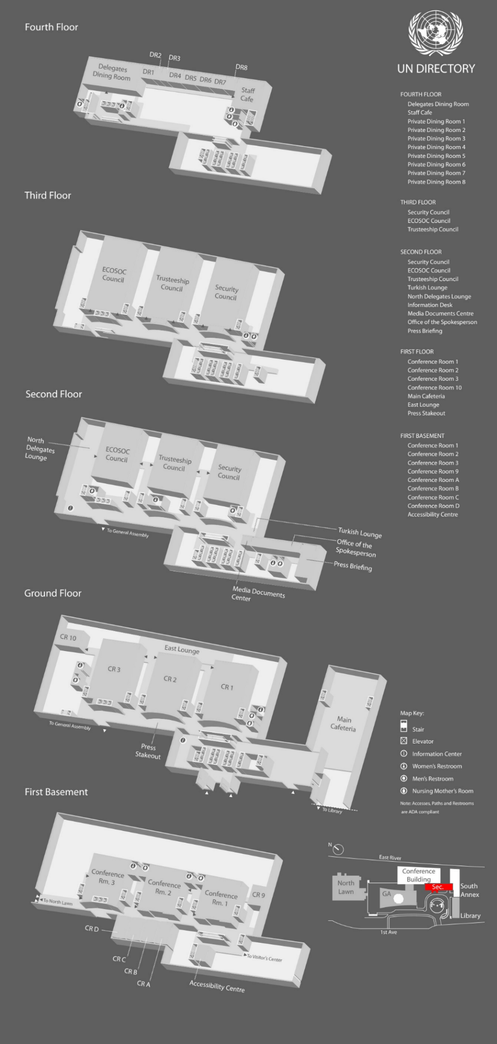

Source: UN Statistics Division. https://ggim.un.org/meetings/GGIM-committee/9th-Session/documents/GA_Building_Layout.pdf

