Public administration as a driver of sustainability within Energy Communities

SUPPLEMENTARY MATERIAL

Table S1. String used in Scopus database
KEY ( energy AND communities ) OR KEY ( public AND administrations ) OR KEY ( public AND administration AND as AND driver AND for AND energy AND communities ) OR KEY ( driver AND for AND energy AND communities ) OR KEY ( energy AND driver ) AND PUBYEAR > 2018 AND PUBYEAR < 2025 AND ( LIMIT-TO ( OA,"all" ) OR LIMIT-TO ( OA,"publisherfullgold" ) OR LIMIT-TO ( OA,"publisherhybridgold" ) OR LIMIT-TO ( OA,"repository" ) ) AND ( LIMIT-TO ( PUBSTAGE,"final" ) ) AND ( LIMIT-TO ( AFFILCOUNTRY,"Italy" ) ) AND ( LIMIT-TO ( SUBJAREA,"ENGI" ) OR LIMIT-TO ( SUBJAREA,"ENVI" ) OR LIMIT-TO ( SUBJAREA,"ENER" ) OR LIMIT-TO ( SUBJAREA,"SOCI" ) ) AND ( LIMIT-TO ( DOCTYPE,"ar" ) OR LIMIT-TO ( DOCTYPE,"cp" ) OR LIMIT-TO ( DOCTYPE,"re" ) ) AND ( LIMIT-TO ( LANGUAGE,"English" ) OR LIMIT-TO ( LANGUAGE,"Italian" ) ) AND ( LIMIT-TO ( EXACTKEYWORD,"Public Administration" ) OR LIMIT-TO ( EXACTKEYWORD,"Energy Efficiency" ) OR LIMIT-TO ( EXACTKEYWORD,"Sustainable Development" ) OR LIMIT-TO ( EXACTKEYWORD,"Italy" ) )

Table S2. Sample analysis by age and gender
Gender | Percentage | Age | Percentage
Man | 48.7% | >25 | 49.7%
Woman | 51.3% | <25 | 50.3%
 | Number of participants |  | Number of participants
Woman under 25 | 81 | Man under 25 | 77
Woman over 25 | 80 | Man over 25 | 76

Figure S1. Trend of year of publication for selected articles
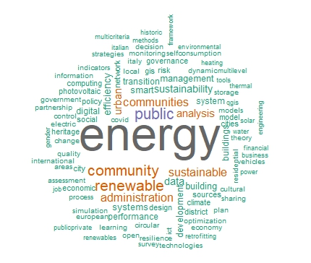
Figure S2. Word Cloud

