Appendix 1
Search Strings Used in Systematic Literature Review
Scopus | TITLE-ABS-KEY ( "climate litigation" OR "climate lawsuit*" OR "climate change litigation" OR "private climate*" ) AND TITLE-ABS-KEY ( "fossil fuel*" OR "oil*" OR "gas*" OR "coal*" OR "petrol*" OR "energ*" )
Lexis Nexis | ("climate change litigation" OR "climate lawsuit*" OR "private climate litigation" OR ("private lawsuit*" AND "climate change")) AND ("fossil fuel compan*" OR "oil compan*" OR "gas compan*" OR "coal compan*" OR "energy compan*") AND ("company" OR "companies" OR "corporation*" OR "business*")

Appendix 2
Attributes Identified per Court Cases and their Operationalisation
Plaintiff | Party bringing the case before the court.  - Plaintiff name  - Plaintiff composition  - Plaintiff country
Defendant | The fossil fuel company – or group thereof – being sued for the act mentioned by the plaintiff(s).  - Defendant name  - Defendant composition  - Defendant country
Year of Filing | Year of the official start of the judicial process
Legislative Body | Judicial body before which the case was brought
Country of Filing | Country in which the filing of the court case has occurred (headquarter location/country of establishment was used in cases of international organisations/tribunals)
Area of Jurisdiction | Area over which the judicial body has competence
Subject | Object or act of contestation in the case
Case Category | Act violating a specific piece of legislation. The classification system of the Sabin Centre for Climate Change Law is used here for easy retrieval.
Principal Legislation | Main pieces of legislation from which the arguments were drawn. The pieces of legislation indicated in the Sabin Centre for Climate Change Law were used here
Plaintiff Arguments | Main reason(s) for bringing the case before the judicial body.  - Short summary of arguments by plaintiff  - Plaintiff argument category
Defendant Arguments | Main arguments used in defence by fossil fuel company.  - Short summary of arguments by defendant  - Defendant argument category
Requests | Remedies/actions requested by plaintiff
Outcome | Decision made by the court.  - Outcome  - Won = (Majority of) Arguments by plaintiffs were accepted  - Lost = (Majority of) Arguments by plaintiffs were rejected  - Pending = No final decision  - Dismissed = Dismissed by court on specified grounds  - Settled = Agreement between parties without judicial oversight  - Consent Decree = Agreement between parties with judicial oversight and enforcement  - Short summary of judge decision  - Decision category
Notes | Any specific and important details about the case

Appendix 3
Example from Case Study Database
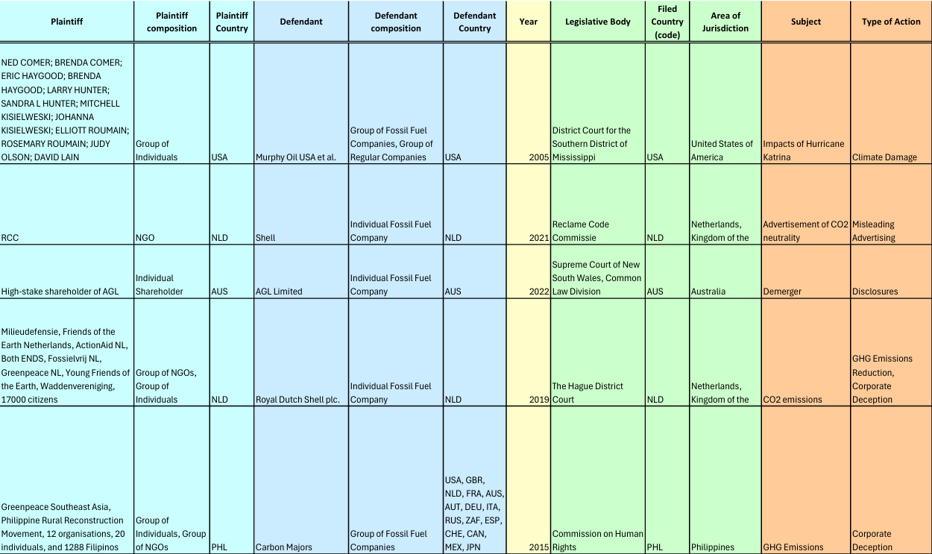
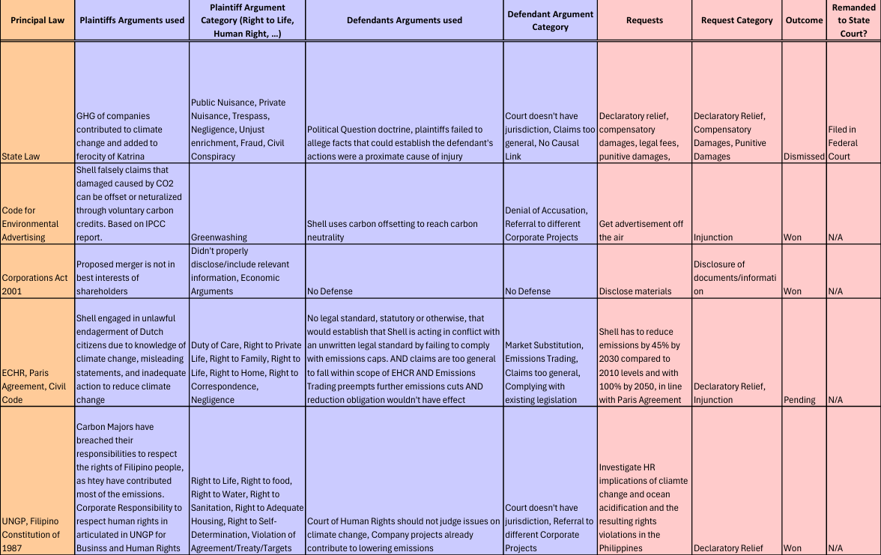
(continued)

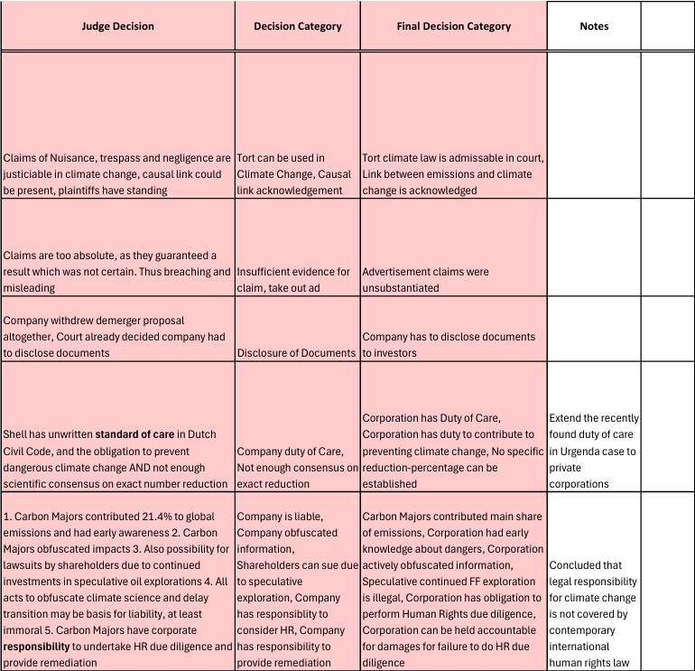
(continued)
N.B.: Any columns shown in this database extract that are not listed in Appendix 2 have solely been created and used for data processing purposes

Appendix 4
Categorization of Plaintiff Arguments
Moral Norm Violation
  - Business Has Social Responsibility
  - Encouragement of Environmental Damage
  - Entrenching Dependency on FF
  - Sowing Distrust in Science
  - Influencing Political Processes
  - Endangerment of People
  - Emissions Abroad Should Be Taken into Account
Procedural Violation
  - Procedural Objection
  - No Proper EIA
  - No EIA
  - Lack of Authorization
  - Failure to Receive Right Permit
  - Retaliatory Arrest
  - False Detention, Arrest, and Imprisonment
Human-Rights Violation
  - Rights of Children
  - Right to a Dignified Life
  - Right to Adequate Housing
  - Right to Bodily Integrity
  - Right to Clean Air and a Healthy Environment
  - Right to Correspondence
  - Right to Culture
  - Right to Enjoy a Healthy and ecologically balanced Environment
  - Right to Enjoy a Stable Climate
  - Right to Food
  - Right to Free Expression
  - Right to Health
  - Right to Home
  - Right to Human Dignity
  - Right to Information
  - Right to Land and Territory
  - Right to Life
  - Right to Private Life
  - Right to Safety
  - Right to Sanitation
  - Right to Self-Determination
  - Right to the Highest Attainable Standard of Physical and Mental Health
  - Right to Water
  - Rights of Nature
  - Right to Family
  - Right to a Peaceful Life
  - Right to Property
Specific Non-compliance
  - Violation of Religious Freedom Restoration Act
  - Violation of Paris Agreement/Climate Targets
  - Failure to Comply with Prior Rulings
  - Violation of CAA
  - Violation of Agreement/Treaty/Targets
Tort Law Violation/Civil Liability
  - Trespass
  - Strict Liability
  - Statutory Nuisance
  - Public Nuisance
  - Private Nuisance
  - Nuisance Violation of Code
  - Negligence
  - Involuntary Manslaughter
  - Intentional Torts
  - Design Defect
  - Civil Conspiracy
  - Assault
  - Failure to Warn
  - Aiding and Abetting
Corporate Misconduct/Deception
  - Wrong Representation of Emissions
  - Unjust Enrichment
  - Unfair Competition
  - Misrepresentation of Facts
  - Lack of Transparency
  - Greenwashing
  - Fraud
  - Enrichment by Intervention
  - Didn’t Properly Disclose/Include Relevant Information
  - Deception or Unfair Acts
  - Breach of Good Faith
  - Breach of Fiduciary Duty
  - Breach of Contract
  - Failure to Set an Appropriate Emissions Target
  - Failure of the Strategy to Manage Climate Risk
  - Economic Arguments
  - Carbon Grabbing
Environmental Damage & Harm
  - Damaging Biodiversity
  - Neglecting to Address Disaster
  - Impairment of Public Trust Resources
  - Water Pollution
Legal Duty Violation
  - Duty of Environmental Vigilance
  - Duty to Cease Contributing to Climate Change
  - Duty of Vigilance
  - Duty of Care
Other Violation
  - Referral to Different Case
  - Pollution is Excluded from Coverage
  - Legal Procedural Objection

