Table S1 Molecular docking results.
compound | Affinity (kcal/mol) | CNN affinity | CNN pose score
Alpha-synuclein (α-syn Ser129)
Berberine (BBR) | -5.11 | 4.31 | 0.53
Caffeine (CAF) | -3.26 | 3.07 | 0.72
Metformin (MTF) | -3.23 | 2.69 | 0.68
Polo-like kinase (PLK)
BBR | -8.49 | 6.34 | 0.30
CAF | -5.90 | 4.96 | 0.93
MTF | -3.87 | 3.61 | 0.61
co-crystal ligand | -8.58 | 7.36 | 0.97
Casein kinase 2 (CK2)
BBR | -9.09 | 6.84 | 0.77
CAF | -5.78 | 5.26 | 0.95
MTF | -4.29 | 3.84 | 0.63
co-crystal ligand | -10.19 | 8.10 | 0.99
G protein-coupled receptor kinase (GRK)
BBR | -11.06 | 6.91 | 0.70
CAF | -6.44 | 5.12 | 0.78
MTF | -5.02 | 3.35 | 0.37
co-crystal ligand | -8.85 | 5.53 | 0.46

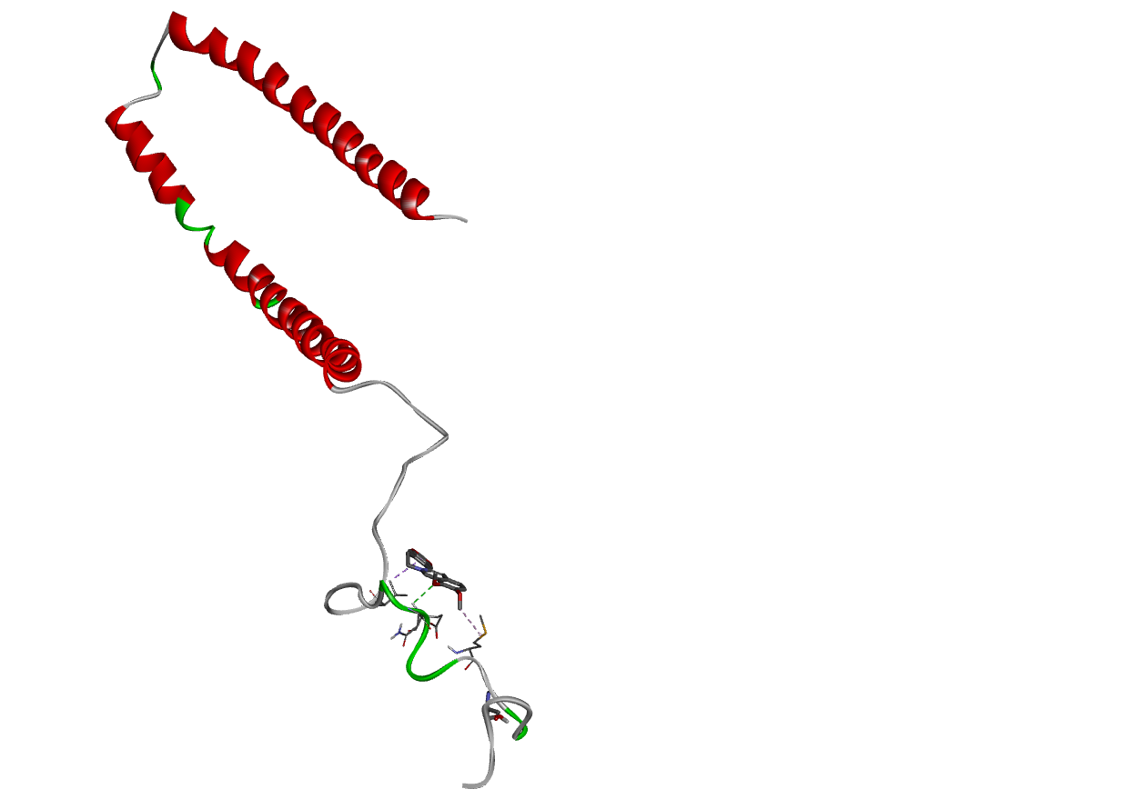 |  | 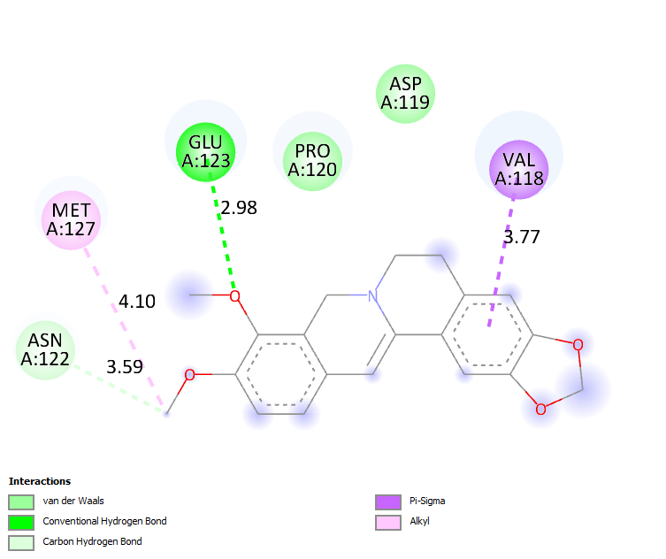
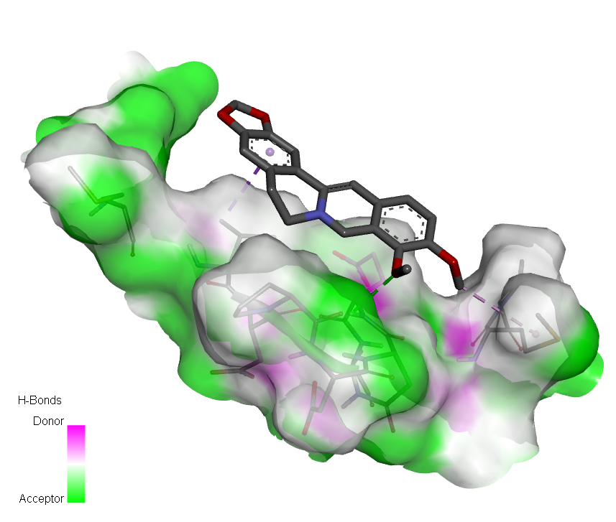
(A)
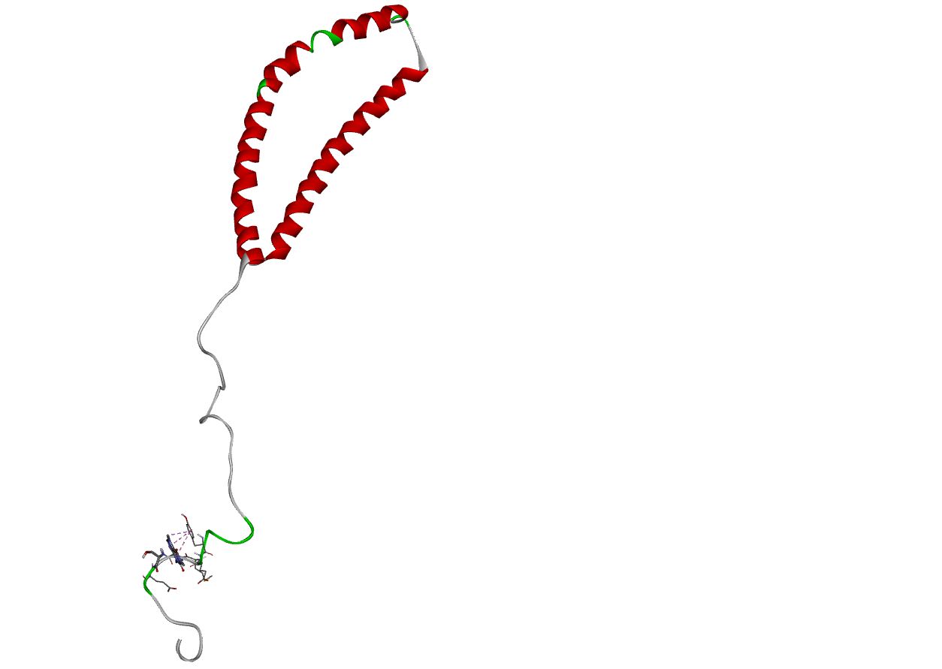 |  |  | 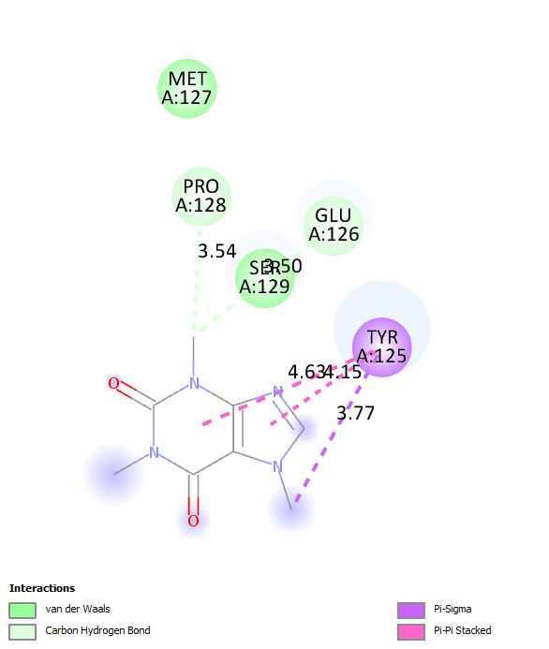
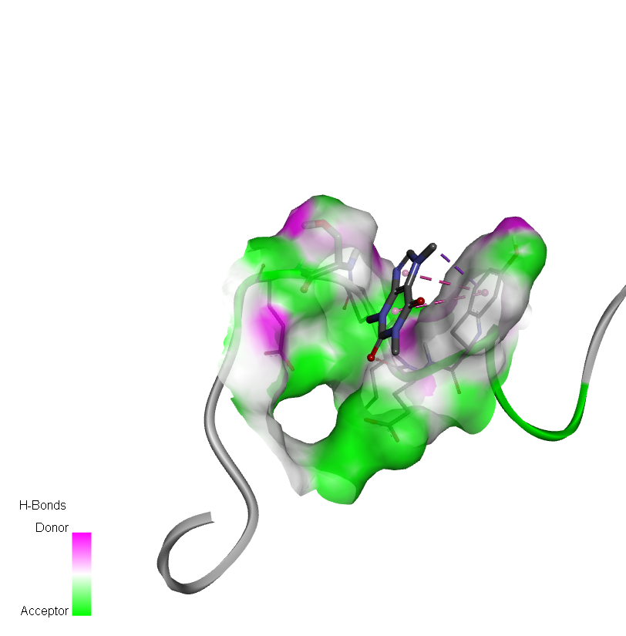
(B)
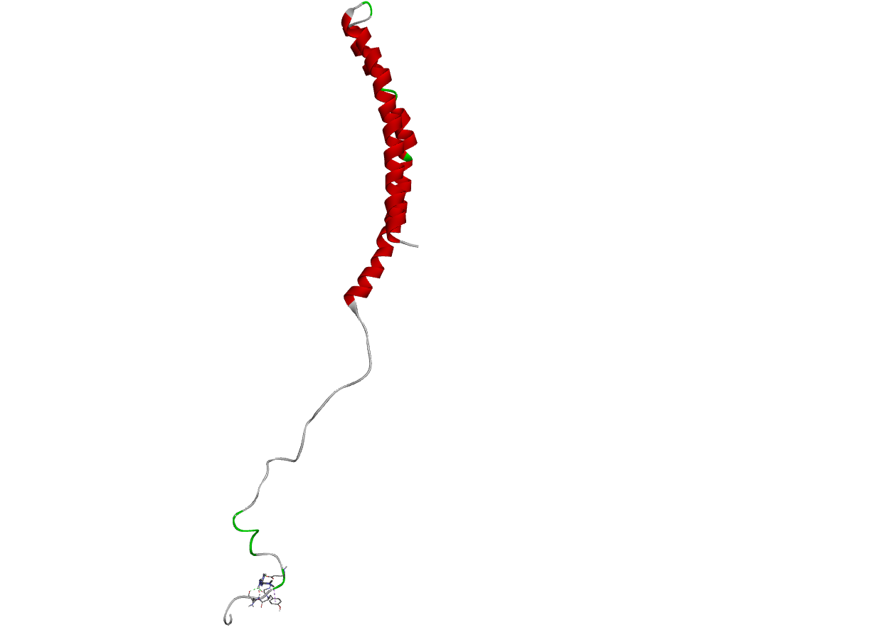 | 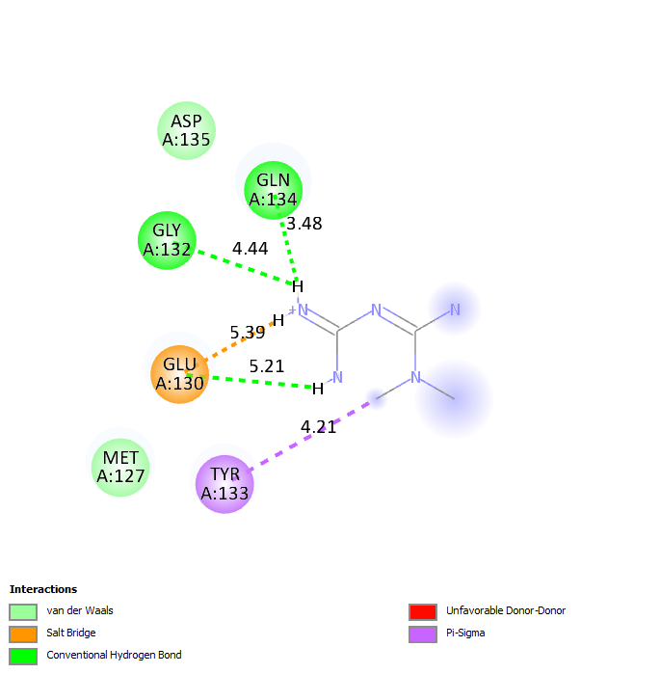
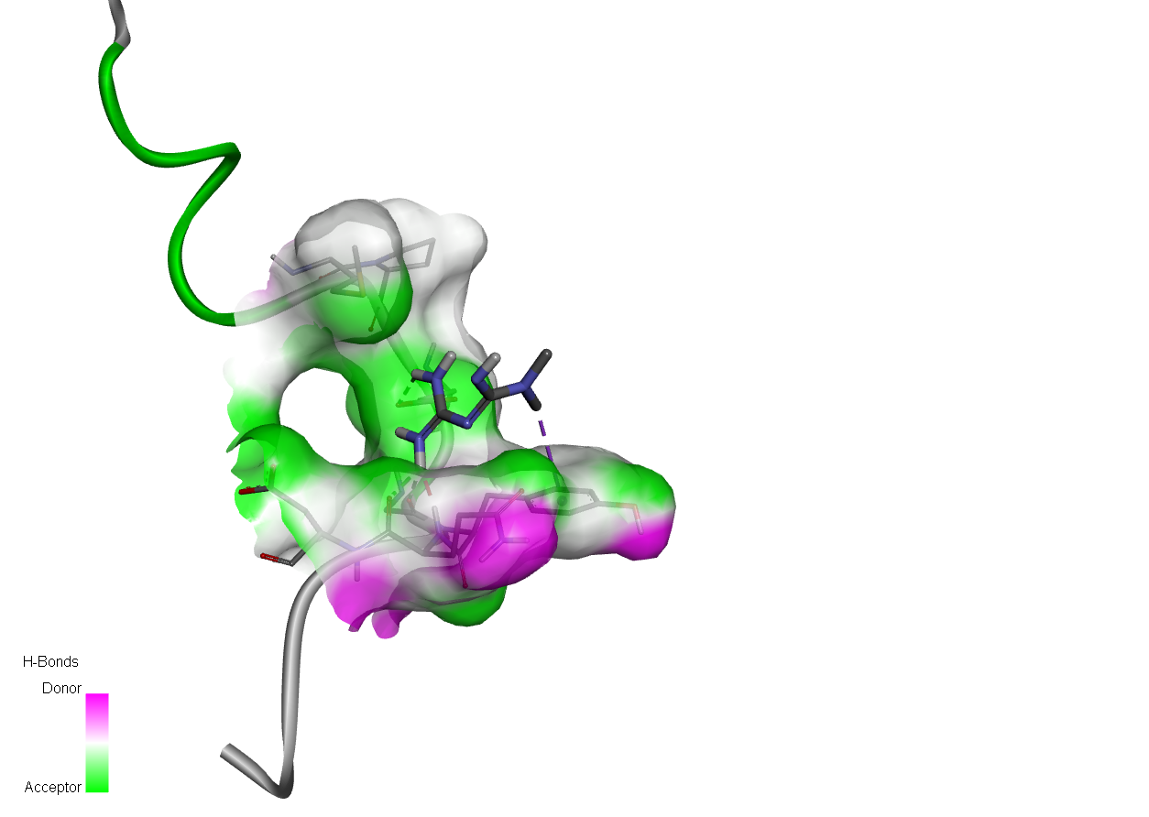
(C)
Fig. 1 Docking analysis against α-syn Ser129. (A) Docking of BBR with α-syn with the grid box being set at residue Ser129 and Blind docking of BBR with α-syn showing the generated nine poses (with affinities around -3.67 kcal/mol) none of them bound to Ser129 residue, (B) Docking of CAF with α-syn with the grid box being set at residue Ser129 and Blind docking of CAF with α-syn showing the generated nine poses (with affinities around -3.67 kcal/mol) none of them bound to Ser129 residue and (C) Docking of MTF with α-syn with the grid box being set at residue Ser129.
 |  | 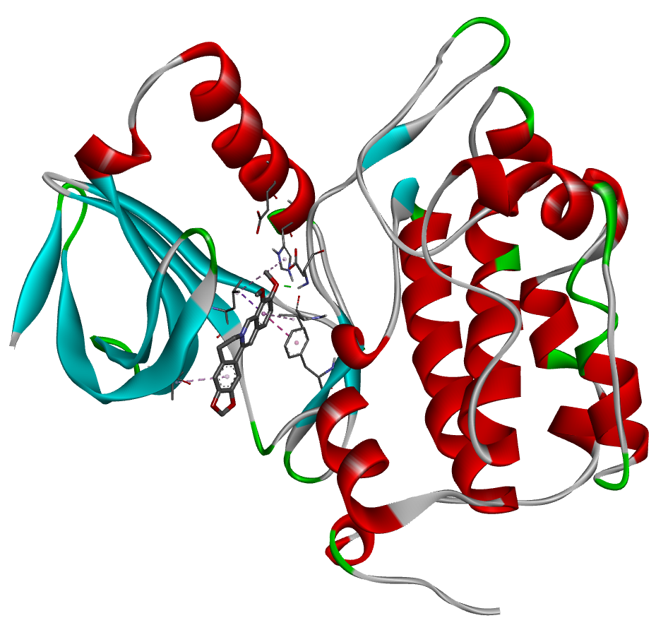 | 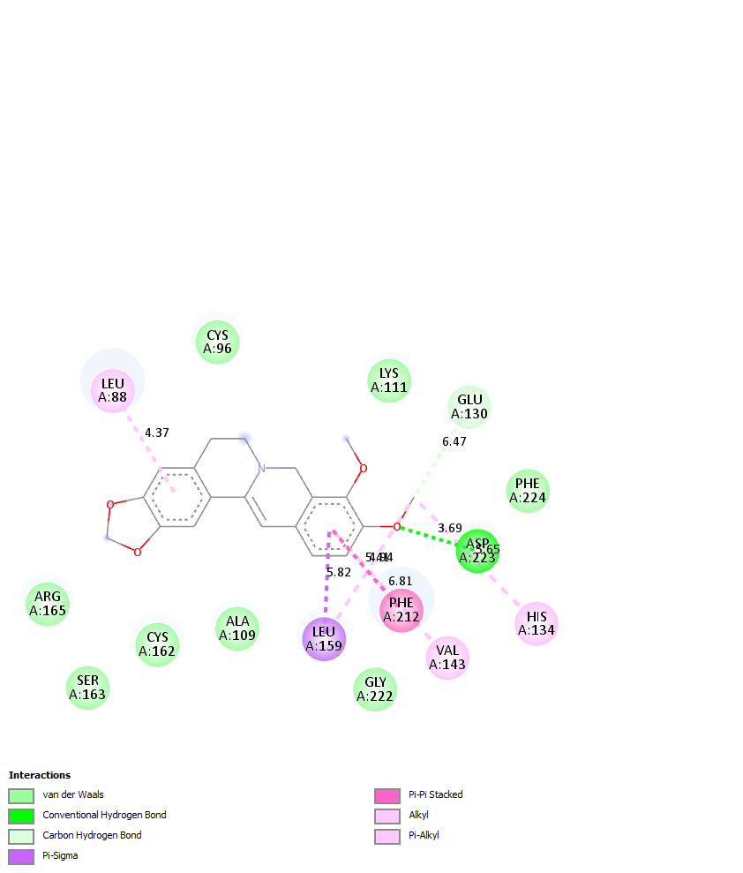
 |  | 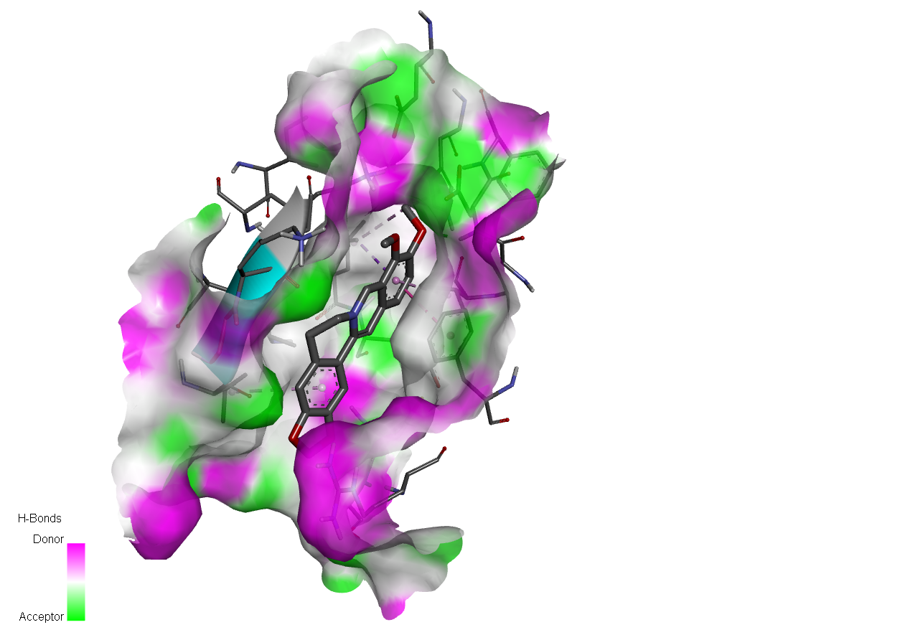
 |  | (A)
 | 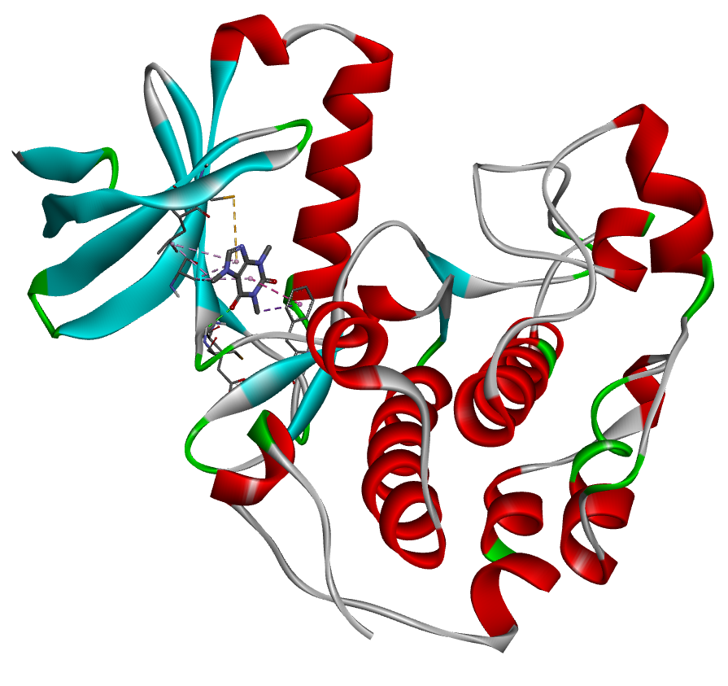 |  |  |  | 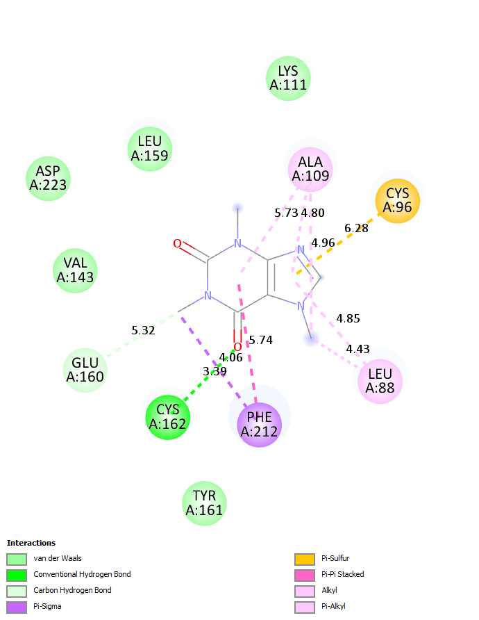
 | 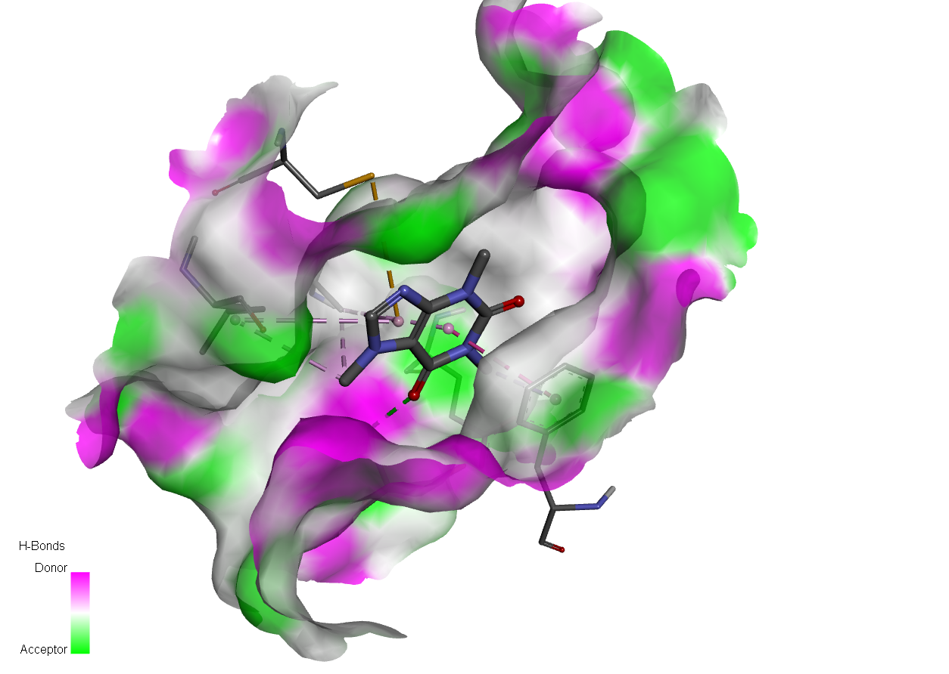
 | (B)
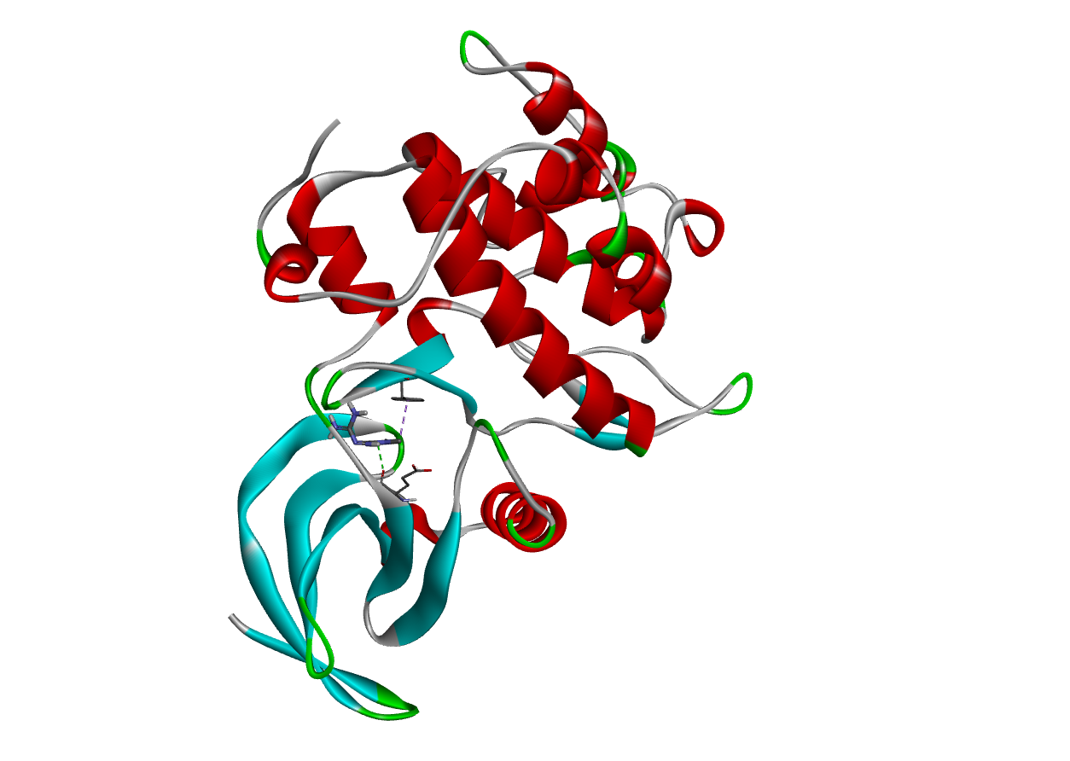 |  |  |  | 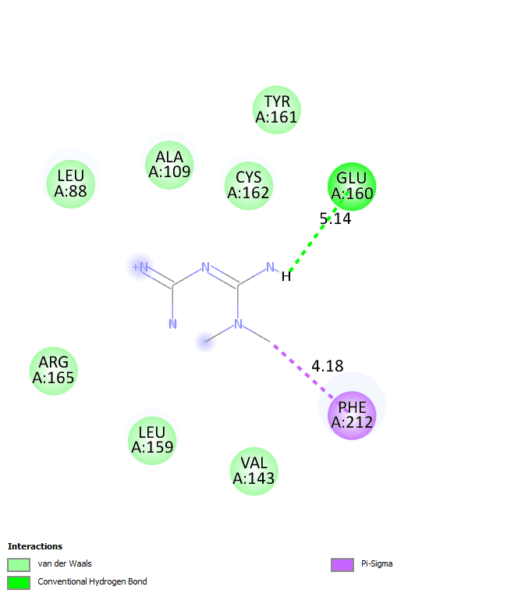
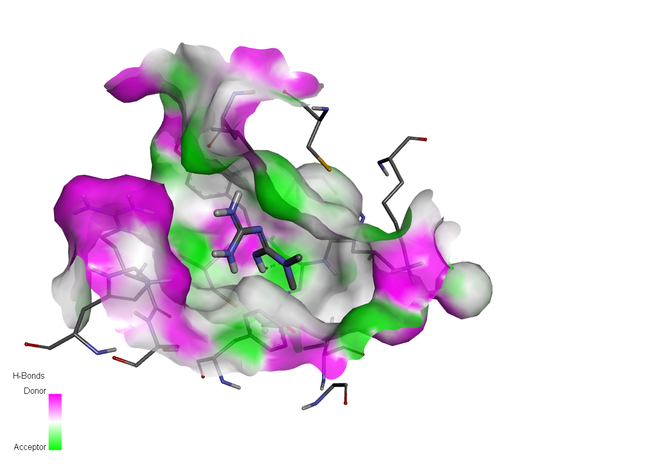
(C)
Fig. 2 Docking analysis against PLK. (A) Docking of BBR with PLK, (B) Docking of CAF with PLK and (C) Docking of MTF with PLK.
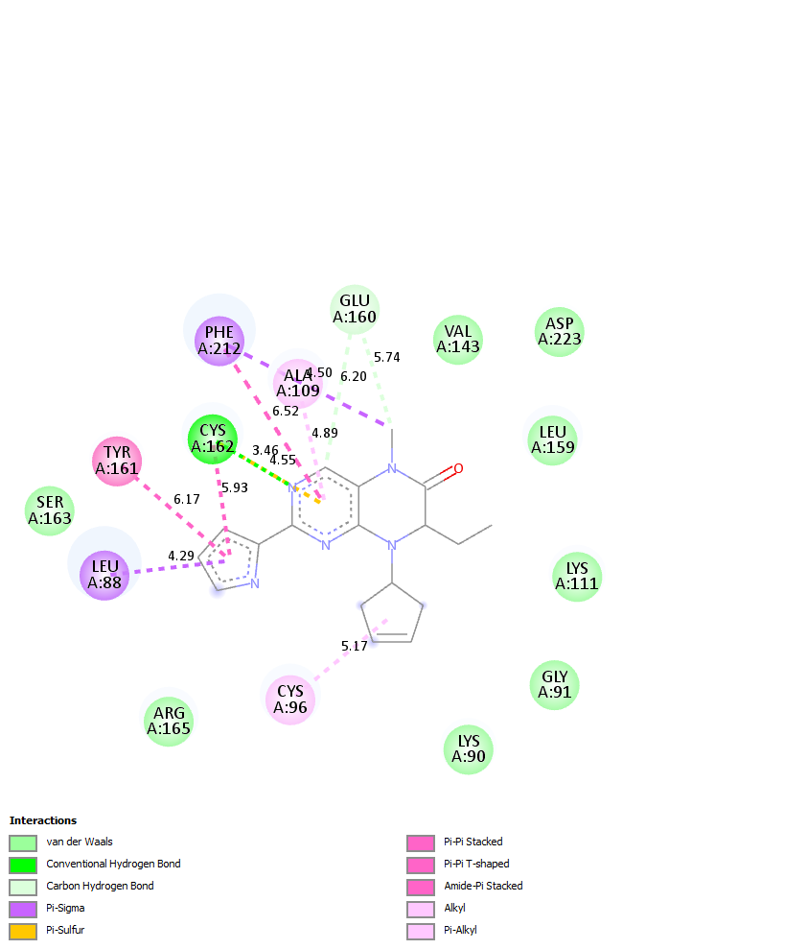
Fig. 3 Docking of the co-crystal ligand with PLK.

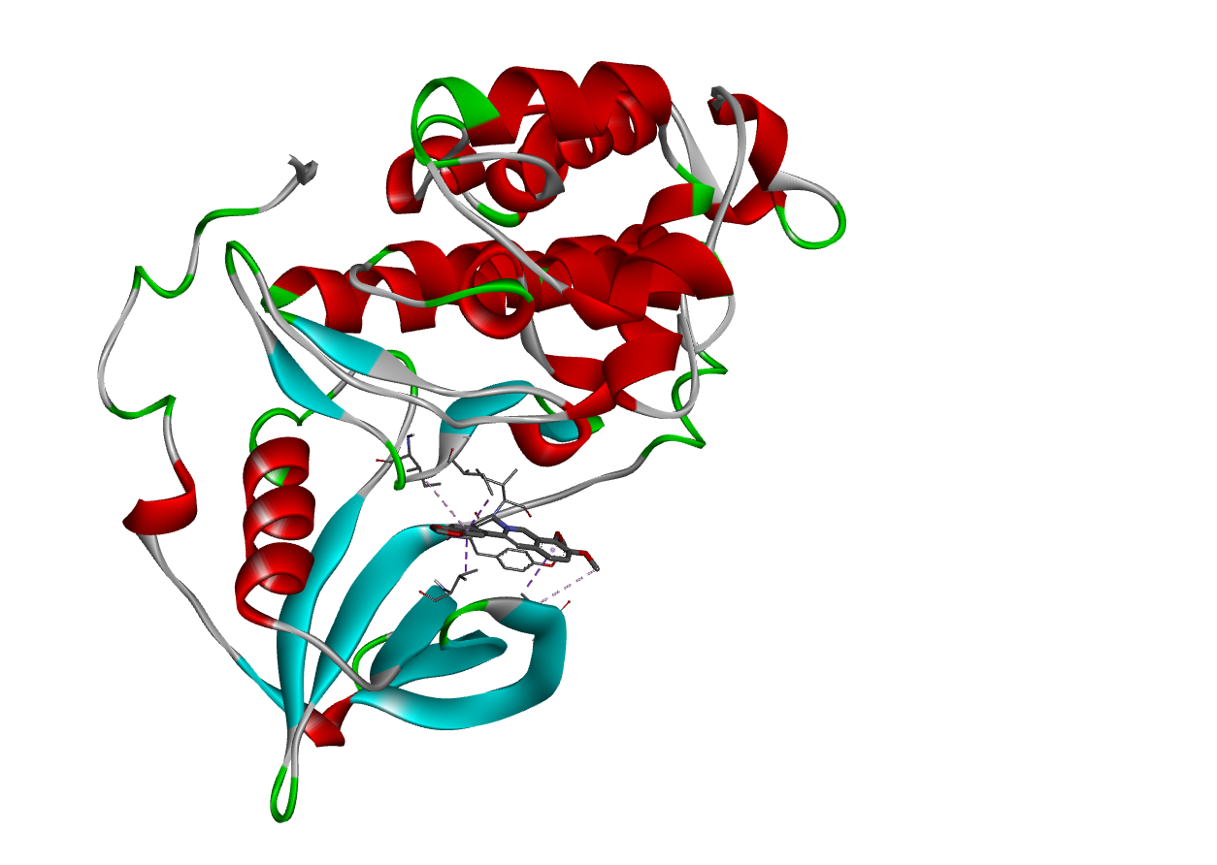 |  | 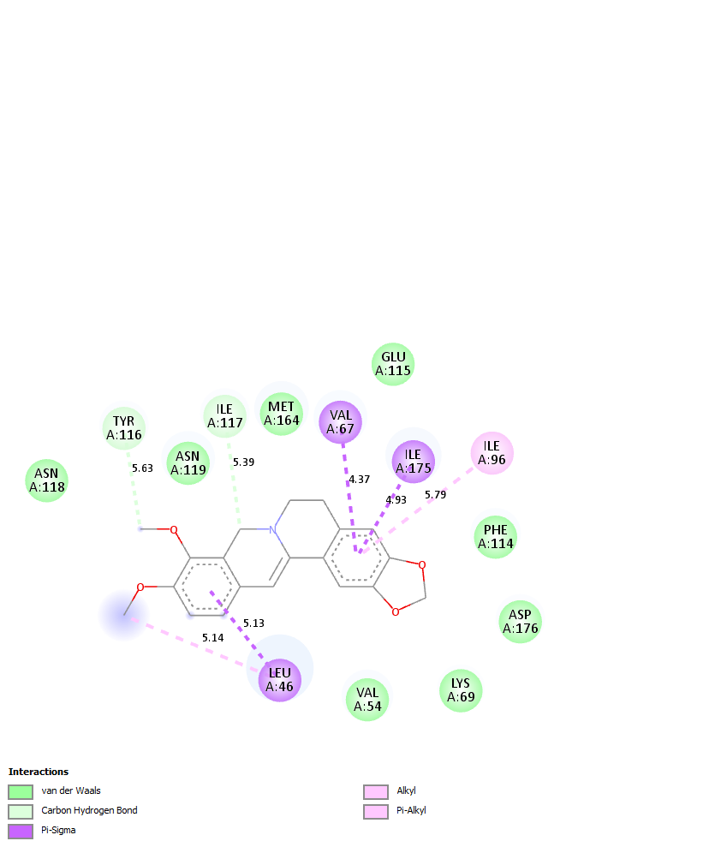
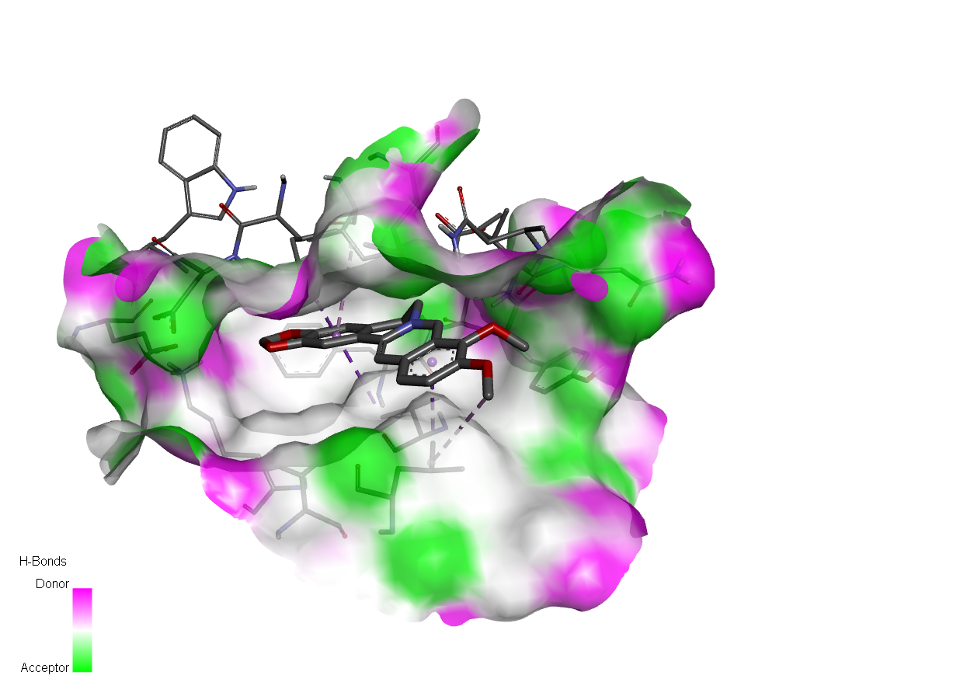
(A)
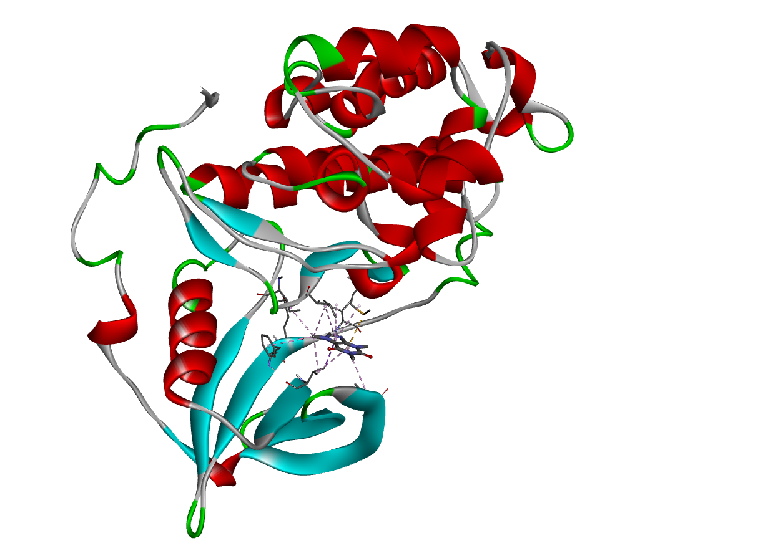 |  |  | 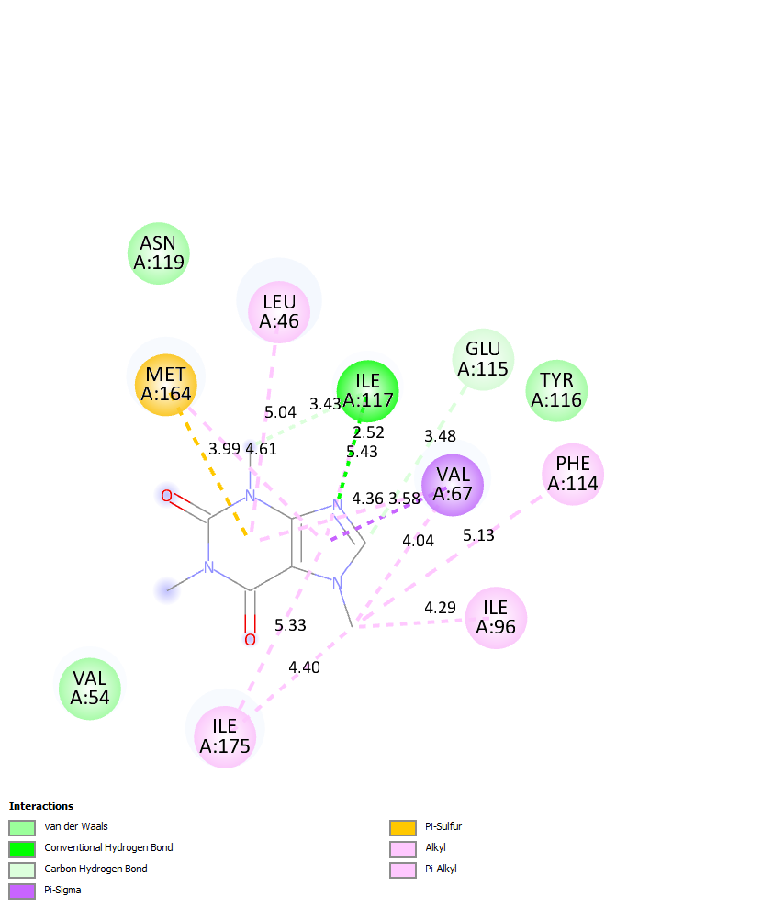
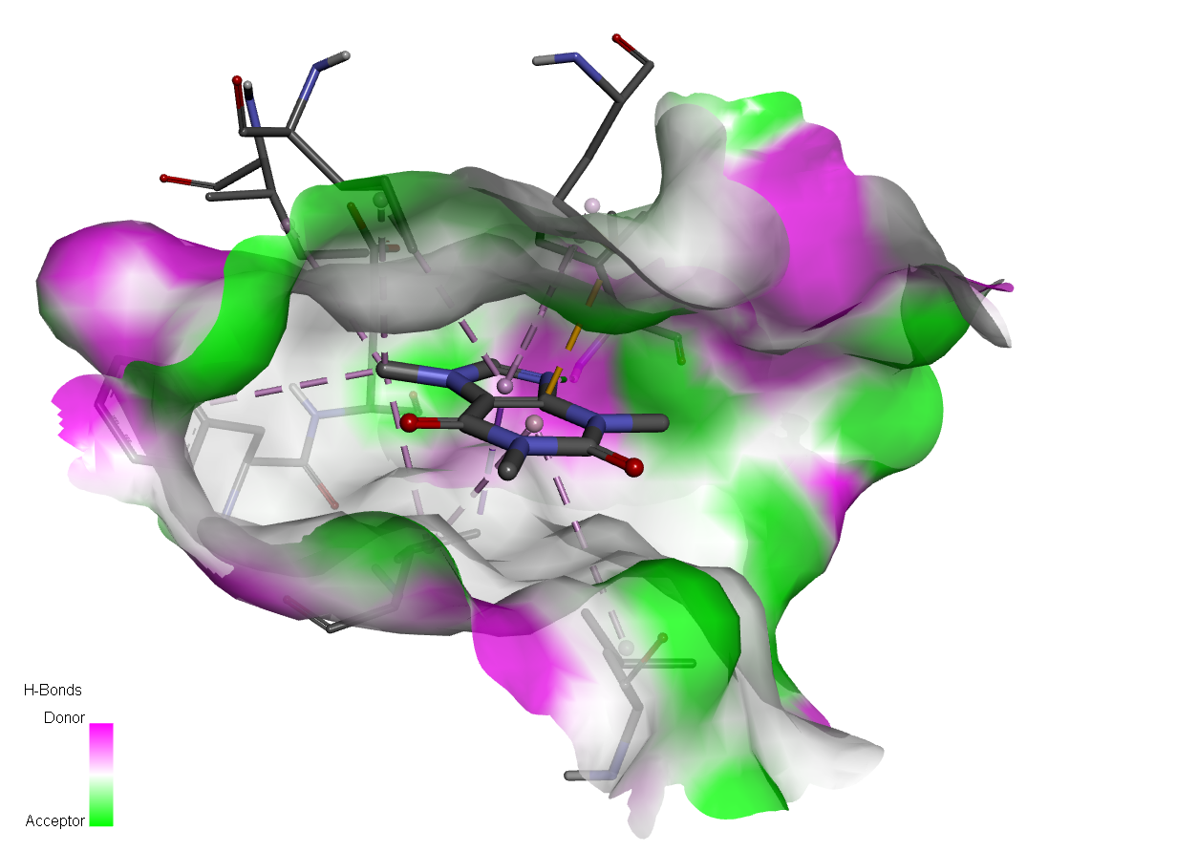
(B)
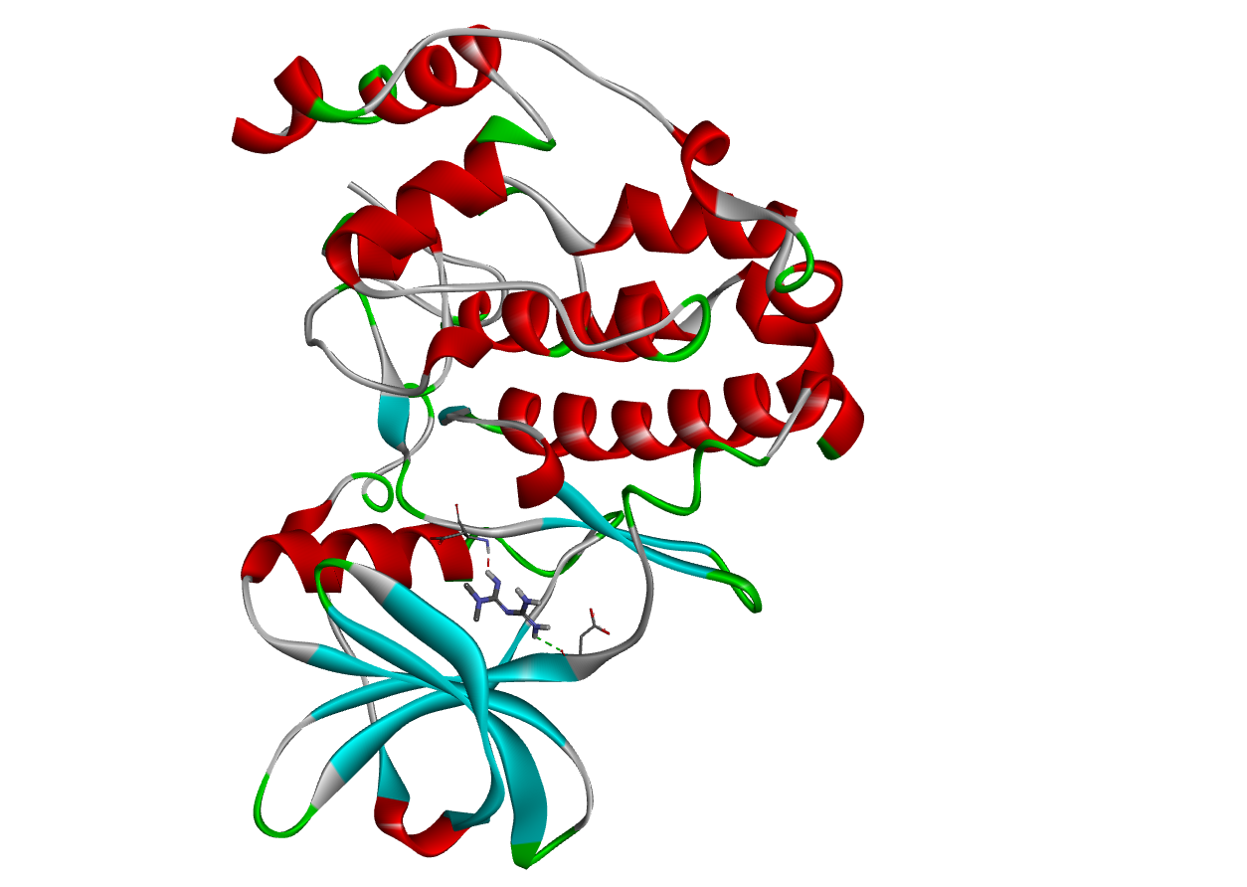 | 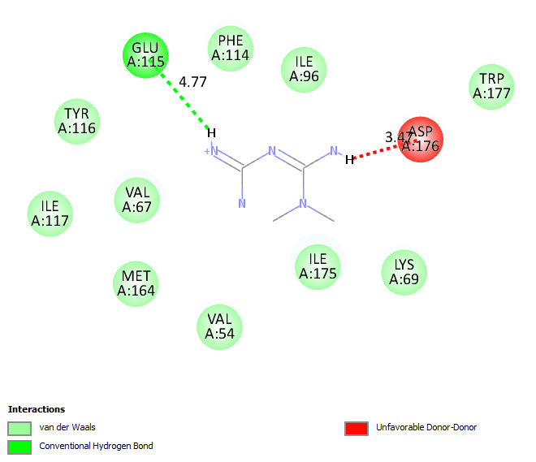
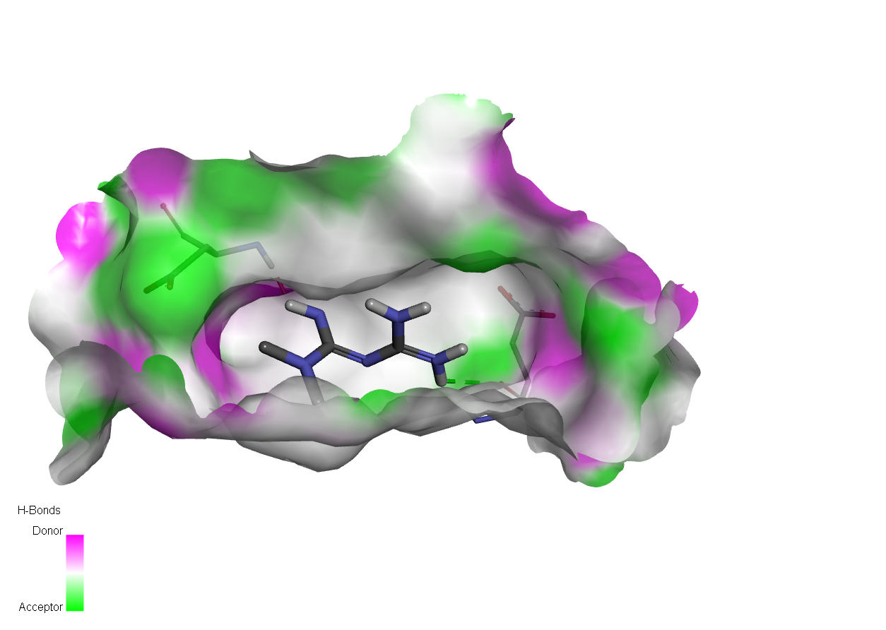
(C)
Fig. 4 Docking analysis against CK2. (A) Docking of BBR with CK2, (B) Docking of CAF with CK2 and (C) Docking of MTF with CK2.

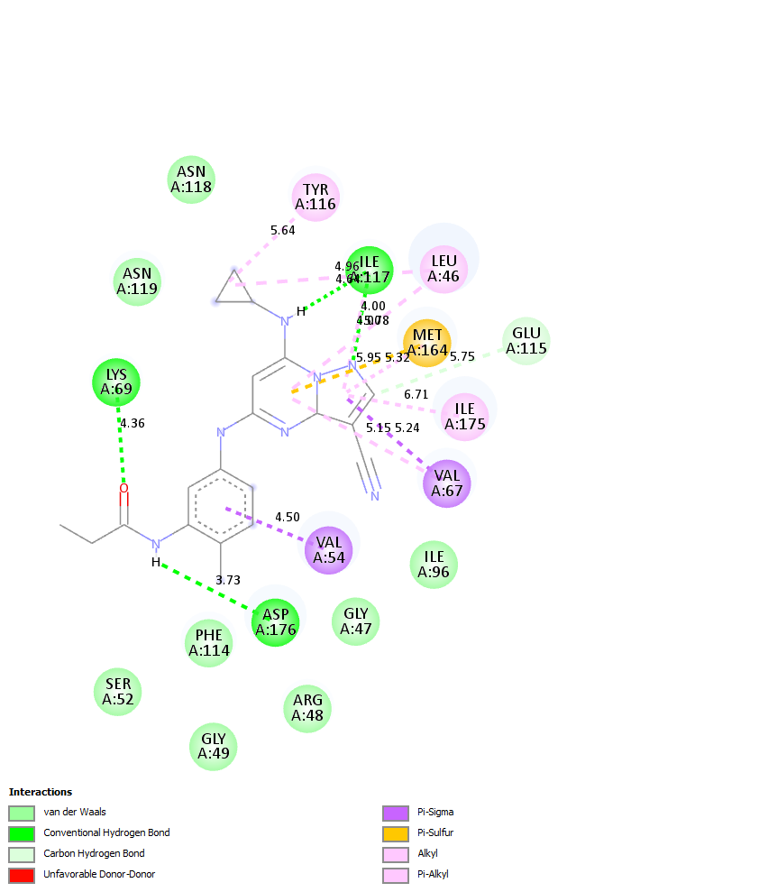
Fig. 5 Docking of the co-crystal ligand with CK2

 | 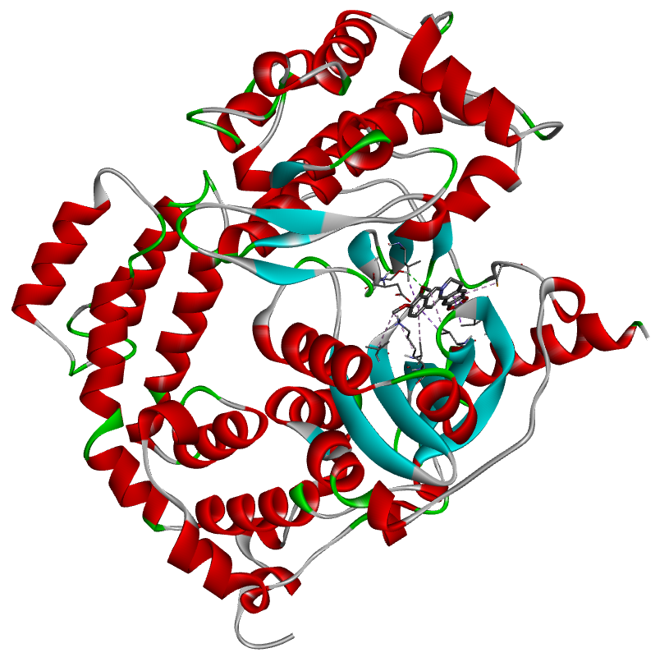 |  | 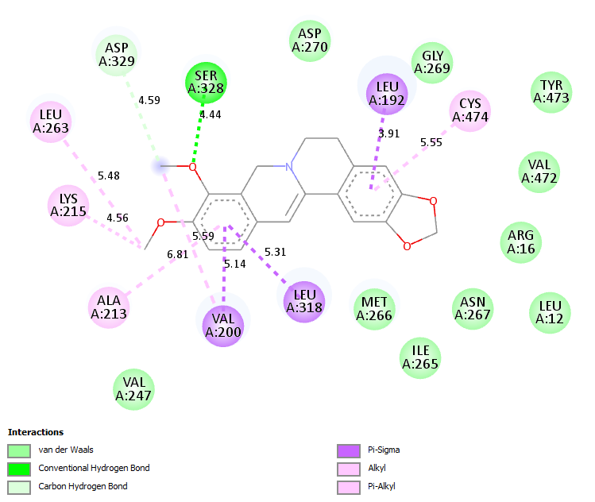
 | 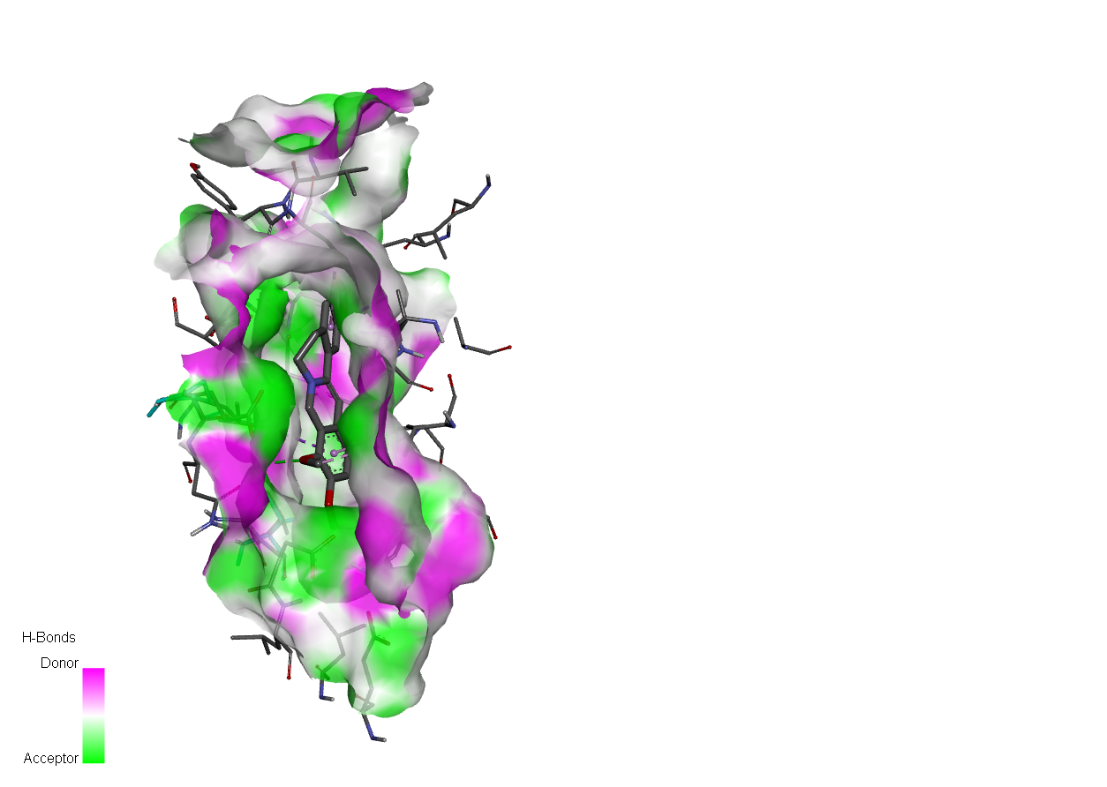
 | (A)
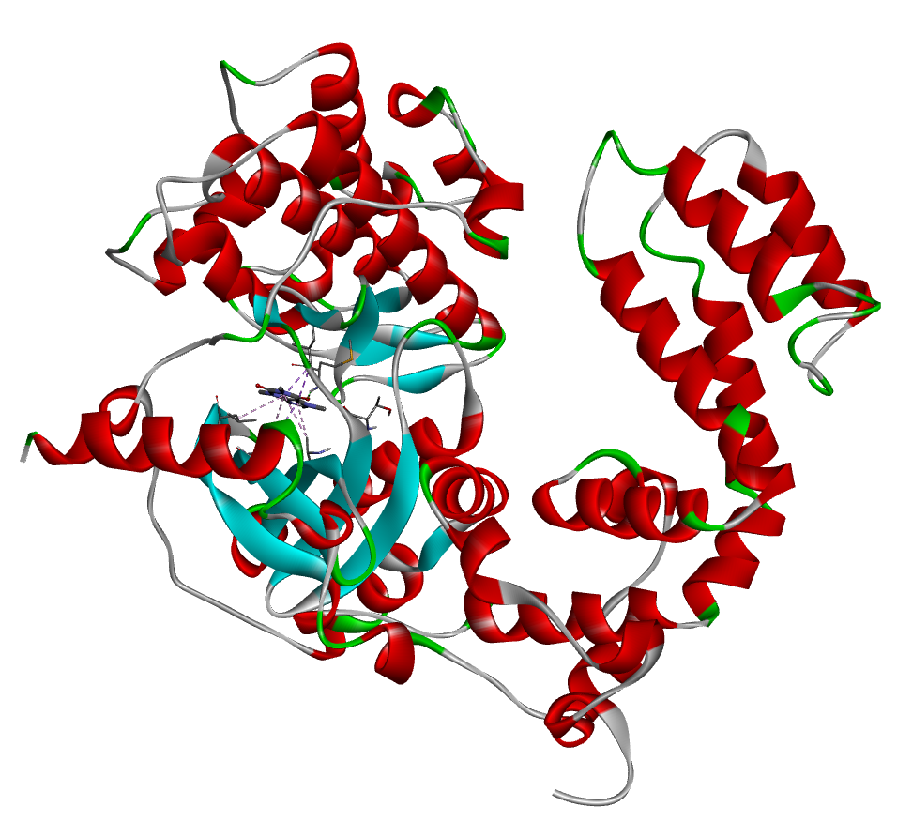 |  |  |  | 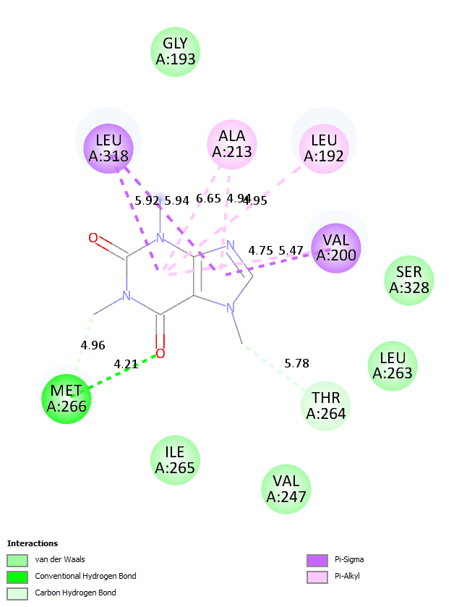
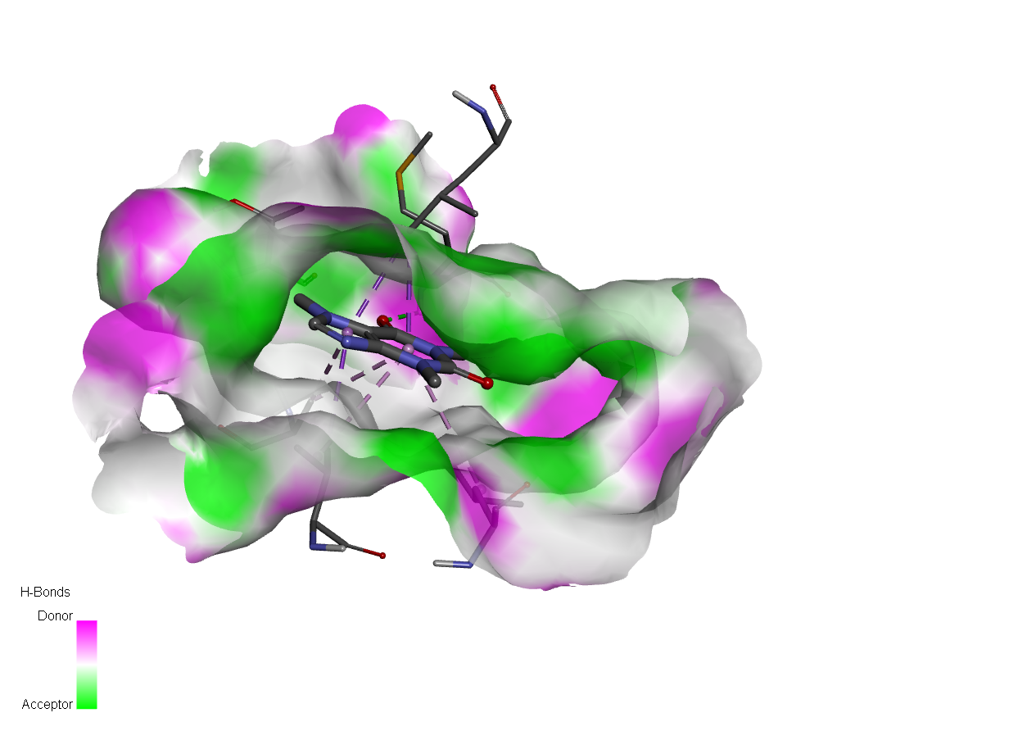
(B)
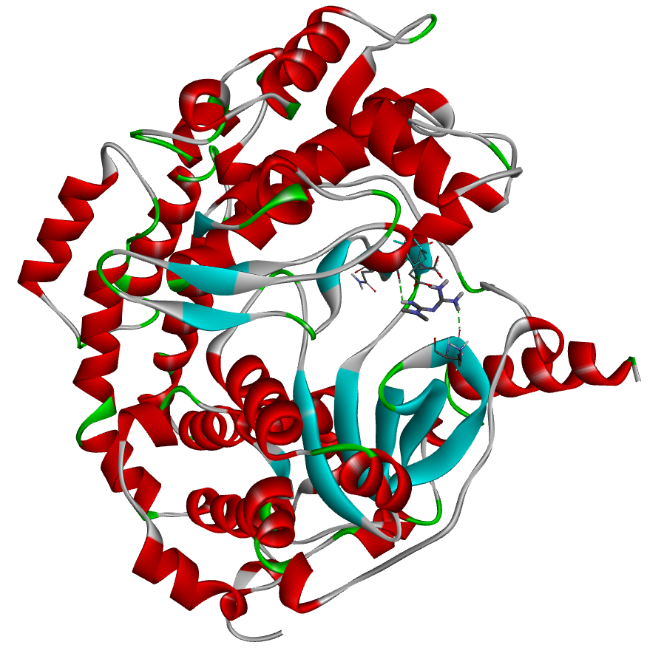 |  | 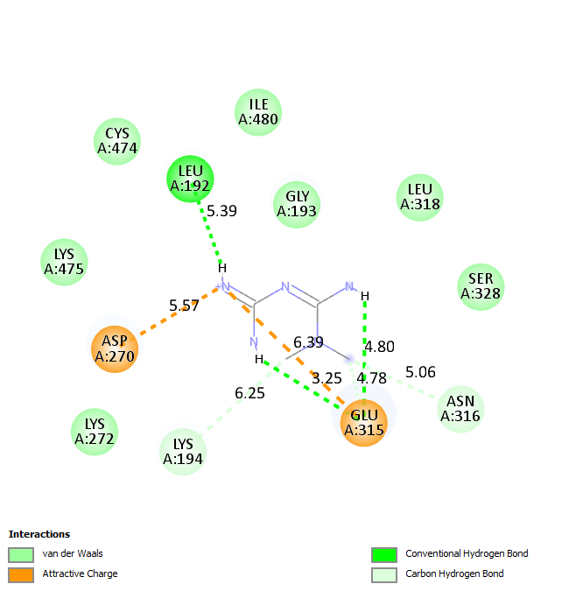
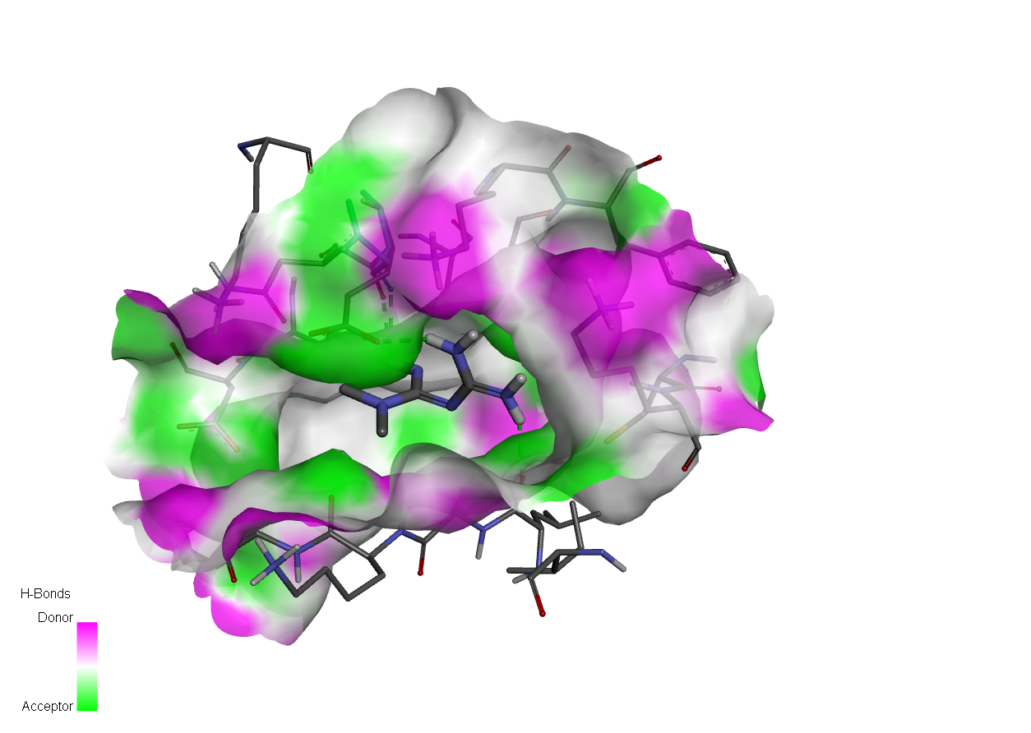
(C)
Fig. 6 Docking analysis against GRK. (A) Docking of BBR with GRK, (B) Docking of CAF with GRK and (C) Docking of MTF with GRK.
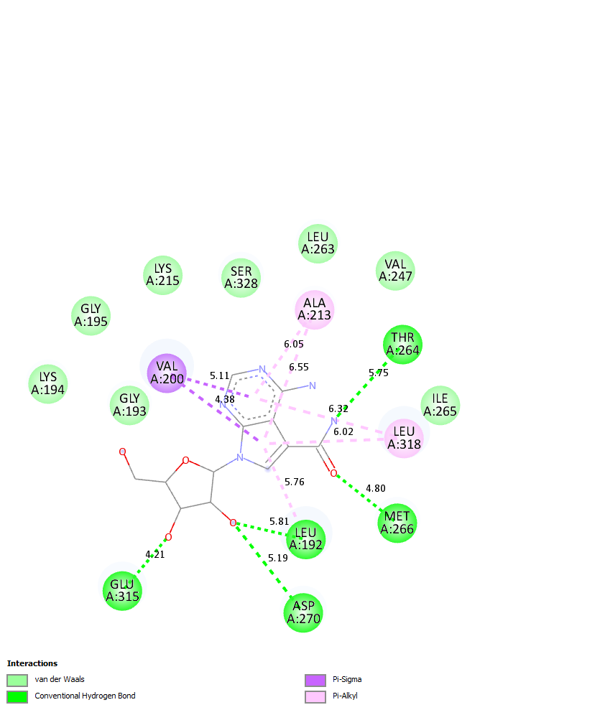
Fig. 7 Docking of the co-crystal ligand with GRK.

