Uncropped western blot gels

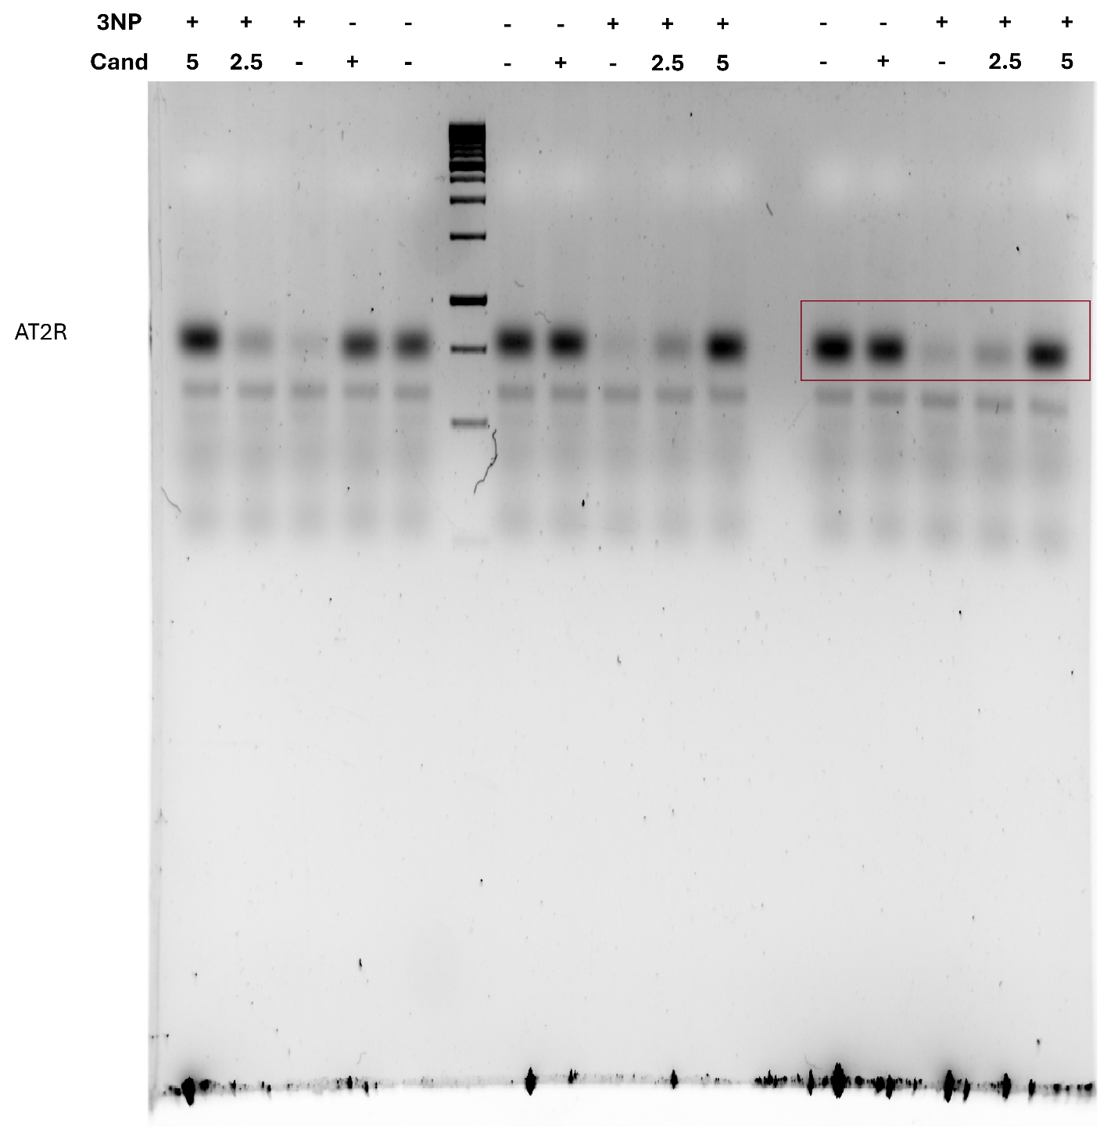
Figure 1 uncropped gel of AT2R
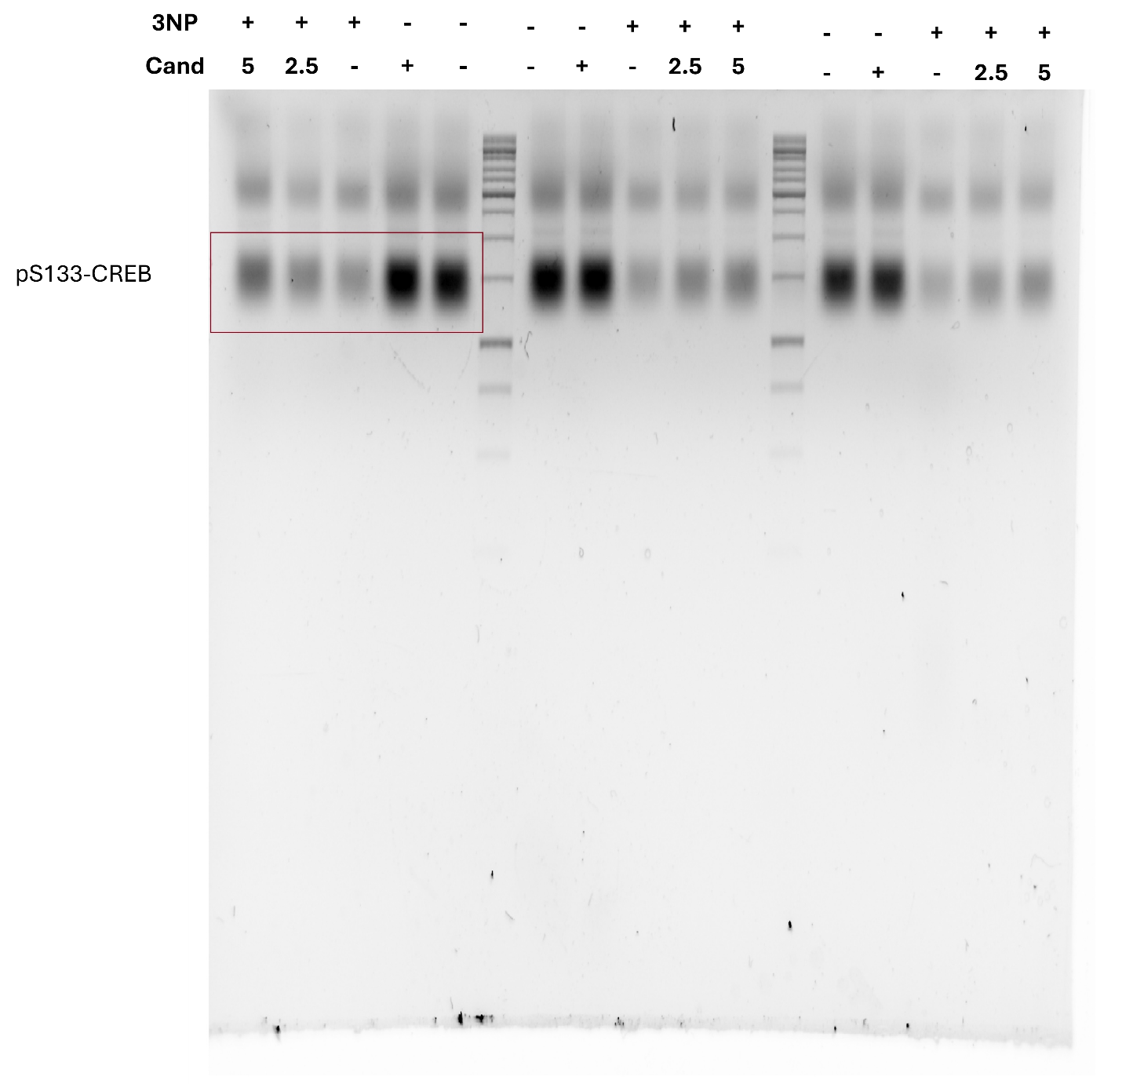
Figure 2 uncropped gel of pS133-CREB
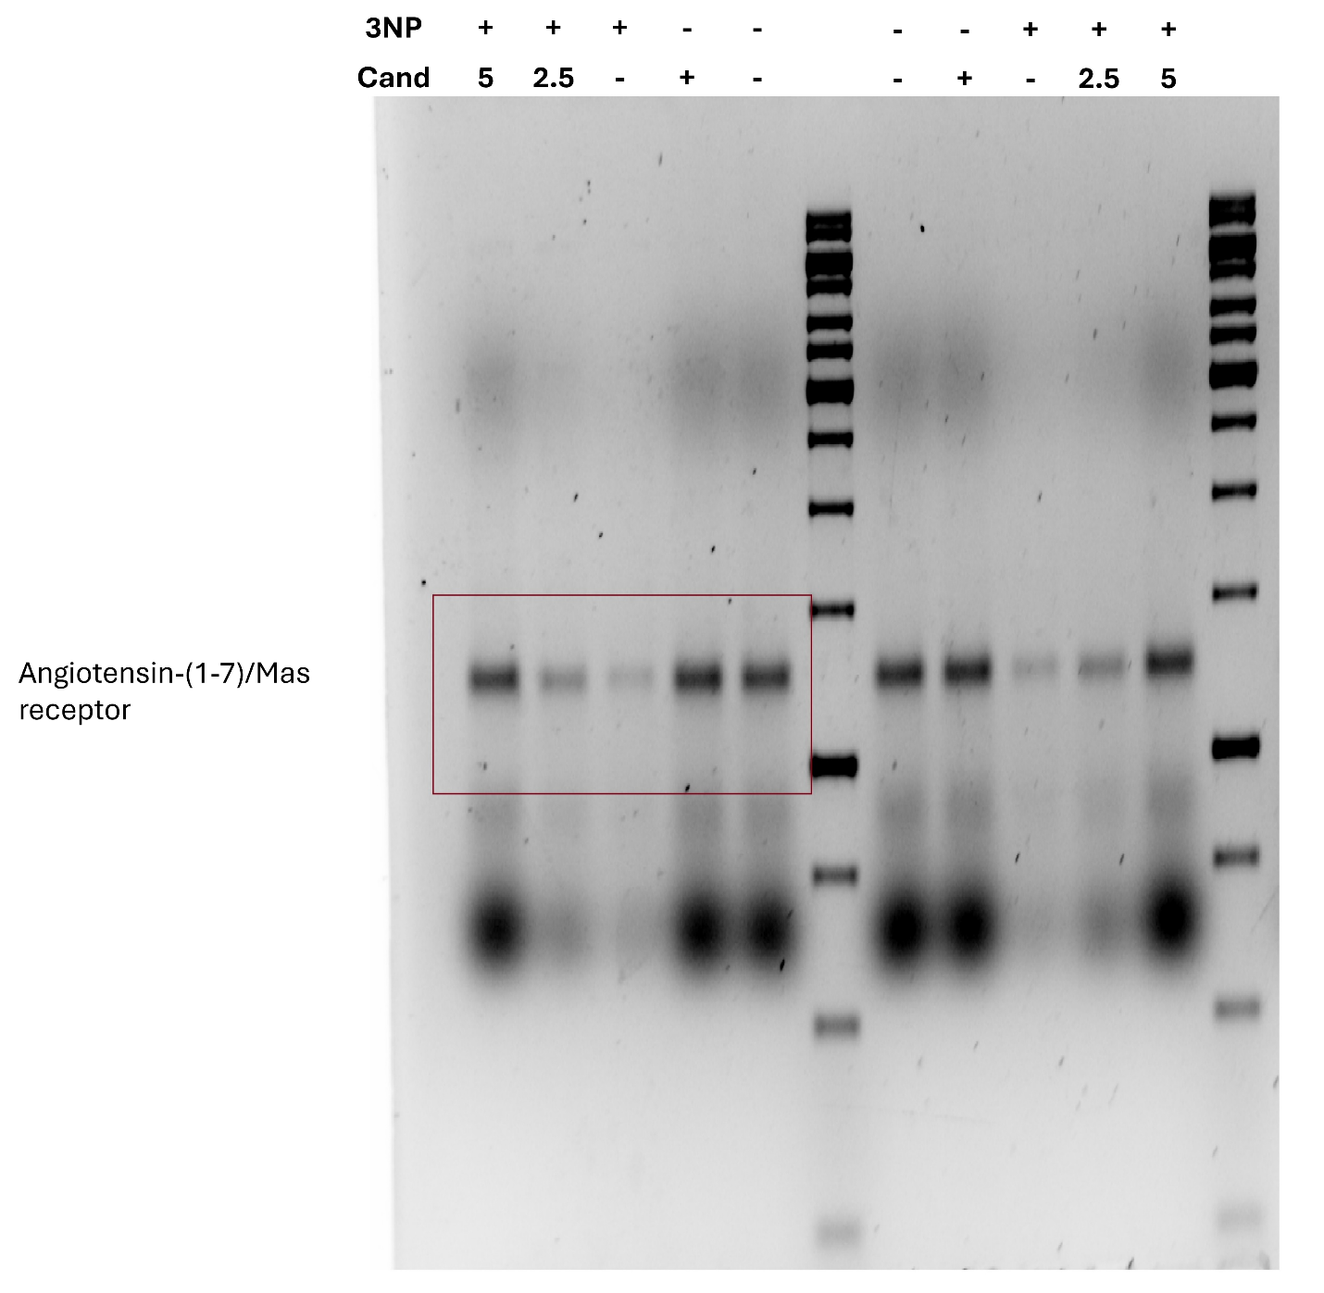
Figure 3 uncropped gel of Angiotensin-(1-7)/Mas receptor

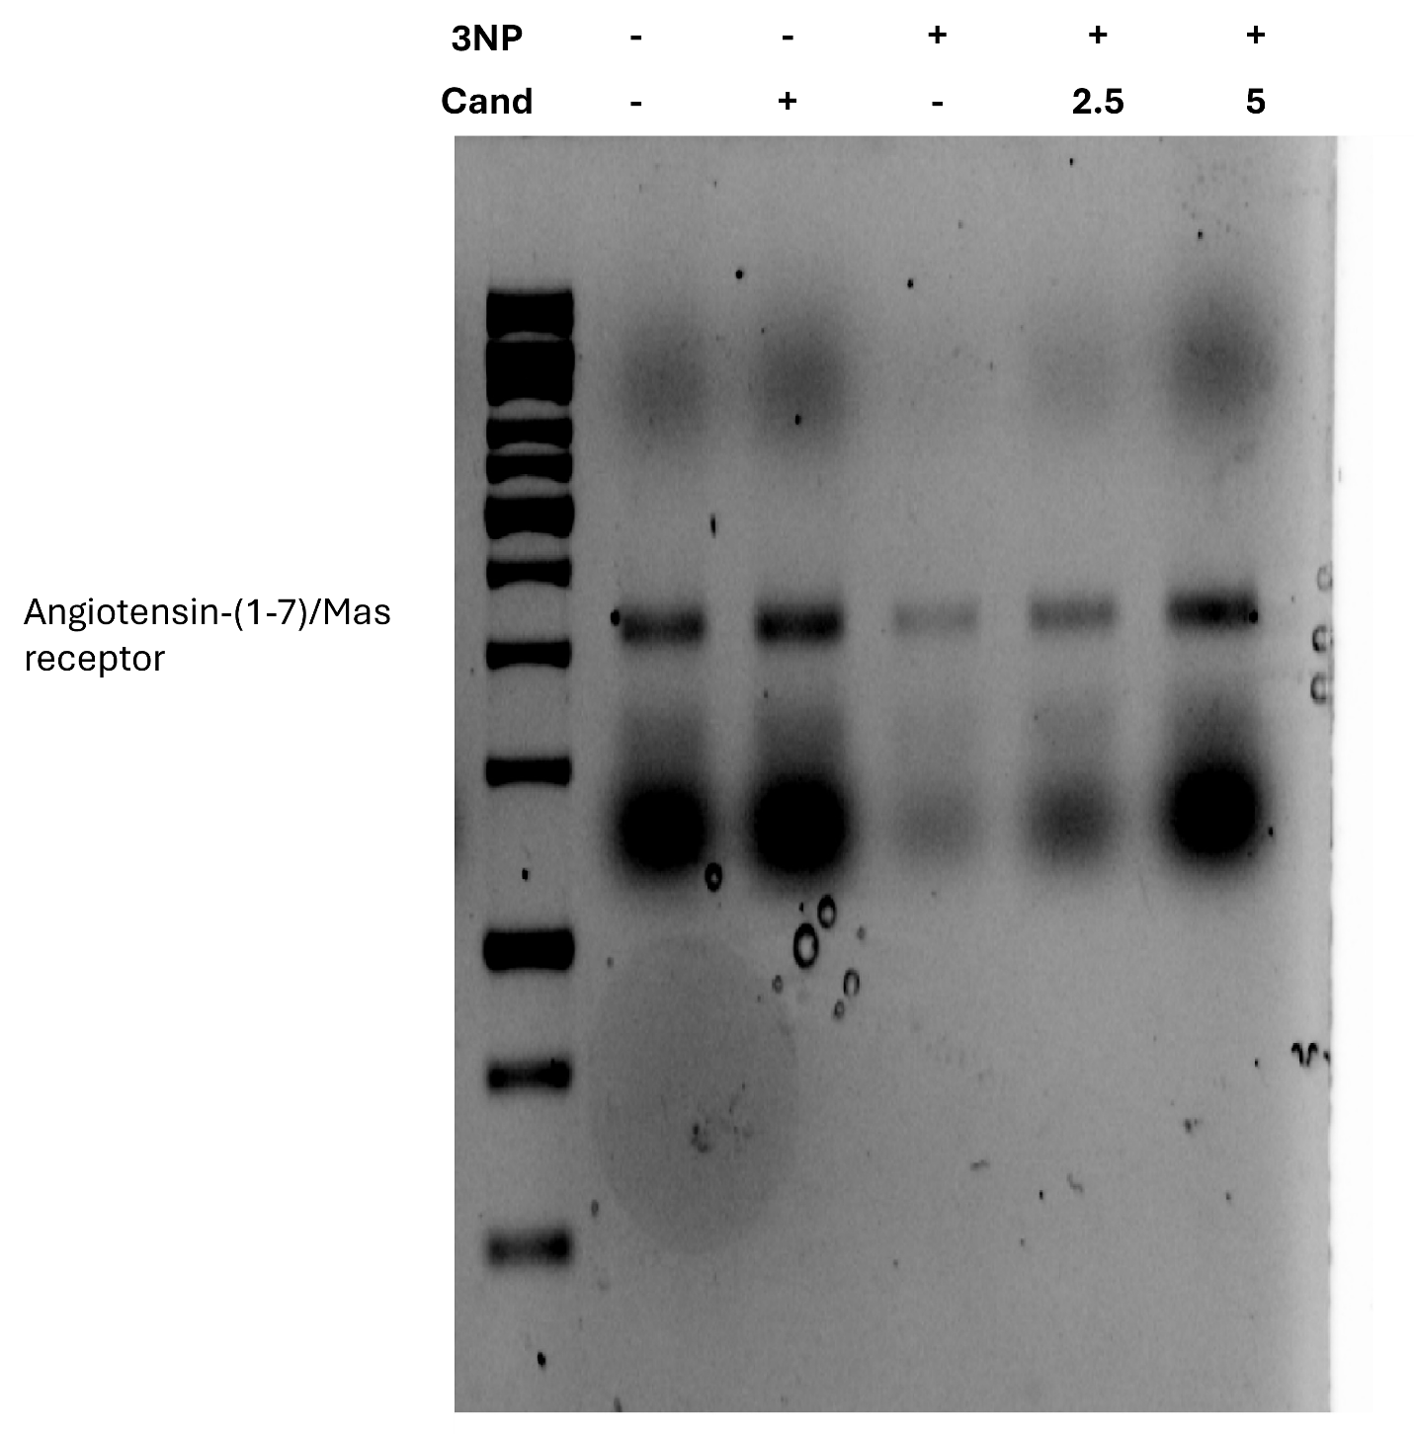
Figure 4 uncropped gel of Angiotensin-(1-7)/Mas receptor

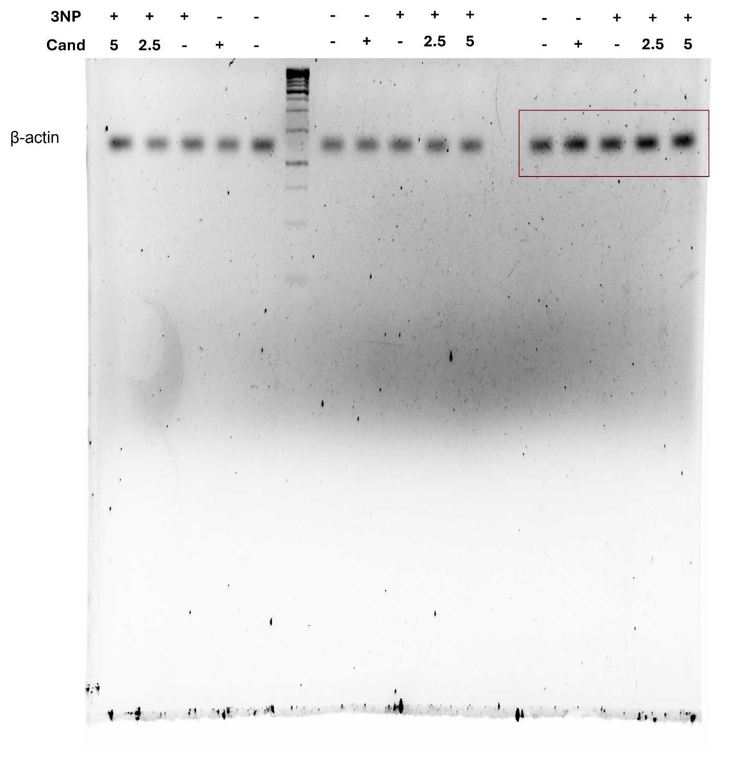
Figure 5 uncropped gel of β-actin

