Supplementary Data
Supplementary Figure 1. Cancer Specific Survival, and related Hazard Function
Supplementary table 1: Age and survival months in the groups
Supplementary table 2: Overall Survival Details, Log-Rank Test
Supplementary table 3: Life Tables analysis for Overall Survival
Supplementary table 4: Cancer-specific Survival Details, Log-Rank Test
Supplementary table 5: Life Tables analysis for Cancer-Specific Survival
Supplementary table 6: Details of Cox-Regression Model for overall survival.
Supplementary table 7: Details of Cox-Regression Model for Cancer-Specific survival.
Supplementary table 8: Details of Cox-Regression Model for Overall and Cancer-Specific survival with considering tumor size.

Supplementary Figure 1. Cancer Specific Survival- related Hazard Function
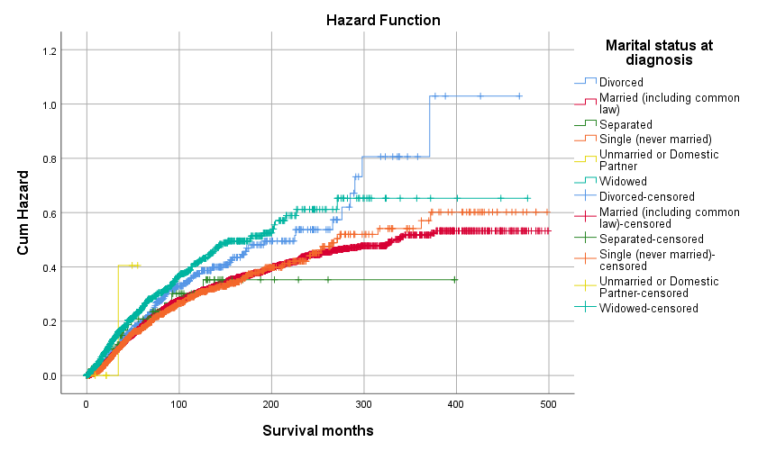
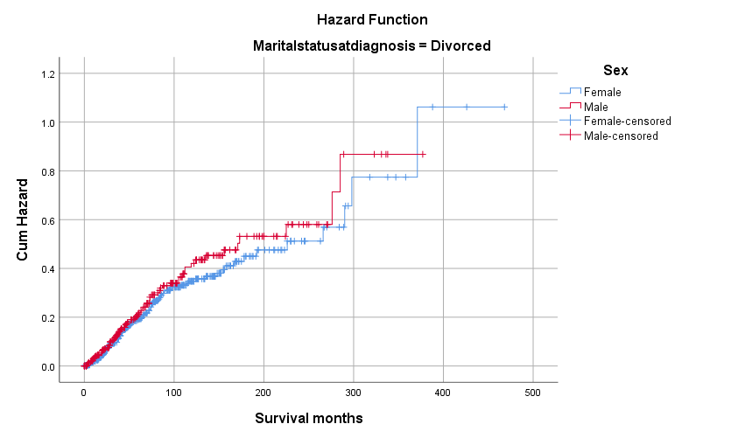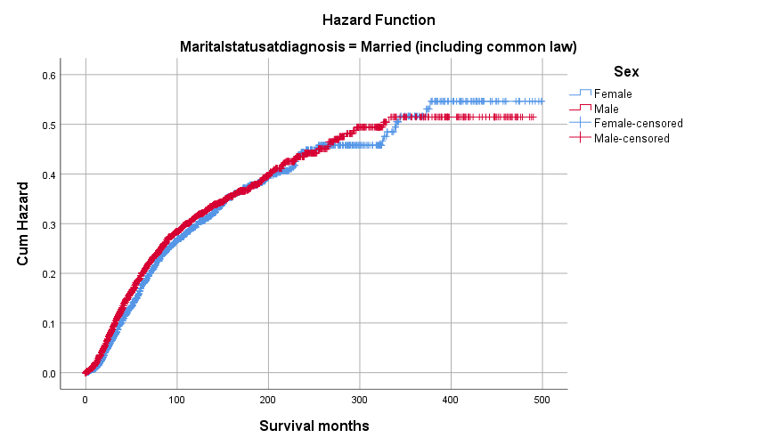
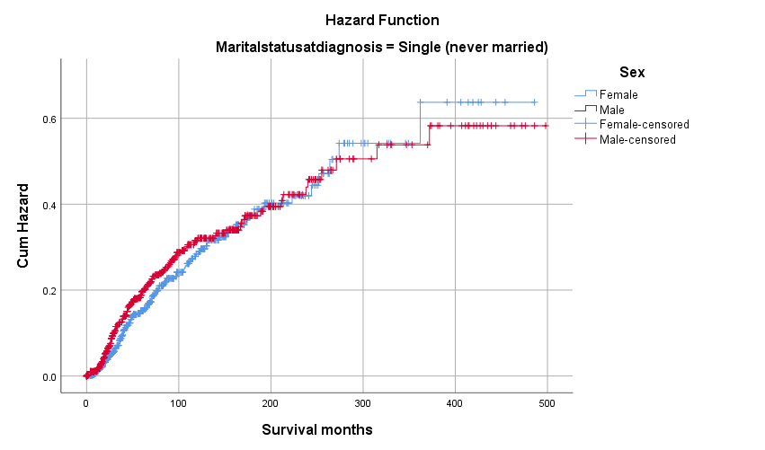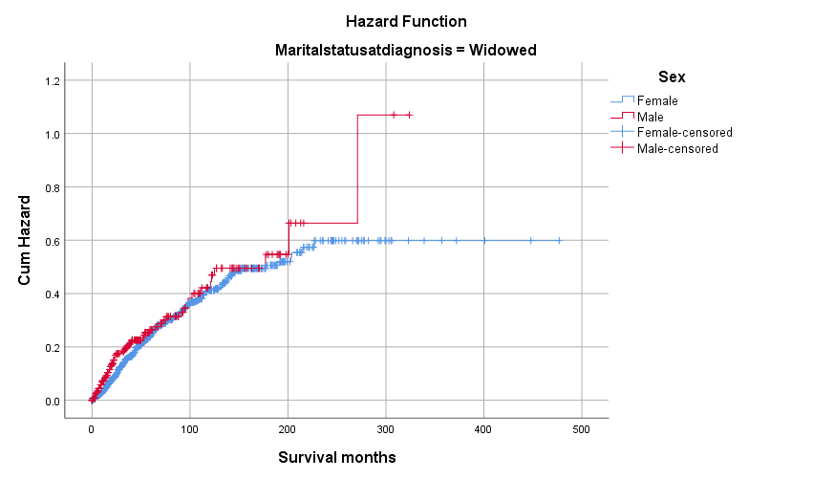

Urban – Metropolitan
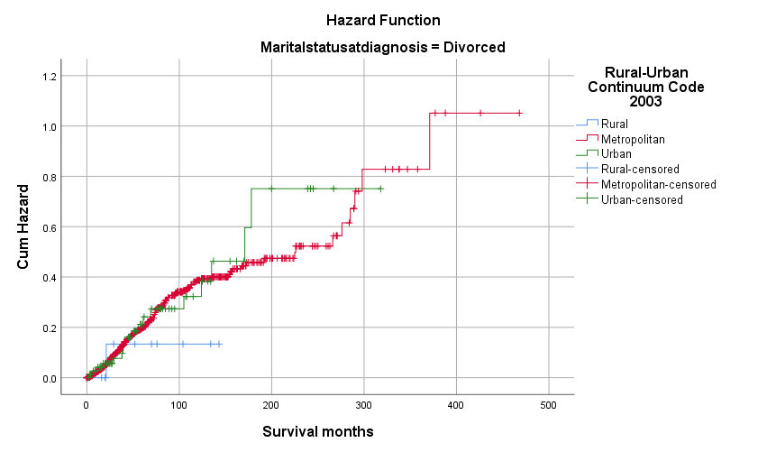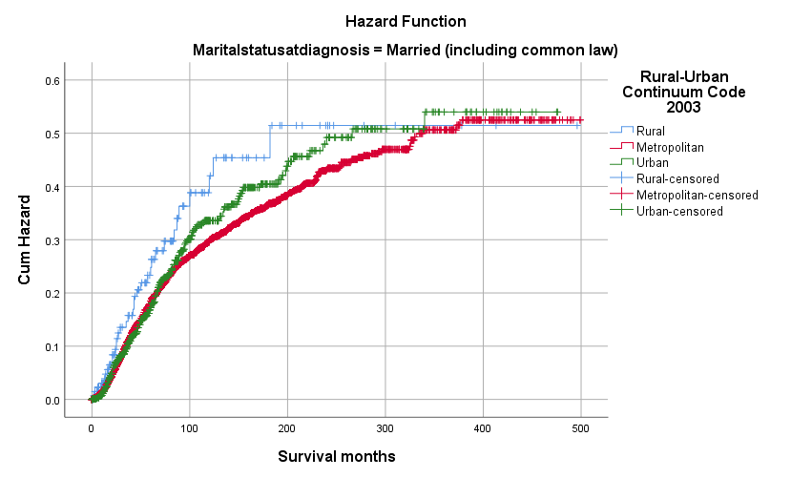
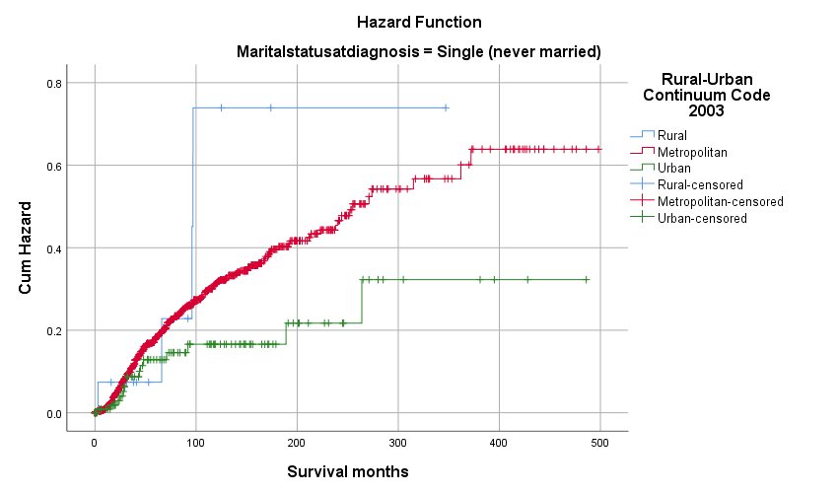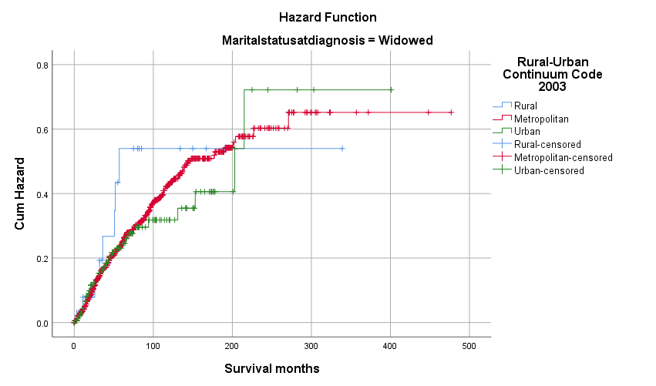
Supplementary Table 1: Age at diagnosis and survival time of the patients
 |  |  | Sex
 |  |  | Female |  |  |  |  | Male |  |  |  | Total
 |  |  | Mean | 95.0% Lower CL | 95.0% Upper CL | SD | Mean |  | 95.0% Lower CL | 95.0% Upper CL | SD | Mean | 95.0% Lower CL | 95.0% Upper CL | SD
Age at diagnosis | Marital status at diagnosis | Divorced ^{*1} | 60.8 | 59.7 | 62.0 | 12.1 | 58.8 |  | 57.5 | 60.0 | 10.9 | 60.0 | 59.1 | 60.8 | 11.6
Age at diagnosis | Marital status at diagnosis | Married (including common law) ^{*2} | 59.2 | 58.7 | 59.7 | 13.2 | 61.9 |  | 61.4 | 62.3 | 13.4 | 60.8 | 60.5 | 61.1 | 13.4
Age at diagnosis | Marital status at diagnosis | Separated | 58.9 | 54.2 | 63.7 | 16.8 | 59.9 |  | 55.5 | 64.3 | 12.4 | 59.3 | 56.0 | 62.6 | 15.2
Age at diagnosis | Marital status at diagnosis | Single (never married) | 54.2 | 52.7 | 55.7 | 18.4 | 52.3 |  | 51.0 | 53.6 | 17.6 | 53.2 | 52.2 | 54.2 | 18.0
Age at diagnosis | Marital status at diagnosis | Unmarried or Domestic Partner | 66.0 |  |  |  | 61.7 |  | 46.5 | 76.8 | 14.4 | 62.3 | 50.0 | 74.6 | 13.3
Age at diagnosis | Marital status at diagnosis | Widowed | 75.8 | 75.2 | 76.4 | 9.8 | 75.8 |  | 74.4 | 77.1 | 10.5 | 75.8 | 75.2 | 76.4 | 9.9
Age at diagnosis | Marital status at diagnosis | Total | 62.0 | 61.6 | 62.4 | 15.1 | 61.0 |  | 60.6 | 61.4 | 14.6 | 61.5 | 61.2 | 61.8 | 14.8
Significance:
*1 B( .022)
*2 A(< .0005)
Results are based on two-sided tests assuming equal variances. For each significant pair, the key of the smaller category appears in the category with the larger mean.
Significance level for upper case letters (A, B, C): .05
a. This category is not used in comparisons because the sum of case weights is less than two.
b. Tests are adjusted for all pairwise comparisons within a row of each innermost subtable using the Bonferroni correction.

Supplementary table 2: Overall Survival Details, Log-Rank Test

Case Processing Summary
Marital status at diagnosis | Total N | N of Events | Censored
Marital status at diagnosis | Total N | N of Events | N | Percent
Divorced | 719 | 349 | 370 | 51.5%
Married (including common law) | 6517 | 2944 | 3573 | 54.8%
Separated | 84 | 44 | 40 | 47.6%
Single (never married) | 1292 | 494 | 798 | 61.8%
Unmarried or Domestic Partner | 7 | 3 | 4 | 57.1%
Widowed | 1169 | 837 | 332 | 28.4%
Overall | 9788 | 4671 | 5117 | 52.3%

Means and Medians for Survival Time
Marital status at diagnosis | Meanª |  |  |  | Median
Marital status at diagnosis | Estimate | Std. Error | 95% Confidence Interval |  | Estimate | Std. Error | 95% Confidence Interval
Marital status at diagnosis | Estimate | Std. Error | Lower Bound | Upper Bound |  |  | Lower Bound | Upper Bound
Divorced | 161.8 | 7.9 | 146.3 | 177.3 | 118.0 | 8.4 | 101.5 | 134.5
Married (including common law) | 196.4 | 3.0 | 190.4 | 202.3 | 150.0 | 3.7 | 142.8 | 157.2
Separated | 148.0 | 20.4 | 108.0 | 188.0 | 113.0 | 15.2 | 83.2 | 142.8
Single (never married) | 229.0 | 8.2 | 212.9 | 245.1 | 173.0 | 12.8 | 148.0 | 198.0
Unmarried or Domestic Partner | 41.0 | 6.1 | 29.1 | 52.9 | 49.0 | 11.9 | 25.8 | 72.2
Widowed | 102.3 | 3.4 | 95.6 | 109.0 | 74.0 | 3.7 | 66.7 | 81.3
Overall | 184.0 | 2.4 | 179.3 | 188.7 | 133.0 | 2.7 | 127.8 | 138.2
a. Estimation is limited to the largest survival time if it is censored.

Pairwise Comparisons
 | Marital status at diagnosis | Divorced |  | Married (including common law) |  | Separated |  | Single (never married) |  | Unmarried or Domestic Partner |  | Widowed
 | Marital status at diagnosis | Χ² | Sig. | Χ² | Sig. | Χ² | Sig. | Χ² | Sig. | Χ² | Sig. | Χ² | Sig.
Log Rank (Mantel-Cox) | Divorced |  |  | 12.1 | .001 | .6 | .448 | 21.1 | .000 | 3.9 | .048 | 67.0 | .000
Log Rank (Mantel-Cox) | Married (including common law) | 12.1 | .001 |  |  | 4.2 | .040 | 8.1 | .004 | 4.7 | .030 | 336.9 | .000
Log Rank (Mantel-Cox) | Separated | .6 | .448 | 4.2 | .040 |  |  | 7.5 | .006 | 2.5 | .111 | 6.4 | .012
Log Rank (Mantel-Cox) | Single (never married) | 21.1 | .000 | 8.1 | .004 | 7.5 | .006 |  |  | 5.1 | .023 | 225.9 | .000
Log Rank (Mantel-Cox) | Unmarried or Domestic Partner | 3.9 | .048 | 4.7 | .030 | 2.5 | .111 | 5.1 | .023 |  |  | .8 | .361
Log Rank (Mantel-Cox) | Widowed | 67.0 | .000 | 336.9 | .000 | 6.4 | .012 | 225.9 | .000 | .8 | .361
Χ² = Chi-Square, Sig. = Significance in p-value

Supplementary table 3: Life Tables analysis for Overall Survival
Group/  Controls | Months | N  Entering Interval | N  Withdrawing during Interval | N  Exposed to Risk | N  of Terminal Events | %  Terminating | % Surviving | Cum. % Surviving at EI | SE of CP Surviving at EI | Pairwise Wilcoxon (Gehan) Sig.
All Patients, MST = 139.24 m | 0 | 10556 | 2420 | 9346.0 | 2603 | 27.9% | 72.1% | 72.1% | 0.00
All Patients, MST = 139.24 m | 60 | 5533 | 1329 | 4868.5 | 1224 | 25.1% | 74.9% | 54.0% | 0.01
All Patients, MST = 139.24 m | 120 | 2980 | 931 | 2514.5 | 582 | 23.1% | 76.9% | 41.5% | 0.01
All Patients, MST = 139.24 m | 180 | 1467 | 448 | 1243.0 | 285 | 22.9% | 77.1% | 32.0% | 0.01
All Patients, MST = 139.24 m | 240 | 734 | 463 | 502.5 | 271 | 53.9% | 46.1% | 14.7% | 0.01
A. Single, MST= 177.1 M | 0 | 1292 | 341 | 1121.5 | 276 | 24.6% | 75.4% | 75.4% | 0.01 | C, D
A. Single, MST= 177.1 M | 60 | 675 | 186 | 582.0 | 123 | 21.1% | 78.9% | 59.5% | 0.02 | C, D
A. Single, MST= 177.1 M | 120 | 366 | 134 | 299.0 | 50 | 16.7% | 83.3% | 49.5% | 0.02 | C, D
A. Single, MST= 177.1 M | 180 | 182 | 60 | 152.0 | 21 | 13.8% | 86.2% | 42.7% | 0.02 | C, D
A. Single, MST= 177.1 M | 240 | 101 | 77 | 62.5 | 24 | 38.4% | 61.6% | 26.3% | 0.03 | C, D
B. Married, MST=155.1 M | 0 | 6517 | 1484 | 5775.0 | 1505 | 26.1% | 73.9% | 73.9% | 0.01 | C, D
B. Married, MST=155.1 M | 60 | 3528 | 855 | 3100.5 | 706 | 22.8% | 77.2% | 57.1% | 0.01 | C, D
B. Married, MST=155.1 M | 120 | 1967 | 630 | 1652.0 | 351 | 21.2% | 78.8% | 45.0% | 0.01 | C, D
B. Married, MST=155.1 M | 180 | 986 | 289 | 841.5 | 180 | 21.4% | 78.6% | 35.4% | 0.01 | C, D
B. Married, MST=155.1 M | 240 | 517 | 315 | 359.5 | 202 | 56.2% | 43.8% | 15.5% | 0.01 | C, D
C. Widowed, MST= 77.8 M | 0 | 1169 | 164 | 1087.0 | 467 | 43.0% | 57.0% | 57.0% | 0.02 | A, B, D
C. Widowed, MST= 77.8 M | 60 | 538 | 79 | 498.5 | 207 | 41.5% | 58.5% | 33.4% | 0.02 | A, B, D
C. Widowed, MST= 77.8 M | 120 | 252 | 53 | 225.5 | 94 | 41.7% | 58.3% | 19.4% | 0.01 | A, B, D
C. Widowed, MST= 77.8 M | 180 | 105 | 22 | 94.0 | 45 | 47.9% | 52.1% | 10.1% | 0.01 | A, B, D
C. Widowed, MST= 77.8 M | 240 | 38 | 14 | 31.0 | 24 | 77.4% | 22.6% | 2.3% | 0.01 | A, B, D
D. Divorced, MST= 119.86 M | 0 | 719 | 174 | 632.0 | 176 | 27.8% | 72.2% | 72.2% | 0.02 | A, B, C
D. Divorced, MST= 119.86 M | 60 | 369 | 88 | 325.0 | 100 | 30.8% | 69.2% | 50.0% | 0.02 | A, B, C
D. Divorced, MST= 119.86 M | 120 | 181 | 58 | 152.0 | 43 | 28.3% | 71.7% | 35.8% | 0.02 | A, B, C
D. Divorced, MST= 119.86 M | 180 | 80 | 24 | 68.000 | 18 | 26.5% | 73.5% | 26.3% | 0.03 | A, B, C
D. Divorced, MST= 119.86 M | 240 | 38 | 26 | 25.000 | 12 | 48.0% | 52.0% | 13.7% | 0.03 | A, B, C
N: Number, EI: End of Interval, Cum. %: Cumulative Proportion, %: Proportion, PD: Probability Density, SE: Standard Error, Sig.: Significance (p-value of the test)

Supplementary table 4: Cancer-specific Survival Details, Log-Rank Test

Case Processing Summary
Marital status at diagnosis | Total N | N of Events | Censored
Marital status at diagnosis | Total N | N of Events | N | Percent
Divorced | 719 | 173 | 546 | 75.9%
Married (including common law) | 6517 | 1390 | 5127 | 78.7%
Separated | 84 | 17 | 67 | 79.8%
Single (never married) | 1292 | 266 | 1026 | 79.4%
Unmarried or Domestic Partner | 7 | 1 | 6 | 85.7%
Widowed | 1169 | 295 | 874 | 74.8%
Overall | 9788 | 2142 | 7646 | 78.1%

Means and Medians for Survival Time
Marital status at diagnosis | Meanª |  |  |  | Median
Marital status at diagnosis | Estimate | Std. Error | 95% Confidence Interval |  | Estimate | Std. Error | 95% Confidence Interval
Marital status at diagnosis | Estimate | Std. Error | Lower Bound | Upper Bound | Estimate | Std. Error | Lower Bound | Upper Bound
Divorced | 274.6 | 15.0 | 245.2 | 304.0 | 290.0 | 15.0 | 260.7 | 319.3
Married (including common law) | 340.8 | 4.0 | 332.8 | 348.7 | . | . | . | .
Separated | 295.7 | 22.0 | 252.5 | 338.8 | . | . | . | .
Single (never married) | 333.3 | 9.6 | 314.4 | 352.2 | . | . | . | .
Unmarried or Domestic Partner | 48.0 | 5.7 | 36.8 | 59.2 | . | . | . | .
Widowed | 291.5 | 10.6 | 270.7 | 312.4 | . | . | . | .
Overall | 332.4 | 3.5 | 325.6 | 339.3 | . | . | . | .
a. Estimation is limited to the largest survival time if it is censored.

Pairwise Comparisons
 | Marital status at diagnosis | Divorced |  | Married (including common law) |  | Separated |  | Single (never married) |  | Unmarried or Domestic Partner |  | Widowed
 | Marital status at diagnosis | Χ² | Sig. | Χ² | Sig. | Χ² | Sig. | Χ² | Sig. | Χ² | Sig. | Χ² | Sig.
Log Rank (Mantel-Cox) | Divorced |  |  | 6.1 | .014 | .3 | .568 | 4.9 | .028 | .3 | .593 | 2.3 | .131
Log Rank (Mantel-Cox) | Married (including common law) | 6.1 | .014 |  |  | .0 | .833 | .0 | .921 | .4 | .509 | 28.0 | .000
Log Rank (Mantel-Cox) | Separated | .3 | .568 | .0 | .833 |  |  | .1 | .789 | .1 | .703 | 1.3 | .257
Log Rank (Mantel-Cox) | Single (never married) | 4.9 | .028 | .0 | .921 | .1 | .789 |  |  | .4 | .504 | 17.2 | .000
Log Rank (Mantel-Cox) | Unmarried or Domestic Partner | .3 | .593 | .4 | .509 | .1 | .703 | .4 | .504 |  |  | .0 | .842
Log Rank (Mantel-Cox) | Widowed | 2.3 | .131 | 28.0 | .000 | 1.3 | .257 | 17.2 | .000 | .0 | .842
Χ² = Chi-Square, Sig. = Significance in p-value

Supplementary table 5: Life Tables analysis for Cancer-Specific Survival
Group/  Controls | Months | N Entering Interval | N  Withdrawing during Interval | N Exposed to Risk | N of Terminal Events | % Terminating | % Surviving | Cum. % Surviving at EI | SE of CP Surviving at EI | Pairwise Wilcoxon (Gehan) Sig.
All Patients, MST = 240 m | 0 | 10556 | 3595 | 8758.5 | 1428 | 16.3% | 83.7% | 83.7% | 0.00
All Patients, MST = 240 m | 60 | 5533 | 1977 | 4544.5 | 576 | 12.7% | 87.3% | 73.1% | 0.01
All Patients, MST = 240 m | 120 | 2980 | 1353 | 2303.5 | 160 | 6.9% | 93.1% | 68.0% | 0.01
All Patients, MST = 240 m | 180 | 1467 | 666 | 1134.0 | 67 | 5.9% | 94.1% | 64.0% | 0.01
All Patients, MST = 240 m | 240 | 734 | 690 | 389.0 | 44 | 11.3% | 88.7% | 56.8% | 0.01
A. Single, MST = 240 m | 0 | 1292 | 455 | 1064.5 | 162 | 15.2% | 84.8% | 84.8% | 0.01 | C, D
A. Single, MST = 240 m | 60 | 675 | 242 | 554.0 | 67 | 12.1% | 87.9% | 74.5% | 0.02 | C, D
A. Single, MST = 240 m | 120 | 366 | 165 | 283.5 | 19 | 6.7% | 93.3% | 69.5% | 0.02 | C, D
A. Single, MST = 240 m | 180 | 182 | 73 | 145.5 | 8 | 5.5% | 94.5% | 65.7% | 0.02 | C, D
A. Single, MST = 240 m | 240 | 101 | 91 | 55.5 | 10 | 18.0% | 82.0% | 53.9% | 0.04 | C, D
B. Married, MST = 240 m | 0 | 6517 | 2127 | 5453.5 | 862 | 15.8% | 84.2% | 84.2% | 0.00 | C, D
B. Married, MST = 240 m | 60 | 3528 | 1209 | 2923.5 | 352 | 12.0% | 88.0% | 74.1% | 0.01 | C, D
B. Married, MST = 240 m | 120 | 1967 | 877 | 1528.5 | 104 | 6.8% | 93.2% | 69.0% | 0.01 | C, D
B. Married, MST = 240 m | 180 | 986 | 422 | 775.0 | 47 | 6.1% | 93.9% | 64.8% | 0.01 | C, D
B. Married, MST = 240 m | 240 | 517 | 492 | 271.0 | 25 | 9.2% | 90.8% | 58.9% | 0.01 | C, D
C. Widowed, MST = 240 m | 0 | 1169 | 427 | 955.5 | 204 | 21.4% | 78.6% | 78.6% | 0.01 | A, B, D
C. Widowed, MST = 240 m | 60 | 538 | 220 | 428.0 | 66 | 15.4% | 84.6% | 66.5% | 0.02 | A, B, D
C. Widowed, MST = 240 m | 120 | 252 | 129 | 187.5 | 18 | 9.6% | 90.4% | 60.1% | 0.02 | A, B, D
C. Widowed, MST = 240 m | 180 | 105 | 61 | 74.5 | 6 | 8.1% | 91.9% | 55.3% | 0.03 | A, B, D
C. Widowed, MST = 240 m | 240 | 38 | 37 | 19.5 | 1 | 5.1% | 94.9% | 52.5% | 0.04 | A, B, D
D. Divorced, MST = 240 m | 0 | 719 | 248 | 595.0 | 102 | 17.1% | 82.9% | 82.9% | 0.02 | C
D. Divorced, MST = 240 m | 60 | 369 | 138 | 300.0 | 50 | 16.7% | 83.3% | 69.0% | 0.02 | C
D. Divorced, MST = 240 m | 120 | 181 | 89 | 136.5 | 12 | 8.8% | 91.2% | 63.0% | 0.03 | C
D. Divorced, MST = 240 m | 180 | 80 | 39 | 60.5 | 3 | 5.0% | 95.0% | 59.9% | 0.03 | C
D. Divorced, MST = 240 m | 240 | 38 | 32 | 22.0 | 6 | 27.3% | 72.7% | 43.5% | 0.06 | C
N: Number, EI: End of Interval, Cum. %: Cumulative Proportion, %: Proportion, PD: Probability Density, SE: Standard Error, Sig.: Significance (p-value of the test)

Supplementary table 6: Details of Cox-Regression Model for overall survival (Model 1).

Omnibus Tests of Model Coefficientsª
-2 Log Likelihood | Overall (score) |  |  | Change From Previous Step |  |  | Change From Previous Block
-2 Log Likelihood | Χ² | df | Sig. | Χ² | df | Sig. | Χ² | df | Sig.
65438.464 | 2386.597 | 13 | .000 | 1825.767 | 13 | .000 | 1825.767 | 13 | .000
a. Beginning Block Number 1. Method = Enter

 | Sig. | HR | 95.0% CI for Exp(B)
 | Sig. | HR | Lower | Upper
Marital status at diagnosis | .000
Reference = Divorced
Marital status at diagnosis (Single) | .004 | .806 | .694 | .935
Marital status at diagnosis (Married) | .000 | .727 | .645 | .820
Marital status at diagnosis (Widowed) | .675 | .971 | .845 | 1.116
Sex (Female) | .000 | .790 | .740 | .843
Age Group in 20s | .000
Reference = 80+
Age Group (0-19) | .000 | .072 | .041 | .126
Age Group (20-39) | .000 | .105 | .087 | .126
Age Group (40-59) | .000 | .205 | .184 | .228
Age Group (60-79) | .000 | .444 | .406 | .486
Primary Site (Choroid) | .116 | .936 | .861 | 1.017
SEER historic stage A | .000
Reference = Distant
SEER historic stage A (Local) | .000 | .135 | .113 | .162
SEER historic stage A (Regional) | .000 | .237 | .193 | .290
Rural Urban | .342
Reference = Metropolitan
Rural Urban (Rural) | .184 | 1.153 | .934 | 1.424
Rural Urban (Urban) | .484 | 1.033 | .944 | 1.130
HR: Hazard Ratio

Supplementary table 7: Details of Cox-Regression Model for Cancer-Specific survival (Model 1).

Omnibus Tests of Model Coefficientsª
-2 Log Likelihood | Overall (score) |  |  | Change From Previous Step |  |  | Change From Previous Block
-2 Log Likelihood | Χ² | df | Sig. | Χ² | df | Sig. | Χ² | df | Sig.
31271.614 | 875.477 | 13 | .000 | 398.287 | 13 | .000 | 398.287 | 13 | .000
a. Beginning Block Number 1. Method = Enter

 | Sig. | HR | 95.0% CI for Exp(B)
 | Sig. | HR | Lower | Upper
Marital status at diagnosis | .009
Reference = Divorced
Marital status at diagnosis (Single) | .091 | .833 | .673 | 1.030
Marital status at diagnosis (Married) | .026 | .822 | .691 | .977
Marital status at diagnosis (Widowed) | .875 | 1.017 | .823 | 1.256
Sex (Female) | .024 | .897 | .816 | .986
Age Group in 20s | .000
Reference = 80+
Age Group (0-19) | .019 | .486 | .265 | .890
Age Group (20-39) | .000 | .508 | .399 | .646
Age Group (40-59) | .000 | .639 | .535 | .763
Age Group (60-79) | .011 | .807 | .684 | .951
Primary Site (Choroid) | .237 | .928 | .819 | 1.051
SEER historic stage A | .000
Reference = Distant
SEER historic stage A (Local) | .000 | .093 | .075 | .116
SEER historic stage A (Regional) | .000 | .178 | .138 | .229
Rural Urban | .348
Reference = Metropolitan
Rural Urban (Rural) | .176 | 1.236 | .910 | 1.680
Rural Urban (Urban) | .543 | 1.043 | .912 | 1.192
HR: Hazard Ratio

Supplementary table 8: Details of Cox-Regression Model for Overall and Cancer-Specific survival with considering tumor size (Model 2).
Summary | - Overall |  |  |  | Cancer-Specific Survival
 |  | N | Percent |  |  |  | N | Percent
Cases available in analysis | Eventª | 348 | 3.3% |  | Cases available in analysis | Eventª | 182 | 1.7%
Cases available in analysis | Censored | 1447 | 13.7% |  | Cases available in analysis | Censored | 1595 | 15.1%
Cases available in analysis | Total | 1795 | 17.0% |  | Cases available in analysis | Total | 1777 | 16.8%
Cases dropped | Cases with missing values | 8762 | 83.0% |  | Cases dropped | Cases with missing values | 8762 | 83.0%
Cases dropped | Cases with negative time | 0 | 0.0% |  | Cases dropped | Cases with negative time | 0 | 0.0%
Cases dropped | Censored cases before the earliest event in a stratum | 0 | 0.0% |  | Cases dropped | Censored cases before the earliest event in a stratum | 18 | 0.2%
Cases dropped | Total | 8762 | 83.0% |  | Cases dropped | Total | 8780 | 83.2%
Total |  | 10557 | 100.0% |  | Total |  | 10557 | 100.0%
a. Dependent Variable: Survival months |  |  |  |  | a. Dependent Variable: Survival months

Omnibus Tests of Model Coefficientsª for Overall Survival
-2 Log Likelihood | Overall (score) |  |  | Change From Previous Step |  |  | Change From Previous Block
-2 Log Likelihood | Chi-square | df | Sig. | Chi-square | df | Sig. | Chi-square | df | Sig.
4607.758 | 279.320 | 10 | 0.000 | 192.563 | 10 | 0.000 | 192.563 | 10 | 0.000
Omnibus Tests of Model Coefficientsª for Cancer-Specific Survival
-2 Log Likelihood | Overall (score) |  |  | Change From Previous Step |  |  | Change From Previous Block
-2 Log Likelihood | Chi-square | df | Sig. | Chi-square | df | Sig. | Chi-square | df | Sig.
2445.674 | 165.608 | 10 | 0.000 | 67.706 | 10 | 0.000 | 67.706 | 10 | 0.000

COX Model for Overall Survival |  |  |  |  |  |  | COX Model for Cancer-Specific Survival
 | Sig. | HR | 95.0% CI for Exp(B) |  |  |  |  | Sig. | HR | 95.0% CI for Exp(B)
 | Sig. | HR | Lower | Upper |  |  |  | Sig. | HR | Lower | Upper
Sex (Female) | 0.000 | 0.665 | 0.529 | 0.835 |  |  | Sex (Female) | 0.015 | 0.679 | 0.497 | 0.927
Age at diagnosis | 0.000 | 1.044 | 1.034 | 1.054 |  |  | Age at diagnosis | 0.102 | 1.010 | 0.998 | 1.022
Marital status at diagnosis | 0.066 |  |  |  |  |  | Marital status at diagnosis | 0.307
Marital status at diagnosis(Single) * | 0.312 | 1.268 | 0.800 | 2.009 |  |  | Marital status at diagnosis(Single) * | 0.443 | 1.301 | 0.664 | 2.550
Marital status at diagnosis(Married) * | 0.468 | 0.862 | 0.577 | 1.287 |  |  | Marital status at diagnosis(Married) * | 0.610 | 1.164 | 0.650 | 2.082
Marital status at diagnosis(Widowed) * | 0.715 | 1.095 | 0.672 | 1.784 |  |  | Marital status at diagnosis(Widowed) * | 0.108 | 1.816 | 0.878 | 3.756
Primary Site (Choroid) | 0.002 | 0.577 | 0.408 | 0.817 |  |  | Primary Site (Choroid) | 0.006 | 0.525 | 0.331 | 0.833
SEER stage (1973-2015) § | 0.000 |  |  |  |  |  | SEER stage (1973-2015) | 0.000
SEER stage (1973-2015)(Local) § | 0.000 | 0.073 | 0.043 | 0.125 |  |  | SEER stage (1973-2015)(Local) § | 0.000 | 0.051 | 0.026 | 0.099
SEER historic stage A (1973-2015)(Regional) § | 0.000 | 0.125 | 0.064 | 0.244 |  |  | SEER historic stage A (1973-2015)(Regional) § | 0.000 | 0.082 | 0.034 | 0.197
Basal Diameter | 0.001 | 1.001 | 1.001 | 1.002 |  |  | Basal Diameter | 0.010 | 1.001 | 1.000 | 1.002
Thickness (Depth) | 0.035 | 1.001 | 1.000 | 1.002 |  |  | Thickness (Depth) | 0.232 | 1.001 | 0.999 | 1.002
* Compared to divorced
§ Compared to Metastatic

Supplementary table 9: Detailed Patients’ Characteristics.
MS Excel Sheet

