APPENDIX

Appendix A1: Propensity Score Matching Approach
To identify comparable US and European multinational groups in Section 4.2, we retrieve consolidated financial data for all MNEs in our samples from the Compustat Global and North America database. Then, we perform the PSM in two steps, following Rosenbaum and Rubin (1983). First, we estimate the probability that the multinational group’s parent firm j is based in the EU using the following probit regression:
${EU}_{j2010}= δ_{1}X_{j2010}+u_{j2010}$ (2)
EU_{j2010} is a time-invariant dummy variable equal to one if the parent firm is located in the EU and zero if it is based in the US. X_{j2010} denotes a vector of different firm characteristics that are found to determine tax expenses (e.g., Chen et al., 2010; Grubert, 2003; Rego, 2003). We include size (SIZE), intangible assets (INT_ASSETS), leverage (LEV), return on assets (ROA), market-to-book ratio (MTB) and R&D (RD). Definitions of the variables are presented in Panel B of Table A1 in the Appendix. We also include the overall ESG score (ESG) to address concerns that the relation between CSR and profit shifting is impacted by the level of CSR. As indicated by the index, the matching is performed in 2010, the first year of our analysis. Based on the probit regression, propensity scores are predicted for EU and US MNEs, respectively. The estimation results are presented in Table A3 in the Appendix.
In a second step, we use the propensity scores to perform a one-to-one nearest neighbor matching in which an EU-based MNE is matched to the most similar US MNE that further is required to operate in the same industry. We refer to the Fama and French 17 classification to find comparable firms. In line with prior literature, we set the caliper, the maximum deviation between EU and US MNEs, to 0.03 (P. C. Austin, 2011).

Figure A1: ESG Scores
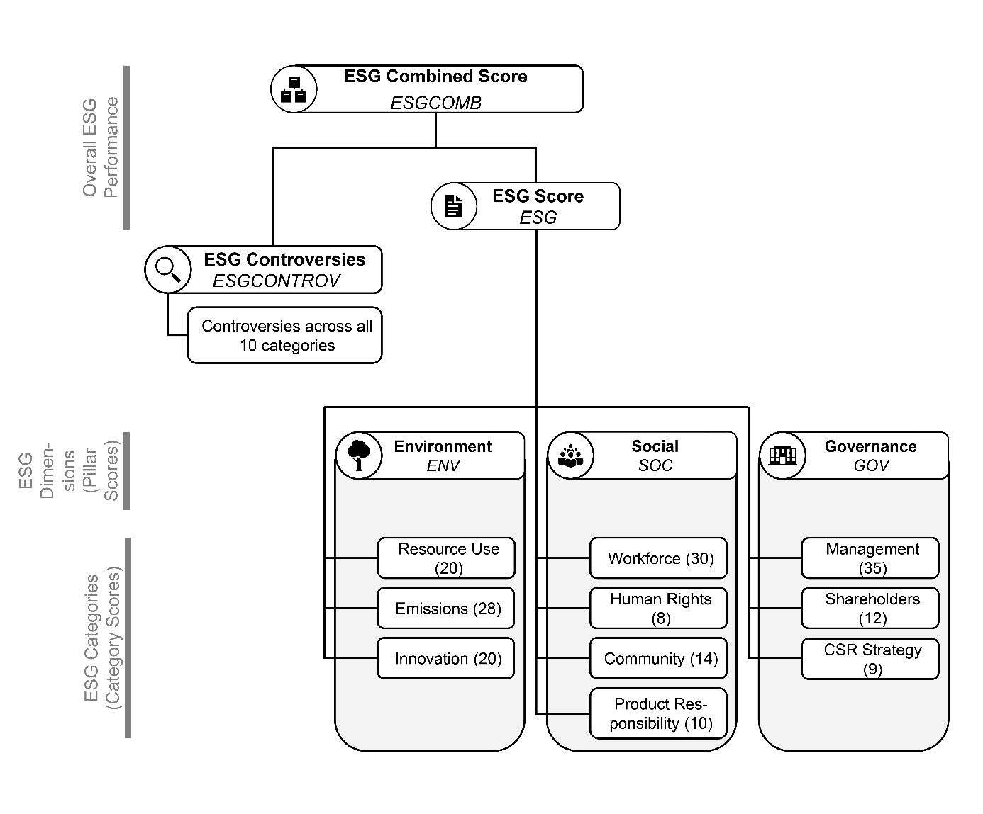
Notes: Figure A1 demonstrates the relation between the different Refinitiv ESG scores (as described in Refinitiv, 2020). Numbers in parentheses report the amount of ESG measures included in the respective scores. Terms in italic demonstrate the corresponding variable names used in our regressions. Refinitiv provides scores for a firm’s overall ESG performance, as well as its performance in ESG dimensions and in different categories. The ESG combined score and the ESG score both measure a firm’s overall CSR performance. The ESG combined score adjusts the ESG score if ESG controversies have occurred which impact the firm. The ESG score measures a firm’s commitment and performance in the 10 ESG categories (resource use, emissions, innovation, workforce, human rights, community, product responsibility, management, shareholders and CSR strategy) based on reported information. The 10 ESG categories belong to three ESG dimensions: the environmental, social and governance dimension. The performance in the three dimensions is represented by the respective pillar scores. For a description of the pillar scores and definition of the different categories incorporated in the ESG score and pillar scores, please refer to
Table A2 in the Appendix.

Table A1: Variable Definitions
Variable |  | Definition |  |  | Source
Panel A: Profit Shifting and CSR
Dependent Variable
PBT | = | Natural logarithm of profit before tax. |  |  | Amadeus
Profit-Shifting Incentive Variable
STR | = | Statutory corporate tax rate of a subsidiary’s jurisdiction. |  |  | Worldwide corporate tax summaries of PwC, KPMG, and EY
CSR Variables
ESG | = |  | ESG score measuring a parent firm’s overall CSR performance. |  | Refinitiv
ESGCOMB | = |  | ESG combined score measuring a parent firm’s overall CSR performance (ESG) discounted based on ESG controversies (ESGCONTROV). |  | Refinitiv
ESGCONTROV | = |  | ESG controversies score measuring the extent of negative media stories on a parent firm. The lower the ESG controversies score, the greater the number of controversies that have occurred. |  | Refinitiv
ENV | = |  | Environmental pillar score measuring a parent firm’s performance in the environmental dimension. |  | Refinitiv
SOC | = |  | Social pillar score measuring a parent firm’s performance in the social dimension. |  | Refinitiv
GOV | = |  | Corporate governance pillar score measuring a parent firm’s performance in the governance dimension. |  | Refinitiv
Subsidiary-Level Controls
CAPITAL | = | Natural logarithm of fixed assets. |  |  | Amadeus
LABOR | = | Natural logarithm of labor compensation. |  |  | Amadeus
INTAN | = | Ratio of intangible assets over total assets. |  |  | Amadeus
Country-Level Data
GDP | = | Natural logarithm of gross domestic product. |  |  | World Bank Development Indicators
GDPC | = | Natural logarithm of gross domestic product per capita. |  |  | World Bank Development Indicators
UNEMPLOY | = | Natural logarithm of unemployment rate. |  |  | World Bank Development Indicators
CORRUPT | = | Corruption index. |  |  | World Bank Worldwide Governance Indicators
PREGULATQ | = | Parent country regulatory quality |  |  | World Bank Worldwide Governance Indicators
PRULEOFLAW | = | Parent country rule of law |  |  | World Bank Worldwide Governance Indicators
PGOVEFF | = | Parent country government effectiveness |  |  | World Bank Worldwide Governance Indicators

Table A2: Composition of ESG Pillar Scores
Pillar | Category Score | Definition
Environmental (ENV) | Resource Use | The resource use score reflects a company’s performance and capacity to reduce the use of materials, energy or water, and to find more eco-efficient solutions by improving supply chain management.
Environmental (ENV) | Emissions | The emission reduction score measures a company’s commitment and effectiveness toward reducing environmental emissions in its production and operational processes.
Environmental (ENV) | Innovation | The innovation score reflects a company’s capacity to reduce the environmental costs and burdens for its customers, thereby creating new market opportunities through new environmental technologies and processes or eco-designed products.
Social  (SOC) | Workforce | The workforce score measures a company’s effectiveness in terms of providing job satisfaction, a healthy and safe workplace, maintaining diversity and equal opportunities and development opportunities for its workforce.
Social  (SOC) | Human Rights | The human rights score measures a company’s effectiveness in terms of respecting fundamental human rights conventions.
Social  (SOC) | Community | The community score measures the company’s commitment to being a good citizen, protecting public health and respecting business ethics.
Social  (SOC) | Product Responsibility | The product responsibility score reflects a company’s capacity to produce quality goods and services, integrating the customer’s health and safety, integrity and data privacy.
Governance (GOV) | Management | The management score measures a company’s commitment and effectiveness toward following best practice corporate governance principles.
Governance (GOV) | Shareholder | The shareholders score measures a company’s effectiveness toward equal treatment of shareholders and the use of anti-takeover devices.
Governance (GOV) | CSR Strategy | The CSR strategy score reflects a company’s practices to communicate that it integrates economic (financial), social and environmental dimensions into its day-to-day decision-making processes.
Notes:
Table A2 describes the composition of the ESG pillar scores (environmental, social and governance) by presenting definitions of the underlying category scores as provided by Refinitiv (2020). The ESG pillar scores measure a firm’s performance in the respective ESG dimension. Terms in italic demonstrate the corresponding variable names used in our regressions. The environmental pillar score consists of the resource use, emissions and innovation category. The social pillar score is an aggregation of the workforce, human rights, community and product responsibility category score. The governance pillar score is calculated based on the management, shareholder and CSR strategy category score. For the environmental and social pillar, the weights of the single categories vary by industry, whereas the weights for the categories incorporated in the governance pillar score are independent of the industry.

Table A3: Probit Regression for PSM
 | (1)
VARIABLES | EU MNE
SIZE | -0.447***
 | (0.000)
INT_ASSETS | -0.109
 | (0.603)
LEV | -0.428
 | (0.116)
ROA | -4.028***
 | (0.000)
MTB | 0.001
 | (0.528)
RD | -10.226***
 | (0.000)
ESG | 0.023***
 | (0.000)
Observations | 633
Pseudo R² | 0.1630
Notes: Table A3 presents the probit regression result used for the prediction of the propensity scores for PSM, based on Equation (3). The dependent variable is an indicator variable which is set to one for EU MNEs and zero for US MNEs. P-values are shown in parentheses. ***, ** and * indicate statistical significance at the 1%, 5% and 10% levels, respectively.

Table A4: One-to-One Nearest Neighbor Matching Quality
Nearest Neighbor 1:1 |  |  |  |  | Bias
Nearest Neighbor 1:1 |  | Mean |  | Bias | Reduction | t-test
Nearest Neighbor 1:1 |  | Treated | Control | (in %) | (in %) | t | p>t
SIZE | Unmatched | 8.2011 | 8.7176 | -33.2 |  | -4.13 | 0.000
 | Matched | 8.4086 | 8.3856 | 1.5 | 95.5 | 0.12 | 0.905
INT_ASSETS | Unmatched | 0.2956 | 0.3166 | -7.7 |  | -0.95 | 0.341
 | Matched | 0.3500 | 0.3128 | 13.7 | -77.3 | 1.21 | 0.229
LEV | Unmatched | 0.2047 | 0.2171 | -6.1 |  | -0.77 | 0.444
 | Matched | 0.2088 | 0.2116 | -1.4 | 77.5 | -0.11 | 0.916
ROA | Unmatched | 0.1095 | 0.1395 | -31.9 |  | -3.95 | 0.000
 | Matched | 0.1255 | 0.1272 | -1.8 | 94.3 | -0.15 | 0.882
MTB | Unmatched | 15.7040 | 3.0408 | 10.8 |  | 1.40 | 0.163
 | Matched | 2.2683 | 3.2040 | -0.8 | 92.6 | -0.66 | 0.511
RD | Unmatched | 0.0135 | 0.0315 | -47.0 |  | -5.71 | 0.000
 | Matched | 0.0185 | 0.0184 | 0.3 | 99.4 | 0.03 | 0.977
ESG | Unmatched | 48.9910 | 45.6800 | 15.9 |  | 1.98 | 0.048
 | Matched | 46.1620 | 46.5570 | -1.9 | 88.1 | -0.15 | 0.879
Notes: Table A4 shows the matching quality by presenting and comparing the relevant matching characteristics between EU and US MNEs before and after the matching. MNEs are matched based on consolidated financial data from Compustat and the ESG score for the year 2010. Results are formed on a one-to-one nearest neighbor matching requiring a difference in propensity scores (caliper) of less than 0.03.

