Online Appendix
Table A.1 Tax Revenue Trends in Tanzania (as a percentage of GDP)
 | 2013 | 2014 | 2015 | 2016 | 2017 | 2018 | 2019 | 2020 | 2021
Income Tax | 4.7 | 5.1 | 4.5 | 4.8 | 4.5 | 4.4 | 4.0 | 4.7 | 4.5
P.A.Y.E. | 2.1 | 2.1 | 2.0 | 2.2 | 2.0 | 1.9 | 1.8 | 1.8 | 1.4
B. Skills & Dev. Levy | 0.2 | 0.2 | 0.2 | 0.3 | 0.2 | 0.2 | 0.2 | 0.2 | 0.2
Individuals | 0.1 | 0.1 | 0.1 | 0.1 | 0.2 | 0.2 | 0.2 | 0.2 | 0.1
Corporate Taxes | 1.5 | 1.9 | 1.3 | 1.4 | 1.3 | 1.3 | 1.2 | 1.8 | 1.7
Withholding taxes | 0.6 | 0.7 | 0.7 | 0.7 | 0.7 | 0.6 | 0.5 | 0.7 | 0.7
Rental Tax | 0.1 | 0.1 | 0.1 | 0.1 | 0.1 | 0.1 | 0.1 | 0.1 | 0.1
All Other direct taxes | 0.1 | 0.0 | 0.0 | 0.0 | 0.1 | 0.1 | 0.1 | 0.1 | 0.3
Consumption Taxes | 2.5 | 2.7 | 2.6 | 2.7 | 2.7 | 2.8 | 2.8 | 2.8 | 3.5
Excises (Domestic) | 0.8 | 1.0 | 0.9 | 0.9 | 0.8 | 0.9 | 0.9 | 0.9 | 0.8
VAT Domestic Products | 0.4 | 0.4 | 0.5 | 0.5 | 0.4 | 0.5 | 0.4 | 0.4 | 0.7
VAT Domestic Services | 1.3 | 1.3 | 1.3 | 1.4 | 1.5 | 1.5 | 1.4 | 1.5 | 0.9
Other Domestic Taxes | 0.3 | 0.3 | 0.3 | 0.3 | 0.3 | 0.1 | 0.1 | 0.1 | 1.1
International Trade Taxes | 4.4 | 4.7 | 4.7 | 5.3 | 5.0 | 5.0 | 4.7 | 4.7 | 3.6
Import Duties | 0.9 | 1.0 | 1.0 | 1.3 | 1.4 | 1.4 | 1.2 | 1.3 | 0.9
Excise Duties | 1.0 | 1.0 | 1.0 | 1.3 | 1.0 | 0.9 | 0.9 | 0.9 | 0.9
VAT on Imports | 1.8 | 1.7 | 1.7 | 1.7 | 1.6 | 1.7 | 1.7 | 1.7 | 1.9
Tax Revenue (% of GDP) | 11.9% | 12.7% | 12.1% | 13.1% | 12.5% | 12.3% | 11.6% | 12.3% | 11.7%
Memorandum Items
Direct Taxes | 4.7 | 5.1 | 4.5 | 4.8 | 4.5 | 4.4 | 4.0 | 4.7 | 4.5
Indirect Taxes | 7.3 | 7.6 | 7.6 | 8.3 | 8.0 | 7.9 | 7.6 | 7.6 | 7.1
Note: The financial years are used. That is, 2005 represents the 2004/05 financial year.
Source: Tanzania Revenue Authority (2022).

Table A 2 Tax Revenue as a Percentage of Total Revenue
Tax Item | 1996/97 | 2000/01 | 2005/06 | 2010/11 | 2015/16 | 2019/20 | 2020/21
PAYE | 7.6 | 10.8 | 14.3 | 17.0 | 17.0 | 14.3 | 12.3
Corporation Tax | 10.8 | 5.4 | 10.1 | 9.8 | 10.4 | 14.4 | 12.1
Individuals | 1.8 | 1.5 | 1.6 | 1.1 | 1.1 | 1.3 | 1.4
Other Income Taxes ª | 4.6 | 7.4 | 5.7 | 5.8 | 8.3 | 8.4 | 9.5
Domestic Excises Duty | 12.2 | 8.0 | 6.7 | 6.0 | 6.6 | 7.1 | 7.0
Domestic VAT | 13.2 | 16.3 | 16.4 | 15.1 | 13.9 | 15.5 | 14.8
Other Domestic Taxes & Charges ^{b} | 15.3 | 2.6 | 1.5 | 2.4 | 2.2 | 1.2 | 1.8
Import Duty | 15.4 | 11.2 | 8.8 | 8.4 | 9.8 | 9.8 | 7.4
Excise Duty on Imports | 5.9 | 10.0 | 6.3 | 11.3 | 9.6 | 6.9 | 8.2
VAT on Imports | 10.8 | 21.1 | 24.9 | 16.6 | 13.0 | 13.6 | 14.5
Other Import Charges ^{c} | 2.4 | 5.8 | 3.8 | 6.5 | 8.2 | 7.6 | 11.0
Total (%) | 100 | 100 | 100 | 100 | 100 | 100 | 100
Note: a – other income taxes here include rental tax, withholding tax, skills and development levy, gaming tax, capital gains and miscellaneous collection tax. b – other domestic taxes and charges include motor vehicle taxes, stamp duty, departure charges and business licenses. c – other import charges include fuel levy, export duties, non-tax revenue and other import-related charges. Only TRA Mainland figures are included.
Source: Tanzania Revenue Authority (2022).

Figure A 1 Distribution of IHS of extra income before and after trimming.
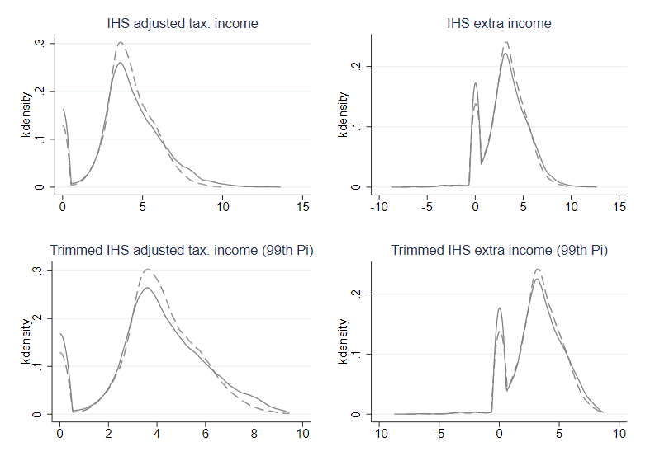Notes: Kernel density graphs for the treated group (solid line) and control group (dashed line) before and after trimming at the 99% level at the top.
Source: authors’ estimations based on iTax data.

Figure A 2 Estimates based on the Rambachan and Roth (2022) approach.

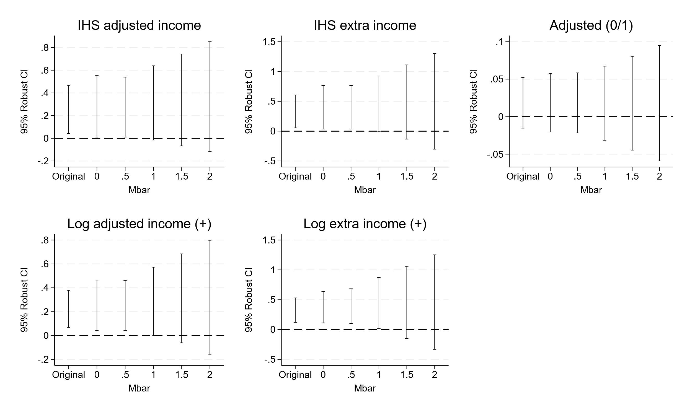
Source: authors’ estimations based on iTax data.

