Supporting Information
Polymer-metal complexes as emerging catalysts for electrochemical reduction of carbon dioxide
Daniele Sassone†,‡, Juqin Zeng*†, Marco Fontana†, Adriano Sacco†, M.Amin Farkhondehfal†, Monica Periolatto‡, Candido F. Pirri†,‡, Sergio Bocchini†
†Center for Sustainable Future Technologies (CSFT)@Polito, Istituto Italiano di Tecnologia, Via Livorno 60, 10144 Torino, Italy.
‡Department of Applied Science and Technology - DISAT, Politecnico di Torino, Corso Duca degli Abruzzi 24, 10129 Torino, Italy.
*Corresponding author: juqin.zeng@iit.it, Tel: +39 011 2257719
ORCID of the authors
Daniele Sassone (0000-0003-4343-4565); Juqin Zeng (0000-0001-8885-020X); Adriano Sacco (0000-0002-9229-2113); Marco Fontana (0000-0003-0894-2193); Amin Farkhondehfal (0000-0002-5433-5653); Monica Periolatto (0000-0002-6748-9563); Candido Fabrizio Pirri (0000-0003-4991-9459); Sergio Bocchini (0000-0003-2876-2317)

Schematic representation of the electrochemical cell
A detailed scheme illustrating the cell is reported in Scheme S1. In a two-compartment cell, divided by a Nafion membrane, two different electrodes are placed and immersed in a 0.1 M KHCO₃ solution. In the cathodic compartment, a carbon electrode where the PANI-based catalysts were drop-casted is placed. In the anodic compartment, a Pt foil is used as anode. During the experiment, a continuous flow of pure CO₂ gas passes through both chambers. The gas flow is required for the catalysis itself but also for dragging the reduced gas products formed during the experiment through the outlet of the cell. Gas detection is monitored online during the experiment, while liquid products are analyzed at the end of the test.
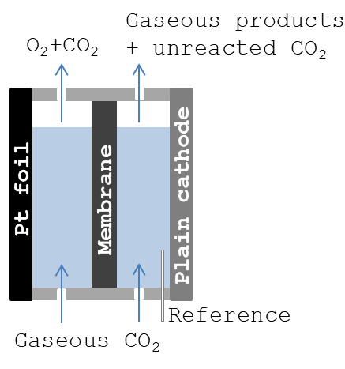
Scheme S1 A schematic representation of the cell.
Inductively Coupled Plasma-mass spectroscopy (ICP-MS) analysis
ICP-MS was performed on an Icap Q ICP-MS (Thermo Fisher) and the data were collected and processed by the related Thermo Fischer ICP Software. An ICP multi-element standard solution, 1000 mg/L in diluted nitric acid (Certipur®, Sigma Aldrich) was used as reference for determination of the calibration curves. For each metal investigated, the standard solution was properly diluted with bidistilled water to obtain four metal solutions in the suitable range of concentrations. In all cases, calibration curves with R²>0.999 were found. Each value is the mean of three measurements, with Standard Deviations calculated between 0.34 for Fe. PANI samples were prepared placing the powders under vacuum and at 60 °C for at least a week, then 10 mg were collected for each sample and then digested in 10 mL of concentrated nitric acid to generate the stock solutions. An aliquot of 22.2 µL for each sample was taken and diluted till 10 mL with water and then analyzed.
Fourier-transform infrared spectroscopy (FT-IR)
The FT-IR spectrum recorded for the ES-PANI is reported in Figure S1. At 3172 cm⁻¹ and 3031 cm⁻¹ the hydrogen-bonded ν_{N-H} of secondary amines and ν_{C-H} of aromatic rings stretching are present. At 1597 cm⁻¹ and 1495 cm⁻¹ the bands of the C-N and C-C stretching of the benzenoid and quinoid rings of the polymer chain are recorded and at 1312 cm⁻¹ there is the C-N stretching of aromatic amines. At 1151 cm⁻¹ there is the stretching of quinoid ring and at 819 cm⁻¹ the out of plane bending of para-disubstituted benzene is recorded. Peaks due to residual of methanol solvent at 2917 and 2836 cm⁻¹ are also present: the ν_{CH3} symmetric and asymmetric stretching [1].
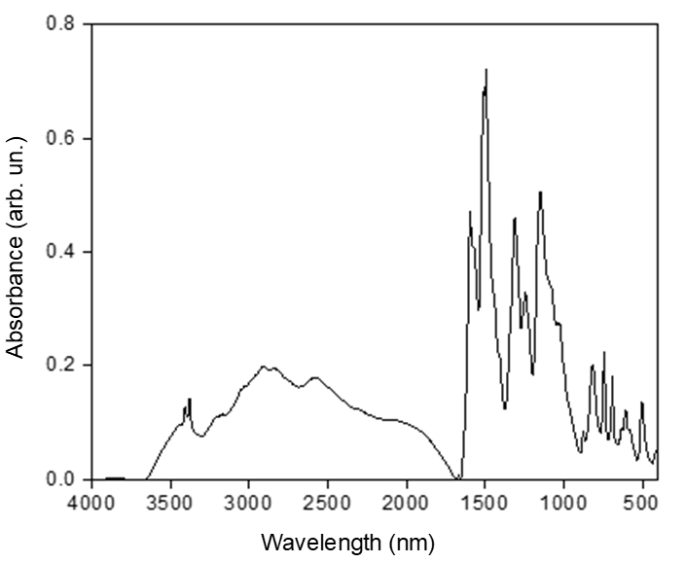
Figure S1 FT-IR spectrum of ES-PANI.

X-ray Photoelectron Spectroscopy
Figure S2 reports representative survey spectra for all the analyzed samples, alongside labels for the most intense peaks related to the detected chemical elements.

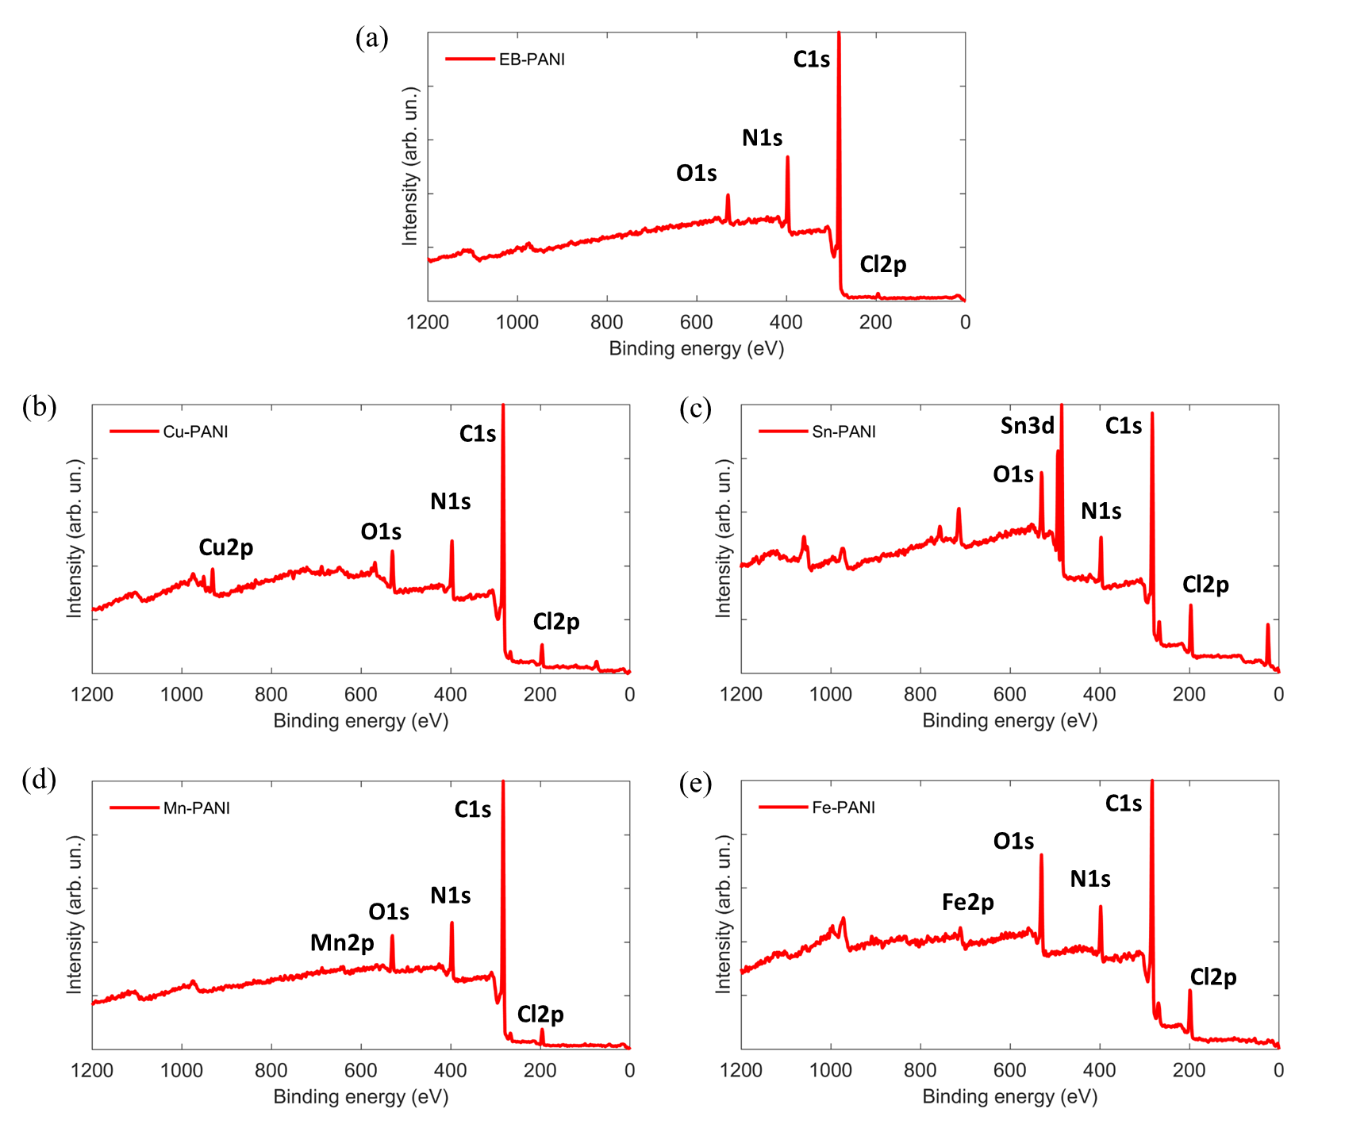
Figure S2 XPS survey spectra for samples EB-PANI (a), Cu-PANI (b), Sn-PANI (c), Mn-PANI (d), Fe-PANI (e).
Field-emission scanning electron microscopy (FESEM)
FESEM characterization was performed with the following configuration: SE2 detector for secondary-electron imaging, BSE detector for back-scattered electron imaging. As shown in Figure S3, the samples are in the form of nanopowders constituted of aggregated nanoparticles, with no evidence of residual metal salts or any metal-containing nanostructures, as confirmed by BSE imaging, which provides atomic-number (Z) contrast in the images.
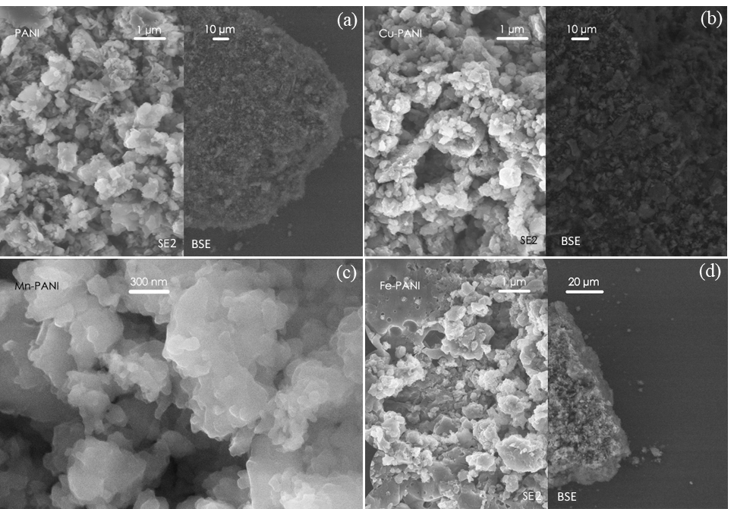
Figure S3 FESEM images of (a) EB-PANI, (b) Cu-PANI, (c) Mn-PANI and (d) Fe-PANI obtained by secondary electron signal (SE2 detector) and backscattered electron signal (BSE detector).

Chronoamperometric (CA) measurements
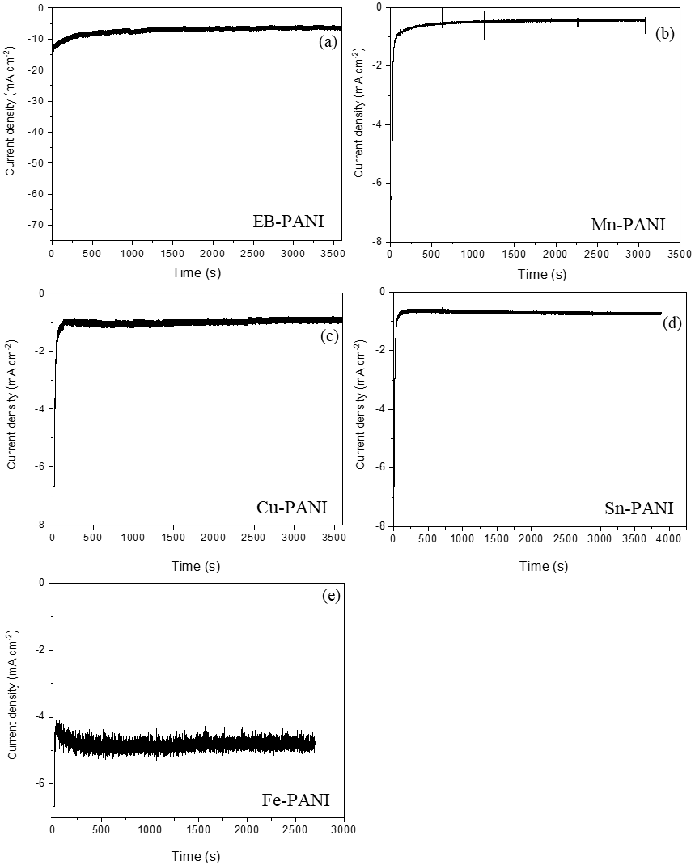
Figure S4 Chronoamperometric measurements on PANI-based electrodes in CO₂-saturated 0.1 M KHCO₃ electrolyte at -0.79 V vs RHE: (a) EB-PANI, (b) Mn-PANI, (c) Cu-PANI, (d) Sn-PANI and (e) Fe-PANI.
Chronoamperometric (CA) measurements
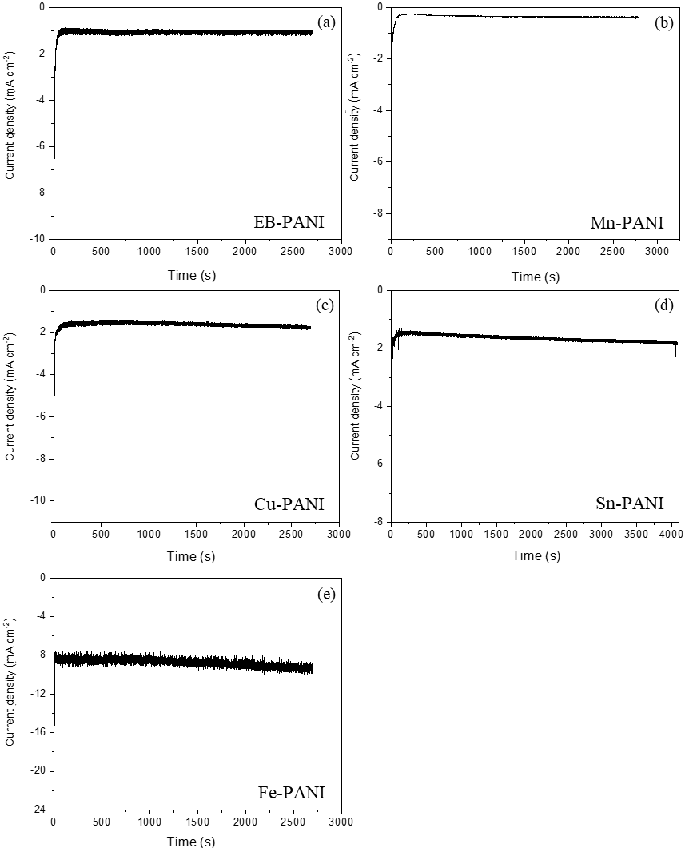
Figure S5 Chronoamperometric measurements on PANI-based electrodes in CO₂-saturated 0.1 M KHCO₃ electrolyte at -0.99 V vs RHE: (a) EB-PANI, (b) Mn-PANI, (c) Cu-PANI, (d) Sn-PANI and (e) Fe-PANI.
Product analysis
Figure S6 CO₂RR on various electrodes in CO₂-saturated 0.1 M KHCO₃ solution at -0.79 V vs RHE. (a) FE of products and (b) partial current density.

Cyclic voltammetry (CV) and Electrochemical Impedance Spectroscopy (EIS)
The activity of PANI-based electrodes was studied by CV in CO₂-saturated 0.1 M KHCO₃ electrolyte. As shown in Figure S7a, doping of Cu, Sn and Fe significantly increases the electrode activity of PANI, while Mn doping shows no enhancement, probably due to its much lower loading compared to other metals.
EIS was performed in N₂-purged and CO₂-saturated 0.1 M KHCO₃ electrolyte in order to better understand the role of the metal cations in polyaniline. Representative Nyquist plots of the impedance for the Cu-PANI sample acquired at different potentials in CO₂-saturated electrolyte are shown in Fig. S8, which includes experimental data and curves calculated exploiting the equivalent circuit reported as inset. Each component of the total resistance can be separated performing EIS measurements and fitting data with a proper model [2]. In particular, information about the charge transfer resistance (R_{CT}, the resistance associated to the electrocatalytic process) was evaluated in this work and reported in Figure S7b-f. The charge transfer resistances obtained in the N₂-purged and CO₂-saturated solutions for each catalyst are compared. Under N₂ atmosphere, H₂O is the only chemical specie able to be reduced. Instead, under CO₂ atmosphere, both H₂O reduction and CO₂ reduction reactions compete. The EB-PANI electrode shows a great difference between the R_{CT} values in the two solutions at most investigated potentials and much lower R_{CT} values in the N₂ one, implying that H₂O reduction could be dominant. Mn-PANI electrode performs completely differently from the EB-PANI and it displays a lower R_{CT} value in CO₂ electrolyte at each potential except -0.99 V, indicating its possible selectivity for the CO₂RR. For Cu-PANI and Sn-PANI, the difference of between R_{CT} values in the two solutions is much smaller than that in the PANI, indicating that they could be more selective for the CO₂RR with respect to the latter. In contrast, Fe-PANI shows a significantly lower R_{CT} value in N₂ electrolyte with respect to that in the CO₂ one, indicating its scarce selectivity for the CO₂RR. Combining the CV and EIS analyses, it is expected that doping PANI with Cu and Sn could increase both the electrode activity and selectivity toward the CO₂RR, while Fe doping could largely enhance the activity for H₂O reduction. The characteristics of Mn-PANI are not clear, since it demonstrates low activity but possible selectivity for the CO₂RR, thus requiring additional investigation. The product analysis with µGC and HPLC has been conducted in order to confirm the performance of various catalyst.
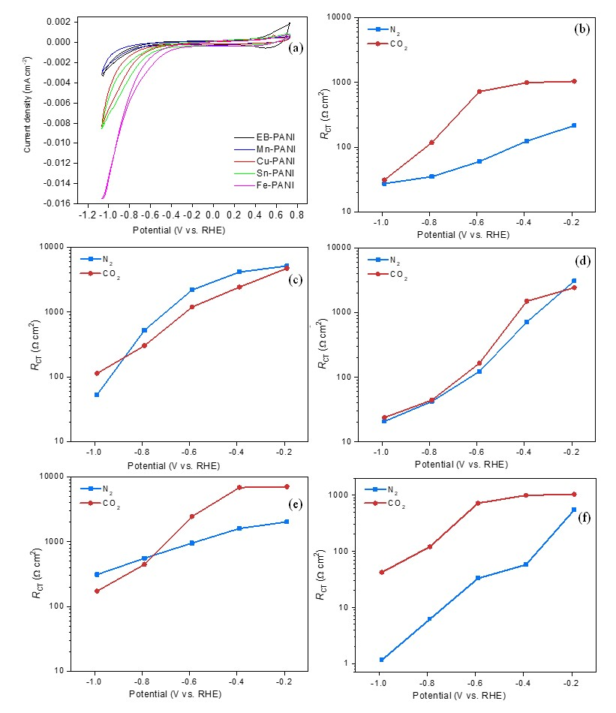
Figure S7 (a) cyclic voltammograms of EB-PANI, Mn-PANI, Cu-PANI, Sn-PANI and Fe-PANI. Charge transfer resistance, R_{CT}, in N₂-purged and CO₂-daturated electrolyte: (b) EB-PANI, (c) Mn-PANI, (d) Cu-PANI, (e) Sn-PANI and (f) Fe-PANI.
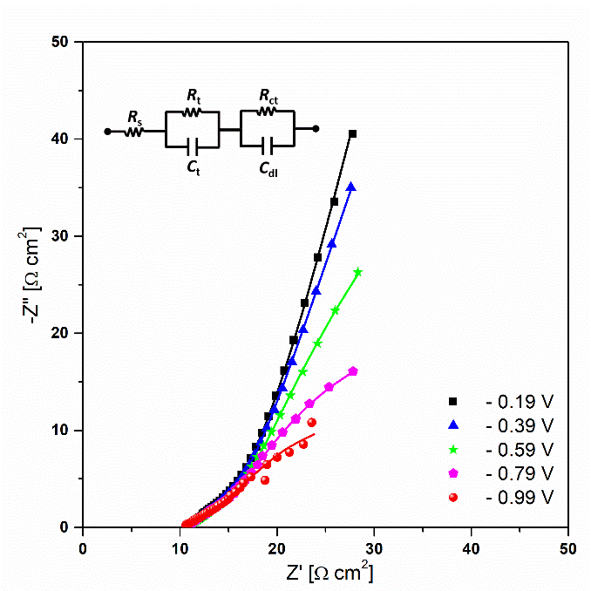
Figure S8 Nyquist plot of the impedance data acquired on Cu-PANI electrode in CO₂-saturated electrolyte at different potentials (the points are experimental data; the lines are calculated using the equivalent circuit shown in the inset).

Double layer capacitance (C_{dl})
The C_{dl} values of various electrodes (PANI, Cu-PANI, Mn-PANI and Sn-PANI) are evaluated by cyclic voltammetry at various scan rates in a potential range where no faradaic process occurs. The geometric current density is plotted against the scan rate and the slope of the linear fitting quantifies the C_{dl}.
Figure S9 Determination of double-layer capacitance for various electrodes in N₂-purged 0.1 M KHCO₃: (a) representing CVs on Cu-PANI electrode; (b) Capacitance values calculated from the slopes of current densities vs. scan rate.

References
1. Chiolerio A, Bocchini S, Crepaldi M, Bejtka K, Pirri CF (2017) Bridging Electrochemical and Electron Devices: Fast Resistive Switching Based on Polyaniline from One Pot Synthesis Using FeCl₃ as Oxidant and Co-Doping Agent. Synth Met 229:72-81. https://doi.org/10.1016/j.synthmet.2017.05.001
2. Sacco A (2018) Electrochemical Impedance Spectroscopy as a Tool to Investigate the Electroreduction of Carbon Dioxide: A Short Review. J CO2 Util. 27:22-31. https://doi.org/10.1016/j.jcou.2018.06.020

