SUPPORTYING INFORMATION

Electrochemical sensor based on epoxy-functionalized BEA nanozeolite and graphene oxide modified glassy carbon electrode for bisphenol E determination
Alex H. Miller ^{a, b, 1}, Huong Thi-Thanh Nguyen ª, José G. Nery ^{b}, Alistair J. Fielding ^{a,*}
ª Centre for Natural Products Discovery, School of Pharmacy and Biomolecular Science, Liverpool John Moores University, James Parsons Building, Byrom Street, Liverpool, L3 3AF, United Kingdom.
^{b} Physics Department, Institute of Biosciences, Letters, and Exact Sciences – IBILCE / São Paulo State University – UNESP, São José do Rio Preto, São Paulo, 15054-000, Brazil.
Orcid: AHM (0000-0001-8269-850X), HTTN (0000-0002-3261-9866), JGN (0000-0003-0647-8921) and AJF (0000-0002-4437-9791)
¹ Present address: Department of Chemistry, University of York, Heslington, York YO10 5DD, United Kingdom.
Corresponding Author
*e-mail: a.j.fielding@ljmu.ac.uk

Figure S1. XRD patterns of the calcinated BEA nanozeolite (A). FT-IR of BEA before and after alkoxysilane functionalization (B). SEM images of the calcinated BEA material in higher (C) and lower magnification (D).
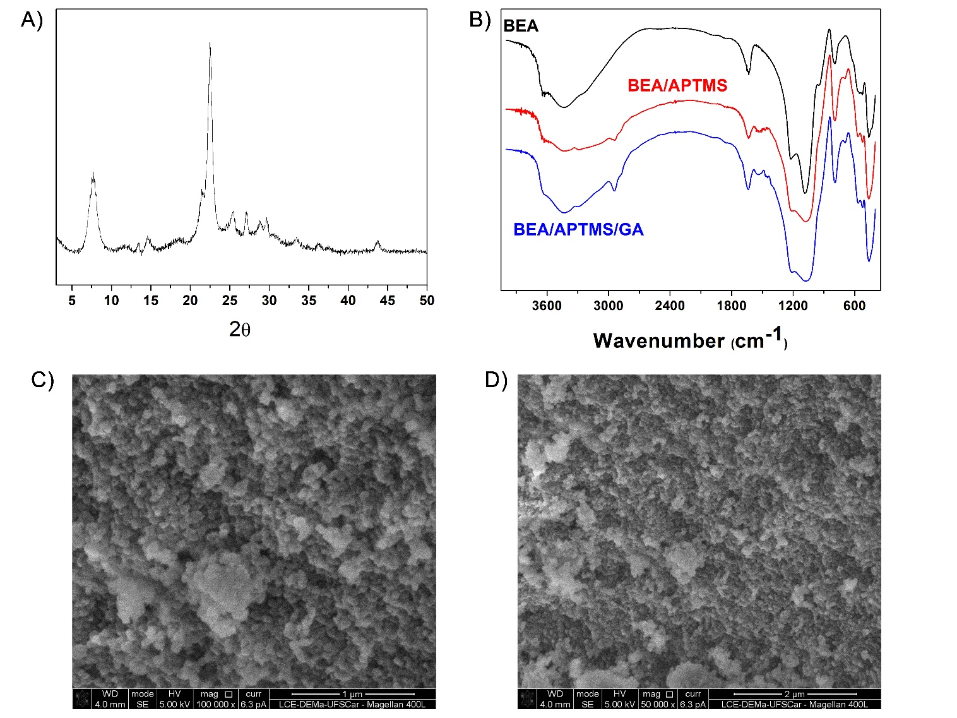

Figure S2. FT-IR of GO before and after functionalization.
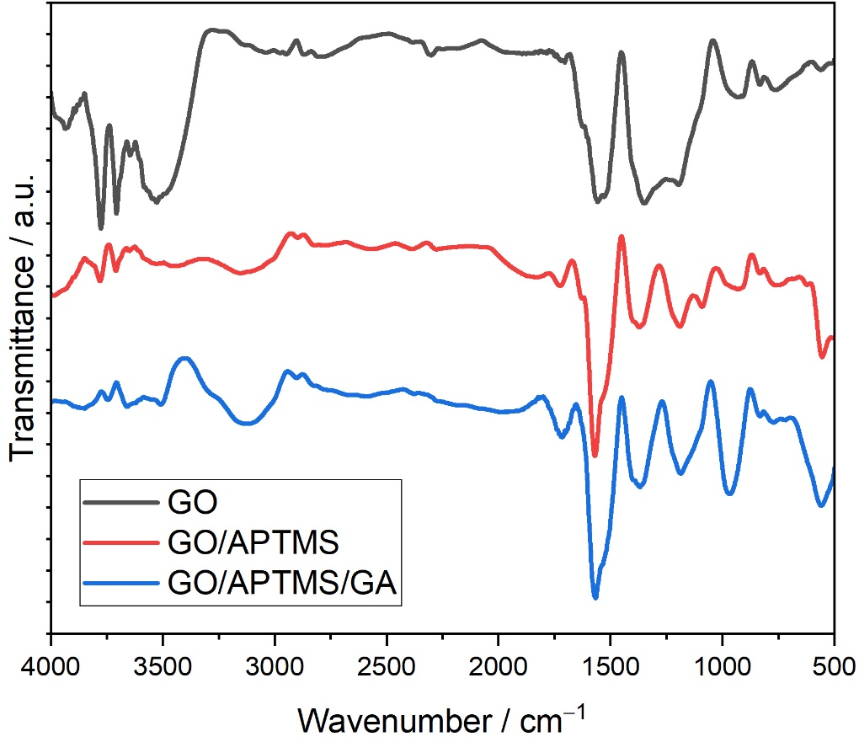

Figure S3. Cyclic voltammograms of 50 µM BPE in phosphate buffer pH 5 (solid black lines) at bare or modified GCE electrodes. Doted lines are the background CV curves obtained in the absence of BPE. Scan rate of 50 mV/s, N₂ atmosphere.
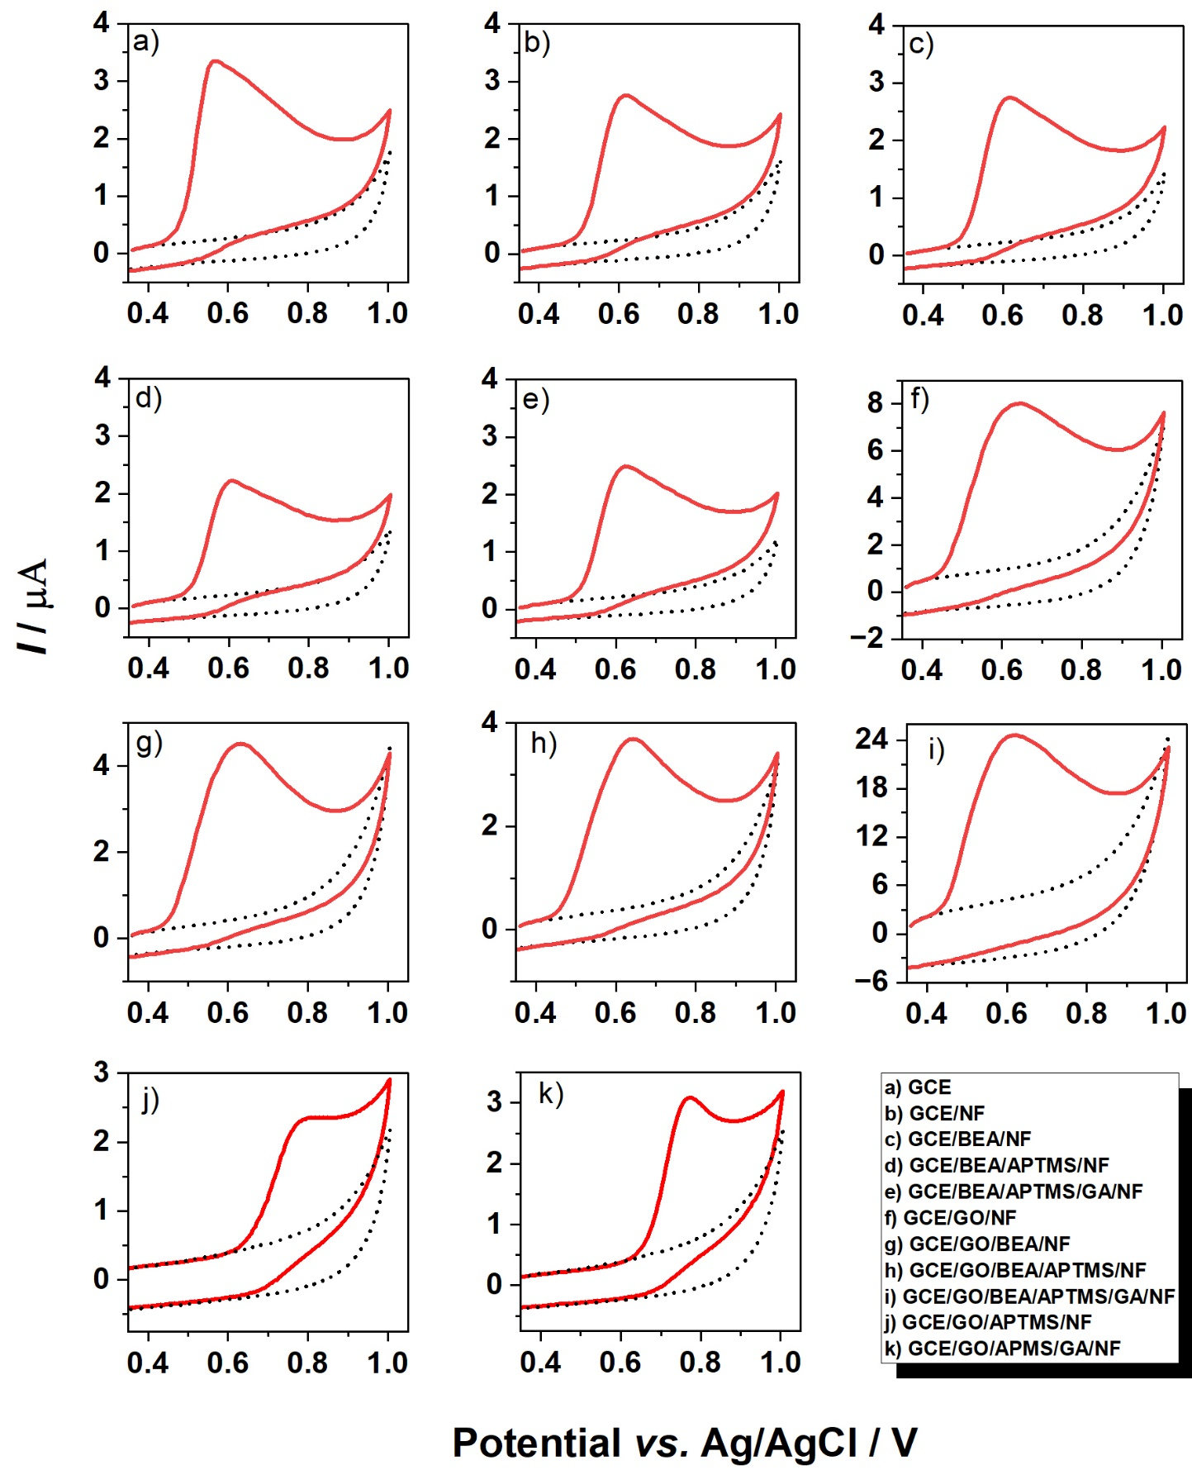

Figure S4. A) The CV curves of 50 µM BPA in different pH values (Britton-Robinson buffer) at GCE/GO/BEA/APTMS/GA/NF electrode. Background was first recorded in the absence of analyte and subtracted from the respective voltammograms. Scan rate 100 mVs⁻¹, N₂ atmosphere. B) E_{p} vs. pH plot. Regression equation: E_{pa} = (−0.0528 ± 0.002)pH + (0.942 ± 0.001) (V, R = 0.999).
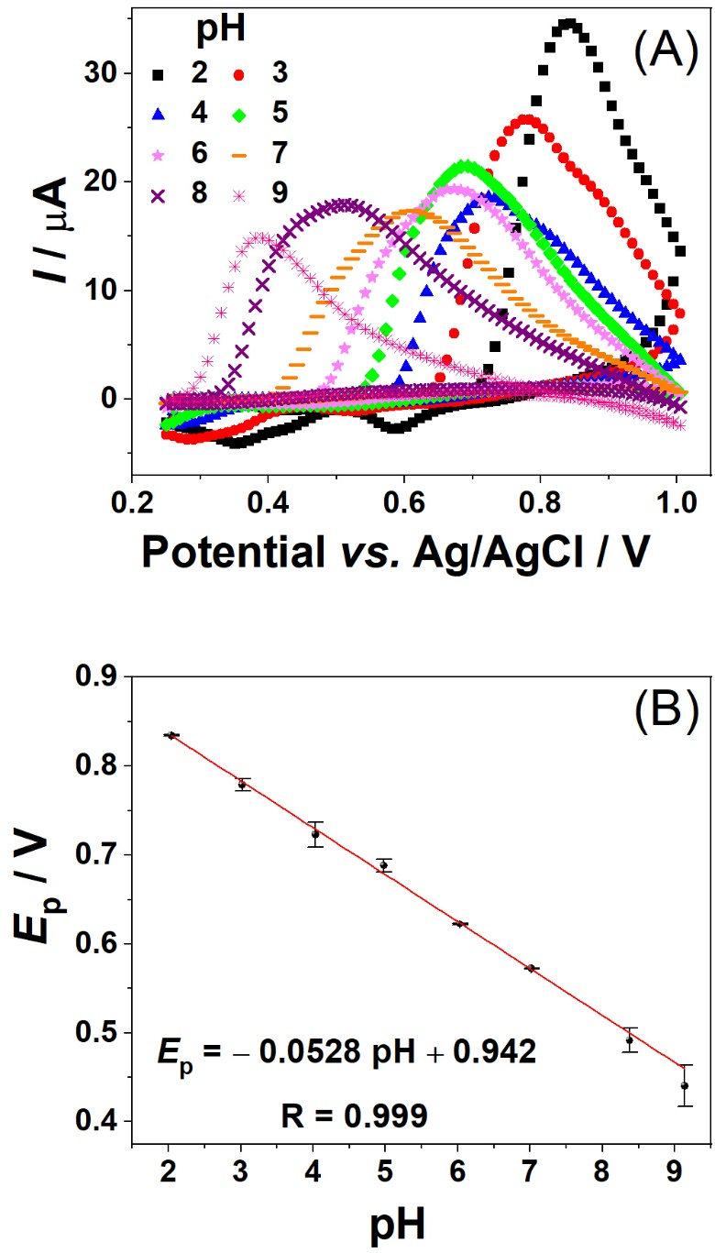

Figure S5. SEM images of bare GCE surface (A), GCE/GO/BEA/APTMS/GA (B) and GCE/GO/BEA/APTMS/GA/NF with lower magnification (C) and higher magnification (D).
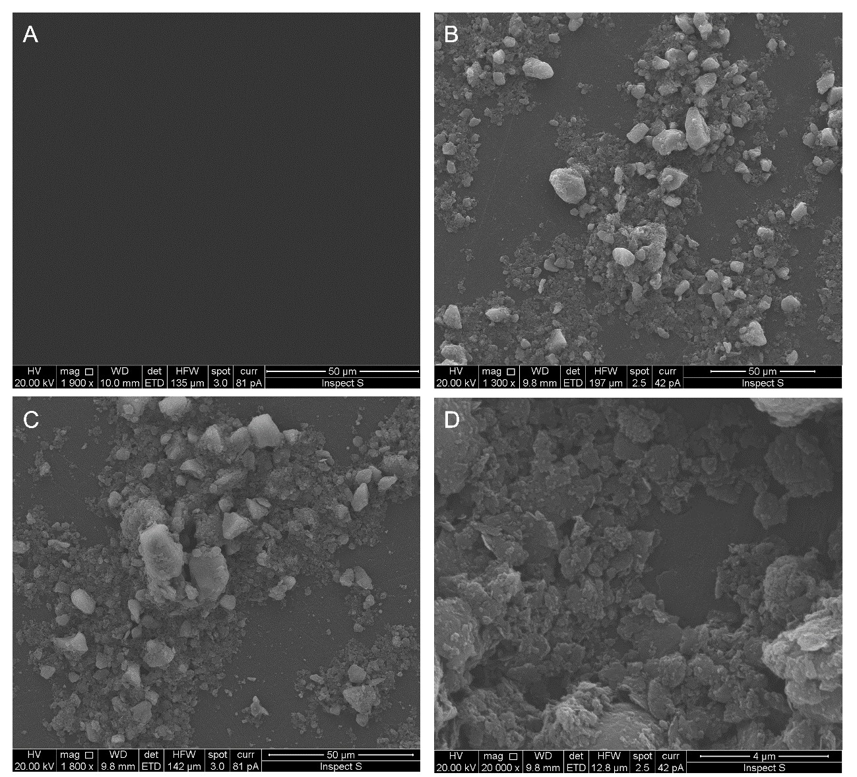

Figure S6. The DPV curves for different BPA concentrations (A): a – 0.07, b – 0.20, c – 0.33, d – 0.46, e – 0.71, f – 1.19, g – 2.09, h – 3.10, I – 4.00, j – 4.81 and k – 6.21 µM. Linear regression for the calibration C_{BPA} versus anodic peak current (I_{p}) (B). The increment potential, pulse period, pulse amplitude and pulse width were adjusted at 0.075 mV, 0.4 s, 0.05 V and 0.075 s, respectively.
