Supplementary Information
Elevated Pressure CO₂ Reduction in a Flow Cell
Andrew R.T. Morrison‡⁂, Nandalal Girichandran‡, Quincy Wols, Ruud Kortlever*

Large-Scale Energy Storage, Process & Energy Department,
Faculty of Mechanical, Maritime and Materials Engineering,
Delft University of Technology, Leeghwaterstraat 39, 2628 CB Delft, The Netherlands
‡ - These authors contributed equally

Table of Contents

S1. Exploded View of the Flow Cell 3
S2. PEIS at Different Applied Gas Pressures 4
S3. Reservoir Design 5
S4. GC Response Time Calculations – Two Flow Rate Strategy 6
S6. Standard Curve of a HPLC measurement 10
S7. GC analysis and Faradaic Efficiency Calculations 11
References 12

S1. Exploded View of the Flow Cell

Figure S1: Components of the flow cell: (a) Insulation port for clamp to press against, (b) End Plate - Stainless steel, (c) Anode – IrMMO foil, (d) Anode flow plate – PEEK, (e) Membrane – Nafion 117, (f) O ring – Kalrez, (g) Cathode flow plate – PEEK, (h) Cathode – Gold foil.

S2. PEIS at Different Applied Gas Pressures

The impedance measurement were carried out at 0 V, where there is no significant reaction taking place. The resistance values measured are comparable to the work of Lobaccaro et al. [1], and are typical for a such an H-cell configuration.
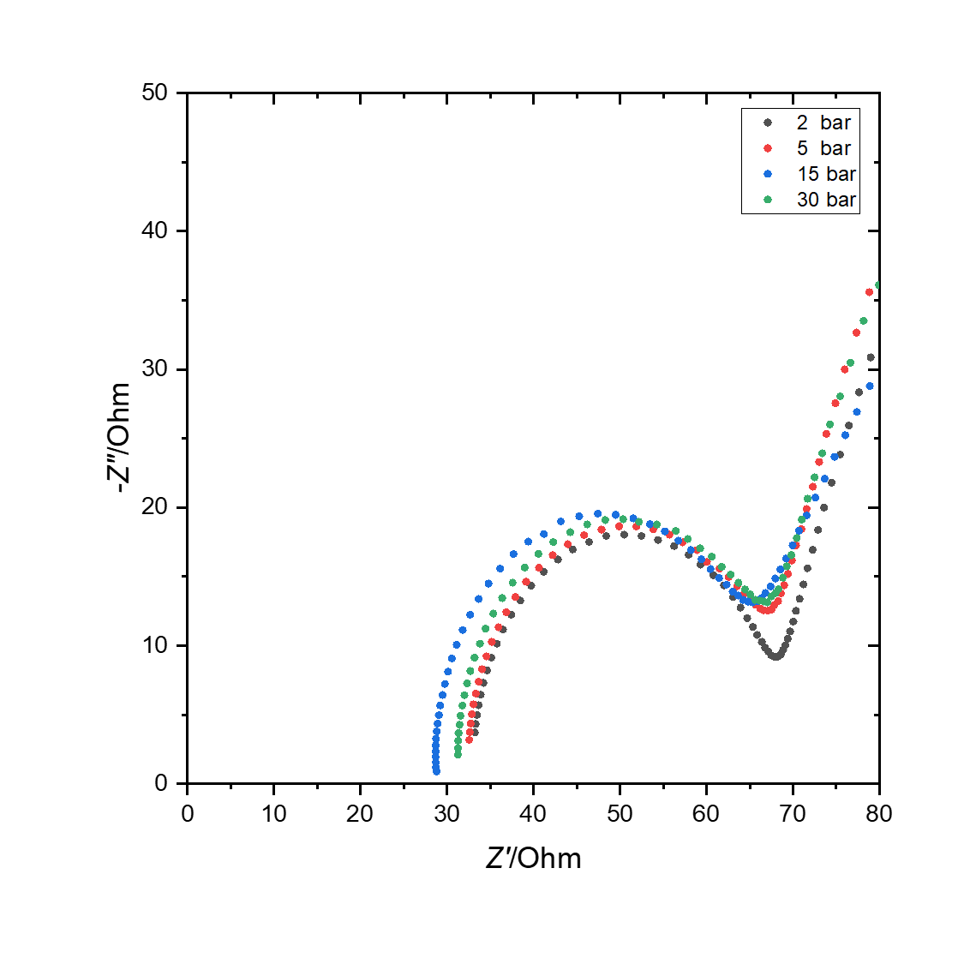
Figure S2: Nyquist plots at different pressures recorded at the start of the experiments using a Au foil as WE and Ag/AgCl as RE in a 0.1 M KHCO₃ electrolyte. Frequency range: 50 mHz to 700 kHz.

S3. Reservoir Design

The main body of the reservoir frame is made from Aluminum 5083 which supports the pistons and cylinder in position while the pressure is increased. The pistons are made from PEEK and their main purpose is in sealing the cylinder, making it gas tight. The diameter of the pistons is around 38.05 mm and the use of IDEX O-rings ensures a snug fit in the stainless steel 316 alloy cylinder. The main volume of the reservoir was adjusted using a piece PEEK cylinder that could slide in and out of the cylindrical space. The top piston had four holes to accommodate four tubes namely: the high-pressure gas inlet, a gas outlet to the GC, electrolyte to the reactor, and products from the reactor.

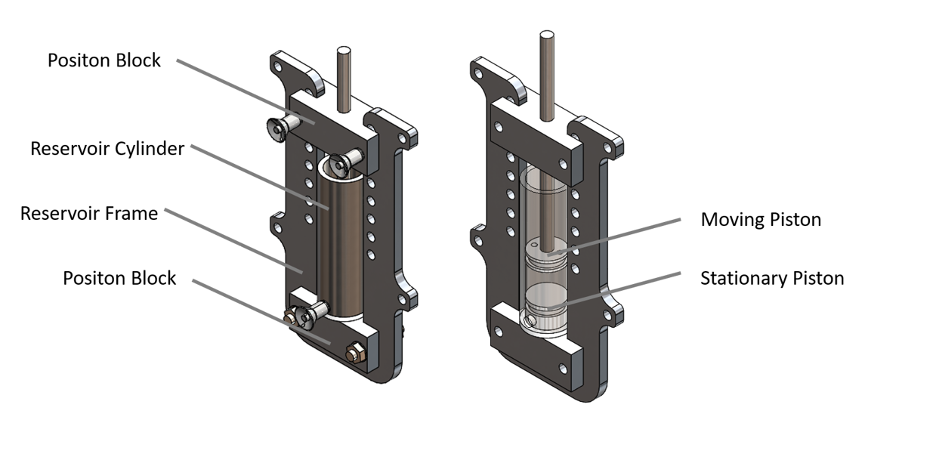
Figure S3: A simplified diagram of the gas-liquid reservoir used to pressurize the electrolyte using high-pressure CO₂.

S4. GC Response Time Calculations – Two Flow Rate Strategy

One of the challenges of operating at high pressure is that it complicates online GC measurements. This is because the added pressure increases the effective volume of the headspace. The headspace will increase linearly with the pressure. The volume of headspace that is being sampled by the GC is a key factor because of the dynamics that affect GC settling time (the time that it takes the GC signal to be within 5% of the final concentration in the head space), which goes as:
$t_{s}≈\frac{3∙V_{h_eff}}{q}$ (S1)

where t_{s} is the settling time, V_{h_eff} is the effective volume of headspace (Pressure*V_{h}), and q is the flowrate of gas from the headspace to the GC. It is also possible to add a delay term, based on the linear velocity of the products from the reactor to the reservoir and from the reservoir to the GC, however this is only significant if the delay is lower than the settling time. This also neglects the time that must be taken after the concentration has reached its equilibrium to ensure the equilibrium has been reached in a real experiment, but this is similar in all conditions. The settling time is thus determined by the flow rate of gas to the GC and the size of the headspace. The flow rate of the gas from the reservoir to the GC also affects the steady-state value, which means that the flow rate determines the sensitivity of the GC measurement. So, while it can be increased to decrease settling time, there is some limit. Similarly, there are practical limits to the size of headspace that can be consistently achieved due to engineering restrictions.
The solution to these issues is to use a switching flow rate to the GC. In the initial period of the experiment a low flow rate can be used. The initial rate must be low enough that pressure cannot build up, but otherwise any rate, as low as possible, is desirable. The low flow rate allows the concentration in the head space to build more quickly than a faster flow rate, but the settling time would be longer because of the higher steady state value. So, switching to the high flow rate after a low flow rate combines the quickly increasing concentration with the low equilibrium concentration of a fast flow rate to decrease the overall time. The trick, then, is to switch to a faster flow rate approximately when you expect that the reservoir concentration will be near the final concentration. To explain why, consider the more general derivation of equation S1. Starting from the simple differential equation representing the flow of products into the head space, and outflow of gases to the GC. The change in amount of the product in the headspace in time will increase at the rate of production and decrease at the rate that the product leaves the headspace:
$\frac{dn}{dt}=r-c∙q$ (S2)

where n is the amount (mol) of gas in the headspace to be measured and c is the concentration in the headspace. Solving this, and converting amount to concentration via volume, V, gives the general solution of:
$c\left(t\right)=\frac{\left(r-e^{-{qt}/V}∙\left(r-c{}_{0}q\right)\right)}{q}$ (S3)

where c₀ is the initial concentration. The final concentration can be seen to be r/q, by taking the limit of eq. S3 as t→∞. The time at which a given target concentration is reached is given by re-arranging eq S3.:
$t_{tar}=\frac{-V}{q}ln\left(\frac{r-c_{tar}q}{r-c_{0}q}\right)$ (S4)

To evaluate how much quicker the two-speed switching strategy is we will allow the concentration to run to a percentage of the final concentration. Consider a high (q_{h}) and a slow (q_{s}) flow rate. We will consider q_{h} equal to 40x q_{l} (0.2 ml/min and 8 ml/min). The final concentration in question is based on the high flow, and therefore is r/q_{h}. Concentration reaches 80% when:
$t_{l}=\frac{-V}{q_{l}}ln\left(\frac{r-0.8r/{q_{h}}q_{l}}{r-c_{0}q_{l}}\right)=\frac{-V}{q_{l}}ln\left(\frac{r-0.8*0.025r}{r}\right)$ (S5)
$t_{l}≈\frac{0.808V}{q_{h}}$ (S6)

Then from 80% concentration the time to get to with 5% of the final concentration:
$t_{h}=\frac{-V}{q_{h}}ln\left(\frac{r-0.95r/{q_{h}}q_{h}}{r-0.8r/{q_{h}}q_{h}}\right)=\frac{-V}{q_{l}}ln\left(\frac{r-0.025r}{r}\right)$ (S7)
$t_{l}≈\frac{1.38V}{q_{h}}$ (S8)

And the total time to reach within 5% of the final concentration when the flow rate is switched from 0.02 to 8 ml/min when the headspace concentration reaches 80%:
$t_{80\%}≈\frac{2.2V}{q_{h}}$ (S9)

Of course, when running a real experiment, the final concentration is not known, but by repeated experimentation the final concentration can be estimated accurately, but it will not be exact each time. However, the method is not that sensitive to the exact percentage of final concentration reached. This method will work for a range of stopping points for the slow flow rate. In the general case the total time to within 5% of the equilibrium value is
$t_{p}=\left\{\begin{aligned}-\left(40\ln\left(1-0.025p\right)+ln\left(\frac{0.05}{1-p}\right)\right) p<0.95 \\ -\left(40\ln\left(1-0.025p\right)+ln\left(\frac{-0.05}{1-p}\right)\right) p>1.05\end{aligned}\right.$ (S10)
for switching to fast flow at a percentage, p, of the final equilibrium value, this equation has been plotted in figure S4. As can be seen, time will be saved for any value of p<1.27, and a substantial time saving is made if the final concentration can be estimated within ±15%.

Figure S4: The relationship between switching time between slow and high flow and the total time the GC will take to reach with 5% of the final concentration.
S5. Comparison of High Pressure CO₂ Reduction Studies

Entry | *P_{CO2} / bar | T/ºC | Current density / mA cm⁻² | Electrolyte | Cathode | Cell type | FE_{CO2RR}  / % | Reference
1 | 30 | 25 | 10 | 0.1 M KHCO₃ | Au foil | Parallel plate Flow | 60 | This work
2 | 30 | 25 | 12 | 0.2 M K₂SO₄ | Ag plate | Autoclave | 67 | [2]
3 | 30 | 25 | 120 | 0.5 M KHCO₃ | Ni-NC | Autoclave | 90 | [3]
4 | 30 | 45 | 6-13 | 1-ethyl-3-methyl-imidazolium triflate | Zn–Cu | Autoclave | 97 | [4]
5 | 30 | 25 | 163 | 0.1 M KHCO₃ | Agu plate | Autoclave | 77 | [5]
6 | 60 |  | 215 | 0.5 M KHCO₃ | Sn plate | Autoclave | ~100 | [6]
7 | 24.6 | 60 | 275 | 0.5 M K₂SO₄ | Ag GDE | GDE | 80 | [7]
8 | 7 | 25 | 80-100 | 7 M KOH | Ag GDE | GDE | 85-90 | [8]
9 | 50 | Amb | 30 | 0.5 M KHCO₃ | Sn plate | Parallel plate flow | 80 | [9]
10 | 30 | Amb | 45 | 0.1 M KHCO₃ | Sn plate | Parallel plate flow | 80 | [10]

S6. Standard Curve of a HPLC measurement

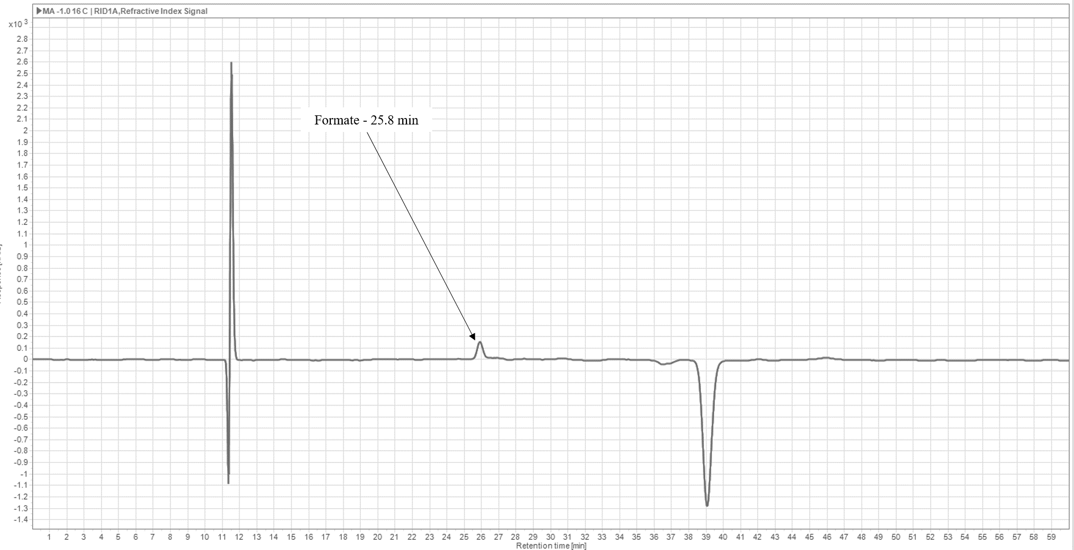

Figure S5: Standard HPLC curve for the detection of formate/formic acid. The presence of formic acid (FA) either as an acid or as its conjugate base formate is dependent on pH. Dissolving CO₂ gas at high pressures into 0.1 M KHCO₃ would result in an acidic pH. However, in our system a liquid sample was collected only after depressurizing the system which would result in release of all dissolved excess CO₂ at the pressure studied. Therefore, the electrolyte would revert back to an alkaline pH and we expect formate as the main form of FA. This corresponds with conditions that the standard curve was taken at.

S7. GC analysis and Faradaic Efficiency Calculations

The GC we use directly utilizes CO₂ as the carrier and we calibrate it using gas mixtures namely, ethylene, CO, CH4 and H2 in different concentrations with CO₂ as the bulk gas. The high-pressure gas stream from our reservoir is first sent through a pressure reducer that delivers the gases at a constant pressure of ~ 3 bar to a mass flow controller (MFC, Bronkhorst). Using the MFC we control the volumetric rate to the GC (in our case we switch between two values, 0.2 mln/min and 8 mln/min in order to speed up the GC settling time). The columns in the GC have been modified to handle CO₂ as carrier gas and so we don’t see CO₂ as a separate but rather it forms the baseline.
FE gaseous products = (n*F*X*molar flow rate)/ I
Where, n = number of electrons, F = Faraday’s constant (96485 C/mol), X = mole fraction of gaseous product measured by the GC, I = total current applied.
For liquid product analysis, HPLC was used (details are provided in the paper).
FE liquid products = (n*F*C*V)/Q_{tot}
Where, C = concentration derived from HPLC peak integration, V = volume of the catholyte from which the sample is collected for analysis, Q_{tot} = total charge passed during the experiment.

References

[1] P. Lobaccaro, M.R. Singh, E.L. Clark, Y. Kwon, A.T. Bell, J.W. Ager, Effects of temperature and gas–liquid mass transfer on the operation of small electrochemical cells for the quantitative evaluation of CO₂ reduction electrocatalysts, Physical Chemistry Chemical Physics, 18(38) (2016), 26777-26785.

[2] F. Proietto, F. Berche, A. Galia, O. Scialdone, Electrochemical conversion of pressurized CO₂ at simple silver-based cathodes in undivided cells: study of the effect of pressure and other operative parameters, Journal of Applied Electrochemistry, 51 (2021), 267-282.

[3] F. Proietto, S. Li, A. Loria, X.-M. Hu, A. Galia, M. Ceccato, K. Daasbjerg, O. Scialdone, High-pressure synthesis of CO and syngas from CO₂ reduction using Ni−N-doped porous carbon electrocatalyst, Chemical Engineering Journal, 429 (2022), 132251.

[4] T. Pardal, S. Messias, M. Sousa, A.S.R. Machado, C.M. Rangel, D. Nunes, J.V. Pinto, R. Martins, M.N. da Ponte, Syngas production by electrochemical CO₂ reduction in an ionic liquid based-electrolyte, Journal of CO2 Utilization, 18 (2017), 62-72.

[5] K. Hara, A. Kudo, T. Sakata, Electrochemical reduction of carbon dioxide under high pressure on various electrodes in an aqueous electrolyte, Journal of Electroanalytical Chemistry, 391(1) (1995), 141-147.

[6] M. Todoroki, K. Hara, A. Kudo, T. Sakata, Electrochemical reduction of high pressure CO₂ at Pb, Hg and In electrodes in an aqueous KHCO₃ solution, Journal of Electroanalytical Chemistry, 394(1) (1995), 199-203.

[7] E.J. Dufek, T.E. Lister, S.G. Stone, M.E. McIlwain, Operation of a Pressurized System for Continuous Reduction of CO₂, Journal of The Electrochemical Society, 159(9) (2012), F514-F517.

[8] C.M. Gabardo, A. Seifitokaldani, J.P. Edwards, C.-T. Dinh, T. Burdyny, M.G. Kibria, C.P. O’Brien, E.H. Sargent, D. Sinton, Combined high alkalinity and pressurization enable efficient CO₂ electroreduction to CO, Energy & Environmental Science, 11(9) (2018), 2531-2539.

[9] M. Ramdin, A.R.T. Morrison, M. de Groen, R. van Haperen, R. de Kler, E. Irtem, A.T. Laitinen, L.J.P. van den Broeke, T. Breugelmans, J.P.M. Trusler, W.d. Jong, T.J.H. Vlugt, High-Pressure Electrochemical Reduction of CO₂ to Formic Acid/Formate: Effect of pH on the Downstream Separation Process and Economics, Industrial & Engineering Chemistry Research, 58(51) (2019), 22718–22740.

[10] F. Proietto, B. Schiavo, A. Galia, O. Scialdone, Electrochemical conversion of CO₂ to HCOOH at tin cathode in a pressurized undivided filter-press cell, Electrochimica Acta, 277 (2018), 30-40.

