supporting Information
Electrocatalytic performances of a nickel phthalocyanine-carbon nanotube composite towards the detection of Hg²⁺ ions.

Vuyelwa Ngwenya,ª Peter N. Nelson,^{b} Lydia Rhyman,^{c, d} Ponnadurai Ramasami,^{c, d} Irvin Noel Booysen,ª* Allen Mambanda,ª*
ªSchool of Chemistry and Physics, University of KwaZulu-Natal, Private Bag X01, Scottsville, Pietermaritzburg, 3209.
^{b} Department of Chemistry, Faculty of Science and Technology, The University of the West Indies Mona, Kingston, Jamaica.
^{c} Computational Chemistry Group, Department of Chemistry, Faculty of Science, University of Mauritius, Réduit, 80837, Mauritius.
Centre of Natural Product Research, Department of Chemical Sciences, University of Johannesburg, Doornfontein Campus, Johannesburg 2028, South Africa.

Fig. S1a: Chemical structure of 1 showing the proton (A) and carbon (B) numbering.

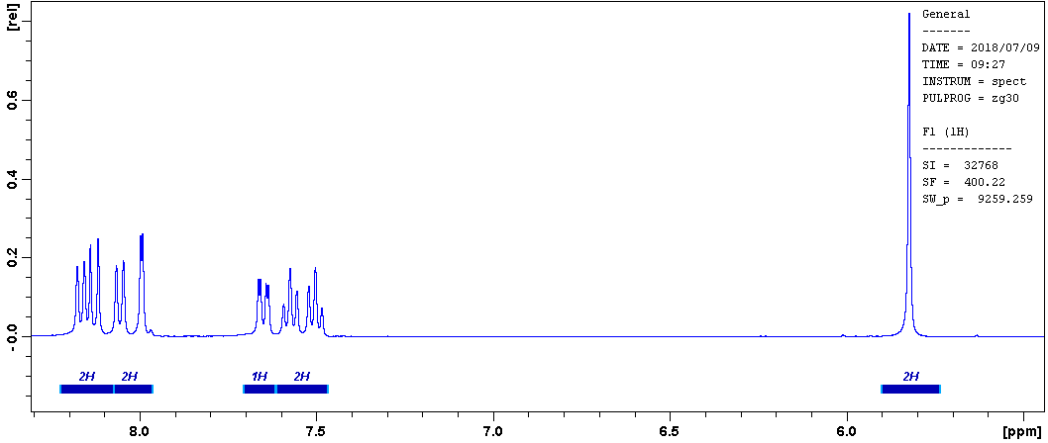
Fig. S1b: ¹H NMR spectrum of 1.

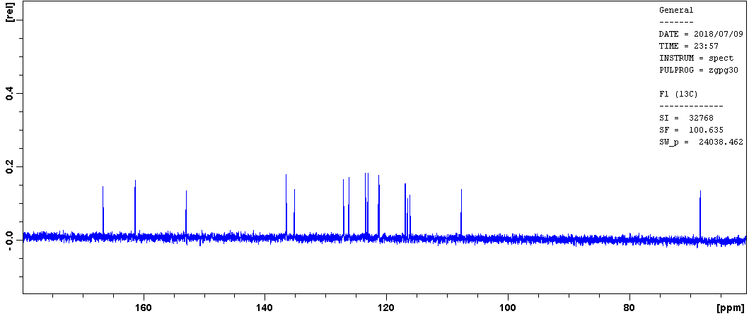
Fig. S1c: ¹³C NMR spectrum of 1.

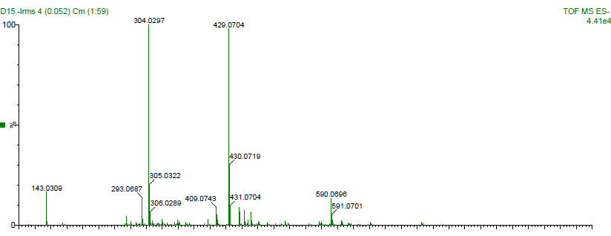

Fig. S1d: Low-resolution ESI⁺-MS spectrum of 1.
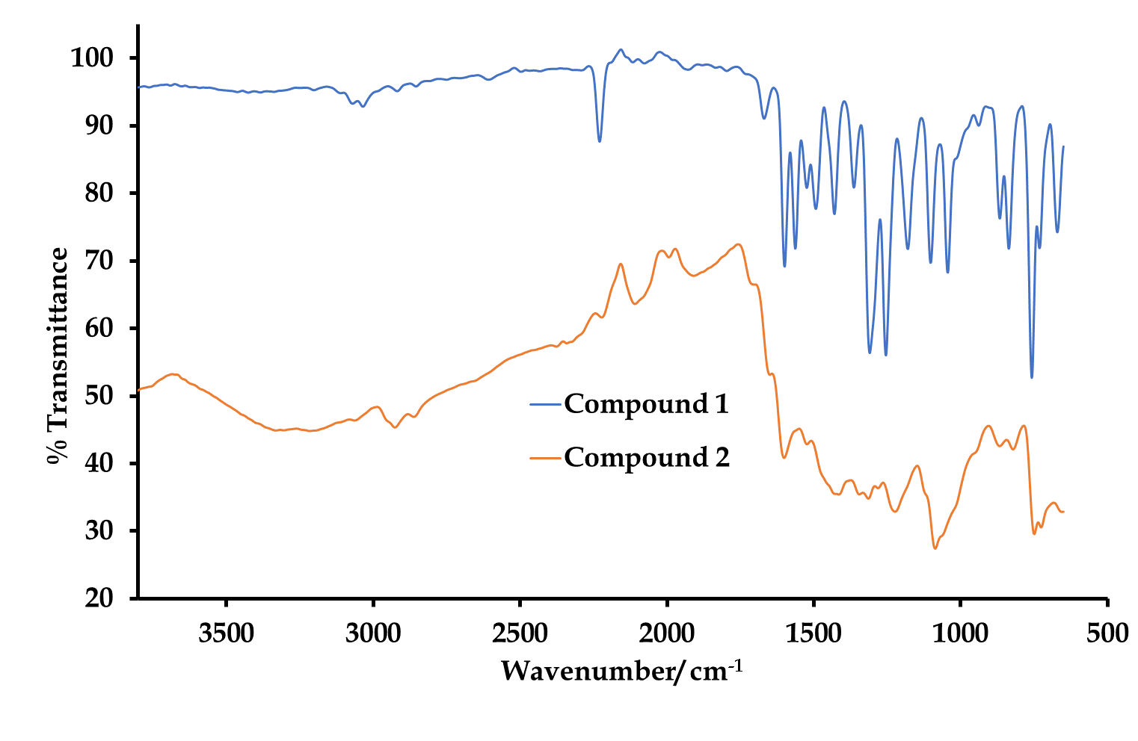
Fig. S2a: Overlay IR spectra of 1 and 2

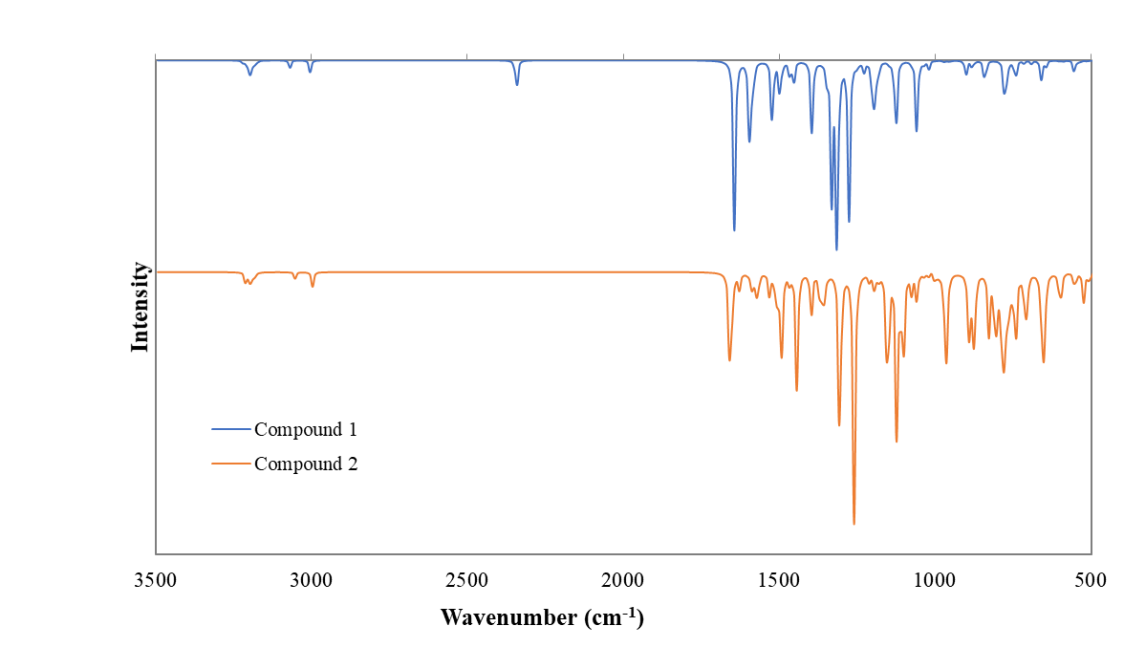
Fig. S2b: Simulated IR spectra of 1 and 2. The frequency range 500 – 3500 cm⁻¹ of 1 is magnified by 7 for comparison with 2. The frequency range 500-1000 cm⁻¹ of 2 is magnified by 7 for interpretation (1 was optimised using the B3LYP/6-311G(d,p) method).
method).

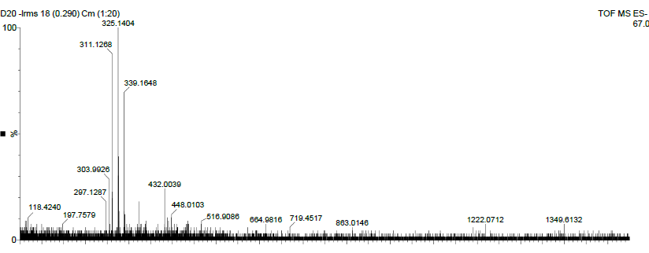
Fig. S3: ESI⁺-MS spectrum of 2.

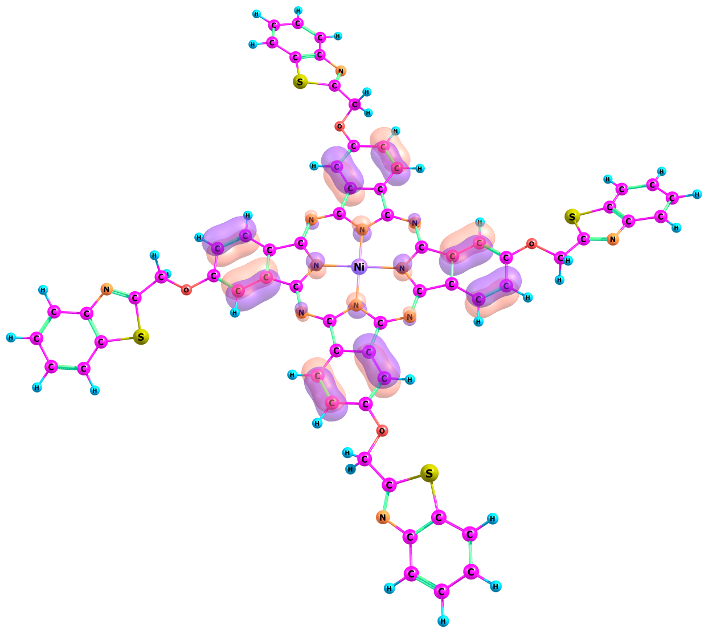 | 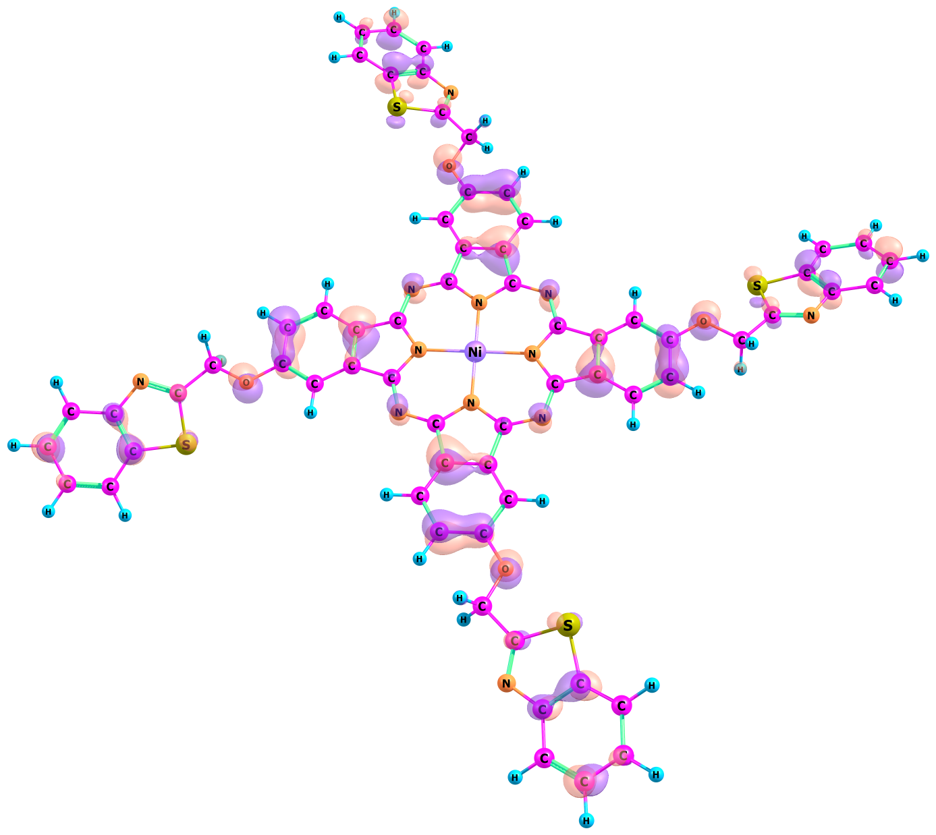
H-16 | H-8
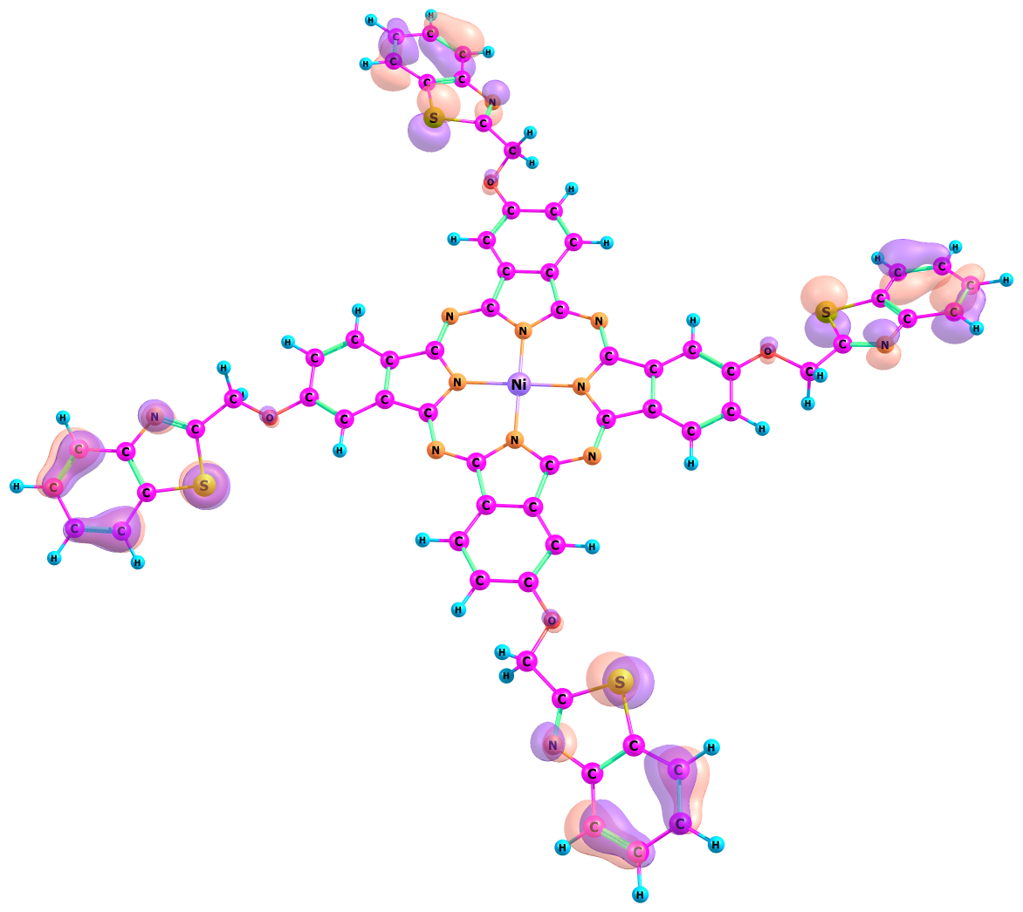 | 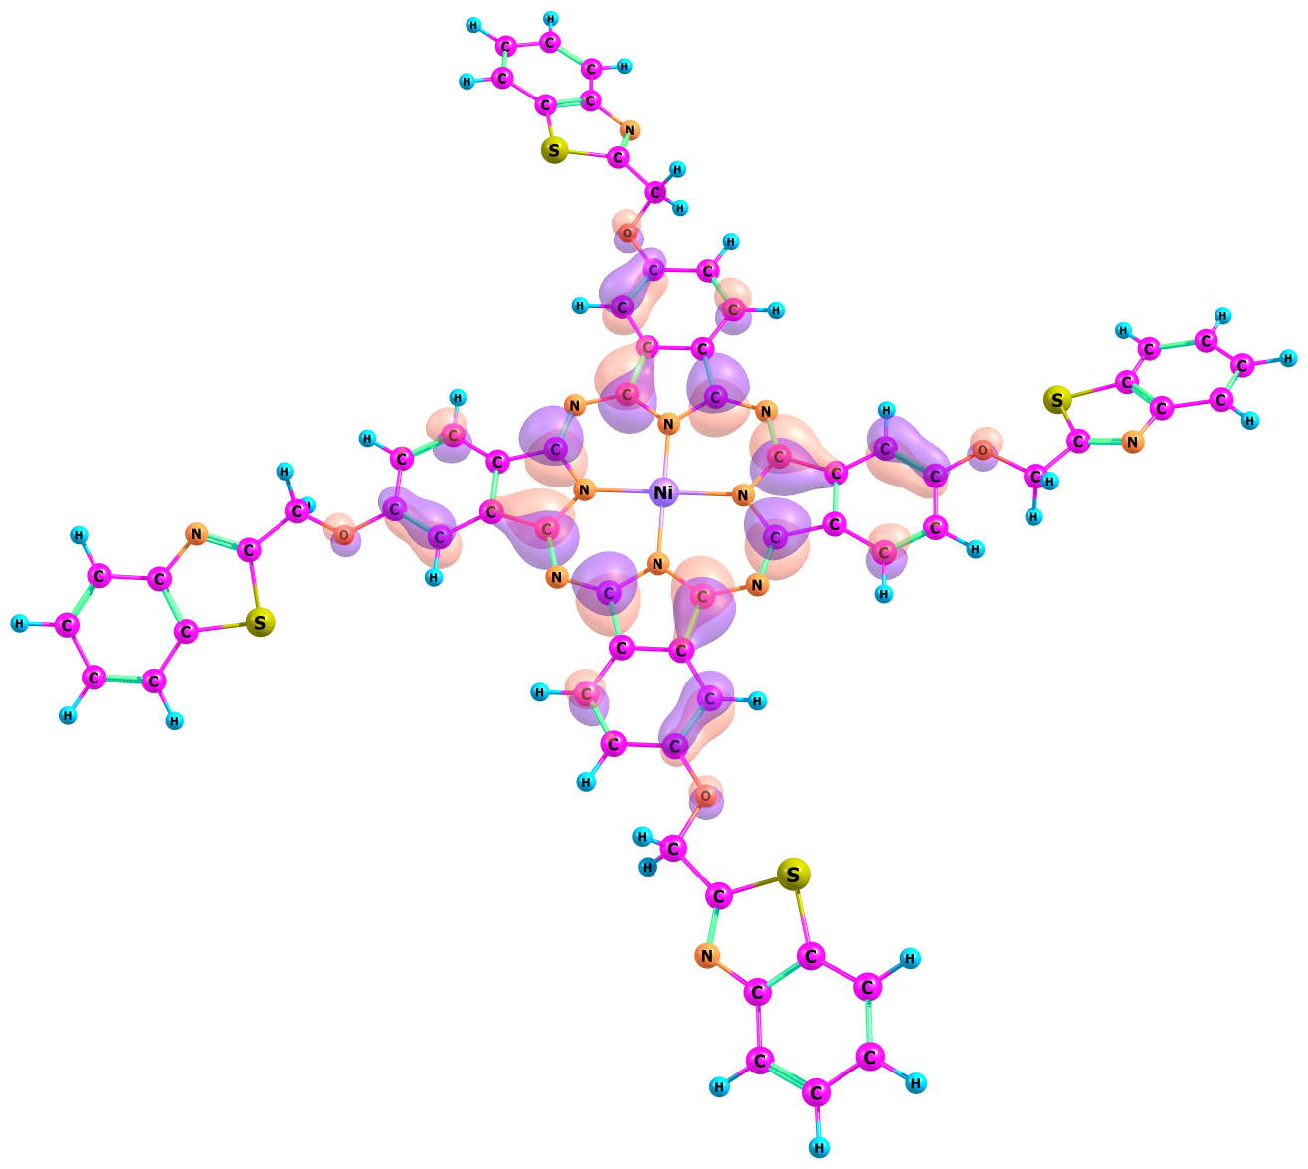
H-4 | H
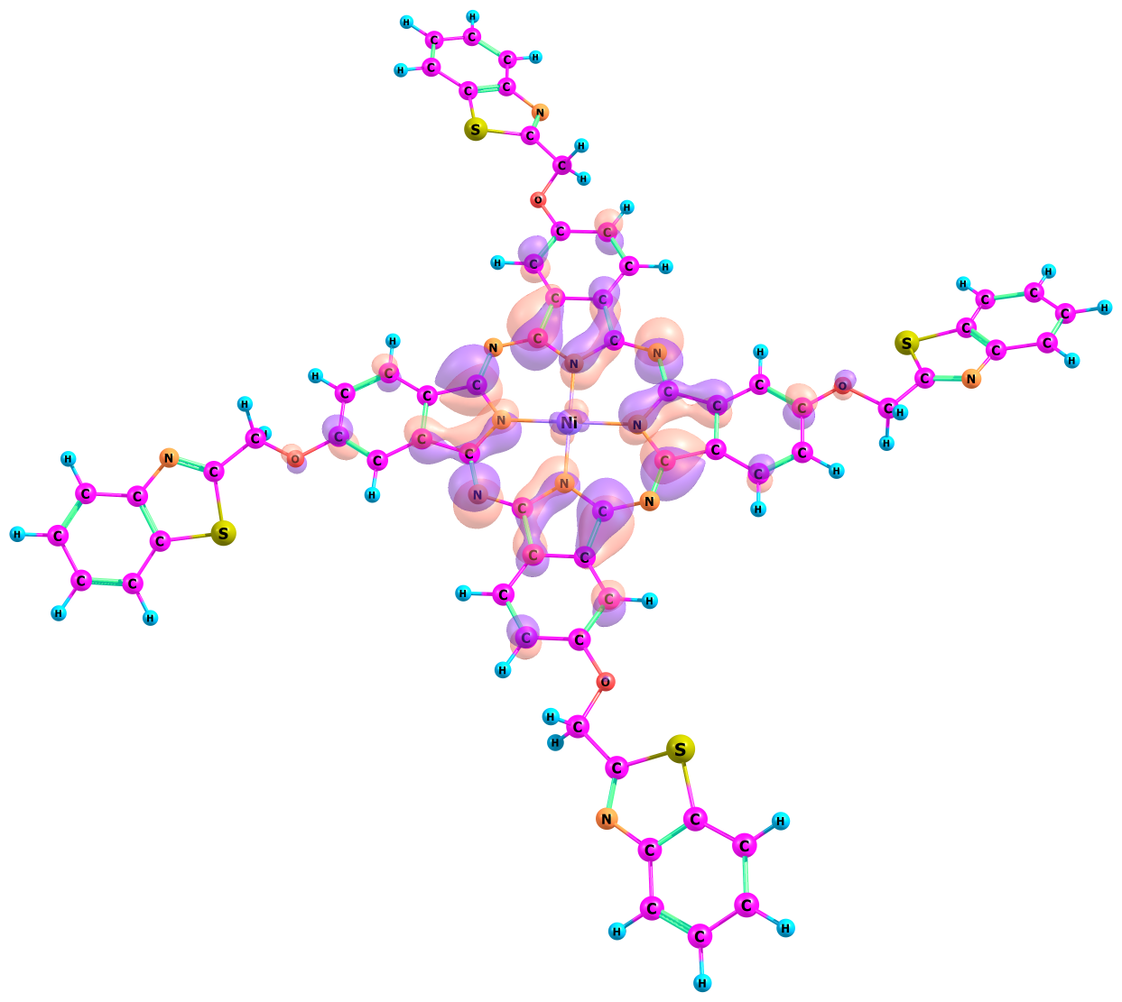 | 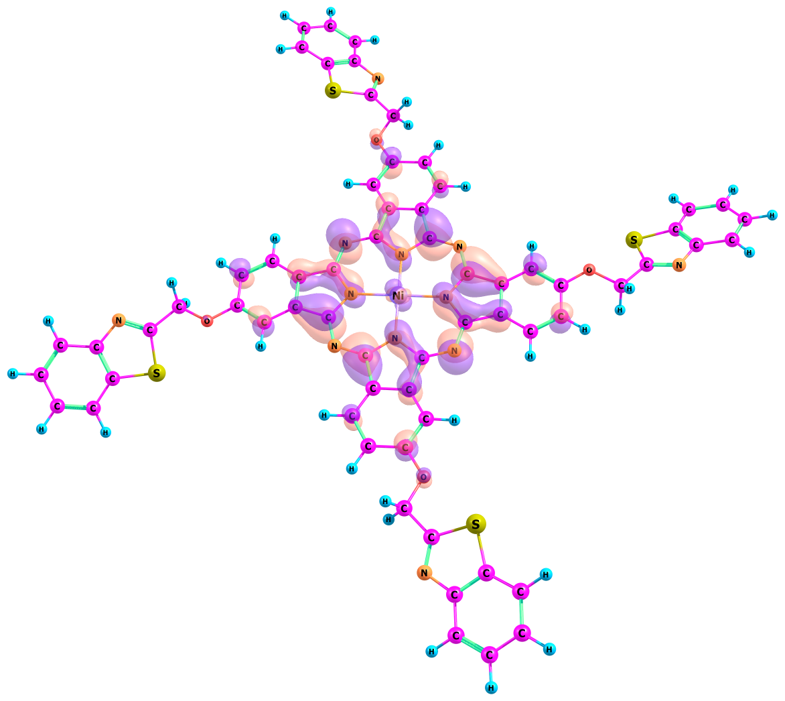
L | L+1
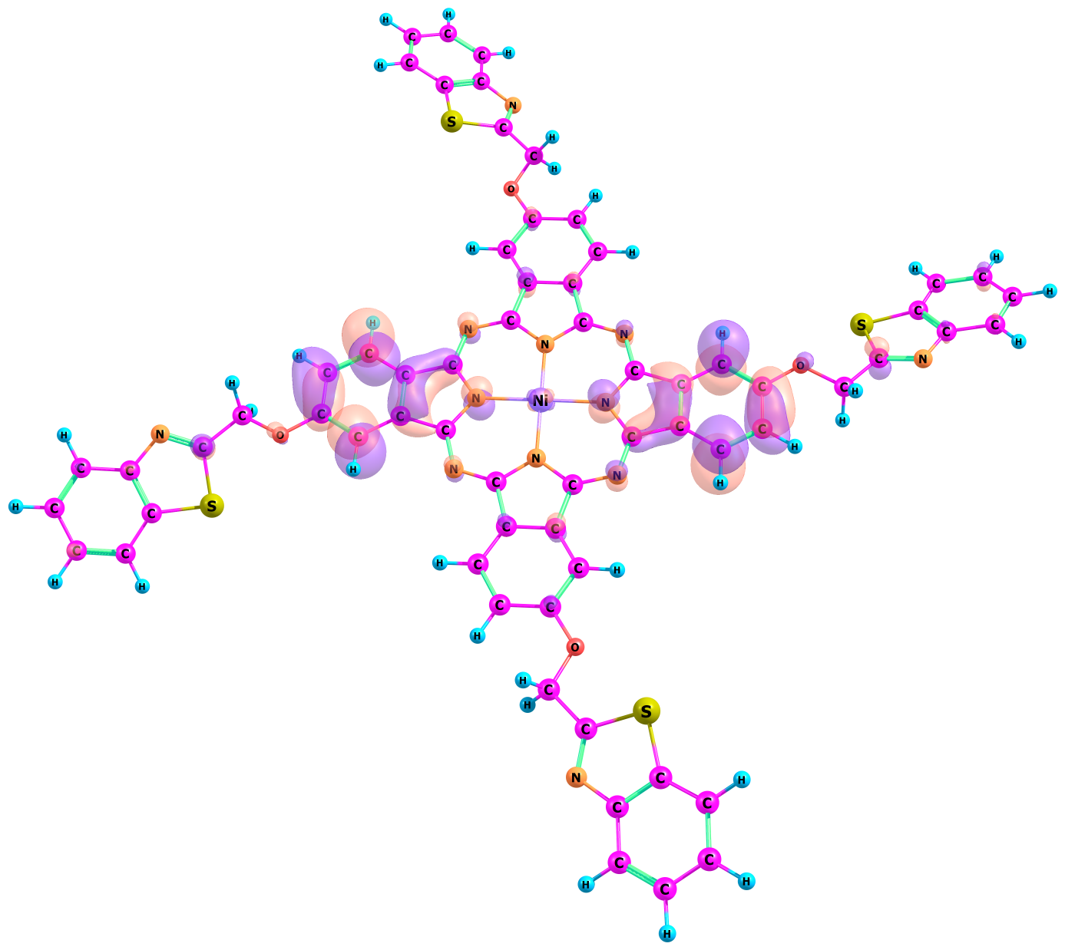 | 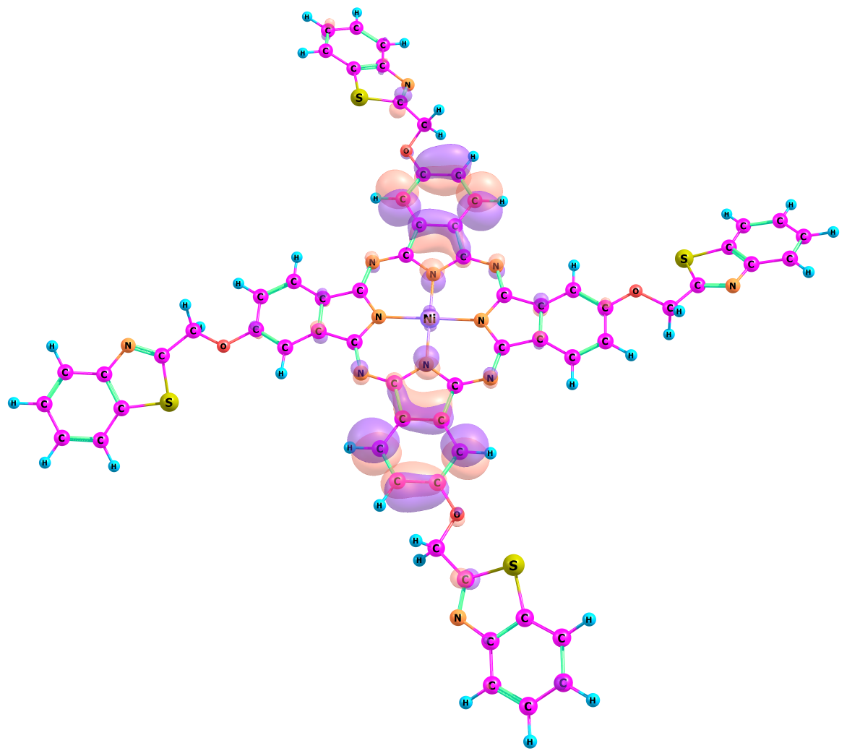
L+10 | L+11

Fig. S4a: Selected frontier molecular orbital surfaces of compound 2, H = Highest Occupied Molecular Orbital, L= Lowest Unoccupied Molecular Orbital (LUMO).

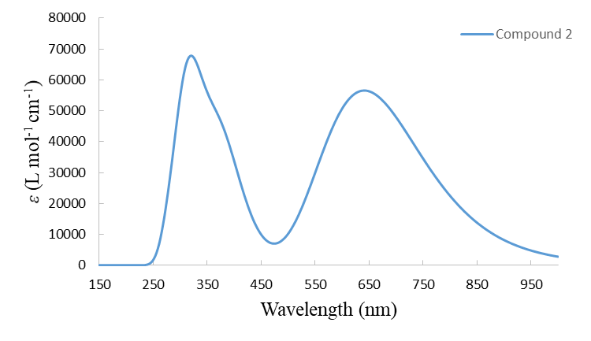
Fig. S4b: Simulated UV-Visible absorption spectrum of 2 in DMF.

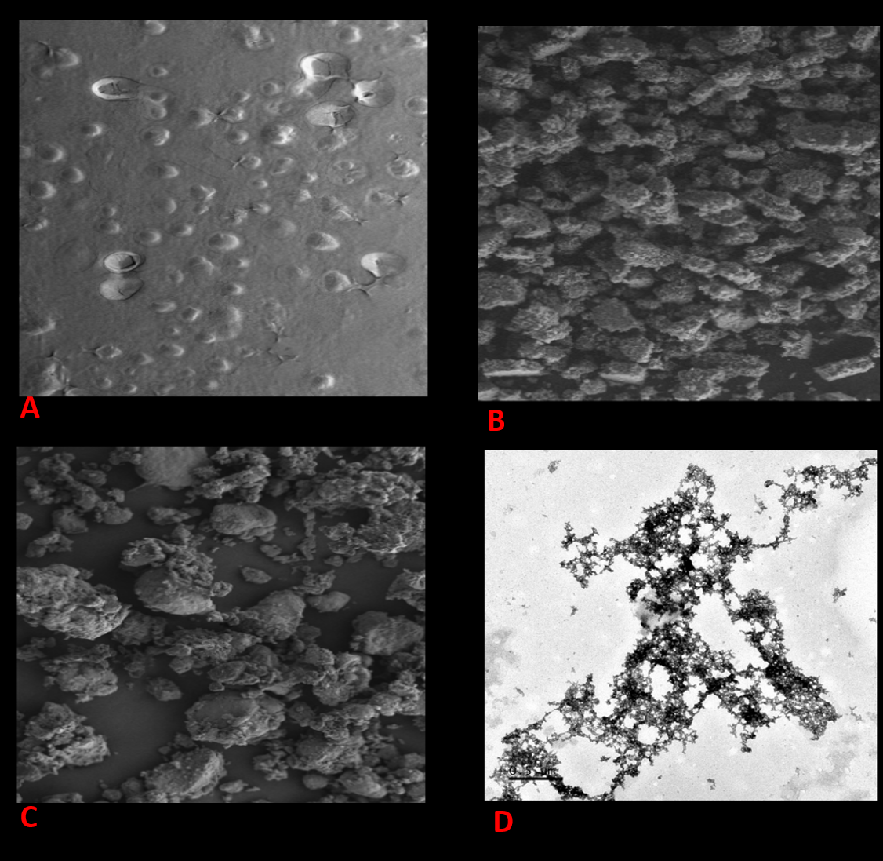

Fig.S5: SEM micrographs of the gold electrode before (A), and after modification with SAM formation of 2 (B), 2-f-MWCNTs (C) 2-f-MWCNTs (C) and the HRSEM (1.0 cm: 0.5 μm magnification) of 2-f-MWCNTs (D).

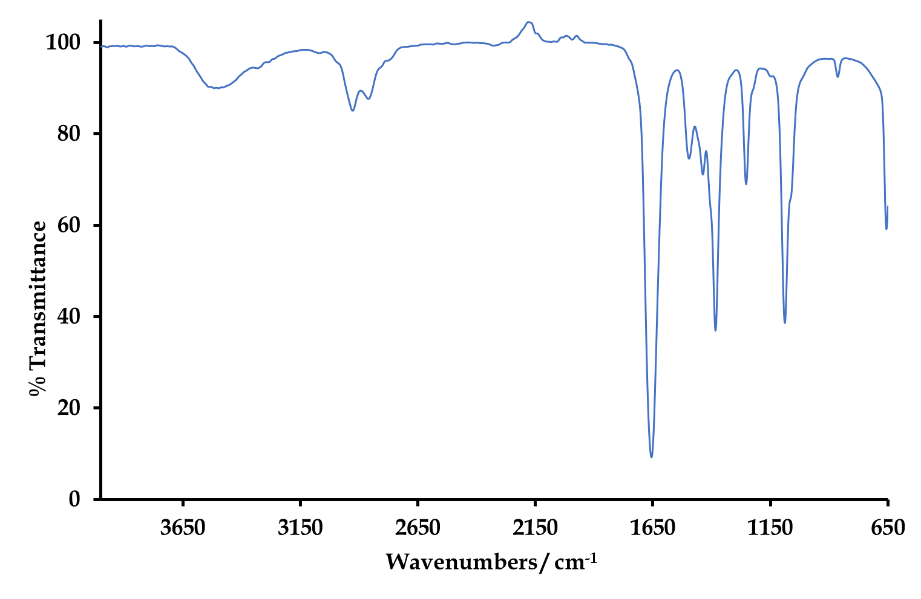
Fig. S6: IR spectrum of the 2-f-MWCNTs nanoconjugate.
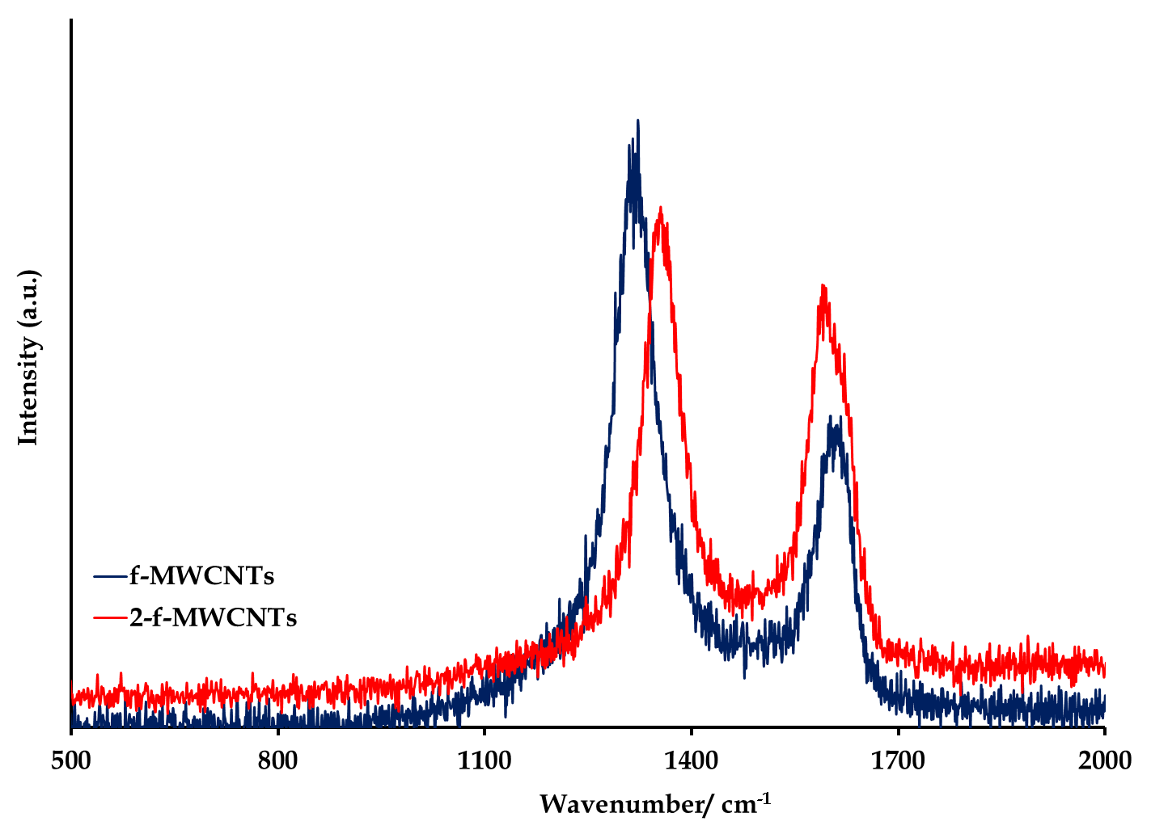
Fig S7: Overlay Raman spectra of the f-MWCNTs and 2-f-MWCNTs.

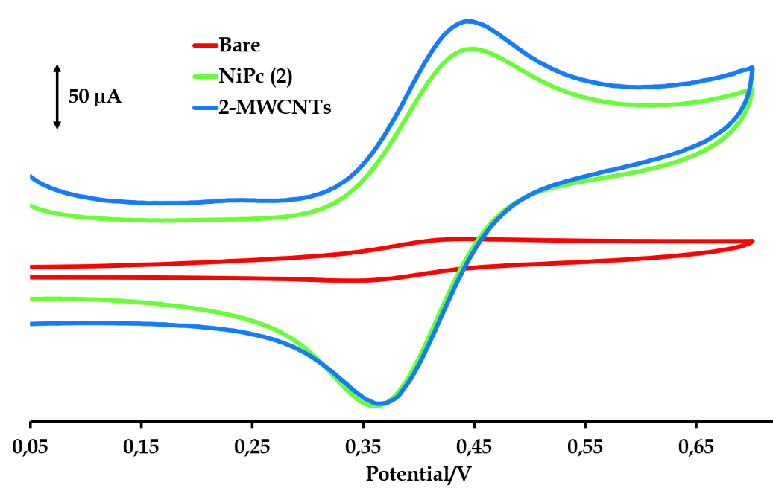

Fig. S8: CVs of 1 mM ferrocene in DMF/ 0.1 M TBABF₄ solution at the Au bare, 2|Au and Au|2-f-MWCNTs set at a scan rate of 100 mV s⁻¹.

Fig S9: DPASVs at varying Hg²⁺ concentrations in a pH 1 (0.1 M HCl/ 0.4 M NaCl) solution at the Au|2-f-MWCNTs.

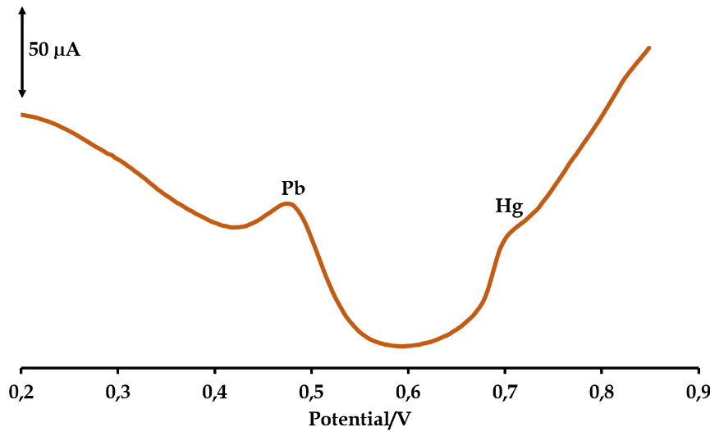
Fig S10a: SWV of a mixture of 1 mM Hg²⁺ and 1 mM Pb²⁺ in PBS buffer using the Au|2-f-MWCNTs electrode.

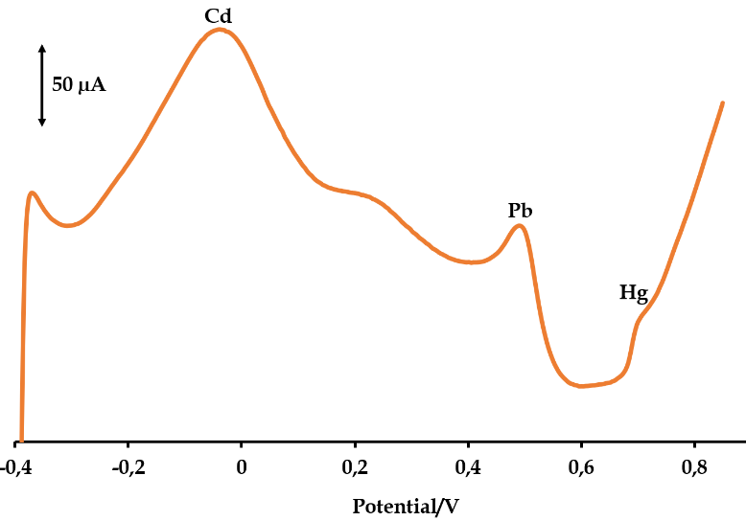
Fig S10b: SWV of a mixture of 1 mM Hg²⁺, 1 mM Pb²⁺ and 1 mM Cd²⁺ions in PBS buffer (pH 7) at the Au|2-f-MWCNTs electrode.

Table S1: Coordinates of the optimised structures of compound 2 in the gas phase and DMF..
Gas phase
N 0.947149000 -1.685288000 -0.000280000
N -0.947149000 1.685288000 -0.000280000
C 1.844885000 2.313466000 0.001632000
C 3.262910000 2.638409000 0.002695000
C 3.947923000 1.414544000 0.001670000
C 2.938141000 0.374747000 -0.000062000
C 2.313466000 -1.844885000 -0.001629000
C 2.638409000 -3.262910000 -0.002693000
C 1.414544000 -3.947923000 -0.001668000
C 0.374747000 -2.938141000 0.000064000
C -1.844885000 -2.313466000 0.001632000
C -3.262910000 -2.638409000 0.002695000
C -3.947923000 -1.414544000 0.001670000
C -2.938141000 -0.374747000 -0.000062000
C -2.313466000 1.844885000 -0.001629000
C -2.638409000 3.262910000 -0.002693000
C -1.414544000 3.947923000 -0.001668000
C -0.374747000 2.938141000 0.000064000
Ni 0.000000000 0.000000000 0.000001000
C 5.337442000 1.379297000 0.001269000
H 5.866251000 0.434401000 -0.002294000
C 6.027925000 2.587687000 0.003713000
H 7.109009000 2.575187000 -0.003031000
C 5.329611000 3.813454000 0.008308000
C 3.933330000 3.851548000 0.006564000
H 3.411304000 4.798999000 0.008109000
C 1.379297000 -5.337442000 -0.001267000
C 2.587688000 -6.027925000 -0.003711000
C 3.813454000 -5.329611000 -0.008307000
C 3.851548000 -3.933330000 -0.006562000
H 0.434401000 -5.866251000 0.002296000
H 2.575188000 -7.109009000 0.003033000
H 4.798999000 -3.411304000 -0.008107000
C -2.587688000 6.027925000 -0.003711000
C -1.379297000 5.337442000 -0.001267000
C -3.851548000 3.933330000 -0.006562000
C -3.813454000 5.329611000 -0.008307000
H -2.575188000 7.109009000 0.003033000
H -0.434401000 5.866251000 0.002296000
H -4.798999000 3.411304000 -0.008107000
C -5.329611000 -3.813454000 0.008308000
C -3.933330000 -3.851548000 0.006564000
C -5.337442000 -1.379297000 0.001269000
C -6.027925000 -2.587687000 0.003713000
H -3.411304000 -4.798999000 0.008109000
H -5.866251000 -0.434401000 -0.002294000
H -7.109009000 -2.575187000 -0.003031000
N -1.685288000 -0.947149000 0.000282000
N 1.685288000 0.947149000 0.000282000
N 3.239080000 -0.908266000 -0.001502000
N -0.908266000 -3.239080000 0.001505000
N -3.239080000 0.908266000 -0.001502000
N 0.908266000 3.239080000 0.001505000
O 5.944630000 5.033647000 0.006511000
O -5.033647000 5.944630000 -0.006509000
O -5.944630000 -5.033647000 0.006511000
O 5.033647000 -5.944630000 -0.006509000
C -5.100258000 7.360021000 -0.097684000
H -4.656775000 7.846380000 0.777827000
H -4.575805000 7.712116000 -0.996233000
C -7.360021000 -5.100257000 0.097685000
H -7.712116000 -4.575805000 0.996234000
H -7.846380000 -4.656774000 -0.777826000
C 5.100258000 -7.360021000 -0.097684000
H 4.656775000 -7.846380000 0.777827000
H 4.575805000 -7.712116000 -0.996233000
C 7.360021000 5.100257000 0.097685000
H 7.712116000 4.575805000 0.996234000
H 7.846380000 4.656774000 -0.777826000
C 9.064617000 8.317690000 0.124200000
C 7.901287000 8.947426000 0.622235000
C 7.876274000 10.315722000 0.894491000
C 9.034986000 11.048207000 0.669742000
C 10.197402000 10.432776000 0.177925000
C 10.221040000 9.074139000 -0.097814000
C 7.756714000 6.543839000 0.183281000
H 6.981257000 10.794299000 1.272726000
H 9.039959000 12.111858000 0.877883000
H 11.086383000 11.029826000 0.011587000
H 11.107575000 8.583168000 -0.479682000
C -8.317691000 9.064615000 -0.124201000
C -8.947426000 7.901285000 -0.622238000
C -10.315721000 7.876272000 -0.894495000
C -11.048207000 9.034983000 -0.669747000
C -10.432777000 10.197400000 -0.177928000
C -9.074141000 10.221038000 0.097813000
C -6.543840000 7.756714000 -0.183281000
H -10.794298000 6.981256000 -1.272732000
H -12.111858000 9.039956000 -0.877889000
H -11.029828000 11.086380000 -0.011590000
H -8.583170000 11.107573000 0.479681000
C 8.317691000 -9.064615000 -0.124201000
C 8.947426000 -7.901285000 -0.622238000
C 10.315721000 -7.876272000 -0.894495000
C 11.048207000 -9.034983000 -0.669747000
C 10.432777000 -10.197400000 -0.177928000
C 9.074141000 -10.221038000 0.097813000
C 6.543840000 -7.756714000 -0.183281000
H 10.794298000 -6.981256000 -1.272732000
H 12.111858000 -9.039956000 -0.877889000
H 11.029828000 -11.086380000 -0.011590000
H 8.583170000 -11.107573000 0.479681000
C -9.064617000 -8.317690000 0.124200000
C -7.901287000 -8.947426000 0.622235000
C -7.876274000 -10.315722000 0.894491000
C -9.034986000 -11.048207000 0.669742000
C -10.197402000 -10.432776000 0.177925000
C -10.221040000 -9.074139000 -0.097814000
C -7.756714000 -6.543839000 0.183281000
H -6.981257000 -10.794299000 1.272726000
H -9.039959000 -12.111858000 0.877883000
H -11.086383000 -11.029826000 0.011587000
H -11.107575000 -8.583168000 -0.479682000
S -6.619766000 -7.763077000 0.786936000
S -7.763076000 6.619765000 -0.786939000
S 6.619766000 7.763077000 0.786936000
S 7.763076000 -6.619765000 -0.786939000
N -8.939340000 -6.957871000 -0.112724000
N -6.957872000 8.939339000 0.112724000
N 8.939340000 6.957871000 -0.112724000
N 6.957872000 -8.939339000 0.112724000
DMF
N 0.668446000 -1.807973000 -0.003595000
N -0.668766000 1.808305000 -0.000806000
C 2.182949000 1.990573000 -0.000644000
C 3.635598000 2.092429000 0.000097000
C 4.120127000 0.776900000 -0.000852000
C 2.956320000 -0.089289000 -0.002384000
C 1.990230000 -2.182921000 -0.004669000
C 2.092122000 -3.635540000 -0.006429000
C 0.776620000 -4.120141000 -0.006335000
C -0.089617000 -2.956332000 -0.004150000
C -2.183254000 -1.990240000 -0.001303000
C -3.635890000 -2.092089000 0.001023000
C -4.120392000 -0.776552000 0.001855000
C -2.956603000 0.089617000 -0.000275000
C -1.990563000 2.183262000 -0.001217000
C -2.092429000 3.635888000 -0.001855000
C -0.776914000 4.120451000 -0.001806000
C 0.089290000 2.956646000 -0.000954000
Ni -0.000148000 0.000163000 -0.002028000
C 5.489366000 0.526241000 -0.001682000
H 5.874656000 -0.485822000 -0.004990000
C 6.361066000 1.610884000 0.000093000
H 7.426465000 1.427401000 -0.005857000
C 5.863942000 2.930825000 0.004109000
C 4.489526000 3.186187000 0.003137000
H 4.125574000 4.205429000 0.004509000
C 0.526072000 -5.489415000 -0.006694000
C 1.610795000 -6.361047000 -0.008533000
C 2.930655000 -5.863790000 -0.011418000
C 3.185937000 -4.489384000 -0.009644000
H -0.485946000 -5.874815000 -0.004142000
H 1.427348000 -7.426446000 -0.003473000
H 4.205154000 -4.125367000 -0.010364000
C -1.610992000 6.361393000 -0.002103000
C -0.526309000 5.489696000 -0.001220000
C -3.186186000 4.489784000 -0.004094000
C -2.930891000 5.864213000 -0.005102000
H -1.427368000 7.426746000 0.003660000
H 0.485745000 5.875017000 0.001255000
H -4.205430000 4.125839000 -0.004618000
C -5.864257000 -2.930441000 0.007748000
C -4.489842000 -3.185828000 0.004451000
C -5.489608000 -0.525836000 0.003453000
C -6.361314000 -1.610474000 0.005717000
H -4.125909000 -4.205075000 0.004434000
H -5.874852000 0.486250000 0.001670000
H -7.426695000 -1.426987000 0.001769000
N -1.808267000 -0.668441000 -0.001774000
N 1.807981000 0.668765000 -0.001970000
N 3.052561000 -1.404127000 -0.003898000
N -1.404462000 -3.052564000 -0.002764000
N -3.052873000 1.404457000 -0.000544000
N 1.404141000 3.052895000 -0.000401000
O 6.663244000 4.038699000 0.001320000
O -4.038938000 6.663270000 -0.000849000
O -6.663634000 -4.038261000 0.004813000
O 4.038584000 -6.663044000 -0.007457000
C -3.878744000 8.077357000 -0.068831000
H -3.366176000 8.467608000 0.815164000
H -3.302654000 8.352520000 -0.960410000
C -8.077456000 -3.877552000 0.078561000
H -8.348433000 -3.301914000 0.971716000
H -8.471176000 -3.364133000 -0.803377000
C 3.878142000 -8.076812000 -0.081886000
H 3.364570000 -8.470906000 0.799773000
H 3.302851000 -8.347643000 -0.975320000
C 8.077247000 3.877835000 0.070430000
H 8.350965000 3.300073000 0.961382000
H 8.468164000 3.366499000 -0.813943000
C 10.257093000 6.801560000 0.035114000
C 9.238385000 7.586370000 0.620214000
C 9.437912000 8.935458000 0.917351000
C 10.678792000 9.490730000 0.627700000
C 11.700849000 8.720352000 0.048677000
C 11.499992000 7.380816000 -0.251225000
C 8.697787000 5.240693000 0.152058000
H 8.652949000 9.533656000 1.362899000
H 10.858597000 10.535334000 0.853147000
H 12.658088000 9.180397000 -0.166315000
H 12.279472000 6.776664000 -0.699569000
C -6.805998000 10.252510000 -0.021798000
C -7.589984000 9.234085000 -0.608479000
C -8.940119000 9.431636000 -0.901984000
C -9.497397000 10.670390000 -0.607068000
C -8.727908000 11.692171000 -0.026361000
C -7.387257000 11.493212000 0.269899000
C -5.242400000 8.696616000 -0.146838000
H -9.537675000 8.646911000 -1.348815000
H -10.542883000 10.848618000 -0.829666000
H -9.189535000 12.647702000 0.192851000
H -6.783790000 12.272490000 0.719507000
C 6.804816000 -10.252969000 -0.042951000
C 7.588605000 -9.232848000 -0.626974000
C 8.938252000 -9.430033000 -0.923015000
C 9.495248000 -10.670159000 -0.633375000
C 8.726059000 -11.693500000 -0.055048000
C 7.385923000 -11.494913000 0.243810000
C 5.241633000 -8.696143000 -0.161506000
H 9.535577000 -8.643985000 -1.367835000
H 10.540289000 -10.848245000 -0.858185000
H 9.187509000 -12.650014000 0.160183000
H 6.782752000 -12.275481000 0.691564000
C -10.255580000 -6.802638000 0.038493000
C -9.236017000 -7.587765000 0.621654000
C -9.434001000 -8.937682000 0.915881000
C -10.674485000 -9.493529000 0.625612000
C -11.697499000 -8.722847000 0.048646000
C -11.498021000 -7.382485000 -0.248610000
C -8.697543000 -5.240722000 0.158256000
H -8.648190000 -9.535953000 1.359877000
H -10.853206000 -10.538765000 0.848949000
H -12.654387000 -9.183362000 -0.166941000
H -12.278199000 -6.778144000 -0.695496000
S -7.804257000 -6.602681000 0.853520000
S -6.603416000 7.804116000 -0.845072000
S 7.805753000 6.601971000 0.850317000
S 6.602350000 -7.801686000 -0.857633000
N -9.909151000 -5.482177000 -0.211281000
N -5.485147000 9.906706000 0.226740000
N 9.909509000 5.481900000 -0.217204000
N 5.484267000 -9.907555000 0.207881000

Table S2: Selected TD-DFT-computed wavelength (nm), oscillator strength (f), and main orbital transition contribution (≥20%) for the absorption spectrum of 2 in DMF.
Wavelength (nm) | Oscillator strength (f) | Orbital transition (%)
Compound 2
323 | 0.416 | H-16→L (77%)
323 | 0.416 | H-16→L+1 (77%)
374 | 0.365 | H-8→L (43%)
 |  | H-4→L (30%)
374 | 0.365 | H-8→L+1 (43%)
 |  | H-4→L+1 (30%)
641 | 0.698 | H→L (98%)
641 | 0.698 | H→L+1 (98%)

