Supplementary information
Electrochemical properties of magnetite nanoparticles supported on carbon paste electrode in various electrolyte solutions: A study by cyclic voltammetry.
M. Corsini, F. Fabrizi de Biani, A. Atrei *
Dipartimento di Biotecnologie, Chimica e Farmacia, Università di Siena, 53100 Siena, Italy
* Corresponding author. e-mail: atrei@unisi.it

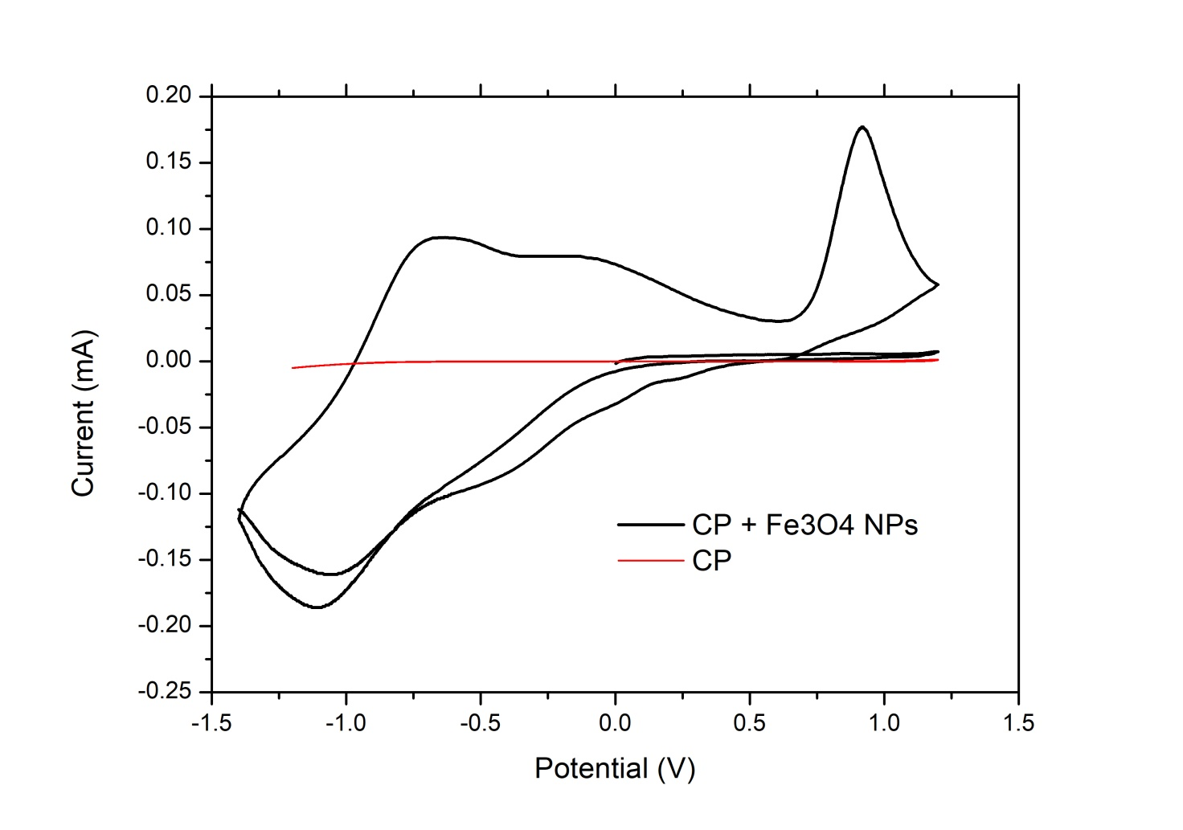
Figure S1.
CV curves of Fe₃O₄ NPs dispersed in carbon paste (CP) (Black lines) and of CP only (Red lines). Supporting electrolyte: NaCl 0.5 M. The potentials are relative to that of the Ag|AgCl|KCl 3 M electrode. The potential scan rate is 50 mV/s.

