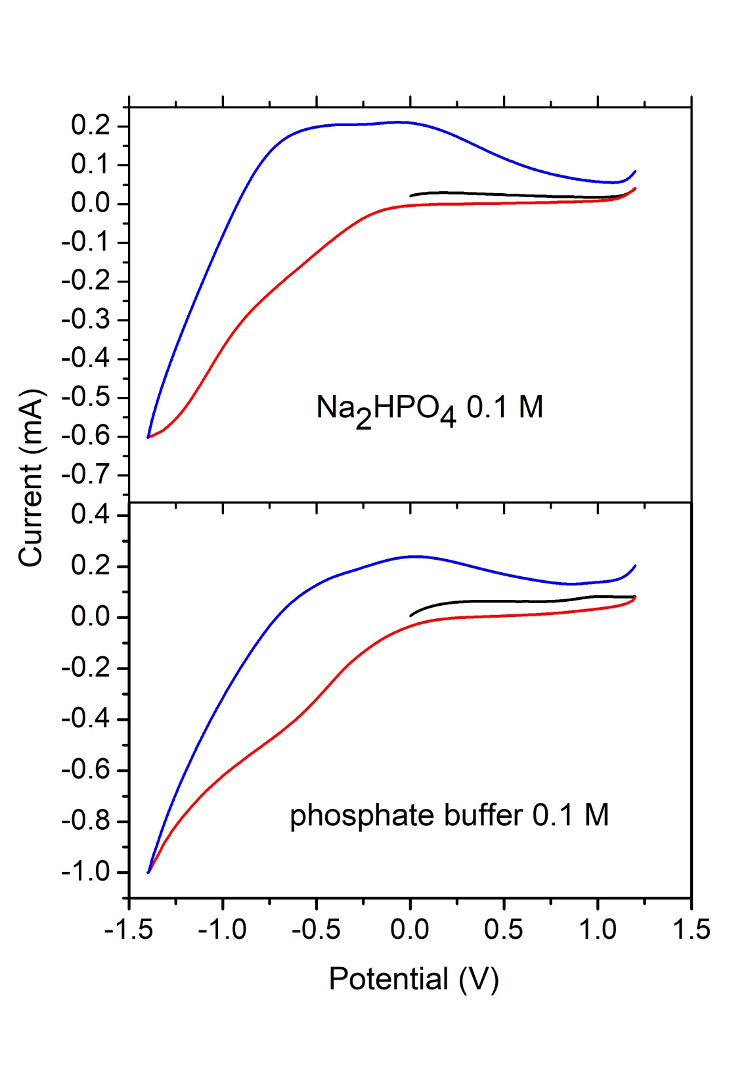

Figure 2S.
CV curves of Fe₃O₄ NPs dispersed in CP. Top panel: Supporting electrolyte is 0.1 M solution of Na₂HPO₄. Bottom panel: Supporting electrolyte is a buffer solution containing Na₂HPO₄ and KH₂PO₄.

