Supplementary Information

Performing cyclic voltammetry in a proton exchange membrane fuel cell stack: what you should keep in mind

Raphaël Riasse*, Sébastien Rosini, Fabrice Micoud

Univ. Grenoble Alpes, CEA, Liten, 38000 Grenoble, France
* Corresponding author
Email address: raphael.riasse@cea.fr

In order to address the risks of performing cyclic voltammetry (CV) with current connection on the stack end plates (full stack polarisation), two stacks with 6 cells are compared. The composition of the membrane electrodes assemblies (MEA) in these stacks is different from the core of the article. These commercial MEAs are composed of TEC10E50E at 0.1/0.3 mg_{Pt} cm⁻² at the anode/cathode respectively with an I/C ratio of 0.8 (Nafion® D2020), a Gore® 788.12 PEM membrane and GDL H14C15 from Freudenberg. Among these stacks, the cells placed in position 1, 2, 4, 5 and 6 are the same (in terms of bipolar plate design and type of MEAs) and only the MEA of the cell 3 is changed:
- In “Stack 1”, this cell is similar to the other (equivalent H₂ cross-over and active surface area);
- In “Stack 2” this cell exhibits an increased hydrogen cross-over. The cross-over has been measured and is equal to 3 mA cm⁻² instead of the 1.5 mA cm⁻² for the other healthy cells.
Two sets of cyclic voltammograms (3 cycles per set) are performed with voltage scan rates of 50 and 25 mV s⁻¹ for two different connections configurations. The first one uses an individual cell polarisation on cell 3 (configuration F in this work) while the second one is obtained with full stack polarisation (Ref configuration with current collection on stack end plates). The evolution of all the individual cell voltages during the CV can be seen on Fig. S1 thereafter.
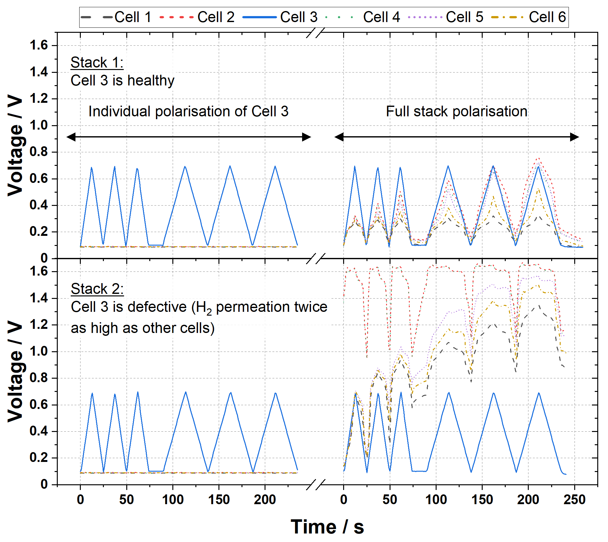
Fig. S1: Evolution of the individual cell voltages as a function of the time during 2 CVs (50 and 25 mV s⁻¹) with an individual cell connection configuration (F) and 2 CVs (50 and 25 mV s⁻¹) with a full stack polarisation (Ref) for two 6-cell stacks. In Stack 1 (top), cell 3 has a similar behaviour (healthy) as the other cells whereas in Stack 2 (bottom), cell 3 exhibits a 2-times higher H₂ cross-over (3 instead of 1.5 mA cm⁻²). Voltage control by potentiostat is performed on cell 3
The individual cell polarisation of cell 3 does not modify the voltages of the other cells for both stacks which stay at their open circuit voltage (between 85 and 90 mV in the conditions of this study) during the CV measurements. However, when the configuration is switched to a full stack polarisation, the other cells’ voltages start to be influenced. For a well-balanced stack, the cells’ voltages tend to follow the variation of the controlled voltage of cell 3. In the case of “defective” cell 3, the voltages of the other cells vary much more importantly. According to their state of health, cell voltage as high as 1.6 V can be reached which is known to cause severe degradation at the cathode side.

Additionally to the data shown in this article, the authors wanted to show the reproducibility of individual cell polarisation on all the cells of a 6-cell stack with similar commercial MEAs as detailed previously for Fig. S1, thus different from the core of the article. The measurements were carried out at the beginning of life of the stack (after proper break-in and polarisation curves in nominal conditions). After a conditioning phase of 30 min at 30 °C, 100 % RH under H₂/N₂ flows of 92.4 NL h⁻¹ and 220 NL h⁻¹, respectively, 3 CVs are performed at 50 mV s⁻¹ for each cell with potential and current connections following configuration F (see Fig. 2). The last cycle is shown for every cell on Fig. S2 thereafter.
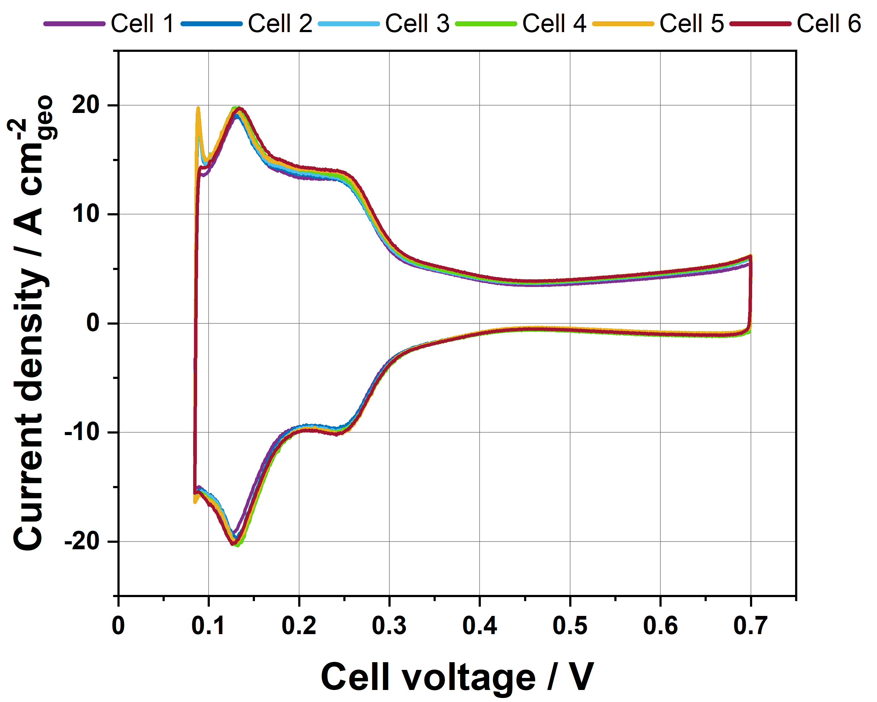
Fig. S2: Cyclic voltammograms performed at 50 mV s⁻¹ for all cells of a 6-cell stack. For all cells, the voltage and current connections are made following individual cell configuration F (See Fig. 2)

