Supplementary material

Mother’s mental health
 | Time-point 1 | Time-point 2 | Time-point 3 | Time-point 4 | Time-point 5
No event | 947 (71%) | 1018 (75%) | 1012 (72%) | 683 (56%) | 718 (69%)
MH event | 384 (29%) | 346 (25%) | 399 (28%) | 534 (44%) | 329 (31%)
Total | 1331 (100%) | 1364 (100%) | 1411 (100%) | 1217 (100%) | 1047 (100%)
Total SDQ
Close to average | 981 (83%) | 1270 (90%) | 1360 (89%) | 1255 (88%) | 1062 (85%)
Slightly raised | 116 (10%) | 79 (6%) | 68 (5%) | 84 (6%) | 75 (6%)
High | 48 (4%) | 34 (2%) | 54 (4%) | 44 (3%) | 50 (4%)
Severe | 37 (3%) | 32 (2%) | 42 (3%) | 47 (3%) | 62 (5%)
Total | 1182 (100%) | 1415 (100%) | 1524 (100%) | 1430 (100%) | 1249 (100%)
Emotional sub-scale
Close to average | 1438 (92%) | 1510 (91%) | 1533 (88%) | 1239 (82%) | 1018 (78%)
Slightly raised | 73 (5%) | 79 (5%) | 93 (5%) | 111 (7%) | 93 (7%)
High | 37 (2%) | 60 (3%) | 87 (5%) | 108 (7%) | 108 (8%)
Severe | 9 (1%) | 14 (1%) | 31 (2%) | 53 (4%) | 82 (6%)
Total | 1557 (100%) | 1663 (100%) | 1744 (100%) | 1511 (100%) | 1301 (100%)
Conduct sub-scale
Close to average | 779 (49%) | 1315 (79%) | 1414 (80%) | 1195 (79%) | 1060 (81%)
Slightly raised | 266 (17%) | 196 (12%) | 179 (10%) | 173 (12%) | 121 (9%)
High | 362 (23%) | 128 (8%) | 130 (7%) | 114 (8%) | 92 (7%)
Severe | 167 (11%) | 35 (2%) | 34 (2%) | 23 (2%) | 32 (2%)
Total | 1574 (100%) | 1674 (100%) | 1757 (100%) | 1505 (100%) | 1305 (100%)
Hyperactivity sub-scale
Close to average | 1121 (75%) | 1332 (82%) | 1390 (79%) | 1240 (82%) | 1104 (85%)
Slightly raised | 240 (16%) | 193 (12%) | 193 (11%) | 157 (10%) | 117 (%)
High | 66 (4%) | 43 (3%) | 76 (4%) | 46 (3%) | 40 (3%)
Severe | 58 (4%) | 65 (3%) | 90 (5%) | 63 (4%) | 45 (4%)
Total | 1485 (100%) | 1633 (100%) | 1749 (100%) | 1506 (100%) | 1306 (100%)
Peer problem sub-scale
Close to average | 1130 (82%) | 1330 (87%) | 1387 (86%) | 1197 (81%) | 979 (75%)
Slightly raised | 132 (10%) | 99 (6%) | 115 (7%) | 118 (8%) | 126 (10%)
High | 78 (6%) | 55 (4%) | 68 (4%) | 80 (5%) | 81 (6%)
Severe | 37 (3%) | 48 (3%) | 51 (3%) | 82 (6%) | 120 (9%)
Total | 1377 (100%) | 1532 (100%) | 1621 (100%) | 1477 (100%) | 1306 (100%)

Table S1: Frequencies of maternal mental health and child difficulties at each time-point

 | MCS Welsh sample at time-point 3  (N=1828) | GP registration at time-point 3  (N=1411)
Child sex
Male | 946 (52%) | 739 (52%)
Female | 882 (48%) | 672 (48%)
Missing | - | -
Birthweight
Low | ~210 (~10%) | ~165 (~10%)
Normal | ~1,620 (~90%) | ~1,250 (~90%)
Missing | <5 | <5
Breastfeeding
Tried to breastfeed | 1,140 (~60%) | ~880 (~60%)
Did not try | 690 (~40%) | ~535 (~40%)
Missing | <5 | <5
Mother's highest qualification
None | 247 (14%) | 198 (14%)
NVQ1/GCSE D-G | 325 (18%) | 239 (17%)
NVQ2/Apprenticeship/GCSE A* -C | 673 (37%) | 529 (37%)
NVQ3/A-level | 174 (10%) | 135 (10%)
Professional qualification/Degree/Diploma/Health professional | 356 (20%) | 272 (19%)
Higher degree | 22 (1%) | 13 (1%)
Missing | 31 (2%) | 25 (2%)
Family net income
£0 – 3099 | 25 (1%) | 19 (1%)
£3100 – 10400 | 485 (27%) | 375 (27%)
£10400 – 20800 | 601 (32%) | 470 (33%)
£20800 – 31200 | 351 (19%) | 266 (19%)
£31200 – 52000 | 226 (12%) | 182 (13%)
£52000+ | 61 (3%) | 42 (3%)
Missing | 79 (4%) | 57 (4%)
Gestational age
25 – 28 weeks | <5 | <5
> 28 – 32 weeks | ~10 (<5%) | ~10 (~1%)
> 32 – 36 weeks | ~70 (~5%) | ~55 (~5%)
> 36 – 40 weeks | ~950 (~50%) | ~720 (~50%)
> 40 – 43 weeks | ~780 (~45%) | ~615 (~45%)
Missing | ~5% | ~15 (~1%)
Table S2: Baseline demographics of children in the total MCS cohort and the GP registered sample. Due to disclosure risks with sample counts between 1 and 4, these have been masked as '<5' and neighbouring categories rounded to the nearest 5 and marked as (~N, ~%)

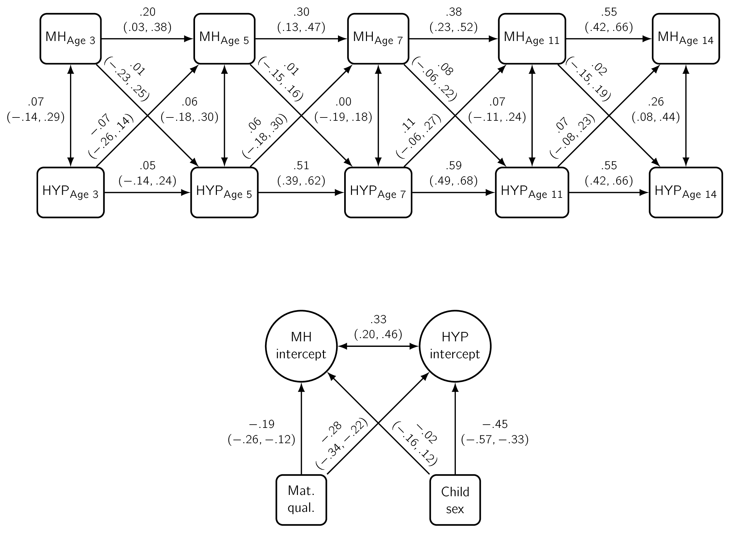
Figure S1: Probit estimates with 95% credible intervals from a random intercept cross-lagged panel model of Hyperactivity (HYP) and maternal mental health (MH). *Adjusted for maternal qualifications and child sex. (N=1841)

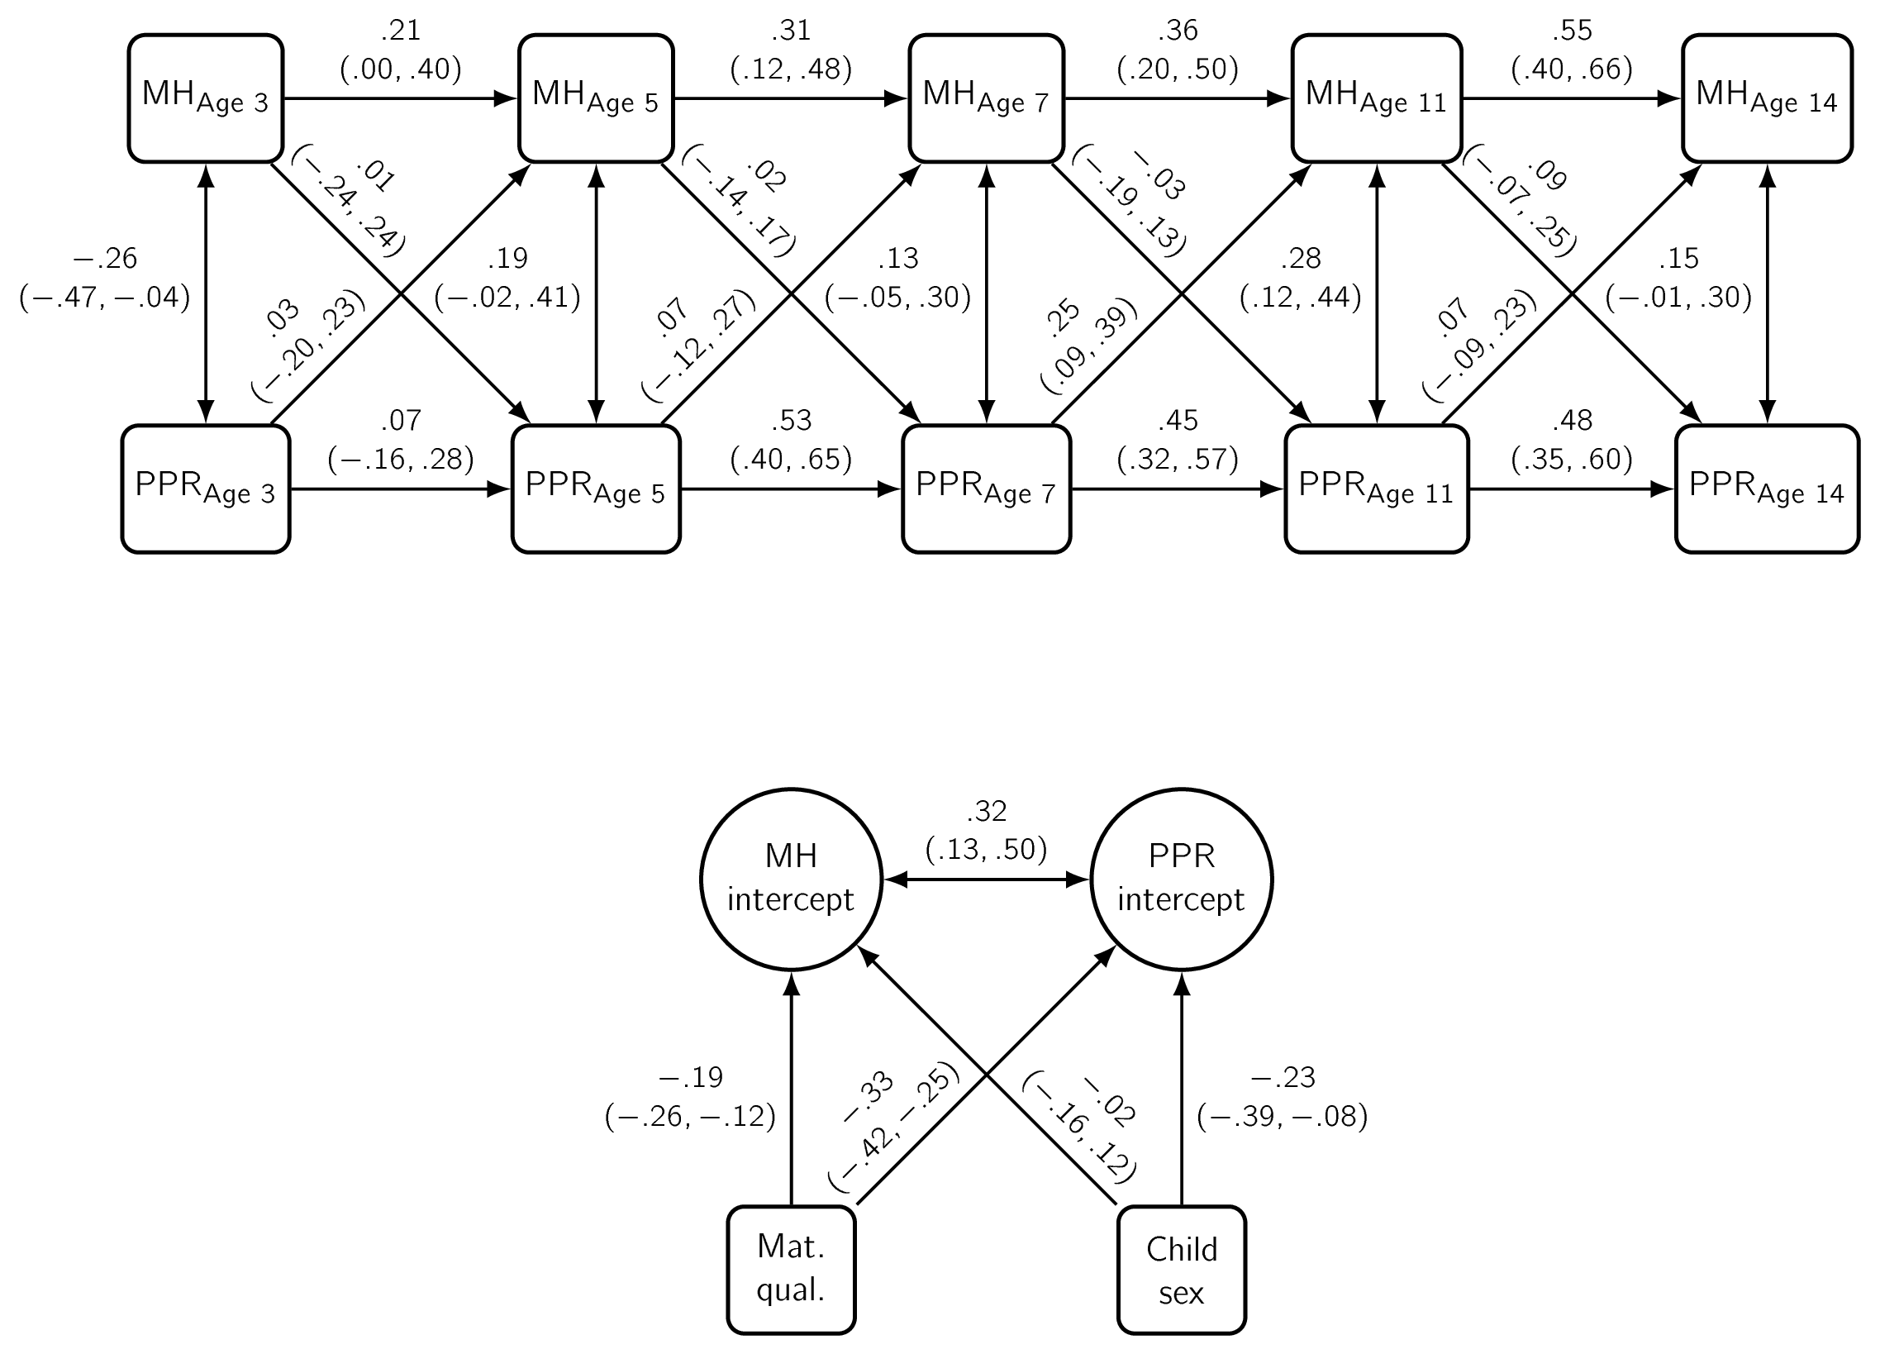
Figure S2: Probit estimates with 95% credible intervals from a random intercept cross-lagged panel model of Peer Problems (PPR) and maternal mental health (MH). *Adjusted for maternal qualifications and child sex. (N=1838)

