Pathways between child maltreatment, psychological symptoms, and life satisfaction: a network analysis in adolescent inpatients – supplementary materials

David R. Kolar, Alessio Maria Monteleone, Giammarco Cascino, Sebastian Ertl, Adrian Meule, Silke Naab, Ulrich Voderholzer

all correspondence to david.kolar@ur.de

Supplementary materials – all correspondence to david.kolar@ur.de

Table S1. Differences between diagnostic groups on key measures.
Table S1 provides mean and standard deviation of key measures at admission of diagnostic groups.
 | Affective disorders |  |  | Anxiety disorders |  |  | Obsessive–  compulsive disorder |  |  | Anorexia nervosa |  |  | Bulimia nervosa
At admission | N | M | SD | N | M | SD | N | M | SD | N | M | SD | N | M | SD | F | df | p
Age | 322 | 16.22ª | 1.12 | 57 | 16.07 | 0.94 | 70 | 16.33 | 1.42 | 375 | 15.78^{a.b} | 1.33 | 72 | 16.11^{b} | 1.12 | 6.48 | 4, 194.38 | <.001
Length of stay | 322 | 77.94^{ab} | 45.40 | 57 | 85.26^{c} | 47.04 | 70 | 98.11ª | 42.84 | 375 | 102.96^{bc} | 53.09 | 72 | 94.78 | 50.35 | 12.06 | 4, 192.52 | <.001
CTQ emotional abuse | 322 | 10.74^{abc} | 5.14 | 57 | 8.32^{ad} | 4.04 | 70 | 8.11^{be} | 4.05 | 375 | 8.52^{c} | 3.91 | 72 | 10.50de | 5.13 | 13.03 | 4, 189.90 | <.001
CTQ emotional neglect | 322 | 10.96^{ab} | 4.38 | 57 | 10.37^{c} | 4.29 | 70 | 8.31^{acd} | 3.47 | 375 | 9.37^{b} | 4.02 | 72 | 10.49^{d} | 4.88 | 10.29 | 4, 190.68 | <.001
CTQ physical abuse | 322 | 5.89^{ab} | 2.10 | 57 | 5.53 | 1.80 | 70 | 5.40ª | 1.68 | 375 | 5.34^{bc} | 1.24 | 72 | 5.85^{c} | 1.73 | 5.15 | 4, 182.94 | <.001
CTQ physical neglect | 322 | 6.82^{ab} | 2.26 | 57 | 6.88^{c} | 2.23 | 70 | 5.96^{ac} | 1.59 | 375 | 6.36^{b} | 2.03 | 72 | 6.83 | 2.63 | 4.72 | 4, 191.83 | .001
CTQ sexual abuse | 322 | 6.00^{ab} | 2.76 | 57 | 5.39 | 2.20 | 70 | 5.23ª | 0.87 | 375 | 5.21^{b} | 1.17 | 72 | 5.68 | 2.24 | 6.34 | 4, 190.68 | <.001
CTQ total score | 322 | 40.41^{abc} | 12.38 | 56 | 36.64ª | 10.95 | 69 | 32.94^{bd} | 8.57 | 371 | 34.86^{ce} | 9.43 | 69 | 39.41de | 12.82 | 14.53 | 4, 185.19 | <.001
BSI GSI | 322 | 1.65^{ab} | 0.68 | 57 | 1.43 | 0.67 | 70 | 1.21^{ac} | 0.72 | 375 | 1.29^{bd} | 0.71 | 72 | 1.59^{cd} | 0.75 | 14.31 | 4, 189.29 | <.001
SWLS total score | 322 | 7.59ª | 6.65 | 57 | 8.06^{b} | 6.99 | 70 | 8.09^{c} | 7.57 | 375 | 6.76^{d} | 6.94 | 72 | 4.79^{abcd} | 5.69 | 4.09 | 4, 191.19 | .003
Note: Differences between diagnostic groups are also displayed as obtained by Welch’s ANOVA and Games-Howell post-hoc comparisons. Statistically significant group differences between diagnostic groups are displayed by shared superscript letters. BSI GSI: Brief Symptom Inventory, Global Severity Index; CTQ: Childhood Trauma Questionnaire; SWLS: Satisfaction With Life Scale.

Table S2. Comparison of admission (composite) scale scores between patients showing without missing and those with missing BSI values at discharge
 | No missing values at discharge |  |  | Missing values at discharge
Measure (at admission) | N | M | SD | Nª | M | SD | t | df | p | d
BSI 30 item mean score | 643 | 1.73 | 0.82 | 253^{b} | 1.86 | 0.80 | -2.05 | 472.18 | .04 | -0.15
SWLS total score | 652 | 15.36 | 6.16 | 244^{c} | 14.86 | 6.59 | 1.02 | 411.25 | .31 | –
CTQ total score | 635 | 7.28 | 2.13 | 261^{d} | 7.78 | 2.48 | -2.84 | 425.81 | .005 | -0.22
Note: ªParticipants are not mutually exclusive. ^{b}Participants missing at least one of the 30 BSI items at discharge. ^{c}Participants missing at least one SWLS item at discharge. ^{d}Participants that were excluded at discharge due to at least one missing item of the BSI or SWLS items that were included in the network analyses. Cohens d was calculated with the mean standard deviation as used in Welch’s t-test; BSI 30 item mean score: Brief Symptom Inventory mean item score based on the 30 items that were selected for inclusion in the network analysis; CTQ: Childhood Trauma Questionnaire; SWLS: Satisfaction With Life Scale.

Table S3. Excluded Items from the BSI-53 according to three criteria.
Item | Item name | Item description | Exclusion criteria
bsi02 | faint | Faintness or dizziness | b
bsi03 | thoughtcontr | Idea someone controls your thoughts | c
bsi04 | blame | Others blame you for your troubles | c
bsi05 | memory | Difficulties remembering | a
bsi07 | chestpain | Chest pain | b
bsi08 | agoraphobia | Afraid in open spaces | a,c
bsi12 | startle | Easily startled | c
bsi20 | feelhurt | Feelings easily hurt | a
bsi26 | checking | Checking behaviors | c
bsi28 | claustrophobia | Afraid to travel in bus, subway, train | c
bsi29 | breathing | Trouble breathing | a, c
bsi31 | avoidfear | Avoiding things due to fear | c
bsi32 | blackout | Mind going blank | a
bsi33 | numb | Numbness of body parts | b
bsi34 | punished | Should receive punishment for sins | c
bsi40 | urgeharm | Urges to harm someone | c
bsi41 | urgebreak | Urges to break things | c
bsi42 | selfconscious | Feeling self-conscious with others | a
bsi45 | panic | Panic or terror | c
bsi46 | arguments | Frequent arguments | c
bsi47 | nervousalone | Nervous when being alone | a
bsi48 | credit | Not receiving credit for achievements | c
bsi51 | takenadvantage | Being taken advantage of | a
Note: Symptoms were measured at admission and discharge. To reduce the number of items for the network analysis, items were excluded based on three criteria: a) theoretical importance in adolescence, b) collinearity of items at admission as identified with the goldbricker function of the networktools package, version 1.3.0 (Jones, 2021) and c) by inspecting histograms and removing items that were of less importance and not frequently endorsed (Fig. 1).

Figure S1. Histograms of all BSI-53 items.
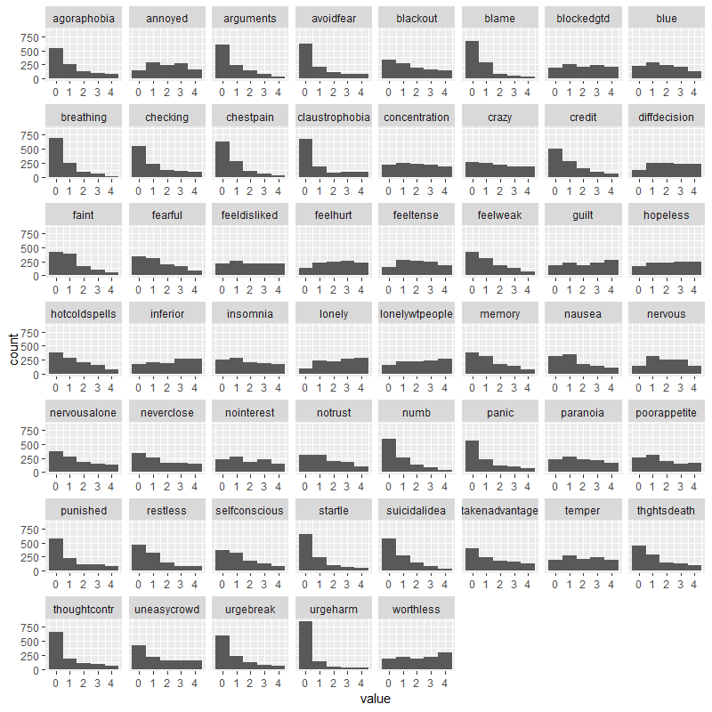

Table S4. Pre-post treatment comparisons on psychopathology and life satisfaction for all participants.
 | Admission |  |  | Discharge
Measure | N | M | SD | N | M | SD | t | df | p | d
BSI-53 GSI | 1104 | 1.44 | 0.72 | 937 | 1.02 | 0.71 | 16.02 | 654 | <.001 | 0.63
SWLS | 1109 | 6.32 | 6.39 | 938 | 7.06 | 6.99 | -9.02 | 654 | <.001 | 0.35
Note: BSI-53 GSI: global severity index of the Brief Symptom Inventory-53; SWLS: Satisfaction With Life Scale.

Figure S2. Directed acyclic graphs (DAGs) showing all pathways from CTQ nodes to SWLS nodes for admission (A) and discharge (B).
A | B
