Supplemental Methods
Maltreatment Exposure
To assess exposure to maltreatment and interpersonal violence youth completed the Childhood Experiences of Care and Abuse Interview (CECA: Bifulco et al., 1994) with a trained researcher and including additional parallel questions about witnessing domestic violence. Youth also completed the Violence Exposure Scale for Children-Revised (VEX-R) to assess the frequency of exposure to different forms of violence (2,3). In addition, maltreatment history was assessed via youth self-report. Youth completed the UCLA PTSD Reaction Index trauma screen (PTSD-RI; Steinberg et al., 2004) and the Childhood Trauma Questionnaire (CTQ; Bernstein et al., 1997) with CTQ validated thresholds for exposure to physical and sexual abuse (6), used as cutoffs. Caregivers also completed the self-report Conflict Tactics Scale-Parent Child Version (CTS; Straus et al., 1998), the Juvenile Victimization Questionnaire (JVQ) lifetime caregiver report (8), and the caregiver version of the PTSD-RI. Youth were classified as experiencing physical or sexual abuse if abuse was reported by the youth on the CECA interview, PTSD-RI, or above the CTQ cutoff, or if it was reported by the parent on the CTS, JVQ, or PTSD-RI. Interrater reliability was good between child and caregiver reports (82.0% agreement; κ= .62). Exposure to emotional abuse, with youth scoring above threshold on the CECA or the CTQ, or witnessing domestic violence, evaluated using the VEX-R interview or PTSD-RI, was assessed from youth report only.
Maltreatment Severity. Maltreatment severity was calculated as the sum of standardized severity of lifetime physical (CTQ), sexual (CTQ), and emotional (CECA and CTQ) abuse. Scores were then split into low (<=0), medium (0-1), and high severity (>1).
Callous-Unemotional Traits
Item Selection. Inter-item correlation of the initial fifteen items revealed five items with low inter-item correlations that on average fell outside of the acceptable range (i.e. CBCL: ‘fearful’, ’feel too guilty’; YSR ‘fearful’, ’feel too guilty’, ‘helpful’; Clark & Watson, 1995). The remaining ten items were entered into an exploratory factor analysis. The Kaiser-Meyer-Olkin measure of sampling adequacy was .7 scoring above the required value of .6 (10,11), and Bartlett’s test of sphericity was significant (χ2 (14) = 462.59, p < .001).
Validity. Total scores from the CBCL conduct problems, attention deficit, and oppositional defiant scales were calculated to assess convergent validity. Items from the attention deficit and conduct problems scales overlapping with those included in the callous-unemotional traits measure (i.e., attention deficit: ‘doesn’t finish things’, ‘poor schoolwork’; conduct problems: ‘mean to others’, ‘lack of guilt’) were not included in the calculation of the attention problems (α = .86, M = 4.06, S.D. = 3.97) and conduct problems (α = .85, M = 2.69, S.D. = 3.7) scale. The oppositional defiant scale (α = .84, M = 2.97, S.D. = 2.72) did not contain any items that overlapped with the callous-unemotional traits measure.
Image preprocessing. Preprocessing of functional images was done using a Gnu Make processing pipeline. Images were slice-time motion corrected (FSL), skull stripped (FSL bet), despiked (AFNI’s 3dDespike), and smoothed with a 6-mm full-width-at-half-maximum kernel (FSL SUSAN). Volumes with excess framewise displacement (>1mm), derivative of variance in blood oxygen level dependent (BOLD) signal across the brain (DVARS) exceeding the upper fence (above 75th percentile + 1.5interquartile range), or signal intensity greater than 3 SD from the mean were regressed out at the subject level. Motion artifacts were modeled using six rigid-body motion parameters and were included in the regression model for each subject along with the time-series extracted from the white matter and ventricles to reduce physiological noise. All models were estimated in FSL.
Supplemental Analyses
Predicting Changes in Callous-Unemotional Traits
Amygdala response to fearful facial expressions did not predict linear or non-linear changes in callous-unemotional traits (Supplemental Table 2).
When including maltreatment exposure in the model, amygdala response to fearful facial expressions did not predict linear or non-linear changes in callous-unemotional traits (Supplemental Table 2). However, maltreatment exposure remained a significant predictor of worsening callous-unemotional traits at follow-up controlling for amygdala response to fearful expressions.
In order to better understand the predictive value of amygdala volume and amygdala response to fearful expressions we entered both into a model predicting change in callous-unemotional traits at follow-up. Left amygdala volume approached significance (p = .051) predicting that, controlling for baseline callous-unemotional traits, as left amygdala volume increased callous-unemotional trait scores decrease at follow-up (Supplemental Table 2). Right amygdala volume did not predict changes in callous-unemotional trait scores over time. Neither left nor right amygdala response to fearful expressions predicted changes in callous-unemotional traits at follow-up. Next, amygdala response to fearful expressions was also added into the models (Supplemental Table 2). Results indicated linear and non-linear associations only for left amygdala volume; once again, reduced volume at baseline predicted increased callous-unemotional traits at follow-up.
Relationship Between Amygdala Volume and Amygdala Response
In order to capture the relationship between amygdala volume and amygdala response to fearful expressions we include a correlation matrix (Supplemental Table 3).
Amygdala Response Interacted with Maltreatment to Predict Callous-Unemotional Traits
As a replication of a study conducted by Meffert and colleagues we investigated if amygdala response to fearful expressions interacted with maltreatment severity to predict callous-unemotional traits (12). There was no significant moderation effect (Supplemental Table 4). Notably, the original publication reports this interaction for fear intensity modulated amygdala response which our task did not test.

Supplemental Tables

Supplemental Table 1. Bivariate correlations among IQ scores with relevant study variables.

 | 1 | 2 | 3 | 4 | 5
1. IQ | - | - | - | - | -
2. Right amygdala volume | .06 | - | - | - | -
3. Left amygdala volume | .06 | .75** | - | - | -
4. Maltreatment exposure | -.10 | -.24* | -.27** | - | -
5. CU traits T1 | -.03 | -.08 | -.05 | .35** | -
6. CU traits T2 | -.06 | -.15 | -.14 | .50** | .27**
Note: N = 161, *p < .05. **p < .01.

Supplemental Table 2. Residualized change model predicting changes in callous-unemotional traits between baseline and follow-up. Gender (male = 0, female = 1) and age in years were included as covariates (models marked with a, n=113; models marked with b, n=110). Age was mean centered and both baseline and follow-up callous-unemotional traits scores were log transformed.
 | Left Amygdala |  |  |  | Right Amygdala
 | b | s.e. | p |  | b | s.e. | p
Callous-Unemotional Traits ª
Amygdala Response to Fearful  Expressions | -0.02 | 0.01 | 0.195 |  | -0.01 | 0.01 | 0.354
Gender | -0.01 | 0.03 | 0.707 |  | -0.01 | 0.03 | 0.637
Age | 0.01 | 0.01 | 0.614 |  | 0.01 | 0.01 | 0.624
Baseline Callous-Unemotional  Traits | 0.72 | 0.08 | <.001 |  | 0.72 | 0.08 | <.001
Second Order Polynomial ª
Amygdala Response to Fearful  Expressions | -0.03 | 0.02 | 0.208 |  | -0.02 | 0.02 | 0.314
Gender | -0.01 | 0.01 | 0.678 |  | -0.02 | 0.03 | 0.598
Age | 0.01 | 0.01 | 0.566 |  | 0.01 | 0.01 | 0.671
Baseline Callous-Unemotional  Traits | 0.72 | 0.08 | <.001 |  | 0.72 | 0.08 | <.001
Amygdala Volume^2 | 0.01 | 0.01 | 0.542 |  | 0.01 | 0.01 | 0.585
Callous-Unemotional Traits and Maltreatment Exposure ª
Amygdala Response to Fearful  Expressions | -0.01 | 0.01 | 0.287 |  | -0.01 | 0.01 | 0.492
Gender | -0.02 | 0.03 | 0.431 |  | -0.02 | 0.03 | 0.387
Age | 0.01 | 0.01 | 0.704 |  | 0.01 | 0.01 | 0.715
Baseline Callous-Unemotional  Traits | 0.59 | 0.09 | <.001 |  | 0.59 | 0.09 | <.001
Maltreatment Exposure | 0.09 | 0.03 | 0.012 |  | 0.09 | 0.03 | 0.011
Second Order Polynomial ª
Amygdala Response to Fearful  Expressions | -0.02 | 0.02 | 0.312 |  | -0.02 | 0.02 | 0.327
Gender | -0.02 | 0.03 | 0.418 |  | -0.02 | 0.03 | 0.348
Age | 0.006 | 0.01 | 0.664 |  | 3.9E-03 | 0.01 | 0.778
Baseline Callous-Unemotional  Traits | 0.59 | 0.09 | <.001 |  | 0.59 | 0.09 | <.001
Maltreatment Exposure | 0.08 | 0.03 | 0.013 |  | 0.09 | 0.034 | 0.01
Amygdala Response to Fearful  Expressions^2 | 4.9E-03 | 0.01 | 0.637 |  | 0.01 | 0.01 | 0.48
Callous-Unemotional Traits ^{b}
Amygdala Volume | -1.0E-04 | 5.2E-05 | 0.051 |  | -7.7E-05 | 4.8E-05 | 0.107
Amygdala Response to Fearful  Expressions | -0.02 | 0.01 | 0.1 |  | -0.02 | 0.01 | 0.232
Gender | -0.04 | 0.03 | 0.19 |  | -0.04 | 0.03 | 0.163
Age | 0.01 | 0.01 | 0.497 |  | 0.01 | 0.01 | 0.591
Baseline Callous-Unemotional  Traits | 0.66 | 0.08 | <.001 |  | 0.67 | 0.08 | <.001
Second Order Polynomial ^{b}
Amygdala Volume | 1.0E-03 | 0.00 | 0.047 |  | 4.0E-04 | 0.00 | 0.327
Amygdala Response to Fearful  Expressions | -0.03 | 0.02 | 0.242 |  | -0.03 | 0.02 | 0.125
Gender | -0.03 | 0.03 | 0.367 |  | -0.05 | 0.03 | 0.141
Age | 0.01 | 0.01 | 0.458 |  | 0.01 | 0.01 | 0.598
Baseline Callous-Unemotional  Traits | 0.7 | 0.08 | <.001 |  | 0.67 | 0.08 | <.001
Amygdala Volume^2 | -2.8E-07 | 1.3E-07 | 0.028 |  | -1.2E-07 | 1.0E-07 | 0.248
Amygdala Response to Fearful  Expressions^2 | 4.6E-03 | 0.01 | 0.653 |  | 0.01 | 0.01 | 0.343

Supplemental Table 3. Linear and non-linear relationships between amygdala volume and response to fearful expressions

 | Left Amygdala Volume | Right Amygdala Volume | Left Amygdala Response | Right Amygdala Response
Left Amygdala Volume | 1 | 0.75*** | -0.06 | -0.02
Right Amygdala Volume | 0.78*** | 1 | -0.1 | -0.05
Left Amygdala Response | -0.04 | -0.07 | 1 | 0.66***
Right Amygdala Response | -4.55E-03 | -0.03 | 0.63*** | 1
Note. The top triangle is Pearson’s correlation coefficients and the bottom triangle is Spearman’s correlation coefficient. *p<.05,**p<.01,***p<.001

Supplemental Table 4. Regression model predicting callous-unemotional traits at baseline. Gender (male = 0, female = 1) and age in years were included as covariates (n=147). Age was mean centered and baseline callous-unemotional traits scores were log transformed.
 | Left Amygdala |  |  |  | Right Amygdala
 | b | s.e. | p | b |  | s.e. | p
Callous-Unemotional Traits
Gender | -0.16 | 0.16 | 0.319 | -0.18 |  | 0.16 | 0.245
Age | 0.02 | 0.08 | 0.836 | 0.02 |  | 0.08 | 0.794
Amygdala Response to Fearful Expressions | -0.04 | 0.09 | 0.693 | -0.10 |  | 0.08 | 0.237
Maltreatment Exposure Severity | 0.65 | 0.14 | <.001 | 0.57 |  | 0.15 | <.001
Amygdala Response* Maltreatment Severity | -0.13 | 0.11 | 0.216 | -0.05 |  | 0.12 | 0.695
Gender | -0.16 | 0.16 | 0.319 | -0.18 |  | 0.16 | 0.245
Age | 0.02 | 0.08 | 0.836 | 0.02 |  | 0.08 | 0.794

Supplemental Figures
Supplemental Figure 1. Task effects reported in Weissman et al., 2020
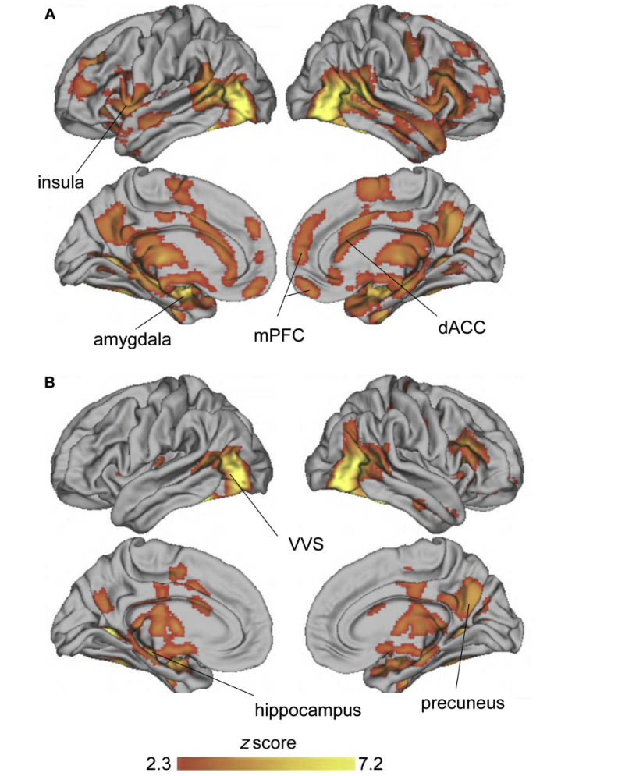

Note: Figure depicts significant activation in the left lateral (top) and medial (bottom) surfaces of the brain when participants viewed (A) fearful vs scrambled and (B) neutral
vs scrambled faces. dACC 1⁄4 dorsal anterior cingulate cortex: mPFC 1⁄4 medial prefrontal cortex; VVS 1⁄4 ventral visual stream. Reported in Weissman et al., 2020.
Supplemental References
1. Bifulco A, Brown GW, Harris TO. Childhood Experience of Care and Abuse (CECA): A Retrospective Interview Measure. Journal of Child Psychology and Psychiatry. 1994 Nov;35(8):1419–35.
2. Raviv A, Raviv A, Shimoni H, Fox NA, Leavitt LA. Children’s Self-Report of Exposure to Violence and Its Relation to Emotional Distress. J Appl Dev Psychol. 1999 Jun;20(2):337–53.
3. Raviv A, Erel O, Fox NA, Leavitt LA, Raviv A, Dar I, et al. Individual measurement of exposure to everyday violence among elementary schoolchildren across various settings. J Community Psychol. 2001 Mar;29(2):117–40.
4. Steinberg AM, Brymer MJ, Decker KB, Pynoos RS. The University of California at Los Angeles post-traumatic stress disorder reaction index. Curr Psychiatry Rep. 2004 Mar;6(2):96–100.
5. Bernstein DP, Ahluvalia T, Pogge D, Handelsman L. Validity of the Childhood Trauma Questionnaire in an Adolescent Psychiatric Population. J Am Acad Child Adolesc Psychiatry. 1997 Mar;36(3):340–8.
6. Walker EA, Unutzer J, Rutter C, Gelfand A, Saunders K, VonKorff M, et al. Costs of Health Care Use by Women HMO Members With a History of Childhood Abuse and Neglect. Arch Gen Psychiatry. 1999 Jul 1;56(7):609.
7. Straus MA, Hamby SL, Finkelhor D, Moore DW, Runyan D. Identification of Child Maltreatment With the Parent-Child Conflict Tactics Scales: Development and Psychometric Data for a National Sample of American Parents. Child Abuse Negl. 1998 Apr;22(4):249–70.
8. Finkelhor D, Ormrod RK, Turner HA, Hamby SL. Measuring poly-victimization using the Juvenile Victimization Questionnaire. Child Abuse Negl. 2005 Nov;29(11):1297–312.
9. Clark LA, Watson D. Constructing validity: Basic issues in objective scale development. Psychol Assess. 1995 Sep;7(3).
10. Kaiser HF. An index of factorial simplicity. Psychometrika [Internet]. 1974 Mar;39(1):31–6. Available from: http://link.springer.com/10.1007/BF02291575
11. Kaiser HF, Rice J. Little Jiffy, Mark Iv. Educ Psychol Meas. 1974 Apr 2;34(1):111–7.
12. Meffert H, Thornton LC, Tyler PM, Botkin ML, Erway AK, Kolli V, et al. Moderation of prior exposure to trauma on the inverse relationship between callous-unemotional traits and amygdala responses to fearful expressions: an exploratory study. Psychol Med. 2018 Nov 12;48(15):2541–9.

