Supplementary Table 1. Mapping Anticipated Components onto Selected Features in the TECH Prototype

 | Anticipated Components
Selected Feature | Motivation | Behavior Change | Interaction | Gamification | Personalization
Login & Settings |  |  |  |  | X
Newsfeed | X |  | X
Goal Setting | X | X |  |  | X
Daily Log & Progress Charts | X | X |  | X | X
Badges & Leaderboard | X |  | X | X
Daily Affirmations & Notifications | X |  | X | X | X
Resources & Contact Us | X

Supplementary Figure 1. Screenshots of TECH App Prototype

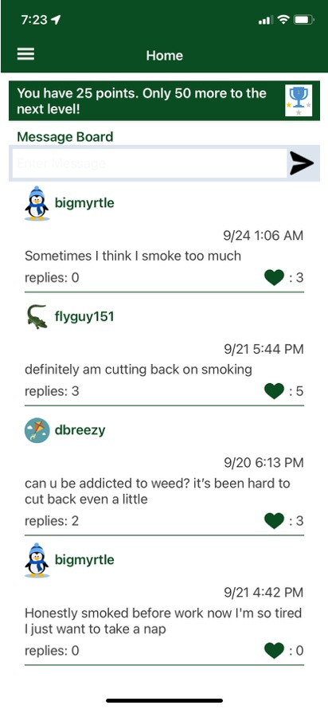 | 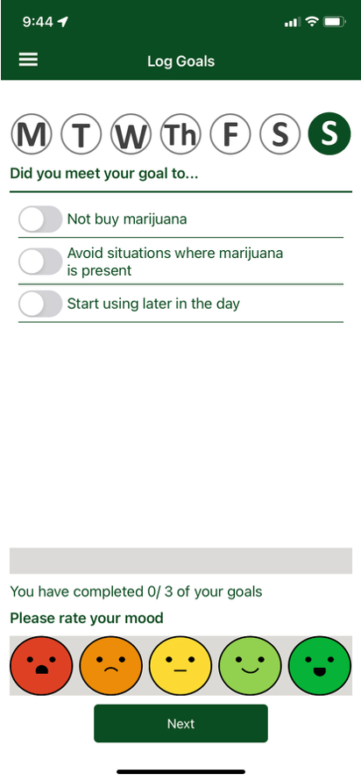
1a. Homepage and Newsfeed | 1b. Daily Goals and Mood Log

