Supplementary Information
S1: Pre-registration plans and deviations
- Pre-registration plans
- Group selection. Children will be assigned to groups based on parent-reported diagnoses (ADHD, autism, dyslexia, dyscalculia, or comparison group) at age 9.
- Possible comorbid groups. If participant numbers permit, children with > 1 neurodevelopmental conditions of interest to the study (e.g., ADHD + autism, dyscalculia + dyslexia) will be allocated to groups reflecting their comorbid status. Power analyses will assess whether the group sizes have sufficient power.
- Data independence. To ensure sampling independency, no more than one member of each twin pair will be selected for participation.
- Statistical analysis. Group differences on key clinical and functional outcomes will be examined using multivariate analysis of variance (MANOVA) and analysis of variance (ANOVA).
- Missing data. Selected participants will have no missing than 15% missing data. Missing values will be imputed.
- Analyzed variables. Multi-informant data from parents, children, and teachers will be used for the main group comparisons at ages 12 and 16.

- Deviations
- Group selection. The selection criterion was changed to include parent-reported neurodevelopmental conditions diagnoses at ages 7, 8, or 9 years due to the limited data availability at 9 years.
- No comorbid groups. Groups composed of participants with two neurodevelopmental conditions were not included due to small group sizes and limited data availability at ages 12 and 16 (see Table 1).
- Inclusion of twin pairs. Both members of twin pairs meeting the group selection criteria were included to maximize data availability.
- Statistical analysis. To account for family variance introduced by the changed selection criterion, random-intercept mixed-effect modeling was employed instead of ANOVAs and MANOVAs.
- Missing data. The threshold for acceptable levels of missing data was raised to 20% to maximize data inclusion.
- Analyzed variables. Parent-reported measures were used exclusively for the analyses due to the limited availability of teacher and child reports at ages 12 and 16. Child reports were utilized only when parent reports were unavailable.
- Additional cross-sectional analysis controlling for SES at ages 12 and 16. Post-hoc Tukey HSD tests (p < .0125) indicated significantly higher SES in the comparison group than in the dyslexia group, with no other group differences. Additional RIMM analyses controlling for SES showed that SES differences did not impact the primary group comparison outcomes (Supplementary Information S2).
- Longitudinal analysis for repeated measures at ages 12 and 16. A longitudinal RIMM were conducted on repeated measures collected at ages 12 and 16 to examine whether the rate of change differ between neurodivergent and comparison group. Measures of ADHD features, peer relationship difficulties, and emotional problems were included, while assessments of autistic traits and academic skills were excluded due to substantial changes in test instruments across timepoints (Supplementary Information S4).
- Unplanned analysis for neurodiverse features. Chi-squared analyses (χ²) were conducted to explore the high levels of clinical features of ADHD and autism at ages 12 and 16 (Supplementary Information S5).
Table 1. Participant numbers for neurodivergent groups
 | Age 7 | Age 8 | Age 9 | N participants meeting data missingness criteria at both 12 and 16 years
Single NC groups (n)
ADHD | 20 | 34 | 0 | 54
Autism | 30 | 20 | 0 | 50
Dyslexia | 568 | 79 | 48 | 695
Dyscalculia | 246 | n/a¹ | 36 | 282
Comorbid NC groups (n)
ADHD + Autism | 12 | 16 | 0 | 5
ADHD + Dyslexia | 13 | 6 | 1 | 6
ADHD + Dyscalculia | 10 | n/a¹ | 11 | 0
Autism + Dyslexia | 21 | 11 | 3 | 3
Autism + Dyscalculia | 21 | n/a¹ | 11 | 2
Dyslexia + Dyscalculia | 424 | n/a¹ | 138 | 0
N of single NC and comorbid NC groups | 1365 | 166 | 248 | 1097
% with comorbid conditions ²
ADHD + Autism | 0.8 | 9.6 | 0 | -
ADHD + Dyslexia | 0.9 | 3.6 | 0.4 | -
ADHD + Dyscalculia | 0.7 | - | 4.4 | -
Autism + Dyslexia | 1.5 | 6.6 | 1.2 | -
Autism + Dyscalculia | 1.5 | - | 4.4 | -
Dyslexia + Dyscalculia | 31.0 | - | 55.6 | -
Notes: NC = Neurodevelopmental conditions. ¹Parent-reported diagnostic information for dyscalculia is unavailable at age 8. ² % is calculated by dividing the n in each comorbid group by the N of single NC and comorbid NC groups at each age. Duplicate reports of diagnoses were removed.

S2. SES
Tukey HSD post-hoc tests comparing each neurodivergent group with the comparison group identified a significant difference only between the comparison and the dyslexia group (Table 2). To examine whether this group difference contributed to any of the reported differences on primary measures, a series of additional RIMM analyses, including SES as a covariate, were conducted on data at ages 12 and 16 (Tables 3 and 4).

 | Mean Difference | 95% CI  Lower Bound | 95% CI  Upper Bound | p-value
Comparison vs. ADHD | 0.41 | 0.33 | 1.14 | 0.555
Comparison vs. Autism | 0.00 | 0.60 | 0.59 | 0.999
Comparison vs. Dyscalculia | 0.32 | 0.63 | 0.02 | 0.031
Comparison vs. Dyslexia | 0.23 | 0.41 | 0.05 | 0.004
Table 2.
Note. p < .0125 shown in bold

Table 3. Results of RIMM between neurodivergent and comparison groups by covarying SES at 12
Strength and Difficulties Questionnaire hyperactivity/inattention subscale (parent-reported)
Effects | Variable | β | σ² | SE | SD | t | p
Fixed | Intercept | 2.58 |  | 0.03 |  | 77.90 | 0.000
 | ADHD | 0.71 |  | 0.35 |  | 2.02 | 0.043
 | Autism | 1.48 |  | 0.32 |  | 4.59 | 0.000
 | Dyscalculia | 0.40 |  | 0.14 |  | 2.84 | 0.004
 | Dyslexia | 0.48 |  | 0.09 |  | 5.22 | 0.000
Random intercept | Family variance |  | 1.75 |  | 1.32
 | SES |  | 0.03 |  | 0.18
 | Residual |  | 2.97 |  | 1.73
Conners inattention subscale (parent-reported)
Effects | Variable | β | σ² | SE | SD | t | p
Fixed | Intercept | 5.03 |  | 0.07 |  | 71.01 | 0.000
 | ADHD | 2.68 |  | 0.76 |  | 3.51 | 0.000
 | Autism | 2.42 |  | 0.70 |  | 3.46 | 0.000
 | Dyscalculia | 0.74 |  | 0.30 |  | 2.42 | 0.012
 | Dyslexia | 1.37 |  | 0.20 |  | 6.87 | 0.000
Random intercept | Family variance |  | 9.67 |  | 3.11
 | SES |  | 0.02 |  | 0.13
 | Residual |  | 13.30 |  | 3.65
Conners Hyperactivity/Impulsivity subscale (parent-reported)
Effects | Variable | β | σ² | SE | SD | t | p
Fixed | Intercept | 3.82 |  | 0.06 |  | 61.13 | 0.000
 | ADHD | 1.67 |  | 0.59 |  | 2.85 | 0.000
 | Autism | 3.01 |  | 0.54 |  | 5.53 | 0.000
 | Dyscalculia | 0.23 |  | 0.23 |  | 1.02 | 0.309
 | Dyslexia | 0.43 |  | 0.15 |  | 2.80 | 0.005
Random intercept | Family variance |  | 8.69 |  | 2.95
 | SES |  | 0.08 |  | 0.28
 | Residual |  | 6.82 |  | 2.61
Childhood Asperger Syndrome Test (parent-reported)
Effects | Variable | β | σ² | SE | SD | t | p
Fixed | Intercept | 4.53 |  | 0.05 |  | 89.38 | 0.000
 | ADHD | 0.67 |  | 0.51 |  | 1.33 | 0.180
 | Autism | 3.10 |  | 0.46 |  | 6.67 | 0.000
 | Dyscalculia | 0.47 |  | 0.30 |  | 3.33 | 0.010
 | Dyslexia | 0.52 |  | 0.13 |  | 3.92 | 0.000
Random intercept | Family variance |  | 4.76 |  | 2.18
 | SES |  | 0.09 |  | 0.30
 | Residual |  | 5.55 |  | 2.36
Note. p < .0125 is shown in bold

Table 3. Cont
Note. p < .0125 is shown in bold

Reading web test (child-completed)
Effects | Variable | β | σ² | SE | SD | t | p
Fixed | Intercept | -59.50 |  | 0.24 |  | 252.03 | 0.000
 | ADHD | -2.85 |  | 2.03 |  | -1.40 | 0.160
 | Autism | -0.87 |  | 1.87 |  | -0.47 | 0.640
 | Dyscalculia | -2.07 |  | 0.80 |  | -2.58 | 0.010
 | Dyslexia | -4.49 |  | 0.53 |  | -8.46 | 0.000
Random intercept | Family variance |  | 77.06 |  | 8.78
 | SES |  | 6.21 |  | 2.49
 | Residual |  | 88.52 |  | 9.41

Table 3. Cont.
Maths web test (child-completed)
Effects | Variable | β | σ² | SE | SD | t | p
Fixed | Intercept | 69.54 |  | 0.25 |  | 275.81 | 0.000
 | ADHD | -3.64 |  | 2.09 |  | -1.74 | 0.082
 | Autism | -3.01 |  | 1.92 |  | -1.57 | 0.116
 | Dyscalculia | -4.58 |  | 0.83 |  | -5.53 | 0.000
 | Dyslexia | -3.39 |  | 0.55 |  | -6.21 | 0.000
Random intercept | Family variance |  | 70.97 |  | 8.42
 | SES |  | 9.08 |  | 3.01
 | Residual |  | 97.56 |  | 9.88
Strength and Difficulties Questionnaire peer problems subscale (parent-reported)
Effects | Variable | β | σ² | SE | SD | t | p
Fixed | Intercept | 0.99 |  | 0.02 |  | 45.28 | 0.000
 | ADHD | 0.08 |  | 0.23 |  | 0.37 | 0.712
 | Autism | 0.61 |  | 0.21 |  | 2.90 | 0.003
 | Dyscalculia | 0.19 |  | 0.09 |  | 2.07 | 0.038
 | Dyslexia | 0.26 |  | 0.06 |  | 4.40 | 0.000
Random intercept | Family variance |  | 1.02 |  | 1.01
 | SES |  | 0.00 |  | 0.03
 | Residual |  | 1.12 |  | 1.06
Strength and Difficulties Questionnaire peer problems subscale (child-reported)
Effects | Variable | β | σ² | SE | SD | t | p
Fixed | Intercept | 1.31 |  | 0.02 |  | 58.21 | 0.000
 | ADHD | 0.48 |  | 0.25 |  | 1.89 | 0.058
 | Autism | 0.19 |  | 0.23 |  | 0.81 | 0.420
 | Dyscalculia | 0.27 |  | 0.10 |  | 1.70 | 0.056
 | Dyslexia | 0.22 |  | 0.07 |  | 3.30 | 0.000
Random intercept | Family variance |  | 0.87 |  | 0.93
 | SES |  | 0.00 |  | 0.00
 | Residual |  | 1.57 |  | 1.25
Mood and Feeling Questionnaire (child-reported)
Effects | Variable | β | σ² | SE | SD | t | p
Fixed | Intercept | 2.17 |  | 0.05 |  | 46.00 | 0.000
 | ADHD | 2.00 |  | 0.52 |  | 3.83 | 0.000
 | Autism | 0.81 |  | 0.47 |  | 1.72 | 0.086
 | Dyscalculia | 0.49 |  | 0.21 |  | 2.37 | 0.018
 | Dyslexia | 0.40 |  | 0.14 |  | 2.97 | 0.003
Random intercept | Family variance |  | 3.57 |  | 1.89
 | SES |  | 0.03 |  | 0.18
 | Residual |  | 6.66 |  | 2.58
Note. p < .0125 shown in bold

Table 3.
Strength and Difficulties Questionnaire emotion subscale (child-reported)
Effects | Variable | β | σ² | SE | SD | t | p
Fixed | Intercept | 2.12 |  | 0.03 |  | 70.06 | 0.000
 | ADHD | 1.25 |  | 0.34 |  | 3.71 | 0.000
 | Autism | 0.38 |  | 0.31 |  | 1.23 | 0.217
 | Dyscalculia | 0.36 |  | 0.13 |  | 2.64 | 0.008
 | Dyslexia | 0.27 |  | 0.09 |  | 3.06 | 0.002
Random intercept | Family variance |  | 1.30 |  | 1.14
 | SES |  | 0.02 |  | 0.16
 | Residual |  | 2.91 |  | 1.71
Note. p < .0125 shown in bold

Table 4. Results of RIMM between neurodivergent and comparison groups by covarying SES at 16
Strength and Difficulties Questionnaire hyperactivity/inattention subscale (parent-reported)
Effects | Variable | β | σ² | SE | SD | t | p
Fixed | Intercept | 2.11 |  | 0.03 |  | 72.10 | 0.000
 | ADHD | 0.76 |  | 0.30 |  | 2.53 | 0.011
 | Autism | 1.04 |  | 0.28 |  | 3.77 | 0.001
 | Dyscalculia | 0.19 |  | 0.12 |  | 1.55 | 0.121
 | Dyslexia | 0.41 |  | 0.08 |  | 5.14 | 0.000
Random intercept | Family variance |  | 1.31 |  | 1.14
 | SES |  | 0.04 |  | 0.20
 | Residual |  | 2.16 |  | 1.47
Conners inattention subscale (parent-reported)
Effects | Variable | β | σ² | SE | SD | t | p
Fixed | Intercept | 3.83 |  | 0.07 |  | 54.58 | 0.000
 | ADHD | 2.37 |  | 0.73 |  | 3.24 | 0.001
 | Autism | 2.18 |  | 0.67 |  | 3.25 | 0.001
 | Dyscalculia | 0.64 |  | 0.29 |  | 2.22 | 0.026
 | Dyslexia | 0.87 |  | 0.19 |  | 4.56 | 0.000
Random intercept | Family variance |  | 9.09 |  | 3.01
 | SES |  | 0.10 |  | 0.32
 | Residual |  | 12.06 |  | 3.47
Conners Hyperactivity/Impulsivity subscale (parent-reported)
Effects | Variable | β | σ² | SE | SD | t | p
Fixed | Intercept | 2.29 |  | 0.06 |  | 41.24 | 0.000
 | ADHD | 1.57 |  | 0.48 |  | 3.26 | 0.001
 | Autism | 1.59 |  | 0.44 |  | 3.57 | 0.000
 | Dyscalculia | 0.15 |  | 0.19 |  | 0.81 | 0.417
 | Dyslexia | 0.27 |  | 0.13 |  | 2.14 | 0.032
Random intercept | Family variance |  | 5.03 |  | 2.24
 | SES |  | 0.27 |  | 0.52
 | Residual |  | 4.78 |  | 2.19
Autism Spectrum Quotient(parent-reported)
Effects | Variable | β | σ² | SE | SD | t | p
Fixed | Intercept | 23.59 |  | 0.17 |  | 139.23 | 0.000
 | ADHD | 0.19 |  | 1.53 |  | 0.12 | 0.901
 | Autism | 5.80 |  | 1.43 |  | 4.06 | 0.000
 | Dyscalculia | 0.93 |  | 0.60 |  | 1.55 | 0.121
 | Dyslexia | 0.84 |  | 0.40 |  | 2.08 | 0.037
Random intercept | Family variance |  | 0.74 |  | 8.58
 | SES |  | 0.00 |  | 0.00
 | Residual |  | 0.44 |  | 6.62
Note. p < .0125 shown in bold

Table 4. Cont.
GCSE english subject test (child-reported)
Effects | Variable | β | σ² | SE | SD | t | p
Fixed | Intercept | 9.05 |  | 0.03 |  | 293.34 | 0.000
 | ADHD | -0.52 |  | 0.18 |  | -2.96 | 0.003
 | Autism | -0.13 |  | 0.16 |  | -0.78 | 0.435
 | Dyscalculia | -0.16 |  | 0.07 |  | -2.38 | 0.017
 | Dyslexia | -0.32 |  | 0.05 |  | -6.89 | 0.000
Random intercept | Family variance |  | 0.60 |  | 0.78
 | SES |  | 0.24 |  | 0.49
 | Residual |  | 0.64 |  | 0.80
Note. p < .0125 shown in bold

Table 4. Cont.
GCSE maths subject test (child-reported)
Effects | Variable | β | σ² | SE | SD | t | p
Fixed | Intercept | 9.13 |  | 0.04 |  | 252.63 | 0.000
 | ADHD | -0.61 |  | 0.20 |  | -3.01 | 0.002
 | Autism | -0.04 |  | 0.19 |  | -0.21 | 0.832
 | Dyscalculia | -0.42 |  | 0.08 |  | -5.35 | 0.000
 | Dyslexia | -0.24 |  | 0.05 |  | -4.46 | 0.000
Random intercept | Family variance |  | 0.91 |  | 0.95
 | SES |  | 0.33 |  | 0.57
 | Residual |  | 0.81 |  | 0.90
Strength and Difficulties Questionnaire peer problems subscale (child-reported)
Effects | Variable | β | σ² | SE | SD | t | p
Fixed | Intercept | 1.50 |  | 0.02 |  | 71.22 | 0.000
 | ADHD | 0.05 |  | 0.24 |  | 0.19 | 0.850
 | Autism | 0.69 |  | 0.22 |  | 3.12 | 0.001
 | Dyscalculia | 0.00 |  | 0.10 |  | 0.04 | 0.970
 | Dyslexia | 0.18 |  | 0.06 |  | 2.88 | 0.004
Random intercept | Family variance |  | 0.72 |  | 0.85
 | SES |  | 0.00 |  | 0.00
 | Residual |  | 1.47 |  | 1.21
Short Mood and Feeling Questionnaire (child-reported)
Effects | Variable | β | σ² | SE | SD | t | p
Fixed | Intercept | 3.54 |  | 0.06 |  | 57.12 | 0.000
 | ADHD | -0.28 |  | 0.71 |  | -0.40 | 0.690
 | Autism | 0.83 |  | 0.64 |  | 1.30 | 0.190
 | Dyscalculia | 0.15 |  | 0.28 |  | 0.52 | 0.600
 | Dyslexia | 0.24 |  | 0.18 |  | 1.28 | 0.200
Random intercept | Family variance |  | 6.38 |  | 2.53
 | SES |  | 0.00 |  | 0.04
 | Residual |  | 12.38 |  | 3.52
Strength and Difficulties Questionnaire emotion subscale (child-reported)
Effects | Variable | β | σ² | SE | SD | t | p
Fixed | Intercept | 2.72 |  | 0.03 |  | 81.91 | 0.000
 | ADHD | 0.20 |  | 0.36 |  | 0.57 | 0.570
 | Autism | 0.27 |  | 0.33 |  | 0.81 | 0.420
 | Dyscalculia | 0.03 |  | 0.14 |  | 0.22 | 0.830
 | Dyslexia | 0.03 |  | 0.09 |  | 0.37 | 0.710
Random intercept | Family variance |  | 1.57 |  | 1.25
 | SES |  | 0.03 |  | 0.17
 | Residual |  | 3.25 |  | 1.80
Note. p < .0125 shown in bold

Table 4. Cont.
Childhood Anxiety Sensitivity (child-reported)
Effects | Variable | β | σ² | SE | SD | t | p
Fixed | Intercept | 7.87 |  | 0.08 |  | 94.28 | 0.000
 | ADHD | 0.26 |  | 0.94 |  | 0.28 | 0.780
 | Autism | -0.27 |  | 0.86 |  | -0.43 | 0.670
 | Dyscalculia | 0.28 |  | 0.38 |  | 0.73 | 0.460
 | Dyslexia | 0.09 |  | 0.25 |  | 0.37 | 0.710
Random intercept | Family variance |  | 11.04 |  | 3.32
 | SES |  | 0.06 |  | 0.25
 | Residual |  | 22.12 |  | 4.70
Note. p < .0125 shown in bold

S3. Results of main analyses
Table 5. Summary of RIMM outcomes for each neurodivergent and comparison group at age 12
Strength and Difficulties Questionnaire hyperactivity/inattention subscale (parent-reported)
Effects | Variable | β | σ² | SE | SD | t | p
Fixed | Intercept | 2.61 |  | 0.03 |  | 84.35 | 0.000
 | ADHD | 0.64 |  | 0.31 |  | 2.06 | 0.039
 | Autism | 1.58 |  | 0.32 |  | 4.92 | 0.000
 | Dyscalculia | 0.41 |  | 0.13 |  | 3.02 | 0.003
 | Dyslexia | 0.48 |  | 0.09 |  | 5.34 | 0.000
Random intercept | Family variance |  | 1.81 |  | 1.34
 | Residual |  | 3.04 |  | 1.74
Conners inattention subscale (parent-reported)
Effects | Variable | β | σ² | SE | SD | t | p
Fixed | Intercept | 5.11 |  | 0.07 |  | 73.30 | 0.000
 | ADHD | 1.93 |  | 0.67 |  | 2.87 | 0.004
 | Autism | 2.44 |  | 0.70 |  | 3.48 | 0.001
 | Dyscalculia | 0.84 |  | 0.29 |  | 2.86 | 0.004
 | Dyslexia | 1.42 |  | 0.20 |  | 7.23 | 0.000
Random intercept | Family variance |  | 10.10 |  | 3.18
 | Residual |  | 13.70 |  | 3.71
Conners Hyperactivity/Impulsivity subscale (parent-reported)
Effects | Variable | β | σ² | SE | SD | t | p
Fixed | Intercept | 3.88 |  | 0.06 |  | 64.54 | 0.000
 | ADHD | 1.59 |  | 0.52 |  | 3.05 | 0.002
 | Autism | 3.12 |  | 0.54 |  | 5.74 | 0.000
 | Dyscalculia | 0.30 |  | 0.22 |  | 1.34 | 0.181
 | Dyslexia | 0.45 |  | 0.15 |  | 3.00 | 0.003
Random intercept | Family variance |  | 9.20 |  | 3.03
 | Residual |  | 6.99 |  | 2.64
Childhood Asperger Syndrome Test (parent-reported)
Effects | Variable | β | σ² | SE | SD | t | p
Fixed | Intercept | 4.56 |  | 0.05 |  | 96.65 | 0.000
 | ADHD | 0.72 |  | 0.44 |  | 1.62 | 0.105
 | Autism | 3.39 |  | 0.46 |  | 7.33 | 0.000
 | Dyscalculia | 0.51 |  | 0.19 |  | 2.65 | 0.008
 | Dyslexia | 0.55 |  | 0.13 |  | 4.31 | 0.000
Random intercept | Family variance |  | 4.97 |  | 2.23
 | Residual |  | 5.64 |  | 2.38
Note. p < .0125 shown in bold

Table 5. Cont.
Reading web test (child-completed)
Effects | Variable | β | σ² | SE | SD | t | p
Fixed | Intercept | 59.41 |  | 0.19 |  | 310.80 | 0.000
 | ADHD | -2.56 |  | 1.77 |  | -1.44 | 0.148
 | Autism | -1.81 |  | 1.85 |  | -0.98 | 0.329
 | Dyscalculia | -2.11 |  | 0.76 |  | -2.77 | 0.006
 | Dyslexia | -4.41 |  | 0.51 |  | -8.59 | 0.000
Random intercept | Family variance |  | 83.84 |  | 9.16
 | Residual |  | 88.40 |  | 9.40
Note. p < .0125 shown in bold

Table 5. Cont.
Maths web test (child-completed)
Effects | Variable | β | σ² | SE | SD | t | p
Fixed | Intercept | 69.37 |  | 0.19 |  | 359.65 | 0.000
 | ADHD | -4.15 |  | 1.84 |  | -2.25 | 0.024
 | Autism | -3.96 |  | 1.92 |  | -2.06 | 0.039
 | Dyscalculia | -4.80 |  | 0.80 |  | -6.03 | 0.000
 | Dyslexia | -3.53 |  | 0.53 |  | -6.61 | 0.000
Random intercept | Family variance |  | 80.03 |  | 8.95
 | Residual |  | 100.04 |  | 10.00
Strength and Difficulties Questionnaire peer problems subscale (parent-reported)
Effects | Variable | β | σ² | SE | SD | t | p
Fixed | Intercept | 1.02 |  | 0.02 |  | 47.57 | 0.000
 | ADHD | 0.26 |  | 0.20 |  | 1.30 | 0.194
 | Autism | 0.68 |  | 0.21 |  | 3.25 | 0.001
 | Dyscalculia | 0.16 |  | 0.09 |  | 1.84 | 0.065
 | Dyslexia | 0.27 |  | 0.06 |  | 4.60 | 0.000
Random intercept | Family variance |  | 1.04 |  | 1.02
 | Residual |  | 1.14 |  | 1.07
Strength and Difficulties Questionnaire peer problems subscale (child-reported)
Effects | Variable | β | σ² | SE | SD | t | p
Fixed | Intercept | 0.02 |  | 0.02 |  | 60.18 | 0.000
 | ADHD | 0.22 |  | 0.22 |  | 2.32 | 0.020
 | Autism | 0.23 |  | 0.23 |  | 1.10 | 0.270
 | Dyscalculia | 0.10 |  | 0.10 |  | 2.34 | 0.019
 | Dyslexia | 0.06 |  | 0.06 |  | 3.47 | 0.000
Random intercept | Family variance |  | 0.90 |  | 0.95
 | Residual |  | 1.57 |  | 1.25
Mood and Feeling Questionnaire (child-reported)
Effects | Variable | β | σ² | SE | SD | t | p
Fixed | Intercept | 2.20 |  | 0.05 |  | 48.34 | 0.000
 | ADHD | 1.49 |  | 0.46 |  | 3.28 | 0.001
 | Autism | 0.72 |  | 0.48 |  | 1.51 | 0.131
 | Dyscalculia | 0.47 |  | 0.20 |  | 2.34 | 0.019
 | Dyslexia | 0.42 |  | 0.13 |  | 3.16 | 0.001
Random intercept | Family variance |  | 3.85 |  | 1.96
 | Residual |  | 6.75 |  | 2.60
Note. p < .0125 shown in bold

Table 5. Cont.
Strength and Difficulties Questionnaire emotion subscale (child-reported)
Effects | Variable | β | σ² | SE | SD | t | p
Fixed | Intercept | 2.14 |  | 0.03 |  | 75.53 | 0.000
 | ADHD | 1.02 |  | 0.29 |  | 3.47 | 0.000
 | Autism | 0.34 |  | 0.30 |  | 1.10 | 0.270
 | Dyscalculia | 0.35 |  | 0.13 |  | 2.76 | 0.006
 | Dyslexia | 0.27 |  | 0.09 |  | 3.18 | 0.001
Random intercept | Family variance |  | 1.31 |  | 1.15
 | Residual |  | 2.96 |  | 1.72
Note. p < .0125 shown in bold

Table 6. Summary of RIMM outcomes for each neurodivergent and comparison group at age 16
Strength and Difficulties Questionnaire hyperactivity/inattention subscale (parent-reported)
Effects | Variable | β | σ² | SE | SD | t | p
Fixed | Intercept | 2.14 |  | 0.03 |  | 79.94 | 0.000
 | ADHD | 0.72 |  | 0.26 |  | 2.73 | 0.006
 | Autism | 1.13 |  | 0.28 |  | 4.09 | 0.000
 | Dyscalculia | 0.16 |  | 0.12 |  | 1.37 | 0.172
 | Dyslexia | 0.42 |  | 0.08 |  | 5.46 | 0.000
Random intercept | Family variance |  | 1.38 |  | 1.17
 | Residual |  | 2.22 |  | 1.49
Conners inattention subscale (parent-reported)
Effects | Variable | β | σ² | SE | SD | t | p
Fixed | Intercept | 3.91 |  | 0.07 |  | 58.01 | 0.000
 | ADHD | 2.13 |  | 0.65 |  | 3.29 | 0.001
 | Autism | 2.27 |  | 0.68 |  | 3.37 | 0.000
 | Dyscalculia | 0.63 |  | 0.28 |  | 2.23 | 0.026
 | Dyslexia | 0.87 |  | 0.19 |  | 4.65 | 0.000
Random intercept | Family variance |  | 9.59 |  | 3.10
 | Residual |  | 12.50 |  | 3.54
Conners Hyperactivity/Impulsivity subscale (parent-reported)
Effects | Variable | β | σ² | SE | SD | t | p
Fixed | Intercept | 2.33 |  | 0.05 |  | 48.37 | 0.000
 | ADHD | 1.57 |  | 0.43 |  | 3.65 | 0.000
 | Autism | 1.69 |  | 0.45 |  | 3.77 | 0.000
 | Dyscalculia | 0.14 |  | 0.18 |  | 0.75 | 0.451
 | Dyslexia | 0.30 |  | 0.12 |  | 2.37 | 0.018
Random intercept | Family variance |  | 5.66 |  | 2.38
 | Residual |  | 4.94 |  | 2.22
Autism Spectrum Quotient(parent-reported)
Effects | Variable | β | σ² | SE | SD | t | p
Fixed | Intercept | 23.67 |  | 0.17 |  | 143.57 | 0.000
 | ADHD | -0.09 |  | 1.35 |  | -0.07 | 0.945
 | Autism | 7.11 |  | 1.42 |  | 5.02 | 0.000
 | Dyscalculia | 0.95 |  | 0.57 |  | 2.15 | 0.031
 | Dyslexia | 0.84 |  | 0.39 |  | 1.67 | 0.096
Random intercept | Family variance |  | 73.91 |  | 8.60
 | Residual |  | 44.36 |  | 6.66
Note. p < .0125 shown in bold

Table 6. Cont.
GCSE english subject test (child-reported)
Effects | Variable | β | σ² | SE | SD | t | p
Fixed | Intercept | 9.07 |  | 0.02 |  | 502.45 | 0.000
 | ADHD | -0.69 |  | 0.16 |  | -4.36 | 0.000
 | Autism | -0.05 |  | 0.17 |  | -0.30 | 0.761
 | Dyscalculia | -0.16 |  | 0.07 |  | -2.42 | 0.016
 | Dyslexia | -0.33 |  | 0.05 |  | -7.24 | 0.000
Random intercept | Family variance |  | 0.82 |  | 0.91
 | Residual |  | 0.64 |  | 0.80
Note. p < .0125 shown in bold

Table 6. Cont.
GCSE maths subject test (child-reported)
Effects | Variable | β | σ² | SE | SD | t | p
Fixed | Intercept | 9.13 |  | 0.02 |  | 427.44 | 0.000
 | ADHD | -0.79 |  | 0.18 |  | -4.36 | 0.000
 | Autism | 0.06 |  | 0.19 |  | 0.31 | 0.751
 | Dyscalculia | -0.39 |  | 0.08 |  | -5.03 | 0.000
 | Dyslexia | -0.25 |  | 0.05 |  | -4.85 | 0.000
Random intercept | Family variance |  | 1.19 |  | 1.09
 | Residual |  | 0.83 |  | 0.91
Strength and Difficulties Questionnaire peer problems subscale (child-reported)
Effects | Variable | β | σ² | SE | SD | t | p
Fixed | Intercept | 1.51 |  | 0.02 |  | 73.80 | 0.000
 | ADHD | 0.02 |  | 0.21 |  | 0.11 | 0.910
 | Autism | 0.67 |  | 0.22 |  | 3.06 | 0.002
 | Dyscalculia | 0.02 |  | 0.09 |  | 0.21 | 0.829
 | Dyslexia | 0.18 |  | 0.06 |  | 3.00 | 0.003
Random intercept | Family variance |  | 0.73 |  | 0.85
 | Residual |  | 1.47 |  | 1.21
Short Mood and Feeling Questionnaire (child-reported)
Effects | Variable | β | σ² | SE | SD | t | p
Fixed | Intercept | 3.29 |  | 0.62 |  | 5.36 | 0.000
 | ADHD | 1.04 |  | 0.85 |  | 1.22 | 0.220
 | Autism | 0.28 |  | 0.62 |  | 0.46 | 0.640
 | Dyscalculia | 0.46 |  | 0.67 |  | 0.69 | 0.490
 | Dyslexia | 0.52 |  | 0.64 |  | 0.81 | 0.420
Random intercept | Family variance |  | 6.48 |  | 2.55
 | Residual |  | 12.68 |  | 3.56
Strength and Difficulties Questionnaire emotion subscale (child-reported)
Effects | Variable | β | σ² | SE | SD | t | p
Fixed | Intercept | 2.68 |  | 0.31 |  | 8.61 | 0.000
 | ADHD | 0.24 |  | 0.43 |  | 0.55 | 0.580
 | Autism | 0.05 |  | 0.31 |  | 0.16 | 0.880
 | Dyscalculia | 0.07 |  | 0.34 |  | 0.20 | 0.840
 | Dyslexia | 0.09 |  | 0.32 |  | 0.27 | 0.790
Random intercept | Family variance |  | 1.58 |  | 1.26
 | Residual |  | 3.29 |  | 1.82
Note. p < .0125 shown in bold

Table 6. Cont.
Childhood Anxiety Sensitivity (child-reported)
Effects | Variable | β | σ² | SE | SD | t | p
Fixed | Intercept | 7.52 |  | 0.81 |  | 9.30 | 0.000
 | ADHD | -0.10 |  | 1.12 |  | -0.09 | 0.930
 | Autism | 0.36 |  | 0.81 |  | 0.45 | 0.660
 | Dyscalculia | 0.62 |  | 0.88 |  | 0.71 | 0.480
 | Dyslexia | 0.41 |  | 0.84 |  | 0.49 | 0.620
Random intercept | Family variance |  | 11.20 |  | 3.35
 | Residual |  | 21.90 |  | 4.68
Note. p < .0125 shown in bold

S4. Longitudinal analysis on repeated measures (group x age interaction)
Table 7 presents the descriptive statistics of the longitudinal analysis derived from the RIMM models. Figures 1 to 5 were plotted using the descriptive data from ages 12 and 16 in Table 7. Detailed statistical outcomes of the longitudinal analysis are provided in Table 8.

Table 7. Descriptives of Longitudinal Analyses of Repeated Measures
 | ADHD  Age 12 |  | ADHD  Age 16 |  | Autism  Age 12 |  | Autism  Age 16
 | M | SD | M | SD | M | SD | M | SD
ADHD features
SDQ HYP/I.P | 2.96 | 2.12 | 2.54 | 1.87 | 4.09 | 2.96 | 2.12 | 2.54
Conners I.P | 6.36 | 4.67 | 5.22 | 4.51 | 7.13 | 6.36 | 4.67 | 5.22
Conners HYP/IMP.P | 5.70 | 3.64 | 2.97 | 3.06 | 6.83 | 5.70 | 3.64 | 2.97
Peer relationship difficulties
SDQ Peer.C | 3.34 | 2.09 | 2.31 | 2.21 | 2.44 | 2.10 | 2.90 | 2.22
Internalizing issues
SDQ Emo.C | 1.83 | 1.57 | 1.43 | 1.50 | 1.62 | 1.57 | 2.14 | 1.50
Note. SDQ HYP/I.P = Strengths and Difficulties Questionnaire hyperactivity/inattention subscale (parent-reported) (score 0 to 10). Conners I.P = Conners inattention subscale (parent-reported) (score 0 to 27), Conners HYP/IMP.P = Conners Hyperactivity/Impulsivity subscale (parent-reported) (score 0 to 27), SDQ.Peer.C = Strength and Difficulties Questionnaire peer problems subscale (child-reported) (score 0 to 10), SDQ.Emo.C = Strength and Difficulties Questionnaire emotion subscale (child-reported) (score 0 to 10).

Table 7. Cont.

 | Dyscalculia  Age 12 |  | Dyscalculia  Age 16 |  | Dyslexia  Age 12 |  | Dyslexia  Age 16 |  | Comparison  Age 12 |  | Comparison  Age 16
 | M | SD | M | SD | M | M | SD | SD | M | SD | M | SD
ADHD features
SDQ HYP/I.P | 3.04 | 2.10 | 2.16 | 1.85 | 3.01 | 2.16 | 2.43 | 1.92 | 2.61 | 2.41 | 2.14 | 2.24
Conners I.P | 5.77 | 4.60 | 4.31 | 4.43 | 6.45 | 4.80 | 4.35 | 4.67 | 5.13 | 5.72 | 3.94 | 5.56
Conners HYP/IMP.P | 4.13 | 3.59 | 2.42 | 3.01 | 4.39 | 3.74 | 2.48 | 3.19 | 3.87 | 4.56 | 2.34 | 4.07
Peer relationship difficulties
SDQ Peer.C | 2.53 | 2.08 | 2.63 | 2.20 | 2.44 | 2.14 | 2.69 | 2.24 | 2.14 | 2.23 | 2.73 | 2.41
Internalizing issues
SDQ Emo.C | 1.61 | 1.56 | 1.45 | 1.48 | 1.55 | 1.58 | 1.65 | 1.53 | 1.33 | 1.74 | 1.52 | 1.66

Figure 1. Longitudinal rate of change in SDQ HYP/I.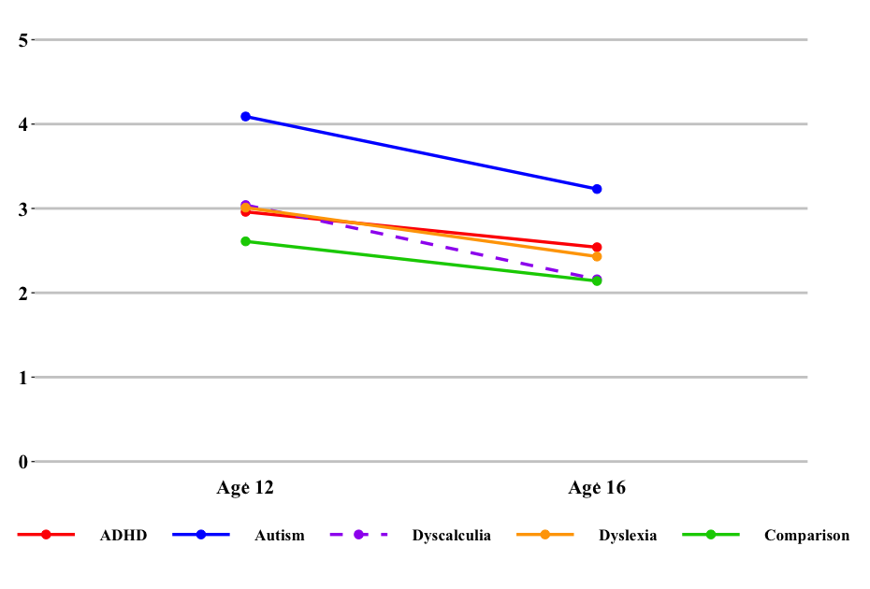Note. The plot range is set to 0–5 for SDQ subscales and 0–10 for Conners subscales to improve visualization. Dashed lines indicate neurodivergent groups showing significant differences in longitudinal slopes compared to the comparison group.

Figure 2. Longitudinal rate of change in Conners. I.P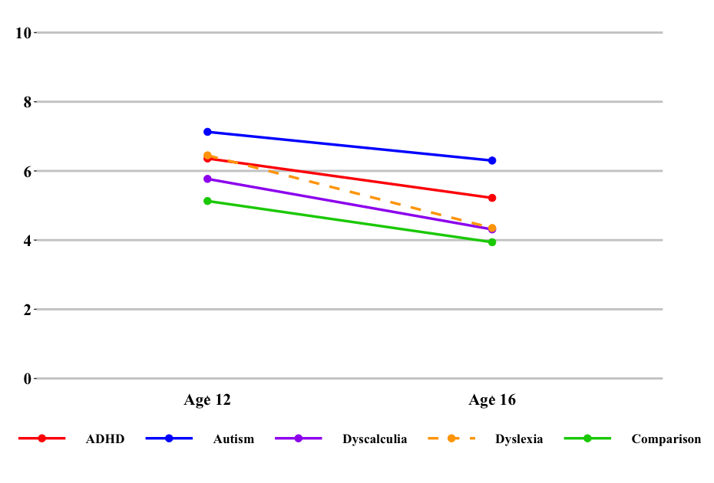
Figure 3. Longitudinal rate of change in Conners.HYP/IMP.P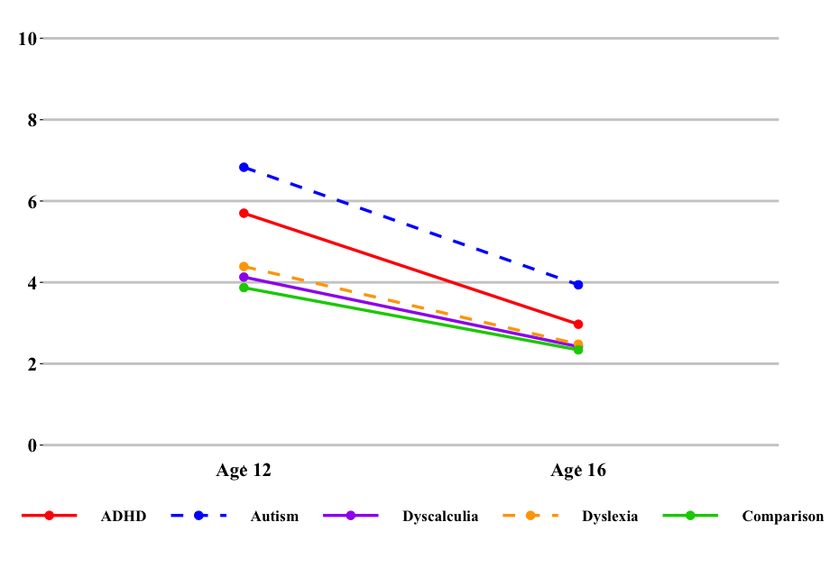

Figure 4. Longitudinal rate of change in SDQ Peer.C
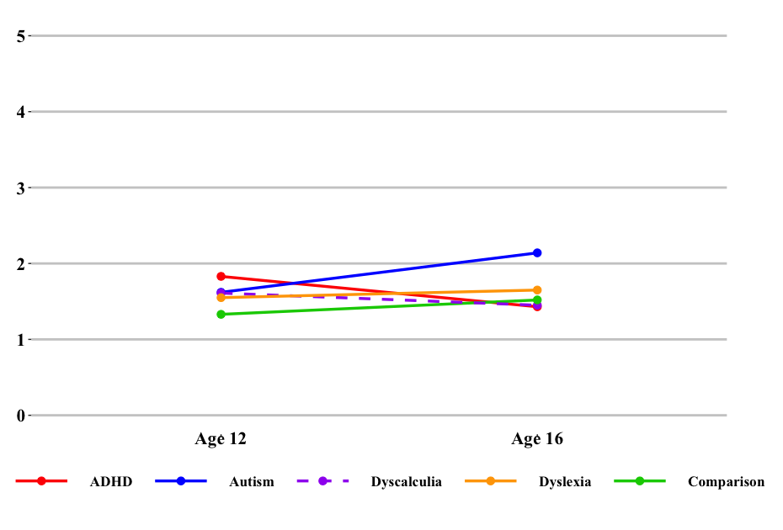

Figure 5. Longitudinal rate of change in SDQ Emo.C
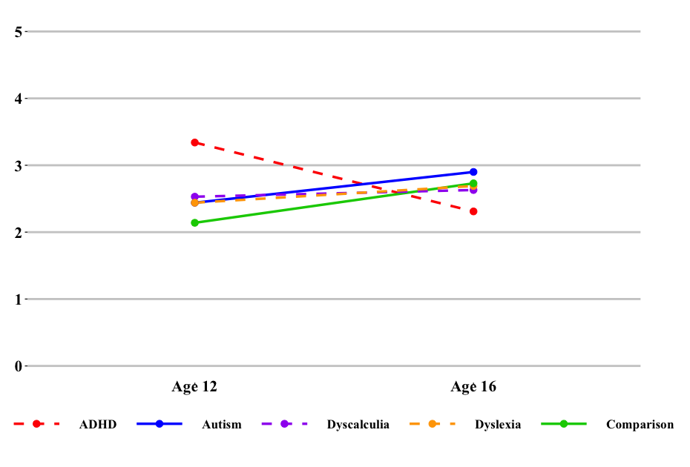
Table 8. Age interaction effect on repeated measures between each neurodivergent to the comparison groups
Strength and Difficulties Questionnaire hyperactivity/inattention subscale (parent-reported)
Effects | Variable | β | σ² | SE |  | SD |  | t | p
Fixed | Intercept | 4.02 |  | 0.10 |  |  |  | 38.85 | 0.000
 | Age | -0.12 |  | 0.01 |  |  |  | -16.79 | 0.000
 | ADHD | 0.20 |  | 1.16 |  |  |  | 0.18 | 0.860
 | Autism | 2.65 |  | 1.21 |  |  |  | 2.20 | 0.028
 | Dyscalculia | 1.66 |  | 0.52 |  |  |  | 3.22 | 0.001
 | Dyslexia | 0.74 |  | 0.34 |  |  |  | 2.18 | 0.029
Interaction | Age: ADHD | 0.01 |  | 0.08 |  |  |  | 0.15 | 0.879
Interaction | Age: Autism | -0.10 |  | 0.08 |  |  |  | -1.19 | 0.235
 | Age: Dyscalculia | -0.10 |  | 0.04 |  |  |  | -2.92 | 0.003
 | Age: Dyslexia | -0.03 |  | 0.02 |  |  |  | -1.21 | 0.226
Random intercept | Intercept |  | 1.53 |  |  | 1.24
Random intercept | Residual |  | 3.20 |  |  | 1.79
Conners inattention subscale (parent-reported)
Effects | Variable | β | σ² |  | SE |  | SD | t | p
Fixed | Intercept | 8.69 |  |  | 0.23 |  |  | 38.00 | 0.000
 | Age | -0.30 |  |  | 0.02 |  |  | -19.02 | 0.000
 | ADHD | 1.10 |  |  | 2.55 |  |  | 0.43 | 0.666
 | Autism | 0.92 |  |  | 2.65 |  |  | 0.35 | 0.729
 | Dyscalculia | 1.46 |  |  | 1.13 |  |  | 1.29 | 0.198
 | Dyslexia | 4.07 |  |  | 0.74 |  |  | 5.47 | 0.000
Interaction | Age: ADHD | 0.01 |  |  | 0.18 |  |  | 0.06 | 0.949
 | Age: Autism | 0.09 |  |  | 0.18 |  |  | 0.49 | 0.623
 | Age: Dyscalculia | -0.07 |  |  | 0.08 |  |  | -0.86 | 0.388
 | Age: Dyslexia | -0.23 |  |  | 0.05 |  |  | -4.43 | 0.000
Random intercept | Intercept |  | 9.67 |  |  |  | 3.11
Random intercept | Residual |  | 14.19 |  |  |  | 3.77
Conners Hyperactivity/Impulsivity subscale (parent-reported)
Effects | Variable | β | σ² |  | SE |  | SD | t | p
Fixed | Intercept | 8.44 |  |  | 0.17 |  |  | 49.14 | 0.000
 | Age | -0.38 |  |  | 0.01 |  |  | -33.54 | 0.000
 | ADHD | 5.44 |  |  | 1.91 |  |  | 2.85 | 0.004
 | Autism | 7.06 |  |  | 1.99 |  |  | 3.56 | 0.000
 | Dyscalculia | 0.82 |  |  | 0.85 |  |  | 0.97 | 0.330
 | Dyslexia | 1.69 |  |  | 0.56 |  |  | 3.04 | 0.002
Interaction | Age: ADHD | -0.30 |  |  | 0.13 |  |  | -2.34 | 0.019
 | Age: Autism | -0.34 |  |  | 0.13 |  |  | -2.55 | 0.010
 | Age: Dyscalculia | -0.05 |  |  | 0.06 |  |  | -0.81 | 0.416
 | Age: Dyslexia | -0.10 |  |  | 0.04 |  |  | -2.59 | 0.009
Random intercept | Intercept |  | 6.08 |  |  |  | 2.47
Random intercept | Residual |  | 9.05 |  |  |  | 3.01
Note. p < .0125 shown in bold

Table 8. Cont.
Note. p < .0125 shown in bold

Strength and Difficulties Questionnaire peer problems subscale (child-reported)
Effects | Variable | β | σ² | SE | SD | t | p
Fixed | Intercept | 0.76 |  | 0.08 |  | 9.46 | 0.000
 | Age | 0.05 |  | 0.01 |  | 8.61 | 0.000
 | ADHD | 2.30 |  | 0.90 |  | 2.56 | 0.010
 | Autism | -0.68 |  | 0.93 |  | -0.73 | 0.467
 | Dyscalculia | 1.33 |  | 0.40 |  | 3.34 | 0.000
 | Dyslexia | 0.47 |  | 0.26 |  | 1.78 | 0.074
Interaction (Age x Group) | Age: ADHD | -0.15 |  | 0.06 |  | -2.39 | 0.016
 | Age: Autism | 0.08 |  | 0.06 |  | 1.25 | 0.211
 | Age: Dyscalculia | -0.09 |  | 0.03 |  | -3.14 | 0.001
 | Age: Dyslexia | -0.02 |  | 0.02 |  | -1.13 | 0.257
Random intercept (family variance) | Intercept |  | 0.66 |  | 0.81
Random intercept (family variance) | Residual |  | 1.78 |  | 1.34
Strength and Difficulties Questionnaire emotion subscale (child-reported)
Effects | Variable | β | σ² | SE | SD | t | p
Fixed | Intercept | 0.38 |  | 0.11 |  | 3.46 | 0.000
 | Age | 0.15 |  | 0.01 |  | 18.80 | 0.000
 | ADHD | 6.07 |  | 1.25 |  | 4.87 | 0.000
 | Autism | 0.68 |  | 1.30 |  | 0.52 | 0.600
 | Dyscalculia | 1.86 |  | 0.55 |  | 3.36 | 0.000
 | Dyslexia | 1.29 |  | 0.36 |  | 3.56 | 0.000
Interaction (Age x Group) | Age: ADHD | -0.41 |  | 0.09 |  | -4.59 | 0.000
 | Age: Autism | -0.03 |  | 0.09 |  | -0.35 | 0.730
 | Age: Dyscalculia | -0.12 |  | 0.04 |  | -3.12 | 0.001
 | Age: Dyslexia | -0.08 |  | 0.03 |  | -3.24 | 0.001
Random intercept (family variance) | Intercept |  | 1.23 |  | 1.11
Random intercept (family variance) | Residual |  | 3.10 |  | 1.76

S5. Unplanned χ² tests of elevated ADHD features and autistic traits
Tables 9 (age 12) and 10 (age 16) present the number of children in each neurodivergent group scoring more than two standard deviations above the mean of the aggregated dataset (N = 7,963) on measures of ADHD and autistic traits, along with the χ² analysis outcomes from pairwise comparisons between each neurodivergent group and the comparison group. Figures 6 to 8 were generated using data from Tables 9 and 10.
At 12 years, all four neurodivergent groups had a significantly higher proportion of children with elevated inattention scores (ADHD 15%; autism 14%; dyscalculia 9%; dyslexia 10%) than the comparison group (4%). A greater proportion of children in the ADHD (26%), autism (20%), and dyslexia (8%) groups had clinically elevated hyperactivity/impulsivity scores compared to the comparison group (4%), but this was not observed in the dyscalculia group (6%). All four neurodivergent groups had a significantly greater proportion of children with elevated autistic traits (ADHD 19%; autism 24%; dyscalculia 10%; dyslexia 12%) than the comparison group (3%). At 16 years, the proportion of elevated inattention scores remained significantly higher in the ADHD (24%), autism (16%), and dyslexia (7%) groups than in the comparison group (5%), but not in the dyscalculia group (6%). Elevated hyperactivity/impulsivity scores were significantly higher across all neurodivergent groups (ADHD 19%; autism 14%; dyscalculia 8%; dyslexia 7%) compared to the comparison group (5%). Clinically elevated autistic traits were significantly higher only in the autism group (24%) than in the comparison group (3%), while the percentages in the other groups (ADHD 4%; dyscalculia 4%; dyslexia: 3%) did not differ significantly from the comparison group.

Figure 6.
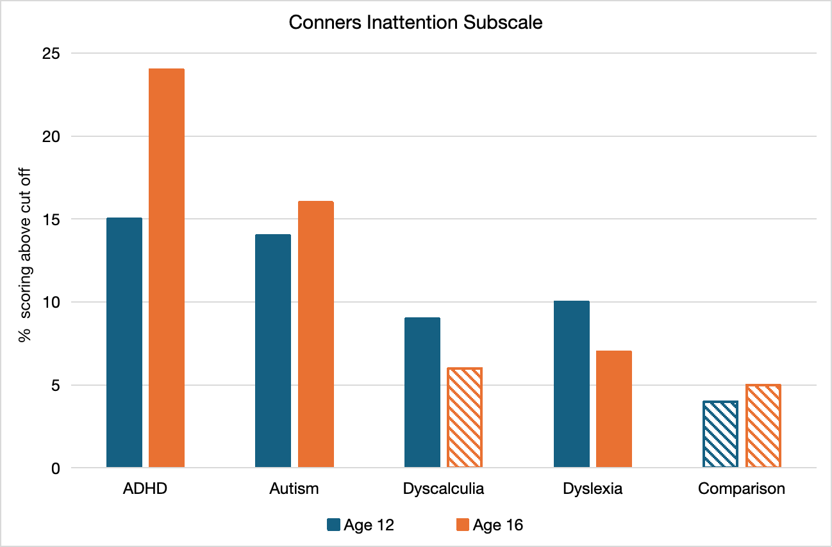
Note. Solid bars indicate a significant difference in the percentage of individuals scoring above the cut-off between the neurodivergent group and the comparison group; dashed bars denote no significant difference.
Figure 7.
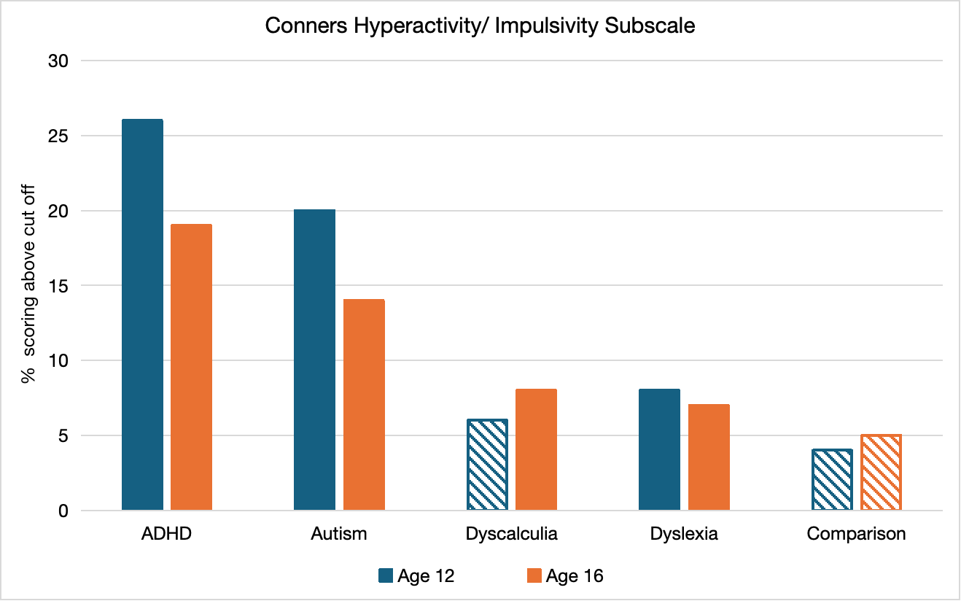

Figure 8.
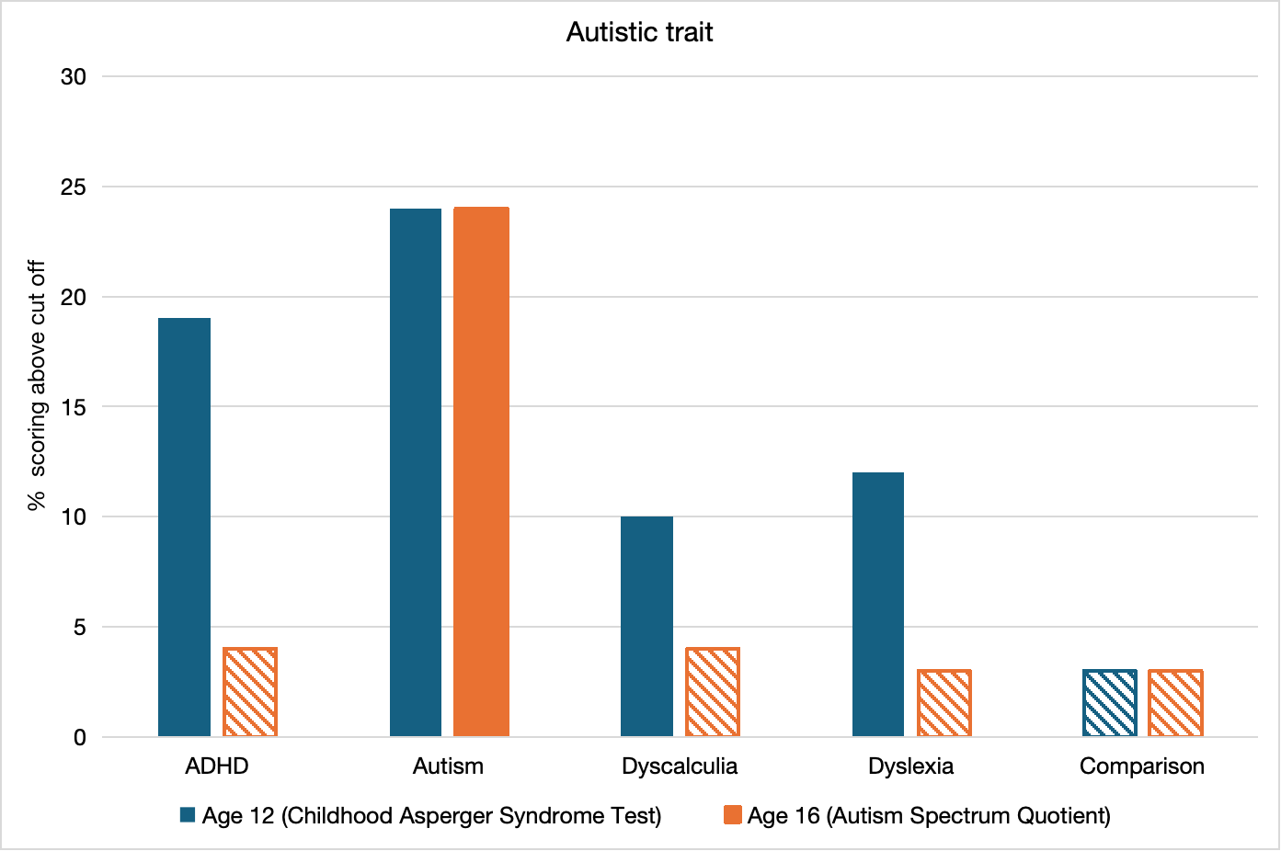
 | Conners inattention scale
 | % of children who score equal or above the cut-off | % of children who score below the cut-off | χ² statistics | p-value vs. comparison group
ADHD (n = 54) | 15% | 85% | 15.27 | 0.000
Autism (n = 50) | 14% | 86% | 12.11 | 0.000
Dyscalculia (n = 282) | 9% | 91% | 12.78 | 0.000
Dyslexia (n = 695) | 10% | 90% | 52.80 | 0.000
Comparison group  (n = 6882) | 4% | 96% | - | -
 | Conners hyperactivity/ impulsivity scale
 | % of children who score equal or above the cut-off | % of children who score below the cut-off | χ² statistics | p-value vs. comparison group
ADHD (n = 54) | 26% | 74% | 66.05 | 0.000
Autism (n = 50) | 20% | 80% | 33.10 | 0.000
Dyscalculia (n = 282) | 6% | 94% | 2.17 | 0.141
Dyslexia (n = 695) | 8% | 92% | 24.48 | 0.000
Comparison group  (n = 6882) | 4% | 96% | - | -
 | Childhood Asperger Syndrome Test
 | % of children who score equal or above the cut-off | % of children who score below the calculated cut-off | χ² statistics | p-value vs. comparison group
ADHD (n = 54) | 19% | 81% | 15.62 | 0.000
Autism (n = 50) | 24% | 76% | 29.49 | 0.000
Dyscalculia (n = 282) | 10% | 90% | 7.19 | 0.007
Dyslexia (n = 695) | 12% | 88% | 43.68 | 0.000
Comparison group  (n = 6882) | 3% | 97% | - | -
Table 9. Results of χ² analysis at age 12
Note. p < .05 shown in bold

Table 10. Results of χ² analysis at age 16
 | Conners inattention scale
 | % of children who score equal or above to the calculated cut-off | % of children who score below to the calculated cut-off | χ² statistics | p-value vs. comparison group
ADHD (n = 54) | 24% | 76% | 41.30 | 0.000
Autism (n = 50) | 16% | 84% | 13.01 | 0.003
Dyscalculia (n = 282) | 6% | 97% | 0.98 | 0.322
Dyslexia (n = 695) | 7% | 93% | 7.86 | 0.005
Comparison group  (n = 6882) | 5% | 95% | - | -
 | Conners hyperactivity/ impulsivity scale
 | % of children who score equal or above to the calculated cut-off | % of children who score below to the calculated cut-off | χ² statistics | p-value vs. comparison group
ADHD (n = 54) | 19% | 81% | 22.74 | 0.000
Autism (n = 50) | 14% | 86% | 9.65 | 0.002
Dyscalculia (n = 282) | 8% | 96% | 5.13 | 0.024
Dyslexia (n = 695) | 7% | 93% | 9.80 | 0.002
Comparison group  (n = 6882) | 5% | 95% | - | -
 | Autism Spectrum Quotient
 | % of children who score equal or above to the calculated cut-off | % of children who score below to the calculated cut-off | χ² statistics | p-value vs. comparison group
ADHD (n = 54) | 4% | 96% | 0.17 | 0.685
Autism (n = 50) | 24% | 76% | 78.18 | 0.000
Dyscalculia (n = 282) | 4% | 96% | 1.77 | 0.184
Dyslexia (n = 695) | 3% | 97% | 1.00 | 0.316
Comparison group  (n = 6882) | 3% | 97% | - | -
Note. p < .05 shown in bold

