Supplemental Appendices

Supplemental Figure 1
Pictural Representation of Mother-Child Dyadic LEGO Task
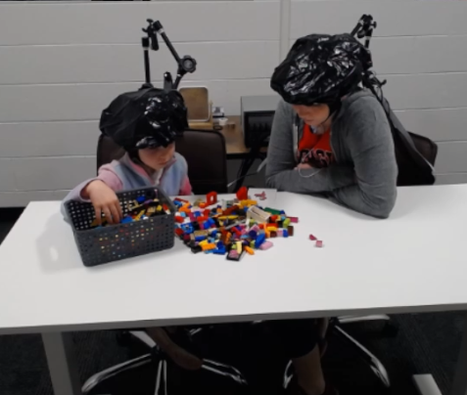

Supplemental Figure 2
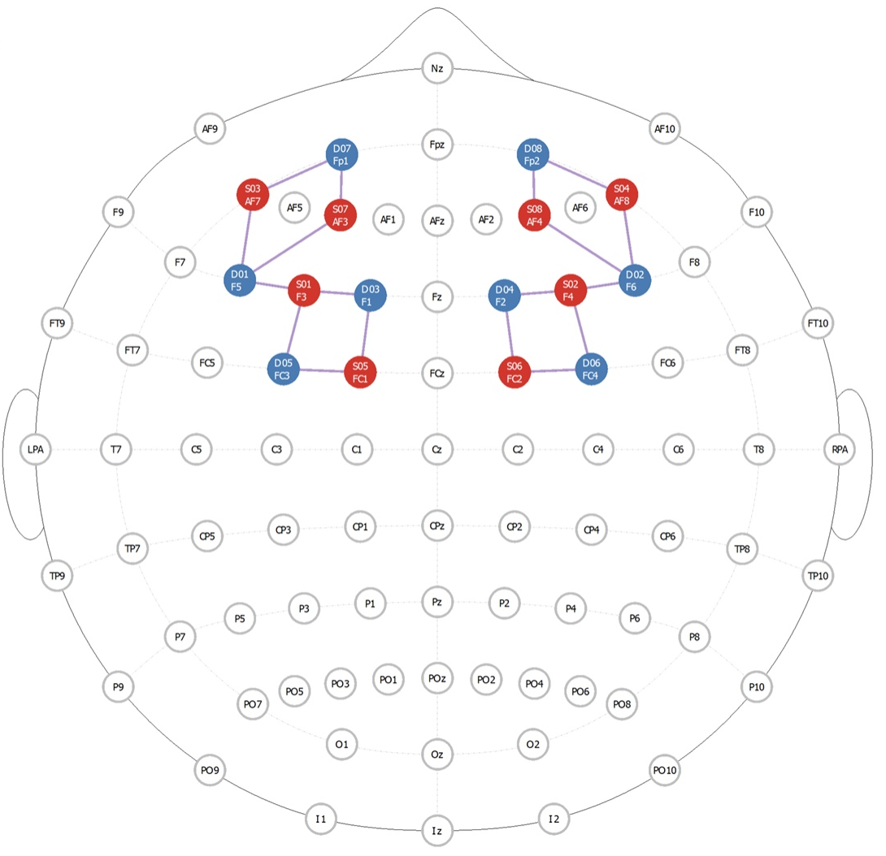
fNIRs Optode Placement Visual

