Figure S1. Distribution of pubertal development and age in the sample (N=200). A) Histogram of pubertal development (PDS Shirtcliff; comparable to Tanner Stages). A score of 1 indicates that pubertal development has not yet started, while a score of 5 indicates that pubertal development seems completed. B) Histogram of age distribution. C) Pubertal development and age are positively correlated (r=.39***, p<.001). r=Pearson correlation coefficient.

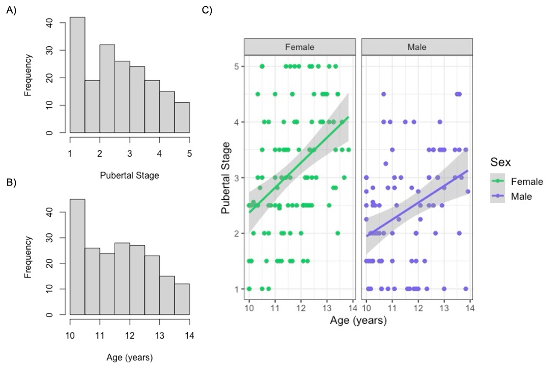

Table S1. Correlations among study variables.

Variable | 1 | 2 | 3 | 4 | 5 | 6 | 7 | 8 | 9
1. Child SCARED | —
2. Parent SCARED | .39** | —
3. ADIS Anxiety Severity | .25* | .25* | —
4. CGAS | -.57** | -.59** | -.48** | —
5. PARS-6 | .55** | .58** | .30** | -.81** | —
6. PDS (Shirtcliff) | .27** | .06 | .22* | -.21** | .12 | —
7. Age (years) | -.08 | -.09 | .03 | .06 | -.10 | .42** | —
8. YSR Anxiety | .81** | .42** | .26* | -.54** | .56** | .26** | -.02 | —
9. CBCL Anxiety | .39** | .80** | .22* | -.62** | .62** | .10 | -.10 | .40** | —

Note. Child SCARED = youth-reported Screen for Child Anxiety-Related Emotional Disorders; Parent SCARED = caregiver-reported SCARED; ADIS = Anxiety Disorders Interview Schedule severity; CGAS = Children’s Global Assessment Scale; PARS-6 = Pediatric Anxiety Rating Scale; PDS = Pubertal Development Scale. *p < .05, **p < .01.

Table S2. Differences in main study variables pre- versus post-COVID shutdown. We compared participants assessed prior to March 2020 (Pre-COVID; n = 96) and those assessed after March 2020 (Post-COVID; n = 104) on all main study variables. Consistent with study recruitment procedures that targeted higher anxiety tertiles in later stages of enrollment, anxiety measures were higher among post-COVID participants. All other demographic and clinical variables remained comparable.
Variable | Pre-COVID (n = 96) | Post-COVID (n = 104) | Test statistic (df) | p | Holm p | Sig.
Continuous measures (M ± SD)
PCA Anxiety Composite | -0.35 (1.00) | 0.33 (1.10) | 2.98 | .003 | .026 | *
Child SCARED | 15.29 (13.20) | 21.75 (14.80) | 3.31 | .001 | .010 | *
Parent SCARED | 10.55 (11.20) | 14.48 (12.90) | 2.33 | .021 | .126 | ns
ADIS Anxiety Severity | 5.29 (0.90) | 5.66 (0.80) | 2.41 | .018 | .126 | ns
CGAS | 73.85 (15.20) | 70.24 (15.60) | -1.66 | .098 | .492 | ns
PARS-6 | 7.48 (6.20) | 8.80 (6.40) | 1.48 | .140 | .560 | ns
PDS (Shirtcliff) | 2.74 (1.10) | 2.85 (1.10) | 0.70 | .486 | 1.000 | ns
Age (years) | 11.69 (1.10) | 11.62 (1.10) | -0.40 | .690 | 1.000 | ns
Categorical measures (n, %)
Female | 55 (57%) | 55 (53%) | 0.23 | .629 | – | ns
ADIS Anxiety Diagnosis (any) | 37 (39%) | 57 (55%) | 7.44 | .006 | – | **
Hispanic | 70 (73%) | 90 (87%) | 3.35 | .067 | – | ns
Race |  |  | 4.91 | .296 | – | ns
White | 76 (79%) | 79 (76%)
Black | 9 (9%) | 10 (10%)
Asian | 2 (2%) | 2 (2%)
Mixed/Other | 9 (10%) | 7 (7%)
Note. Continuous measures are presented as mean (SD). Categorical measures are presented as n (%). Sig. = significance after Holm correction for continuous measures; categorical variables tested with χ² or Fisher’s exact test. Percentages may not sum to 100% due to rounding.

Figure S2. Parent–child discrepancies in anxiety severity as a function of pubertal development, stratified by sex. Linear model predictions of SCARED total anxiety scores are plotted by pubertal development separately for males and females, controlling for age. Consistent with primary results, child-reported anxiety increased with advancing pubertal stage, whereas parent-reported anxiety remained relatively stable. Although females reported higher anxiety overall, this divergence was evident across both sexes, with no evidence of a three-way interaction among informant, puberty, and sex (b=1.73, p=.37). SCARED=Screen for Child Anxiety-Related Emotional Disorders.

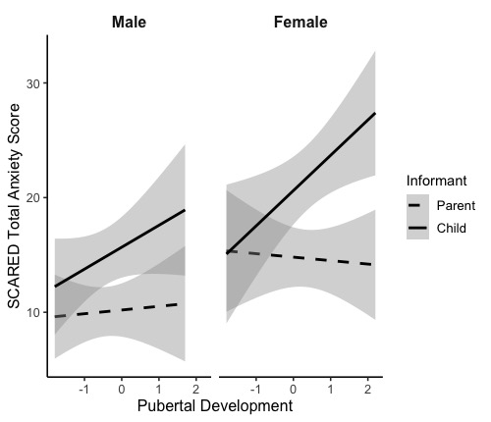
Figure S3. Visualization of parent-child discrepancy during puberty across SCARED subtypes.
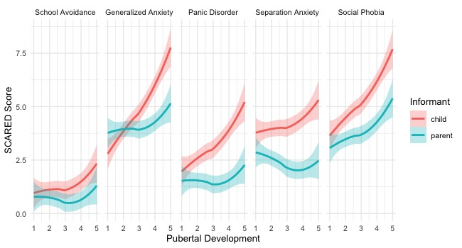
Table S3. Differences in pubertal slopes between child and parent reports across SCARED subtypes.
Anxiety Subtype | Estimate | SE | df | t | p
School Avoidance | 0.21 | 0.24 | 1767.72 | 0.90 | .370
Generalized Anxiety | 0.89 | 0.24 | 1767.72 | 3.80 | < .001
Panic Disorder | 0.62 | 0.24 | 1767.73 | 2.64 | .008
Separation Anxiety | 0.50 | 0.24 | 1768.71 | 2.10 | .036
Social Phobia | 0.43 | 0.24 | 1767.72 | 1.81 | .071

Table S4. PCA anxiety measures of interest. PCA=Principal Components Analysis; SCARED=Screen for Child Anxiety Related Emotional Disorders; PARS=Pediatric Anxiety Rating Scale; ADIS=Anxiety Disorders Interview Schedule. *p<.05, **p<.01, ***p<.001.

4a. Correlation matrix between PCA variables of interest.
 | 1 | 2 | 3 | 4
- Child SCARED | 1 | .40*** | .55*** | .54***
- Parent SCARED | .40*** | 1 | .58*** | .53***
- PARS-6 | .55*** | .58*** | 1 | .78***
- ADIS Diagnosis | .53*** | .55*** | .78*** | 1
4b. Loading matrix of the PCA multi-informant anxiety score.
 | Component 1
Child SCARED | 0.74
Parent SCARED | 0.76
PARS-6 | 0.90
ADIS Diagnosis | 0.88

Figure S4. Scree Plot of Principal Components. Only one component emerged with an eigenvalue >1, meaning it accounted for more variance than is accounted for by one of the original variables alone (eigenvalue=2.7). Component 1 explained 67.8% of the variance in anxiety scores across informants.

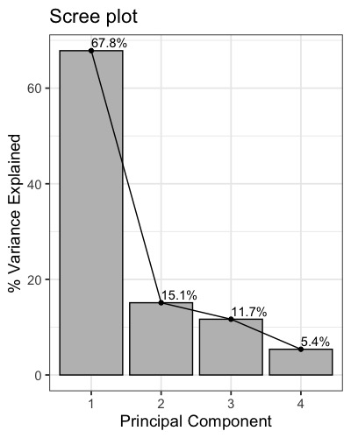

Figure S5. The multi-informant score is significantly associated with ADIS anxiety severity in the clinically anxious participants (n=94). Results of a linear regression analysis revealed that the anxiety trait score was a significant predictor of ADIS Anxiety Severity (β=0.42, p<.001). ADIS=Anxiety Disorders Interview Schedule.
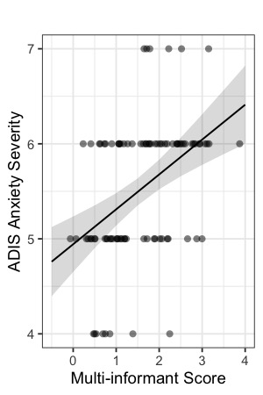

Table S5. Comparison of PCA models with and without ADIS diagnosis

DV | Adj. R² (PCA) | β (PCA) | p | Adj. R² (No ADIS) | β (No ADIS) | p | ΔR²
CGAS | .751 | -8.12 | <.001 | .647 | -8.73 | <.001 | +.105
ADIS Severity | .148 | 0.35 | <.001 | .145 | 0.29 | <.001 | +.003
CBCL Anxiety | .518 | 1.49 | <.001 | .543 | 1.77 | <.001 | -.025
YSR Anxiety | .484 | 1.55 | <.001 | .526 | 1.87 | <.001 | -.041

