Figure S1.
Trondheim Early Secure Study (TESS), Procedure and flow of participants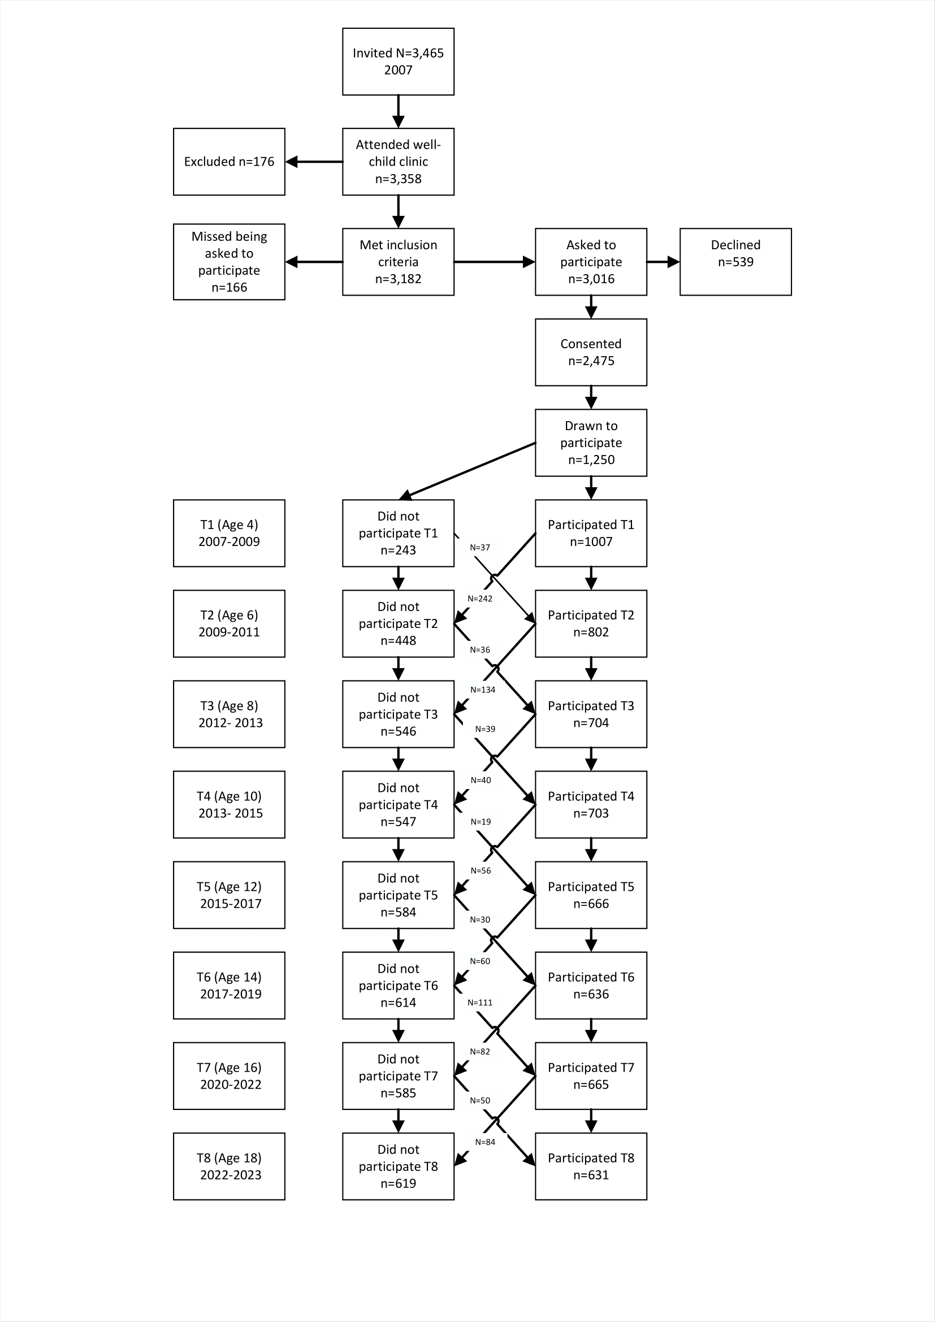
Note: T1 = Time 1, T2 = Time 2, etc. Participant numbers at each assessment point reflect the number of individuals invited to participate minus those who did not participate at the respective time points.

Table S1.
Bivariate correlations between family factors and specialty service use
 | Service use (T5) | Service use (T6) | Service use (T7) | Service use (T8)
Family functioning (T5) | -.06 | -.02 | .02 | -.04
Family functioning (T6) |  | .03 | .05 | -.03
Family functioning (T7) |  |  | -.05 | -.09
Family functioning (T8) |  |  |  | -0.07
Social support (T5) | -.11* | -.06 | -.03 | -.09
Social support (T6) |  | -.01 | -.07 | -.01
Social support (T7) |  |  | -.11* | -.09
Social support (T8) |  |  |  | -.10*
Interparental conflict (T5) | -.01 | .05 | .03 | .07
Interparental conflict (T6) |  | .01 | -.02 | .00
Interparental conflict (T7) |  |  | -.01 | .03
Interparental conflict (T8) |  |  |  | .08
Note: Asterisks indicate level of statistical significance: * p ≤ 0.05, ** p ≤ 0.01, ***p ≤ 0.001.

Table S2.
Standardized autoregressive paths for predictors across adjacent time points
 | 14 years |  |  | 16 years |  |  | 18 years
 | β | 95% CI | p | β | 95% CI | p | β | 95% CI | p
Propensity score as covariate | 0.29 | (0.17, 0.40) | < .001 | 0.27 | (0.16, 0.38) | < .001 | 0.38 | (0.24, 0.52) | < .001
Family functioning | 0.62 | (0.54, 0.70) | < .001 | 0.28 | (0.13, 0.43) | < .001 | 0.43 | (0.31, 0.55) | < .001
Social support | 0.35 | (0.28, 0.43) | < .001 | 0.37 | (0.31, 0.44) | < .001 | 0.36 | (0.29, 0.43) | < .001
Interparental sonflict | 0.66 | (0.58, 0.74) | < .001 | 0.57 | (0.50, 0.64) | < .001 | 0.57 | (0.50, 0.65) | < .001
Note. Values represent standardized coefficients and 95% confidence intervals, and exact p-values.

Table S3.
Standardized concurrent covariances between predictors and specialty service use at the same time point
Predictor  (same wave) | Service use  (12 years) |  | Service use  (14 years) |  | Service use  (16 years) |  | Service use  (18 years)
Predictor  (same wave) | Cov (SE) | p | Cov (SE) | p | Cov (SE) | p | Cov (SE) | p
Propensity score | 0.56 (0.09) | < .001 | 0.34 (0.10) | .005 | 0.52 (0.06) | < .001 | 0.32 (0.07) | < .001
Family functioning | -0.06 (0.04) | .11 | 0.07 (0.04) | .11 | -0.06 (0.05) | .27 | -0.03 (0.04) | .47
Social support | -0.11 (0.04) | .02 | 0.04 (0.04) | .38 | -0.08 (0.04) | .05 | -0.03 (0.04) | .42
Interparental conflict | -0.02 (0.05) | .60 | -0.05 (0.06) | .47 | -0.03 (0.05) | .52 | 0.07 (0.05) | .16
Note. Values represent standardized covariances (standard errors in parentheses) between predictors and service use measured at the same time point.

