Additional Supplemental Material for: The association between emotional and behavioural problems in children with ASD and stress and mental health problems in their parents: a systematic review and meta-analysis.
Journal of Autism and Developmental Disorders.
Supplemental Material 2. Forest plots for all analyses

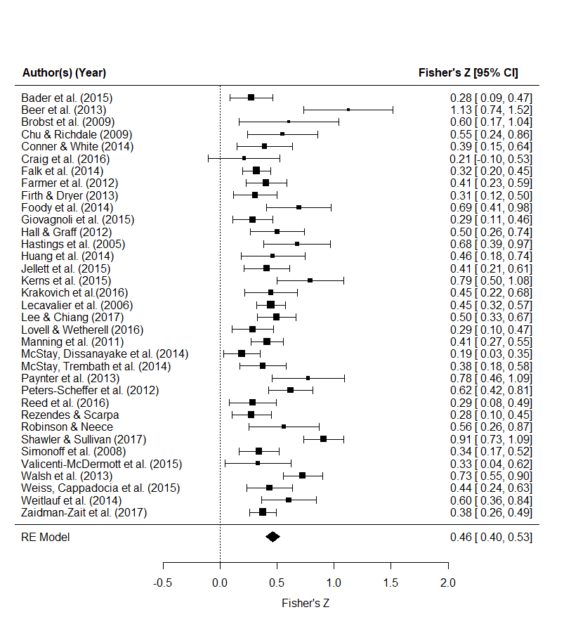
Supplementary Figure 1. Forest plot for Analysis 1 (associations between parenting stress and child total emotional and behavioral problems)

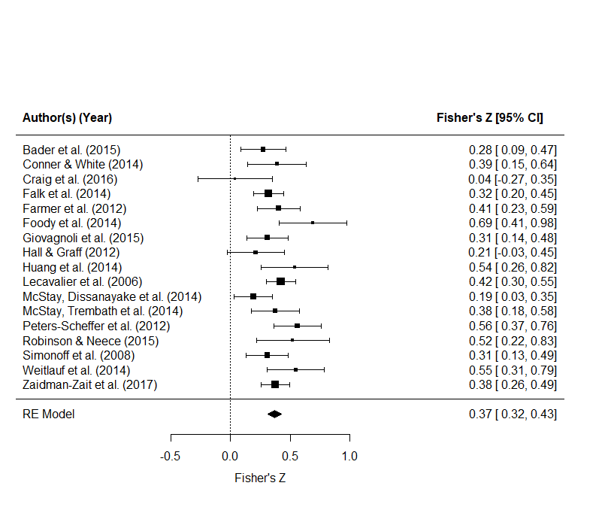
Supplementary Figure 2. Forest plot for Analysis 2 (associations between parenting stress and child externalizing)

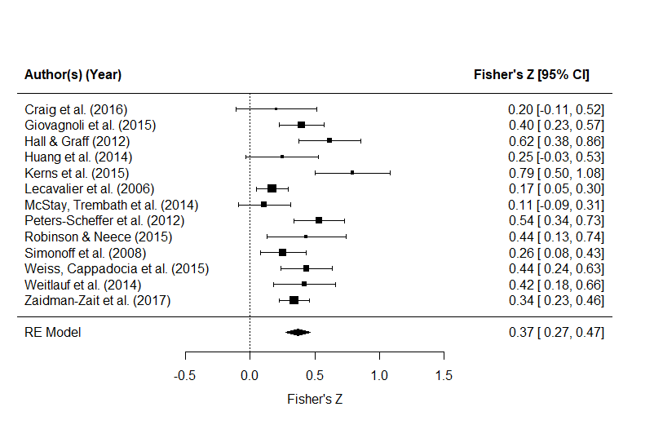
Supplementary Figure 3. Forest plot for Analysis 3 (associations between parenting stress and child internalizing)

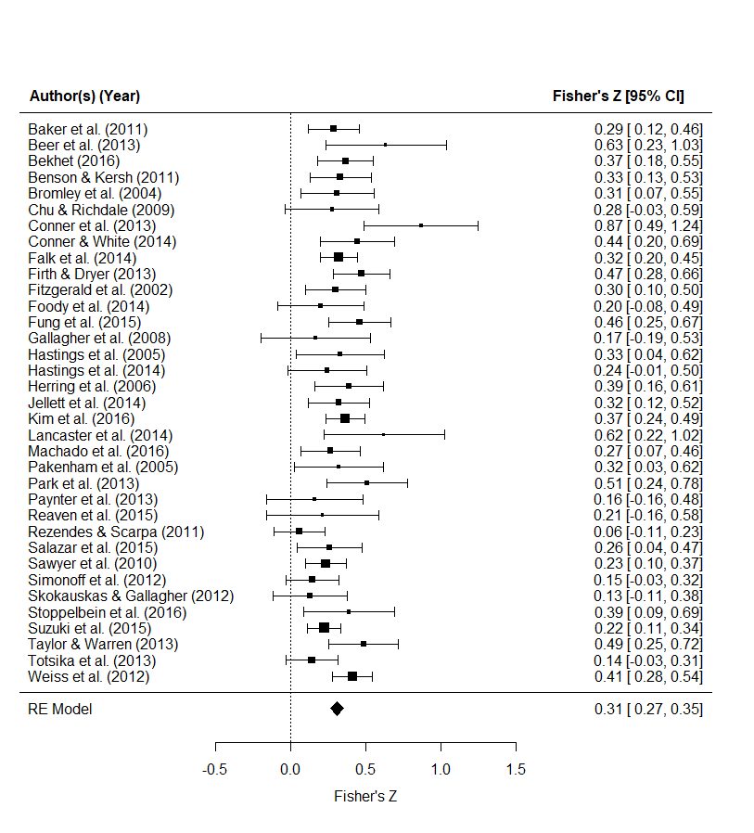
Supplementary Figure 4. Forest plot for Analysis 4 (associations between parent mental health problems and child total emotional and behavioral problems)

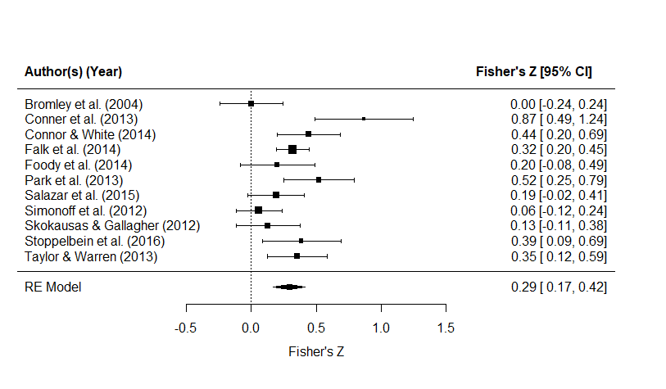
Supplementary Figure 5. Forest plot for Analysis 5 (associations between parent mental health problems and child externalizing)

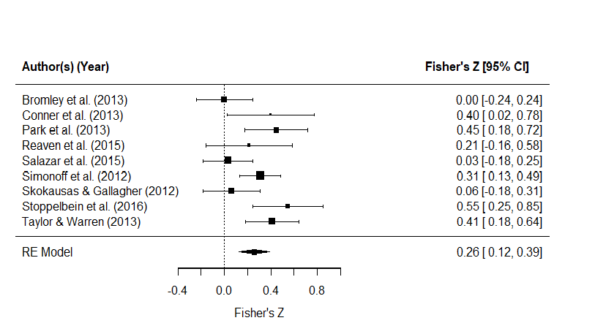
Supplementary Figure 6. Forest plot for Analysis 6 (associations between parent mental health problems and child internalizing)

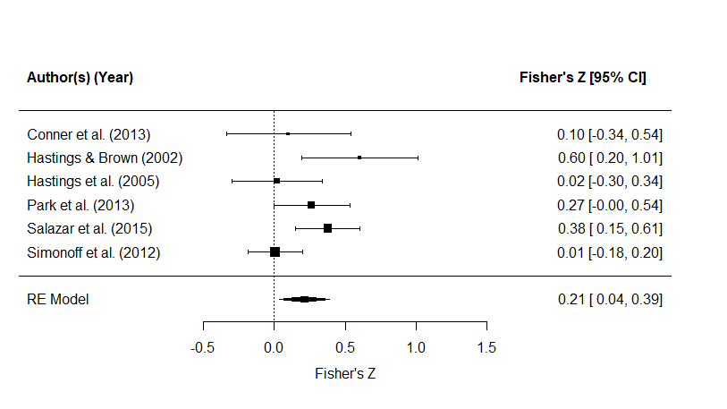
Supplementary Figure 7. Forest plot for Analysis 7 (associations between parent mental health problems and child total emotional and behavioral problems rated by alternative informant)

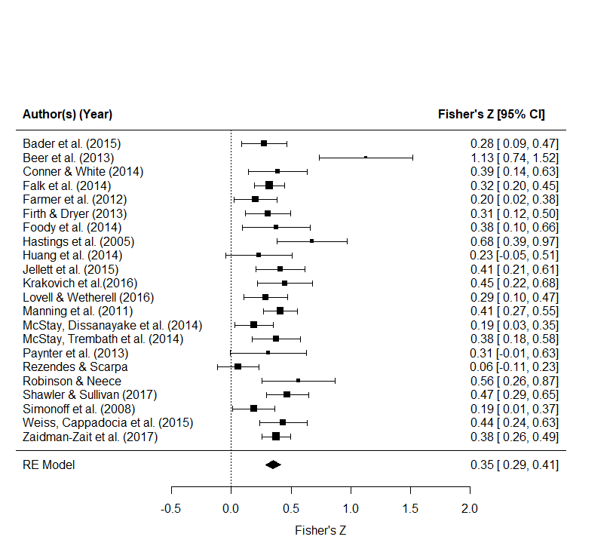
Supplementary Figure 8. Forest plot for Analysis 8 (associations between refined measures of parenting stress and child total emotional and behavioral problems).

