Supplementary Figure 1 (S1):
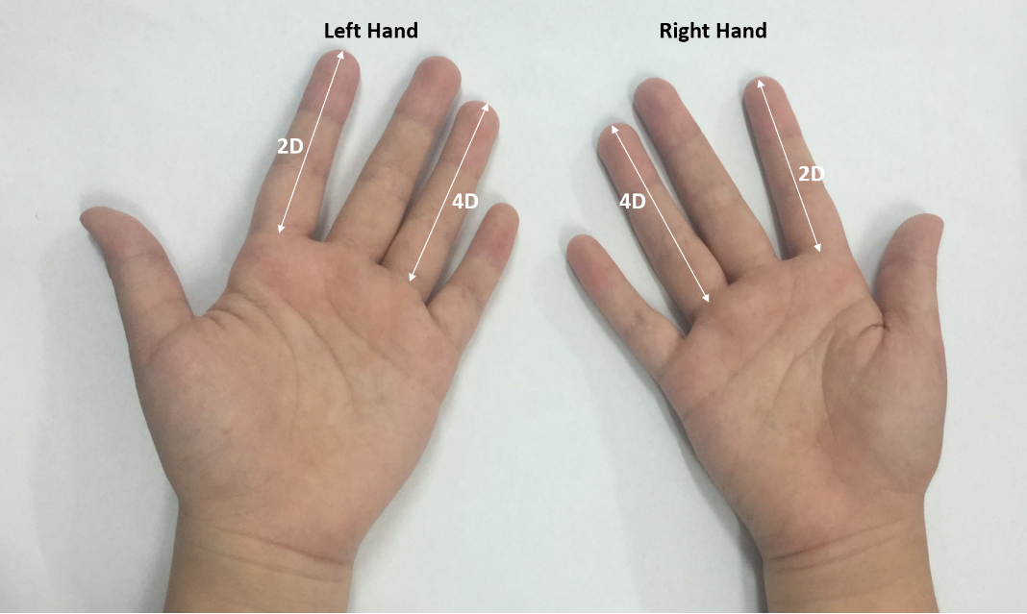
S1. A sample of palm photo obtained from one of the study participants for 2D:4D measurement and analysis

