ESM 1 Online Resource 1: Flowchart Selection
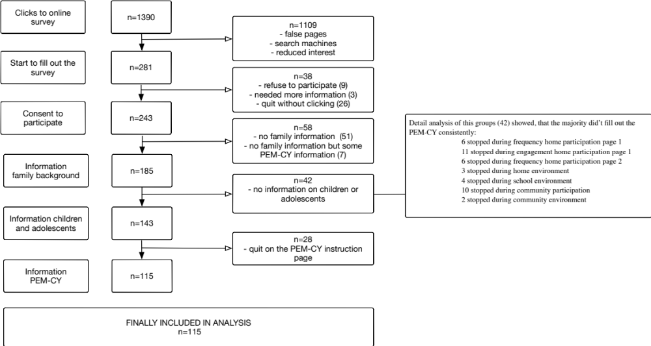
ESM 2: Online Resource 2: Parents rated manifestation of ASD during the last 4 months¹
 | Children with ASD  age 5-11  n=66 |  | Adolescents with ASD  age 12-17  n=55 |  | Total number of youth  age 5-17  n= 115
 | median | IQR | median | IQR | median | IQR
- Ability of expressive language | 5 | 3.5-6 | 6 | 5-6 | 6 | 4-6
- Use of communication aids | 6 | 5-6 | 6 | 6-6 | 6 | 5-6
- Intellectual abilities | 6 | 5-6 | 6 | 4-6 | 6 | 4-6
- Self-harming behavior | 6 | 4.5-6 | 6 | 5-6 | 6 | 5-6
- Reaction to changes | 3 | 1-4 | 3 | 1-4 | 3 | 1-4
- Repetitive behavior | 4 | 2-5 | 4 | 3-5 | 4 | 2-5
- Restricted behavior | 4 | 3-5 | 4 | 2-5 | 4 | 3-5
- Selective eating | 4 | 2-5 | 4 | 3-6 | 4 | 2-5
- Sleeping situation | 3 | 2-5 | 4 | 3-6 | 4 | 2-5
- Interaction with other children | 3 | 3-4 | 4 | 2-4 | 4 | 2-4
- Age appropriate independence | 3 | 2-4 | 4 | 2-5 | 3 | 2-4
¹highest number (6) indicates not been affected, lowest number (1) indicates being strongly affected as rated by parents
Calculations based on Tukey’s range tests

