Supplementary Fig. 1 Mann-Whitney tests (mean ranks) comparing parents who used only their mother tongue to all other parents (only a foreign language, their mother tongue and foreign languages, multiple foreign languages) regarding feeling comfortable, authentic, and free to express themselves when interacting with their child. Note: *p < .05, **p < .01

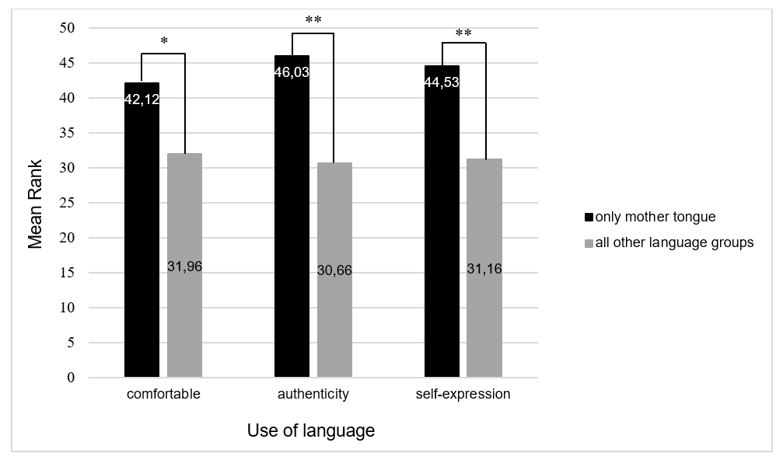

Supplementary Fig. 2 Mann-Whitney tests (mean ranks) comparing parents who used only one foreign language to all other parents (only their mother tongue, their mother tongue and foreign languages, multiple foreign languages) regarding feeling comfortable, authentic, and free to express themselves when interacting with their child. Note: * p < .05, ** p < .01
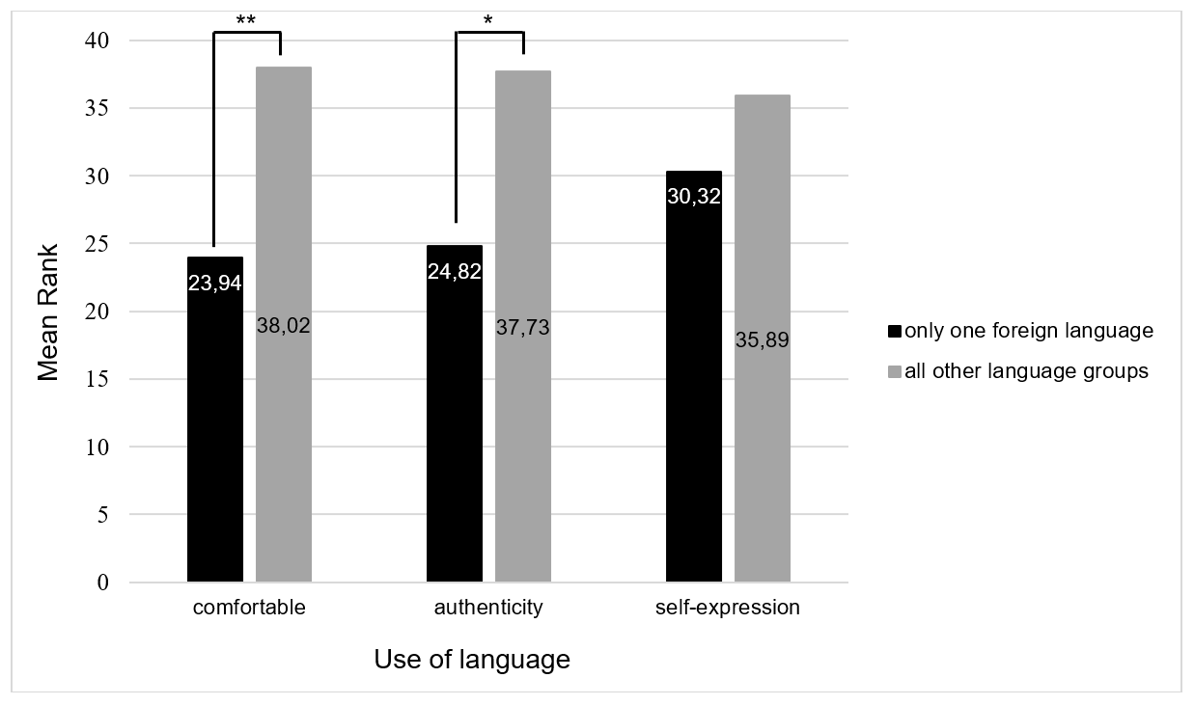

Supplementary Figure 3. Mann-Whitney tests (mean ranks) comparing parents who used only one language with their child to parents who used more than one language, regardless of whether it was their mother tongue or a foreign language, regarding feeling comfortable, authentic, and free to express themselves when interacting with their child. Note: * p < .05, ** p < .01

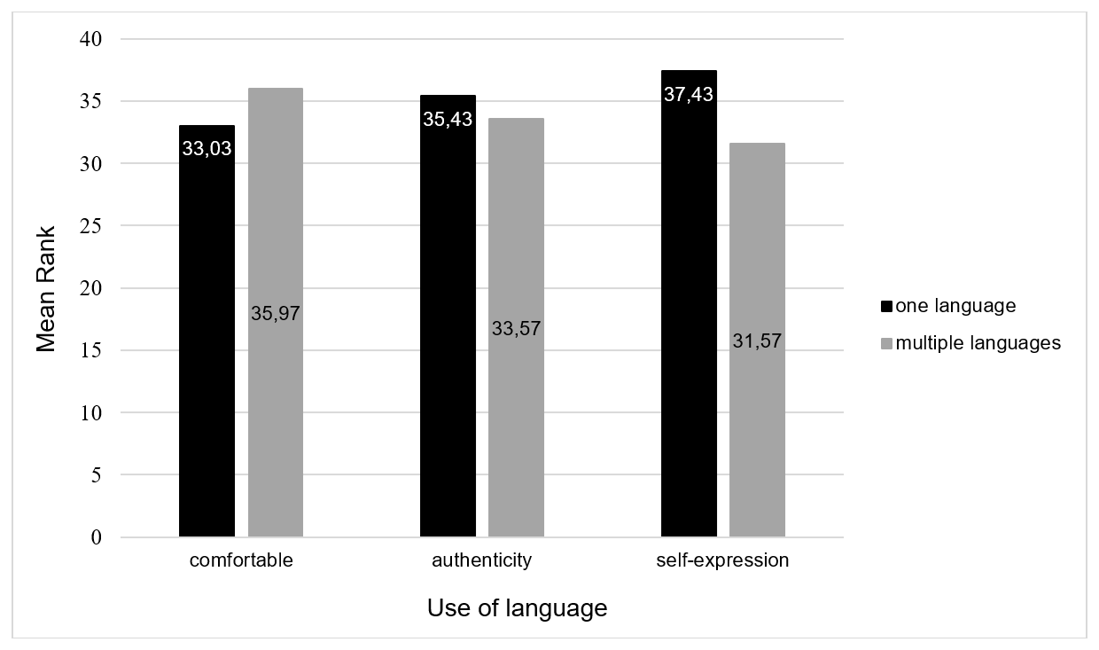

Supplementary Figure 4. Mann-Whitney tests (mean ranks) comparing parents who used their mother tongue, either only their mother tongue or in combination with other languages, to parents who used either one or multiple foreign languages regarding feeling comfortable, authentic, and free to express themselves when interacting with their child. Note: * p < .05, ** p < .01
