Supporting Information
Appendix. Establishing item-response-theory (IRT) based trait scores of sensory patterns
The 14 sensory items extracted from the FYIv3.1 (measured at T1) and SEQv2.1 (measured at T2 & T3) across the three sensory constructs are listed below:
HYPER (5 items) | HYPO (4 items) | SIRS (5 items)
- Refuse certain food textures^{ab} | - Ignore when name called^{ab} | - Look at objects in unusual ways^{*ab}
- Avoid looking at face^{ab} | - Tune-out sounds/noises^{*ab} | - Fascinated with texturesª
- Distressed when touched^{ab} | - Slow to notice new objectsª | - Fascinated with lights^{b}
- Distressed at loud sounds^{*ab} | - Slow to react to pain^{b} | - Flap arms/handsª
- Distressed during grooming^{*a} |  | - Mouth non-food objects^{b}
*Anchor items; ^{ab}common items across FYI-A/B form; ªitems specific to FYI-A form; ^{b}items specific to FYI-B form (Note: All the 14 items are available in the SEQ); HYPER=sensory hyper-responsiveness; HYPO=sensory hypo-responsiveness; SIRS=sensory interests, repetitions and seeking behaviors

To ensure the comparability of construct scores across measures and time-points (i.e., to meet the assumption of measurement invariance) before conducting latent growth modeling, we first tested whether longitudinal invariance held at the configural level over time, followed by metric and scalar invariance tests for each of the three sensory constructs¹ with full-information maximum likelihood (FIML) estimation. Differences in fit indices between models were evaluated to determine whether invariance held at different levels. A decrease in comparative fit index (CFI) or Tucker-Lewis Index (TLI) >.01, or an increase in root-mean-square error of approximation (RMSEA) >.01 indicates measurement non-invariance.² The purpose of invariance testing in the current study was to ensure that at least configural invariance was met before constructing IRT trait scores that adjust for differential item functioning (DIF). Longitudinal invariance testing on each of the constructs demonstrated invariance at least at the configural level (see below for the model fits), indicating that the constructs to be measured by the selected items held constant across time-points.
 | HYPER |  |  | HYPO |  |  | SIRS
 | CFI | TLI | RMSEA | CFI | TLI | RMSEA | CFI | TLI | RMSEA
Configural | .955 | .934 | .039 | 1.00 | 1.00 | <.001 | .982 | .973 | .021
Metric | .951 | .935 | .038 | .981 | .971 | .016 | .978 | .971 | .022
Scalar | .719 | .662 | .087 | .571 | .420 | .072 | .767 | .722 | .067

Next, DIF was evaluated to determine which non-DIF items could be used as anchor items for scale equating, using a test-characteristic-curve equating procedure.³ A relatively conservative criterion (McFadden’s pseudo-R² change ≥0.02 between nested logistic regression DIF models) was used to detect meaningful DIF.⁴ It has been recommended to have at least one anchor item for every four non-common items to avoid construct drift.⁵ As a result, we identified one to two anchor (non-DIF) items for each sensory construct with McFadden’s pseudo-R² change ranging from .003 to .013. By recalibrating group-specific item parameter estimates (i.e., estimates specific to each time-point) for the DIF items, trait scores of HYPER, HYPO, and SIRS that accounted for DIF across time-points were generated. The DIF detection and trait score derivation were implemented with R package lordif.⁶ The descriptive statistics of the trait scores for the full sample are as below:
 | N | Mean | SD | Min | Max | Skewness | Kurtosis
HYPER T1 | 1,515 | .10 | .66 | -1.39 | 2.06 | .23 | 2.54
T2 | 1,507 | -.01 | .75 | -1.35 | 3.03 | .54 | 3.45
T3 | 1,508 | -.10 | .80 | -1.34 | 3.17 | .58 | 3.48
HYPO T1 | 1,517 | -.03 | .59 | -.90 | 1.93 | .41 | 2.48
T2 | 1,508 | .03 | .70 | -.94 | 3.01 | .37 | 2.96
T3 | 1,508 | .06 | .71 | -.86 | 2.79 | .42 | 2.85
SIRS T1 | 1,502 | .11 | .81 | -1.49 | 2.81 | .25 | 2.46
T2 | 1,507 | -.02 | .88 | -1.16 | 2.99 | .46 | 2.60
T3 | 1,508 | -.12 | .85 | -1.03 | 3.22 | .67 | 2.68

References:
- Millsap, R. E. (2012). Statistical Approaches to Measurement Invariance. Routledge.
- Cheung, G. W., & Rensvold, R. B. (2002). Evaluating goodness-of-fit indexes for testing measurement invariance. Structural Equation Modeling, 9, 233-255. doi: 10.1207/s15328007sem0902_5.
- Stocking, M. L., & Lord, F. M. (1983). Developing a common metric in item response theory. Applied Psychological Measurement, 7, 201-210. doi: 10.1177/014662168300700208
- Paz, S. H., Spritzer, K. L., Morales, L. S., & Hays, R. D. (2013). Evaluation of the patient-reported outcomes information system (PROMIS®) Spanish-language physical functioning items. Quality of Life Research, 22, 1819-1830. doi: 10.1007/s11136-012-0292-6.
- Kolen, M. J., Brennan, R. L., & Kolen, M. J. (2004). Test Equating, Scaling, and Linking: Methods and Practices (pp. 177-180). New York: Springer.
- Choi, S. W., Gibbons, L. E., & Crane, P. K. (2016). Lordif: Logistic ordinal regression differential item functioning using IRT. https://CRAN.R-project.org/package=lordif, R package version 0.3-3.

Figure S1. Results of common factor analysis for the PEM-CY measure
a. Scree plots with parallel analysis (200 iterations)
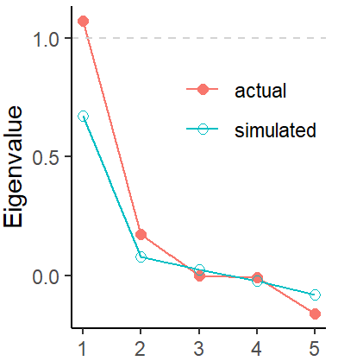
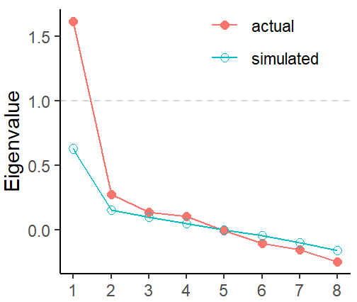
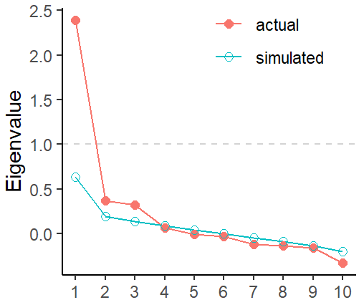
Home (10 items) School (5 items) Community (8 items)
Number of Factors

Home
Factor # | 2 | 3 | 4
BIC | -91.42 | -81.20 | -52.14
TLI | .894 | .967 | .984
RMSEA | .061 | .034 | .024
School
Factor # | 1 | 2
BIC | -12.76 | -4.59
TLI | .826 | .973
RMSEA | .079 | .031
Community
Factor # | 2 | 3 | 4
BIC | -38.00 | -28.05 | -7.73
TLI | .814 | .913 | .899
RMSEA | .072 | .050 | .053
Model fit statistics (with varimax rotation)
Note. Selected factor solution was bolded.

b. Factoring patterns
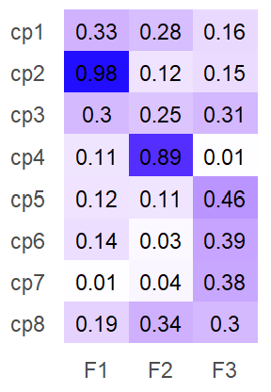
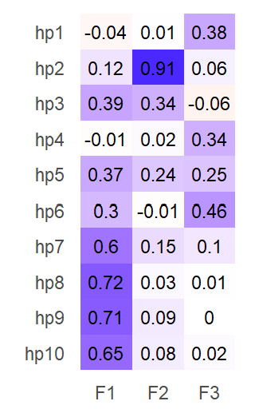
Home (10 items) School (5 items) Community (8 items)

Neighborhood outing
Organized physical
Unstructured physical
Group/volunteer
Together w/ other kids
Community events
Lessons
Religious

Computer games

Arts/hobbies
Social w/ tech
Personal care
Homework
Indoor play
Together w/ people
House chores
School preparation
Watching TV
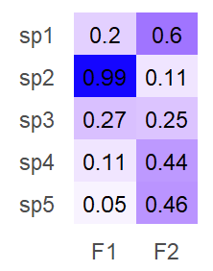
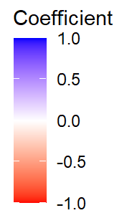

Classroom
Field trip/events
School clubs
Together w/ peers
Special roles

Note. Two items were dropped - "Working for Pay" and "Overnight Trips" due to rare endorsement.

 | Home | School | Community
Factor 1 (F1) | Routines/duties (HP1) | Extracurricular activities (SP1) | Daily outings (CP1)
Factor 2  (F2) | Non-screen-based leisure activities (HP2) | Classroom-based activities (SP2) | Unstructured physical activities (CP2)
Factor 3 (F3) | Screen-based leisure activities (HP3) | -- | Structured group activities (CP3)
c. Factor naming

Table S1. Descriptive statistics of PEM-CY factor scores by clinical outcome group
PEM-CY Factors (Activity Types) | Autistic (N=88) |  |  |  | Non-autistic (N=301)
PEM-CY Factors (Activity Types) | Mean | SD | Skew. | Kurt. | Mean | SD | Skew. | Kurt.
HP1: Routines/duties | -.73 | 1.32 | -.17 | .00 | .21 | .98 | -.60 | .28
HP2: Non-screen-based leisure | -.33 | 1.40 | -.91 | -.34 | .10 | .98 | -2.13 | 6.48
HP3: Screen-based leisure | -.19 | 1.84 | .26 | .30 | .05 | 1.50 | -.15 | -.26
SP1: Extracurricular | -.28 | 1.07 | 1.71 | 3.89 | .08 | .98 | .92 | 1.14
SP2: Classroom-based | -.82 | 1.65 | -.41 | -.45 | .24 | 1.19 | -.76 | 1.38
CP1: Daily outings | -.17 | .93 | .95 | .96 | .05 | 1.04 | .52 | -.23
CP2: Unstructured physical | -.38 | 1.29 | -.62 | -.64 | .11 | 1.04 | -1.07 | .82
CP3: Structured group | -.45 | 1.51 | .81 | -.08 | .13 | 1.50 | .59 | .19

Table S2. Intercorrelations of school-age outcome variables (N=389)
 | 1 | 2 | 3 | 4 | 5 | 6 | 7 | 8 | 9 | 10 | 11 | 12
VABS
1. ABC | --
2. MOT | .64 | --
3. INT | -.34 | -.32 | --
4. EXT | -.44 | -.27 | .59 | --
PEM-CY
5. HP1 | .55 | .44 | -.30 | -.33 | --
6. HP2 | .10 | .06 | -.12 | -.05 | -.05 | --
7. HP3 | .09 | .01 | .00 | -.02 | -.08 | -.04 | --
8. SP1 | .17 | .17 | -.14 | -.11 | .13 | .21 | .09 | --
9. SP2 | .47 | .33 | -.25 | -.31 | .46 | .17 | .01 | -.06 | --
10. CP1 | .17 | .15 | -.03 | -.12 | .18 | .03 | .08 | .33 | .15 | --
11. CP2 | .14 | .27 | -.27 | -.13 | .18 | .17 | .03 | .12 | .17 | -.01 | --
12. CP3 | .32 | .24 | -.16 | -.13 | .20 | .08 | .05 | .15 | .17 | -.12 | -.06 | --
ABC=adaptive behavior composite, MOT=motor skills, INT=internalizing behavior, EXT=externalizing behavior, HP=home participation, SP=school participation, CP=community participation.

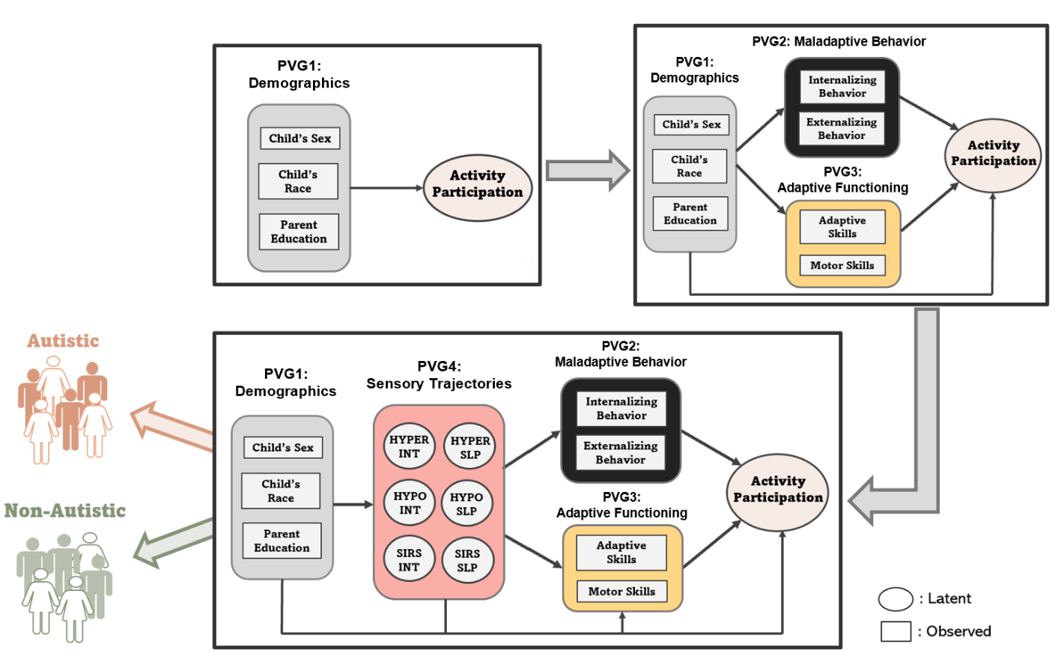
Figure S2. Iterative process for assessing the relative importance of explanatory variables on participation outcomes across autistic and non-autistic groups

The different predictor variable groups (PVG) were added iteratively to assess the change in explained variance (ΔR²) of participation outcomes in the sequence of demographics (PVG1), maladaptive behavior (PVG2), adaptive functioning (PVG3), and sensory trajectories (PVG4). For instance, by comparing the models with PVG1-3 versus with PVG1-4 included, we were able to assess the additional variance explained by sensory trajectories (PVG4) above and beyond other predictors. The whole process was implemented in multigroup models, where R² values were available for each of the autistic and non-autistic groups. INT=intercept; SLP=slope

Setting | χ² | df | CFI | TLI | RMSEA [90% CI]
Home | 3758.04 | 168 | .989 | .960 | .024 [.016, .031]
School | 3785.35 | 150 | .988 | .960 | .025 [.017, .033]
Community | 3796.71 | 168 | .988 | .958 | .024 [.017, .032]
Table S3. Model fit statistics of the hypothesized full model by setting

Table S4. Total effects of predicting variables on adaptive/maladaptive outcomes
 | Adaptive Functioning |  |  | Motor Skills
 | β | SE | p | β | SE | p
Sex | .206 | .047 | <.001*** | .144 | .048 | .003**
Race | -.044 | .051 | .390 | .021 | .060 | .720
Edu | .111 | .048 | .021* | .166 | .049 | .001**
Hyper - Intercept | .098 | .260 | .708 | -.289 | .226 | .201
Slope | -.275 | .080 | .001** | -.279 | .080 | .001**
Hypo - Intercept | -.426 | .201 | .034* | -.005 | .174 | .977
Slope | -.085 | .095 | .368 | -.034 | .085 | .689
SIRS - Intercept | .020 | .128 | .874 | .148 | .124 | .233
Slope | .010 | .097 | .915 | -.065 | .088 | .460
Total variance explained (R²) | 26.5% |  |  | 17.5%
- Adaptive outcomes

 | Internalizing Behavior |  |  | Externalizing Behavior
 | β | SE | p | β | SE | p
Sex | -.050 | .046 | .279 | -.161 | .045 | <.001***
Race | .060 | .045 | .183 | .001 | .048 | .991
Edu | -.151 | .044 | .001** | -.060 | .045 | .182
Hyper - Intercept | .342 | .184 | .063† | .297 | .202 | .142
Slope | .432 | .069 | <.001*** | .148 | .072 | .041*
Hypo - Intercept | .059 | .148 | .691 | .164 | .171 | .338
Slope | .072 | .073 | .323 | .414 | .081 | <.001***
SIRS - Intercept | .000 | .107 | .997 | -.080 | .110 | .465
Slope | -.016 | .073 | .828 | .052 | .073 | .478
Total variance explained (R²) | 30.4% |  |  | 34.5%
- Maladaptive outcomes

Table S5. Total effects of predicting variables on participation outcomes across autistic and non-autistic samples (N=389) in the full model
 | Routines/Duties |  |  | Non-Screen-Based Leisure Activities |  |  | Screen-Based Leisure Activities
 | β | SE | p | β | SE | p | Β | SE | p
Sex | .241 | .046 | <.001*** | .090 | .048 | .059† | -.088 | .050 | .081
Race | .055 | .051 | .287 | -.076 | .058 | .191 | .077 | .065 | .235
Edu | .050 | .048 | .297 | .078 | .052 | .135 | .003 | .051 | .957
Internalizing | -.082 | .059 | .165 | -.142 | .070 | .041* | -.007 | .079 | .929
Externalizing | .013 | .083 | .876 | .214 | .092 | .020* | -.074 | .104 | .475
Adaptive | .431 | .103 | <.001*** | .116 | .105 | .269 | .121 | .118 | .303
Motor | .066 | .075 | .381 | -.056 | .090 | .531 | -.020 | .094 | .829
Hyper - Intercept | -.255 | .222 | .250 | -.039 | .232 | .866 | .311 | .255 | .167
Slope | -.209 | .080 | .009^{**ind1} | .075 | .080 | .346 | -.030 | .085 | .728
Hypo - Intercept | -.092 | .167 | .581 | -.046 | .185 | .804 | -.177 | .189 | .350
Slope | -.135 | .089 | .131 | -.195 | .090 | .031* | .052 | .098 | .597
SIRS - Intercept | .202 | .135 | .105 | -.038 | .124 | .758 | -.106 | .131 | .416
Slope | .000 | .093 | .997 | -.016 | .085 | .852 | .015 | .086 | .862
Total variance explained (R²) | 36.1% |  |  | 8.2% |  |  | 6.5%
- Home participation outcomes
ind1: indirect effect via adaptive skills (β=-.117, SE=.049, p=.016). *p < .05, **p < .01, ***p < .001.

 | Extracurricular Activities |  |  | Classroom-Based Activities
 | β | SE | p | β | SE | p
Sex | .055 | .052 | .292 | .142 | .047 | .003**
Race | -.040 | .056 | .473 | -.065 | .059 | .269
Edu | -.009 | .049 | .857 | .178 | .051 | <.001***
Internalizing | -.096 | .076 | .209 | -.032 | .087 | .716
Externalizing | .118 | .093 | .207 | .036 | .113 | .751
Adaptive | .104 | .108 | .336 | .492 | .121 | <.001***
Motor | .046 | .108 | .616 | -.079 | .091 | .389
Hyper - Intercept | -.293 | .227 | .197 | -.338 | .233 | .146
Slope | -.008 | .083 | .927 | -.081 | .083 | .334^{ind2}
Hypo - Intercept | -.002 | .192 | .992 | .052 | .184 | .779
Slope | -.142 | .099 | .154 | -.282 | .091 | .002**
SIRS - Intercept | .188 | .133 | .157 | .211 | .124 | .090
Slope | -.054 | .090 | .548 | .011 | .094 | .909
Total variance explained (R²) | 8.7% |  |  | 31.8%
- School participation outcomes

ind2: indirect effect via adaptive skills (β=-.135, SE=.059, p=.021). *p < .05, **p < .01, ***p < .001.

 | Daily Outings |  |  |  | Unstructured Physical Activities |  |  | Structured Group Activities
 | β |  | SE | p | β | SE | p | β | SE | p
Sex | .013 | .051 |  | .803 | -.042 | .050 | .400 | .237 | .048 | <.001***
Race | -.022 | .052 |  | .669 | -.136 | .051 | .007** | .033 | .049 | .497
Edu | .030 | .051 |  | .550 | .192 | .049 | <.001*** | .133 | .047 | .005**
Internalizing | .129 | .077 |  | .095 | -.173 | .066 | .009** | -.040 | .070 | .563
Externalizing | -.159 | .096 |  | .097 | .085 | .087 | .329 | .036 | .082 | .659
Adaptive | .109 | .105 |  | .302 | -.068 | .109 | .535 | .188 | .107 | .079
Motor | .088 | .080 |  | .273 | .228 | .084 | .007** | .021 | .087 | .808
Hyper - Intercept | .046 | .229 |  | .841 | -.334 | .238 | .160 | .012 | .224 | .958
Slope | -.114 | .088 |  | .194 | -.094 | .076 | .215^{ind3} | -.117 | .080 | .145
Hypo - Intercept | .047 | .181 |  | .794 | .117 | .184 | .526 | -.279 | .175 | .110
Slope | -.029 | .096 |  | .767 | -.048 | .084 | .565 | .125 | .087 | .152
SIRS - Intercept | -.039 | .131 |  | .766 | .050 | .125 | .692 | .095 | .116 | .413
Slope | .036 | .091 |  | .692 | -.009 | .100 | .924 | -.093 | .083 | .264
Total variance explained (R²) | 6.8% |  |  |  | 16.7% |  |  | 21.6%
- Community participation outcomes
ind3: indirect effects via internalizing behavior (β=-.076, SE=.032, p=.018) and motor skills (β=-.064, SE=.031, p=.036). *p < .05, **p < .01, ***p < .001.

