APPENDIX B
The Mathematics Skills Test Coding Scheme
Mathematical domains | Mathematical Proficiency | Written/  oral | Example | Item number | Scoring and maximum score | Score type (percent correct / time)
Mathematical scores |  | Written+ verbal | Example of the questions in the following sections | 1 until 22 | 37 points
Procedural thinking |  | Written+ verbal | Example of the questions in the following sections | 17,8b.9,10a,  11.18,19-21 | 23 points | Percent
Mastering the basic number combinations |  | Verbal | The participant is asked to retrieve basic facts and must orally answer the question within a limited time frame.  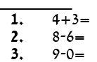  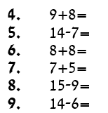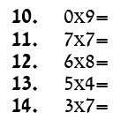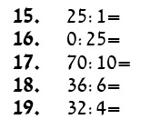 | 18,19,20,21 | 1 point for each section - a total of 8 points | Percent
 | Sums to 10-accuracy | Verbal |  | 18a-d | 1/2 point for each section - a total of 2 points | Percent
 | Sums to 10- time | Verbal |  |  |  | Percent
 | Sums to 20- accuracy | Verbal |  | 19a-d | 1/2 point for each section - a total of 2 points | Percent
 | Sums to 20- time | Verbal
 | With multiplication - accuracy | Verbal |  | 20a-d | 1/2 point for each section - a total of 2 points | Percent
 | Multiplication - time | Verbal
 | Division - accuracy | Verbal |  | 21a-d | 1/2 point for each section - a total of 2 points | Percent
 | Division -time | Verbal
 | Producing a Sequential Counting strategy | Verbal | The participant must count in an ascending sequence up to the number 5,771, and in a descending sequence up to the number 5,399 without mistakes. | 1 a-b | 1 point for each section - a total of 2 points | Percent
 | Addition- written algorithm | Written | 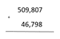 | 2 | 1 point | Percent
 | Subtraction- written algorithm | Written | 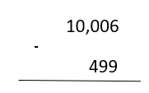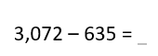 | 3,4,9 | 1 point for each section - a total of 3 points | Percent
 | Combining procedures: addition and subtraction | Written | 540 – 405 + 160 = | 1 | 1 point | Percent
 | Multiplication-written algorithm | Written  + verbal | 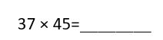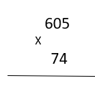 | 5,6;10a,13,22a-b | 1 point for each section - a total of 6 points | Percent
 | Long-division | Written | 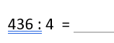 | 7 | 1 point | Percent
 | Order of operations | Written | 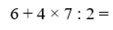 | 8b,11 | 1 point for each section - a total of 2 points | Percent
Arithmetic comprehension |  | Written  +verbal | Explanation of the questions in the following sections | 9,11,8a,10,12-14,  22 | 10 points | Percent
 | Word problems | Written | Explanation of the questions in the following sections | 9,11,8a,10 | 5 points | Percent
 | Word problems that require process thinking | Written | The participant must build a correct algorithm according to the details of the question. | 9,11 | 1 point for each section - a total of 2 points | Percent
 | Word problems that require metacognitive thinking | Written | The participant is required to have a deep understanding and high-level thinking that requires search and analysis-synthesis, in order to derive meaning since the information is not given explicitly. | 8a,10a-b | 1 point for each section - a total of 3 points | Percent
 | Numerical insight | Written  +verbal | The participant is required to answer the question when he relies on mathematical insights of various kinds | 12,13,14,22a-b | 1 point for each section - a total of 5 points | Percent
Algebraic Technique |  | Written |  | 15,16,17 | 4 points
 | Procedure | Written | 3x – 1 = 2x +7 | 15,16 | 1 point for each section - a total of 2 points | Percent
 | Solving a word problem with unknowns | Written | The participant is required to identify an inequality that corresponds to a verbal representation of the question, this section requires process thinking, integration between concepts, matching a mathematical representation to a verbal representation and algebraic and numerical insight. | 17a-b | 1 point for each section - a total of 2 points | Percent

