Supplemental Content

Fig S1. Proposed mediation model with depression mediating the effect of moderate-to-vigorous physical activity (MVPA) on suicidal ideation (SI).
Fig S2. Final directed acyclic graph (DAG) for the association between MVPA and SI with proposed mediators.
Fig S3. Proposed mediation model with depression, anxiety, stress, and resilience mediating the effect of moderate-to-vigorous physical activity (MVPA) on suicidal ideation (SI).

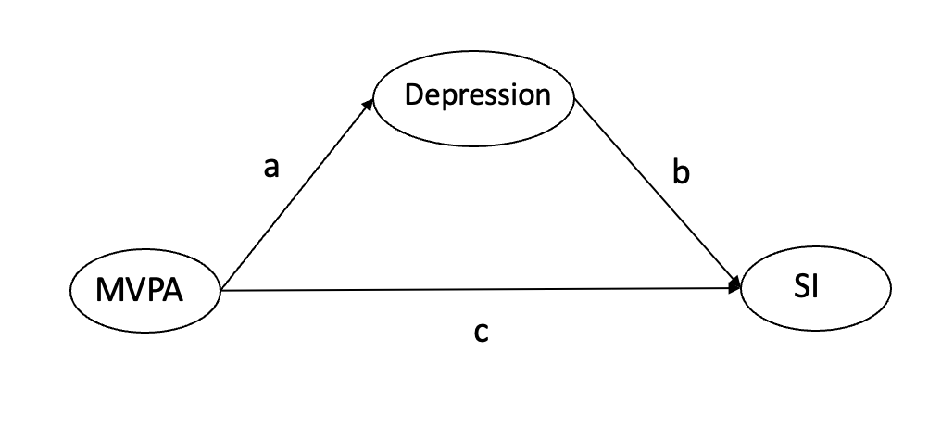
Fig S1. Proposed mediation model with depression mediating the effect of moderate-to-vigorous physical activity (MVPA) on suicidal ideation (SI).

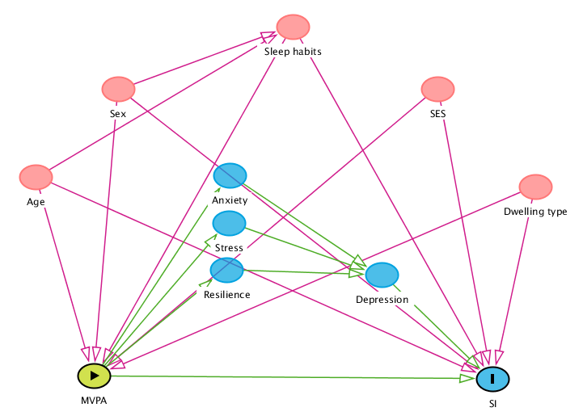
Fig S2. Final directed acyclic graph (DAG) for the association between MVPA and SI with proposed mediators.
The Figure shows that sex, age, sleep habits, socioeconomic status (SES), and dwelling type formed a minimally sufficient confounder set (colored pink) to estimate the effect of moderate-to-vigorous physical activity (MVPA) on suicidal ideation (SI) in adolescents with ADHD. Potential causal paths are shown in green and non-causal paths are shown in pink.
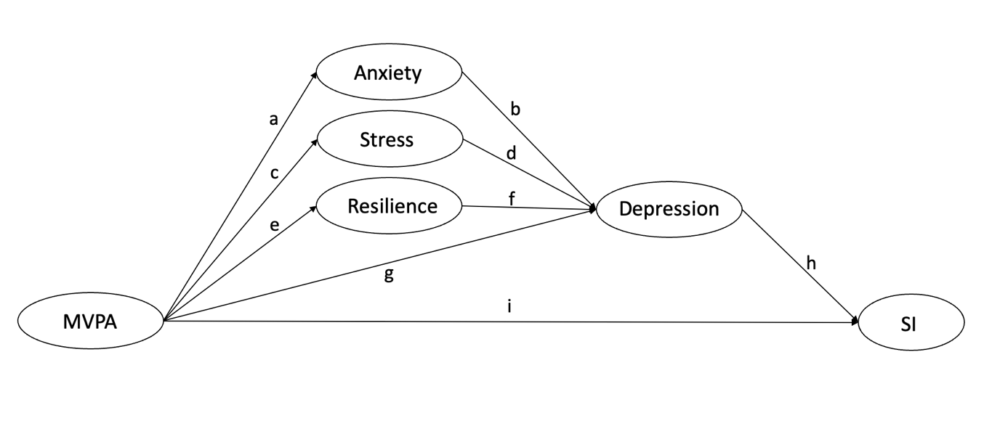
Fig S3. Proposed mediation model with depression, anxiety, stress, and resilience mediating the effect of moderate-to-vigorous physical activity (MVPA) on suicidal ideation (SI).

