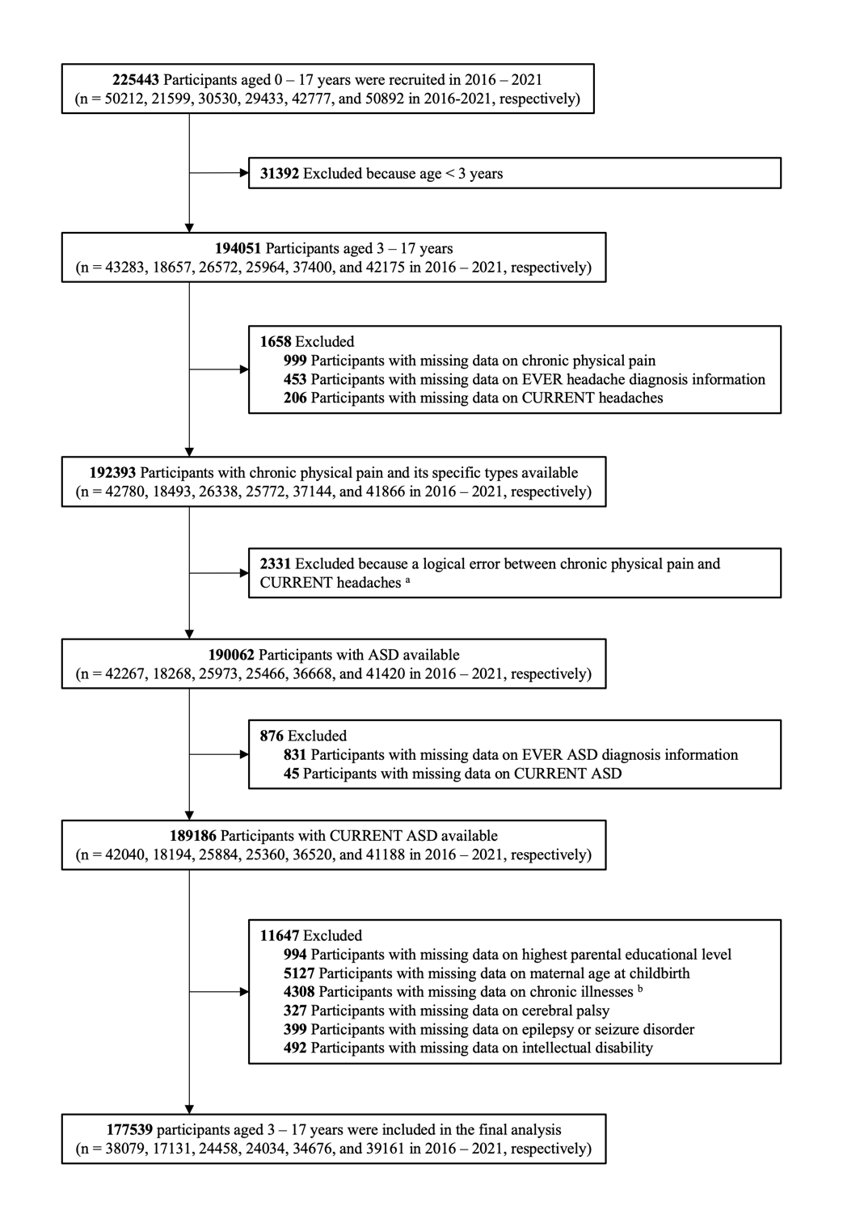
Supplementary Figure 1. Flowchart with unweighted survey sample sizes for children aged 3 – 17 years, National Survey of Children’s Health, 2016–2021.
Abbreviations: ASD = autism spectrum disorders.
ª A logical error means parents reported “NO” to question “During the past 12 months, has the child had difficulty with or experienced any of the following? Repeated or chronic physical pain, including headaches or other back or body pain”, while also reporting “YES” to both of the following questions, “Has a doctor or other health care provider ever told you that the child has frequent or severe headaches including migraine?” and “If yes, does the child currently have the condition?”
^{b} Chronic illnesses include arthritis, asthma, diabetes, heart condition, and cystic fibrosis.

Supplementary Table 1. Weighted prevalence of chronic physical pain and its specific types in the US, 2016–2021.
Participants | Pain types | Weighted Prevalence% (95% CI) |  |  |  |  |  | p  value ª
Participants | Pain types | 2016  (N=38079) | 2017  (N=17131) | 2018  (N=24458) | 2019  (N=24034) | 2020  (N=34676) | 2021  (N=39161) | p  value ª
With  current ASD | Chronic physical pain | 13.23  (9.61, 17.95) | 16.35  (8.04, 30.42) | 16.25  (11.22, 22.95) | 15.85  (11.42, 21.57) | 11.39  (7.41, 17.11) | 13.07  (9.51, 17.69) | 0.74
With  current ASD | Headaches | 5.57  (3.36, 9.09) | 4.59  (2.52, 8.20) | 5.32  (3.18, 8.78) | 5.16  (2.76, 9.44) | 3.59  (2.38, 5.37) | 4.96  (3.04, 8.01) | 0.91
With  current ASD | Other back or body pain | 7.66  (4.98, 11.62) | 11.76  (4.38, 27.93) | 10.93  (6.60, 17.57) | 10.68  (7.26, 15.45) | 7.80  (4.22, 13.98) | 8.10  (5.27, 12.27) | 0.75
Without current ASD | Chronic physical pain | 7.38  (6.80, 8.01) | 6.66  (5.87, 7.55) | 8.05  (7.39, 8.78) | 8.65  (7.87, 9.49) | 6.41  (5.86, 7.02) | 5.4  (4.94, 5.90) | <0.01
Without current ASD | Headaches | 2.40  (2.06, 2.79) | 1.90  (1.58, 2.30) | 2.26  (1.87, 2.72) | 2.18  (1.76, 2.71) | 1.78  (1.49, 2.13) | 1.56  (1.33, 1.82) | 0.02
Without current ASD | Other back or body pain | 4.98  (4.51, 5.50) | 4.76  (4.05, 5.58) | 5.80  (5.25, 6.39) | 6.47  (5.82, 7.18) | 4.63  (4.16, 5.16) | 3.84  (3.45, 4.28) | <0.01
Total | Chronic physical pain | 7.53  (6.95, 8.15) | 6.94  (6.12, 7.88) | 8.28  (7.61, 9.00) | 8.87  (8.11, 9.70) | 6.55  (5.99, 7.16) | 5.63  (5.17, 6.13) | <0.01
Total | Headaches | 2.48  (2.14, 2.87) | 1.98  (1.65, 2.38) | 2.34  (1.96, 2.80) | 2.27  (1.85, 2.79) | 1.83  (1.54, 2.17) | 1.66  (1.43, 1.93) | 0.01
Total | Other back or body pain | 5.05  (4.58, 5.56) | 4.96  (4.21, 5.84) | 5.94  (5.39, 6.54) | 6.60  (5.96, 7.30) | 4.72  (4.25, 5.25) | 3.97  (3.58, 4.41) | <0.01
Abbreviations: CI = confidence interval; ASD = autism spectrum disorders.
ª Unadjusted $χ^{2}$ analysis of the weighted sample.

Supplementary Table 2. Weighted prevalence of chronic physical pain and its specific types across four geographic regions in the US.
Participants | Pain types | Weighted Prevalence% (95% CI) |  |  |  | p  value ª
Participants | Pain types | West  (N=48267) | Midwest  (N=43239) | South  (N=55505) | Northeast  (N=30528) | p  value ª
With  current ASD | Chronic physical pain | 13.93  (7.77, 23.72) | 14.95  (11.6, 19.08) | 14.89  (11.70, 18.77) | 13.52  (9.36, 19.14) | 0.95
With  current ASD | Headaches | 3.29  (1.99, 5.37) | 6.69  (4.42, 10.00) | 5.04  (3.48, 7.24) | 4.64  (2.70, 7.84) | 0.21
With  current ASD | Other back or body pain | 10.64  (4.97, 21.35) | 8.27  (5.88, 11.49) | 9.85  (7.12, 13.48) | 8.88  (5.36, 14.37) | 0.85
Without current ASD | Chronic physical pain | 7.17  (6.50, 7.90) | 7.11  (6.68, 7.56) | 7.42  (6.97, 7.90) | 6.14  (5.62, 6.71) | 0.02
Without current ASD | Headaches | 1.96  (1.58, 2.44) | 1.95  (1.75, 2.17) | 2.17  (1.94, 2.42) | 1.78  (1.52, 2.09) | 0.34
Without current ASD | Other back or body pain | 5.21  (4.67, 5.80) | 5.16  (4.78, 5.56) | 5.26  (4.86, 5.68) | 4.36  (3.91, 4.86) | 0.07
Total | Chronic physical pain | 7.37  (6.68, 8.12) | 7.32  (6.89, 7.77) | 7.63  (7.17, 8.10) | 6.38  (5.85, 6.96) | 0.03
Total | Headaches | 2.00  (1.62, 2.46) | 2.07  (1.87, 2.31) | 2.24  (2.02, 2.49) | 1.88  (1.61, 2.18) | 0.35
Total | Other back or body pain | 5.37  (4.80, 6.00) | 5.24  (4.87, 5.65) | 5.38  (4.99, 5.80) | 4.51  (4.05, 5.01) | 0.08
Abbreviations: CI = confidence interval; ASD = autism spectrum disorders.
ª Unadjusted $χ^{2}$ analysis of the weighted sample.

Supplementary Table 3. Associations between current ASD and chronic physical pain, including its specific types, stratified by access to health care.
Group | Chronic physical pain |  |  | Specific types of chronic physical pain
Group |  |  |  | Headaches |  |  | Other back or body pain
Group | OR (95% CI) |  | p interaction | OR (95% CI) |  | p interaction | OR (95% CI) |  | p interaction
Group | Without current ASD | With  current ASD | p interaction | Without current ASD | With  current ASD | p interaction | Without current ASD | With  current ASD | p interaction
Stratified by access to health care ª |  |  | 0.16 |  |  | 0.17 |  |  | 0.57
Unmet health care needs | 1.00  (reference) | 0.85  (0.56, 1.30) |  | 1.00  (reference) | 0.93  (0.51, 1.70) |  | 1.00  (reference) | 0.86  (0.53, 1.38)
Met health care needs | 1.00  (reference) | 1.81  (1.40, 2.34) |  | 1.00  (reference) | 1.84  (1.34, 2.53) |  | 1.00  (reference) | 1.67  (1.19, 2.35)
Abbreviations: CI = confidence interval; ASD = autism spectrum disorder; OR = odds ratio.
ª Adjusted models were adjusted for the children’s age, sex, race/ethnicity, highest parental educational level, household income level, maternal age at childbirth, chronic illnesses (including arthritis, asthma, diabetes, heart condition, and cystic fibrosis), cerebral palsy, epilepsy or seizure disorder, and intellectual disability.

Supplementary Table 4. Associations between ever ASD and chronic physical pain, including its specific types.
Outcomes | Chronic physical pain |  | Specific types of chronic physical pain
Outcomes |  |  | Headaches |  | Other back or body pain
Outcomes | OR (95% CI) | p value | OR (95% CI) | p value | OR (95% CI) | p value
Model 1 ª |  | <0.01 |  | <0.01 |  | <0.01
Without ever ASD | 1.00 (reference) |  | 1.00 (reference) |  | 1.00 (reference)
With ever ASD | 2.19 (1.78, 2.70) |  | 2.49 (1.97, 3.16) |  | 1.96 (1.48, 2.58)
Model 2 ^{b} |  | <0.01 |  | <0.01 |  | <0.01
Without ever ASD | 1.00 (reference) |  | 1.00 (reference) |  | 1.00 (reference)
With ever ASD | 2.22 (1.81, 2.72) |  | 2.48 (1.94, 3.18) |  | 1.94 (1.48, 2.55)
Model 3 ^{c} |  | <0.01 |  | <0.01 |  | <0.01
Without ever ASD | 1.00 (reference) |  | 1.00 (reference) |  | 1.00 (reference)
With ever ASD | 1.99 (1.64, 2.43) |  | 2.14 (1.64, 2.78) |  | 1.77 (1.36, 2.30)
Model 4 ^{d} |  | <0.01 |  | <0.01 |  | <0.01
Without ever ASD | 1.00 (reference) |  | 1.00 (reference) |  | 1.00 (reference)
With ever ASD | 1.77 (1.43, 2.20) |  | 1.82 (1.38, 2.40) |  | 1.62 (1.21, 2.16)
Abbreviations: CI = confidence interval; ASD = autism spectrum disorders; OR = odds ratio.
ª Crude model without adjustment.
^{b} Adjusted models were adjusted for the children’s age, sex, race/ethnicity, highest parental educational level, household income level, and maternal age at childbirth.
^{c} Adjusted models were adjusted for the children’s age, sex, race/ethnicity, highest parental educational level, household income level, maternal age at childbirth, and chronic illnesses (including arthritis, asthma, diabetes, heart condition, and cystic fibrosis).
^{d} Adjusted models were adjusted for the children’s age, sex, race/ethnicity, highest parental educational level, household income level, maternal age at childbirth, chronic illnesses (including arthritis, asthma, diabetes, heart condition, and cystic fibrosis), cerebral palsy, epilepsy or seizure disorder, and intellectual disability.

Supplementary Table 5. Associations between current ASD and headaches diagnosis.
Outcomes | Headaches diagnosis
Outcomes | OR (95% CI) | p value
Model 1 ª |  | <0.01
Without current ASD | 1.00 (reference)
With current ASD | 2.18 (1.63, 2.93)
Model 2 ^{b} |  | <0.01
Without current ASD | 1.00 (reference)
With current ASD | 2.08 (1.55, 2.79)
Model 3 ^{c} |  | <0.01
Without current ASD | 1.00 (reference)
With current ASD | 1.84 (1.35, 2.52)
Model 4 ^{d} |  | <0.01
Without current ASD | 1.00 (reference)
With current ASD | 1.67 (1.18, 2.36)
Abbreviations: CI = confidence interval; ASD = autism spectrum disorders; OR = odds ratio.
ª Crude model without adjustment.
^{b} The adjusted model was adjusted for the children’s age, sex, race/ethnicity, highest parental educational level, household income level, and maternal age at childbirth.
^{c} The adjusted model was adjusted for the children’s age, sex, race/ethnicity, highest parental educational level, household income level, maternal age at childbirth, and chronic illnesses (including arthritis, asthma, diabetes, heart condition, and cystic fibrosis).
^{d} The adjusted model was adjusted for the children’s age, sex, race/ethnicity, highest parental educational level, household income level, maternal age at childbirth, chronic illnesses (including arthritis, asthma, diabetes, heart condition, and cystic fibrosis), cerebral palsy, epilepsy or seizure disorder, and intellectual disability.
Supplementary Table 6. Associations between ASD severity and chronic physical pain, including its specific types, among children with current ASD ª.
Outcomes | Chronic physical pain |  | Specific types of chronic physical pain
Outcomes |  |  | Headaches |  | Other back or body pain
Outcomes | OR (95% CI) | p value | OR (95% CI) | p value | OR (95% CI) | p value
Model 1 ^{b}
Mild | 1.00 (reference) |  | 1.00 (reference) |  | 1.00 (reference)
Moderate | 1.24 (0.78, 1.95) | 0.36 | 0.72 (0.44, 1.17) | 0.18 | 1.63 (0.90, 2.94) | 0.11
Severe | 1.43 (0.82, 2.49) | 0.20 | 1.08 (0.54, 2.17) | 0.83 | 1.64 (0.80, 3.37) | 0.18
Model 2 ^{c}
Mild | 1.00 (reference) |  | 1.00 (reference) |  | 1.00 (reference)
Moderate | 1.34 (0.89, 2.01) | 0.16 | 0.80 (0.49, 1.31) | 0.38 | 1.70 (1.03, 2.81) | 0.04
Severe | 1.62 (0.88, 3.00) | 0.12 | 1.20 (0.63, 2.31) | 0.58 | 1.84 (0.84, 4.05) | 0.13
Model 3 ^{d}
Mild | 1.00 (reference) |  | 1.00 (reference) |  | 1.00 (reference)
Moderate | 1.28 (0.86, 1.90) | 0.22 | 0.76 (0.45, 1.26) | 0.28 | 1.65 (1.01, 2.69) | 0.04
Severe | 1.68 (0.91, 3.11) | 0.10 | 1.36 (0.71, 2.61) | 0.36 | 1.85 (0.85, 4.05) | 0.12
Model 4 ^{e}
Mild | 1.00 (reference) |  | 1.00 (reference) |  | 1.00 (reference)
Moderate | 1.27 (0.84, 1.91) | 0.26 | 0.74 (0.45, 1.22) | 0.23 | 1.66 (0.99, 2.77) | 0.05
Severe | 1.39 (0.65, 2.96) | 0.39 | 0.98 (0.43, 2.20) | 0.96 | 1.71 (0.66, 4.39) | 0.27
Abbreviations: CI = confidence interval; ASD = autism spectrum disorders; OR = odds ratio.
ª The analysis was conducted in children with current ASD, with data on ASD severity missing for 39 children (N=5272).
^{b} Crude model without adjustment.
^{c} Adjusted models were adjusted for the children’s age, sex, race/ethnicity, highest parental educational level, household income level, and maternal age at childbirth.
^{d} Adjusted models were adjusted for the children’s age, sex, race/ethnicity, highest parental educational level, household income level, maternal age at childbirth, and chronic illnesses (including arthritis, asthma, diabetes, heart condition, and cystic fibrosis).
^{e} Adjusted models were adjusted for the children’s age, sex, race/ethnicity, highest parental educational level, household income level, maternal age at childbirth, chronic illnesses (including arthritis, asthma, diabetes, heart condition, and cystic fibrosis), cerebral palsy, epilepsy or seizure disorder, and intellectual disability.
Supplementary Table 7. Associations between receipt of behavioral treatment for ASD and chronic physical pain, including its specific types, among children with current ASD ª.
Outcomes | Chronic physical pain |  | Specific types of chronic physical pain
Outcomes |  |  | Headaches |  | Other back or body pain
Outcomes | OR (95% CI) | p value | OR (95% CI) | p value | OR (95% CI) | p value
Model 1 ^{b} |  | 0.21 |  | 0.31 |  | 0.38
No | 1.00 (reference) |  | 1.00 (reference) |  | 1.00 (reference)
Yes | 1.33 (0.85, 2.07) |  | 1.28 (0.79, 2.05) |  | 1.31 (0.72, 2.41)
Model 2 ^{c} |  | 0.75 |  | 0.61 |  | 0.98
No | 1.00 (reference) |  | 1.00 (reference) |  | 1.00 (reference)
Yes | 1.07 (0.72, 1.57) |  | 1.14 (0.69, 1.90) |  | 1.01 (0.62, 1.64)
Model 3 ^{d} |  | 0.83 |  | 0.65 |  | 0.98
No | 1.00 (reference) |  | 1.00 (reference) |  | 1.00 (reference)
Yes | 1.04 (0.71, 1.53) |  | 1.12 (0.67, 1.88) |  | 0.99 (0.61, 1.61)
Model 4 ^{e} |  | 0.88 |  | 0.67 |  | 0.99
No | 1.00 (reference) |  | 1.00 (reference) |  | 1.00 (reference)
Yes | 1.03 (0.70, 1.52) |  | 1.12 (0.67, 1.86) |  | 1.00 (0.62, 1.61)
Abbreviations: CI = confidence interval; ASD = autism spectrum disorders; OR = odds ratio.
ª The analysis was conducted in children with current ASD, with data on receipt behavioral treatment for ASD missing for 28 children (N=5283).
^{b} Crude model without adjustment.
^{c} Adjusted models were adjusted for the children’s age, sex, race/ethnicity, highest parental educational level, household income level, and maternal age at childbirth.
^{d} Adjusted models were adjusted for the children’s age, sex, race/ethnicity, highest parental educational level, household income level, maternal age at childbirth, and chronic illnesses (including arthritis, asthma, diabetes, heart condition, and cystic fibrosis).
^{e} Adjusted models were adjusted for the children’s age, sex, race/ethnicity, highest parental educational level, household income level, maternal age at childbirth, chronic illnesses (including arthritis, asthma, diabetes, heart condition, and cystic fibrosis), cerebral palsy, epilepsy or seizure disorder, and intellectual disability.
Supplementary Table 8. Associations between medication use for ASD and chronic physical pain, including its specific types, among children with current ASD ª.
Outcomes | Chronic physical pain |  | Specific types of chronic physical pain
Outcomes |  |  | Headaches |  | Other back or body pain
Outcomes | OR (95% CI) | p value | OR (95% CI) | p value | OR (95% CI) | p value
Model 1 ^{b} |  | 0.05 |  | <0.01 |  | 0.57
No | 1.00 (reference) |  | 1.00 (reference) |  | 1.00 (reference)
Yes | 0.68 (0.82, 2.49) |  | 0.48 (0.30, 0.77) |  | 0.86 (0.52, 1.44)
Model 2 ^{c} |  | 0.24 |  | 0.06 |  | 0.93
No | 1.00 (reference) |  | 1.00 (reference) |  | 1.00 (reference)
Yes | 0.80 (0.55, 1.16) |  | 0.61 (0.37, 1.02) |  | 0.98 (0.62, 1.54)
Model 3 ^{d} |  | 0.49 |  | 0.21 |  | 0.92
No | 1.00 (reference) |  | 1.00 (reference) |  | 1.00 (reference)
Yes | 0.88 (0.60, 1.28) |  | 0.71 (0.42, 1.22) |  | 1.02 (0.64, 1.63)
Model 4 ^{e} |  | 0.49 |  | 0.21 |  | 0.89
No | 1.00 (reference) |  | 1.00 (reference) |  | 1.00 (reference)
Yes | 0.88 (0.60, 1.28) |  | 0.71 (0.41, 1.22) |  | 1.03 (0.66, 1.62)
Abbreviations: CI = confidence interval; ASD = autism spectrum disorders; OR = odds ratio.
ª The analysis was conducted in children with current ASD, with data on medication use for ASD missing for 32 children (N=5279).
^{b} Crude model without adjustment.
^{c} Adjusted models were adjusted for the children’s age, sex, race/ethnicity, highest parental educational level, household income level, and maternal age at childbirth.
^{d} Adjusted models were adjusted for the children’s age, sex, race/ethnicity, highest parental educational level, household income level, maternal age at childbirth, and chronic illnesses (including arthritis, asthma, diabetes, heart condition, and cystic fibrosis).
^{e} Adjusted models were adjusted for the children’s age, sex, race/ethnicity, highest parental educational level, household income level, maternal age at childbirth, chronic illnesses (including arthritis, asthma, diabetes, heart condition, and cystic fibrosis), cerebral palsy, epilepsy or seizure disorder, and intellectual disability.

