SUPPLEMENTARY RESULTS
Statistical approach
Statistical analyses were performed using R (R Core Team, 2024). Analyses were carried out in two stages: (1) logistic mixed-effects models on matching accuracy, and (2) logistic mixed-effects models on labeling accuracy within correct matching responses. Additionally, to analyze the additional interaction effect between Age and Group in the matching and labeling task, starting from the full model we added one interaction effect at time. We compared each model with the full model using ANoVAs. The significance of main effects and interactions was assessed using likelihood ratio tests (as reported in the manuscript). A summary table of the full models is reported below.
Finally, to analyze the nature of the errors in the incorrect responses (selected labels) of the labeling condition, considering the categorical definition of the variables (anger, disgust, fear, happiness, sadness, surprise), a mixed-effects multinomial model was used. The interactions between the expected labels (type of emotion: anger, disgust, fear, happiness, sadness, surprise) and group (ADHD, ASD, SLD, CG) were treated as fixed effects, and single participants were included as random effects. The model was fitted using the “brms” package (Bürkner, 2018), which uses the Markov chain Monte Carlo (MCMC) Bayesian estimation method. The models were assessed using four chains each with 2,000 iterations. The probability distributions of the fixed effects were examined.

Results
Analysis of interaction effects between age and group in matching and labeling task
A non-significant interaction effect between Age and Group emerged in the matching model (χ²(3) = 7.49, p = .06; model with Age*Group interaction AIC = 25881; full model with no interaction AIC = 25883). Additionally, no significant interaction effect between Age and Group was found in the labeling model (χ²(3) = 2.52, p = .47; model with Age*Group interaction AIC = 6487.3; full model with no interaction AIC = 6483.9).

Summary of the full models
Table S1. Full model on matching task.

Predictors | β | S.E. | z | p
Age | .05 | 4.61 | 4.61 | <.001
Reaction time | -.04 | .005 | -8.31 | <.001
Intensity (low) | -.30 | .03 | -9.66 | <.001
Group: ASD | -.28 | .06 | -4.41 | <.001
Group: ADHD | -.20 | .06 | -3.15 | .001
Group: SLD | -.07 | .06 | -1.11 | .36
Notes: CG=Control group as reference group, ASD=group with autism; ADHD=Group with Attention Deficit/Hyperactivity Disorder; SLD=Group with Specific Learning Disorders.

Table S2. Full model on labeling task.
Predictors | β | S.E. | z | p
Age | .17 | .02 | 7.49 | <.001
Intensity (low) | -.23 | .07 | -3.43 | <.001
Labeling: Disgust | -.41 | .12 | -3.45 | <.001
Labeling: Fear | -2.09 | .11 | -19.27 | <.001
Labeling: Happiness | 1.90 | .18 | 10.30 | <.001
Labeling: Sadness | .02 | .12 | .23 | .82
Labeling: Surprise | -.20 | .12 | -1.72 | .08
Group: ASD | -.49 | .13 | -3.69 | <.001
Group: ADHD | -.80 | .13 | -6.24 | <.001
Group: SLD | -.33 | .13 | -2.44 | .02
Notes: Anger=as reference emotion; CG=Control group as reference group, ASD=group with autism; ADHD=Group with Attention Deficit/Hyperactivity Disorder; SLD=Group with Specific Learning Disorders.

Analysis of errors in the labeling condition
Figure S1 (panels A-D) shows the analysis of errors in the labeling condition, specifically the probability of each incorrectly selected label (ANG=anger, FEA=fear, DIG=disgust, HAP=happiness, SAD=sadness, SUP=surprise) has been represented in relation to the expected label (type of emotion) for each group.
Within the ADHD group (Figure S1, panel A), when the anger label was expected, the choice of disgust label [B=.58, C.I. (.41, .74)] was more likely than the other choices [fear B=.15, C.I. (.05, .31); happiness B=.05, C.I. (.01, .18); sadness B=.14, C.I. (.05, .30); surprise B=.03, C.I. (.00, .13)], with no overlaps. When the disgust label was expected, the choice of sadness label [B=.54, C.I. (.28, .78)] was more likely than the other choices [anger B=.08, C.I. (.01, .25); fear B=.19, C.I. (.05, .42); happiness B=.001, C.I. (.001, .001); surprise B=.15, C.I. (.03, .39)], with no significant overlaps. When the fear label was expected, the choice of disgust label [B=.68, C.I. (.54, .81)] was more likely than the other choices [anger B=.02, C.I. (.00, .08); happiness B=.001, C.I. (.001, .001); sadness B=.13, C.I. (.04, .24); surprise B=.15, C.I. (.06, .29)], with no significant overlaps. When the happiness label was expected, the choice of surprise label [B=.51, C.I. (.18, .86)] was more likely than the other choices [anger B=.05, C.I. (.00, .29); disgust B=.13, C.I. (.02, .44); fear B=.05, C.I. (.00, .29); sadness B=.15, C.I. (.02, .45)]. When the sadness label was expected, the choice of disgust label [B=.52, C.I. (.34, .68)] and fear label [B=.34, C.I. (.18, .52)] were more likely than the other choices [anger B=.06, C.I. (.01, .16); happiness B=.01, C.I. (.00, .07); surprise B=.05, C.I. (.01, .16)]. No errors emerged on the surprise label.
Within the ASD group (Figure S1, panel B), when the anger label was expected, the choice of disgust label [B=.51, C.I. (.24, .77)] was more likely than the other choices [fear B=.21, C.I. (.07, .45); happiness B=.09, C.I. (.02, .26); sadness B=.10, C.I. (.02, .26); surprise B=.04, C.I. (.00, .18)]. When the disgust label was expected, the choice of sadness label [B=.61, C.I. (.42, .78)] and anger label [B=.34, C.I. (.19, .51)] were more likely than the other choices [fear B=.001, C.I. (.001, .001); happiness B=.001, C.I. (.001, .001); surprise B=.04, C.I. (.01, .13)]. When the fear label was expected, the choice of disgust label [B=.66, C.I. (.43, .83)] was more likely than the other choices [anger B=.02, C.I. (.00, .07); happiness B=.001, C.I. (.001, .001); sadness B=.16, C.I. (.07, .33); surprise B=.16, C.I. (.05, .33)]. No errors emerged on the happiness label. When the sadness label was expected, the choice of disgust label [B=.35, C.I. (.11, .67)] and anger label [B=.32, C.I. (.12, .60)] were more likely than the other choices [fear B=.11, C.I. (.01, .36); happiness B=.16, C.I. (.03, .42); surprise B=.05, C.I. (.01, .16)]. When the surprise label was expected, the choice of fear label [B=.45, C.I. (.24, .64)] and happiness label [B=.33, C.I. (.16, .53)] were more likely than the other choices [anger B=.07, C.I. (.02, .19); disgust B=.11, C.I. (.03, .27); sadness B=.01, C.I. (.00, .08)].
Within the SLD group (Figure S1, panel C), when the anger label was expected, no specific pattern of errors emerged (surprise B=.28, C.I. (.00, .81); disgust B=.21, C.I. (.00, .63); fear B=.14, C.I. (.06, .45); happiness B=.11, C.I. (.00, .44); sadness B=.01, C.I. (.00, .19)]. When the disgust label was expected, the choice of sadness label [B=.54, C.I. (.17, .85)] was slightly more likely than the other choices [anger B=.17, C.I. (.04, .41)]; fear B=.10, C.I. (.01, .36); happiness B=.01, C.I. (.001, .10); surprise B=.10, C.I. (.01, .45)] with mild overlaps. No errors emerged on the fear label. When the happiness label was expected, the choice of surprise label [B=.93, C.I. (.33, 1.00)] was more likely than the anger choice [B=.07, C.I. (.00, .67)]. When the sadness label was expected, the choice of fear label [B=.57, C.I. (.22, .83)] and disgust label [B=.25, C.I. (.05, .63)] were more likely than the other choices [anger B=.11, C.I. (.03, .29); happiness B=.03, C.I. (.00, .13); surprise B=.00, C.I. (.00, .06)]. When the surprise label was expected, the choice of fear [B=.34, C.I. (.09, .64)], disgust [B=.32, C.I. (.09, .69)] and happiness label [B=.21, C.I. (.04, .53)] were more likely than the other choices [anger B=.06, C.I. (.01, .20); sadness B=.01, C.I. (.00, .15)].
Finally, within the ND group (Figure S1, panel D), when the anger label was expected disgust [B=.36, C.I. (.08, .52)] and surprise label [B=.31, C.I. (.00, .43)] are slightly more likely than the other choices [fear B=.15, C.I. (.00, .27); happiness B=.07, C.I. (.00, .15); sadness B=.08, C.I. (.00, .18)]. When the disgust label was expected, the choice of sadness label [B=.52, C.I. (.39, .62)] was slightly more likely than the other choices [anger B=.13, C.I. (.07, .21)]; fear B=.17, C.I. (.10, .28); happiness B=.04, C.I. (.01, .10); surprise B=.12, C.I. (.06, .21)] with mild overlaps. When the fear label was expected, the choice of disgust label [B=.70, C.I. (.62, .78)] was more likely than the other choices [surprise B=.18, C.I. (.13, .23); sadness B=.09, C.I. (.05, .14); anger B=.02, C.I. (.01, .03); happiness B=.01, C.I. (.00, .02)]. When the happiness label was expected, the choice of surprise label [B=.54, C.I. (.25, .81)] was more likely than the other choices [anger B=.07, C.I. (.00, .31); disgust B=.18, C.I. (.03, .50); fear B=.06, C.I. (.00, .27); anger B=.02, C.I. (.01, .03); sadness B=.06, C.I. (.00, .33)]. When the sadness label was expected, the choice of disgust label [B=.57, C.I. (.44, .71)] was more likely than fear label [B=.33, C.I. (.21, .45)], which were more likely than the other choices [anger B=.05, C.I. (.02, .11); happiness B=.01, C.I. (.00, .04); surprise B=.04, C.I. (.01, .08)]. When the surprise label was expected, the choice of disgust [B=.31, C.I. (.19, .43)], fear [B=.23, C.I. (.14, .33)] and happiness label [B=.33, C.I. (.23, .44)] were more likely than the other choices [anger B=.05, C.I. (.02, .12); sadness B=.06, C.I. (.02, .13)].

Figure S1. Analysis of errors in the labeling condition, as the selected label effect on the expected label in each group. Points represent the posterior mean estimate of the probability of ratings in each response category. Error bars indicate 95% credible intervals.
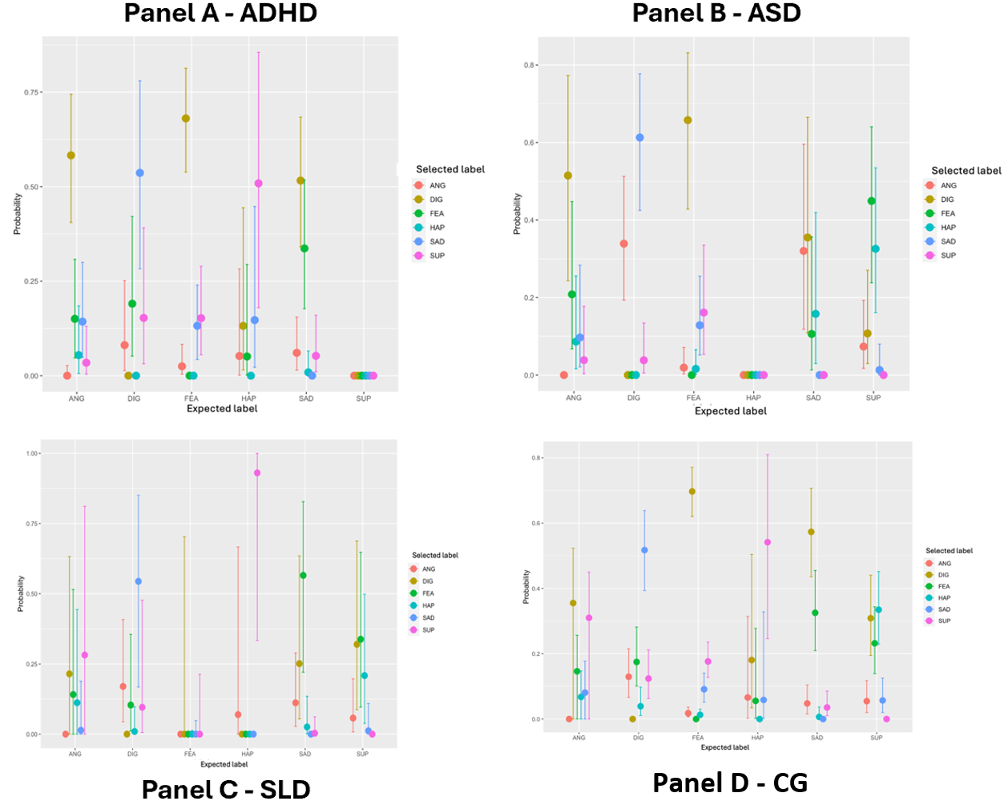
Notes: ANG=anger, FEA=fear, DIG=disgust, HAP=happiness, SAD=sadness, SUP=surprise.

