ASSOCIATION BETWEEN PRENATAL AIR POLLUTION EXPOSURE AND AUTISM IN CHILDREN: EPINED STUDY

SUPPLEMENTARY INFORMATION

S.Figure 1. Covariables identified by Directed Acyclic Graph (DAG) to adjust models investigating the association between exposure air pollution during pregnancy and autism in children
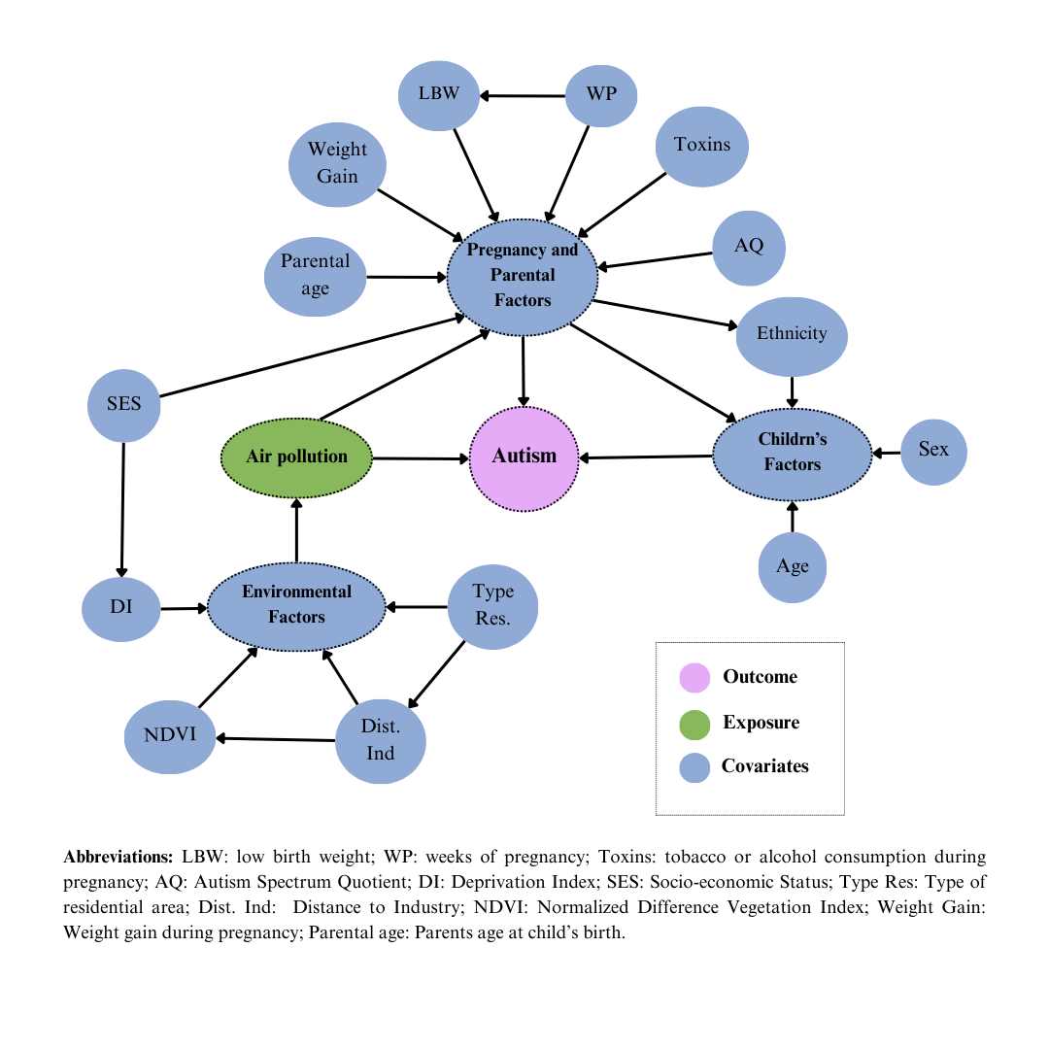

Table 1: Air Pollutants Means By Area of Tarragona Province
 | PM_{2.5} | PM₁₀ | PM_{2.5abs} | PM_{coarse} | NO₂ | NO_{x} | O₃
Baix Camp | 15.47 | 36.64 | 2.15 | 21.19 | 39.74 | 66.91 | 68.49
Baix Penedès | 13.69 | 29.46 | 1.61 | 15.24 | 24.79 | 40.78 | 68.41
Tarragonès | 15.31 | 33.03 | 1.86 | 18.41 | 30.97 | 51.55 | 65.42
Alt Camp | 15.12 | 31.17 | 1.77 | 20.38 | 28.07 | 46.87 | 69.71
Conca de Barberà | 15.24 | 26.75 | 1.52 | 17.68 | 22.01 | 36.95 | 74.59
Priorat | 15.21 | 25.91 | 1.51 | 15.28 | 16.96 | 27.58 | 74.68
Baix Ebre | 14.43 | 34.94 | 1.82 | 19.31 | 31.33 | 52.55 | 76.45
Montsià | 14.67 | 31.25 | 1.79 | 16.96 | 31.56 | 52.44 | 77.12
Ribera d'Ebre | 13.81 | 30.37 | 1.48 | 17.39 | 22.95 | 37.96 | 80.51
Terra Alta | 14.54 | 24.34 | 1.31 | 15.65 | 15.91 | 25.72 | 80.48

Table 2: Phase 1 beta coefficients and 95% confidence intervals for CAST and EDUTEA scores across models.
 | CAST | EDUTEA
 | β (CI 95%) | β (CI 95%)
PM_{2.5}
Model 1 | -0.13 (-0.45- 0.19) | 0.18 (-0.21 - 0.58)
Model 2 | 0.02 (-0.31 - 0.35) | 0.35 (-0.07 - 0.76)
Model 3 | 0.04 (-0.29 - 0.37) | 0.39 (-0.04 - 0.82)
PM₁₀
Model 1 | 0.14 (-0.08 - 0.35) | 0.17 (-0.09 - 0.44)
Model 2 | 0.07 (-0.16 - 0.29) | 0.21 (-0.08 - 0.50)
Model 3 | 0.02 (-0.21 - 0.26) | 0.30 (0.00 - 0.61)
PM_{2.5abs}
Model 1 | 0.00 (0.00 - 0.00) | 0.00 (0.00 - 0.00)
Model 2 | 0.00 (0.00 - 0.00) | 0.00 (0.00 - 0.00)
Model 3 | 0.00 (0.00 - 0.00) | 0.00 (0.00 - 0.00)
PM_{coarse}
Model 1 | 0.13 (-0.13 - 0.26) | 0.21 (0.02 - 0.38)
Model 2 | 0.03 (-0.11 - 0.17) | 0.17 (0.00 - 0.35)
Model 3 | 0.04 (-0.10 - 0.18) | 0.16 (0.03 - 0.29)
NO₂
Model 1 | 0.03 (-0.06 - 0.12) | 0.05 (-0.06 - 0.17)
Model 2 | 0.04 (-0.06 - 0.12) | 0.11 (-0.15 - 0.24)
Model 3 | 0.03 (-0.08 - 0.13) | 0.15 (0.02 - 0.28)
NO_{x}
Model 1 | 0.05 (-0.06 - 0.15) | 0.07 (-0.06 - 0.19)
Model 2 | 0.05 (-0.06 - 0.16) | 0.13 (-0.02 - 0.27)
Model 3 | 0.04 (-0.08 - 0.15) | 0.18 (0.03 - 0.34)
O₃
Model 1 | -0.02 (-0.15 - 0.11) | 0.08 (-0.07 - 0.25)
Model 2 | -0.11(-0.24 - 0.03) | 0.07 (-0.11 - 0.25)
Model 3 | -0.07 (-0.21 - 0.07) | 0.03 (-0.16 - 0.21)
Bold: Significance level p <0.05
Model 1: unadjusted; Model 2: adjusted for NDVI, deprivation index, age, sex, ethnicity and SES; Model 3: adjusted for model 2 covariables + distance to industry, type of residential area.

Table 3: Phase 1 odds ratios and 95% confidence intervals for likelihood of autism vs. non-likelihood across models.

 | PM_{2.5} | PM₁₀ | PM_{2.5abs} | PM_{coarse} | NO₂ | NO_{x} | O₃
 | OR (CI 95%) | OR (CI 95%) | OR (CI 95%) | OR (CI 95%) | OR (CI 95%) | OR (CI 95%) | OR (CI 95%)
Model 1 | 1.10 (0.81 - 1.51) | 1.15 (0.93 - 1.43) | 1.04 (0.81 - 1.32) | 1.08 (0.94 - 1.24) | 1.02 (0.93 - 1.11) | 1.01 (0.92 - 1.13) | 0.95 (0.84 - 1.09)
Model 2 | 1.14 (0.81 - 1.62) | 1.19 (0.93 - 1.52) | 1.14 (0.86 - 1.51) | 1.05 (0.91 - 1.23) | 1.05 (0.94 - 1.17) | 1.06 (0.94 - 1.20) | 0.94 (0.81 - 1.09)
Model 3 | 1.18 (0.83 - 1.68) | 1.20 (0.94 - 1.54) | 1.16 (0.86 - 1.56) | 1.08 (0.93 - 1.25) | 1.06 (0.95 - 1.19) | 1.07 (0.95 - 1.22) | 0.95 (0.81 - 1.11)
Model 1: unadjusted; Model 2: adjusted for NDVI, deprivation index, age, sex, ethnicity and SES; Model 3: adjusted for model 2 covariables + distance to industry, type of residential area.

Table 4: Phase 2 odds ratios and 95% confidence intervals for autism vs. non-autism across trimesters.
 | Model 1 | Model 2 | Model 3 | Model 4
 | OR (CI 95%) | OR (CI 95%) | OR (CI 95%) | OR (CI 95%)
PM_{2.5}
Trimester 1 | 0.68 (0.39 - 1.17) | 0.77 (0.44 - 1.37) | 0.76 (0.41 - 1.38) | 0.83 (0.43 – 1.61)
Trimester 2 | 1.08 (0.65 - 1.79) | 1.33 (0.78 - 2.27) | 1.31 (0.75 - 2.37) | 1.36 (0.75 - 2.47)
Trimester 3 | 1.02 (0.62 - 1.66) | 1.24 (0.74 - 2.07) | 1.15 (0.67 – 1.96) | 1.08 (0.62 – 1.93)
PM₁₀
Trimester 1 | 0.83 (0.55 - 1.24) | 0.93 (0.59 - 1.44) | 0.87 (0.56 - 1.41) | 0.96 (0.58 - 1.57)
Trimester 2 | 1.06 (0.72 - 1.55) | 1.26 (0.84 - 1.89) | 1.22 (0.79 - 1.87) | 1.28 (0.80 – 2.06)
Trimester 3 | 0.99 (0.68 - 1.45) | 1.16 (0.77 - 1.72) | 1.07 (0.70 - 1.64) | 1.05 (0.65 - 1.68)
PM_{2.5abs}
Trimester 1 | 1.00 (1.00 - 1.00) | 1.00 (1.00 - 1.00) | 1.00 (1.00 - 1.00) | 1.00 (1.00 - 1.00)
Trimester 2 | 1.00 (1.00 - 1.00) | 1.00 (1.00 - 1.00) | 1.00 (1.00 - 1.00) | 1.00 (1.00 - 1.00)
Trimester 3 | 1.00 (1.00 - 1.00) | 1.00 (1.00 - 1.00) | 1.00 (1.00 - 1.00) | 1.00 (1.00 - 1.00)
PM_{coarse}
Trimester 1 | 0.92 (0.69 - 1.21) | 0.95 (0.71 - 1.29) | 0.93 (0.67 - 1.26) | 0.98 (0.70 - 1.38)
Trimester 2 | 1.06 (0.81 - 1.38) | 1.14 (0.86 - 1.52) | 1.12 (0.82 - 1.51) | 1.18 (0.84 - 1.65)
Trimester 3 | 1.01 (0.77 - 1.33) | 1.09 (0.82 - 1.45) | 1.03 (0.76 - 1.39) | 1.04 (0.75 - 1.45)
NO₂
Trimester 1 | 0.93 (0.75 - 1.15) | 0.99 (0.77 - 1.28) | 0.97 (0.74 - 1.27) | 0.99 (0.74 - 1.33)
Trimester 2 | 0.98 (0.81 - 1.21) | 1.09 (0.86 - 1.41) | 1.07 (0.82 - 1.39) | 1.07 (0.80 - 1.43)
Trimester 3 | 0.94 (0.77 - 1.16) | 1.03 (0.80 – 1.31) | 0.98 (0.76 - 1.27) | 0.96 (0.72 - 1.29)
NO_{x}
Trimester 1 | 0.92 (0.72 - 1.17) | 0.99 (0.74 - 1.32) | 0.96 (0.70 - 1.31) | 0.98 (0.70 - 1.38)
Trimester 2 | 0.98 (0.77 - 1.24) | 1.10 (0.83 - 1.46) | 1.07 (0.78 - 1.45) | 1.07 (0.77 - 1.49)
Trimester 3 | 0.93 (0.73 - 1.18) | 1.02 (0.77 - 1.34) | 0.97 (0.72 - 1.31) | 0.95 (0.68 - 1.34)
O₃
Trimester 1 | 1.08 (0.92 - 1.26) | 1.04 (0.88 - 1.23) | 1.03 (0.87 - 1.23) | 1.03 (0.85 - 1.25)
Trimester 2 | 1.01 (0.86 - 1.18) | 0.95 (0.81 - 1.12) | 0.96 (0.81 - 1.14) | 1.01 (0.84 - 1.21)
Trimester 3 | 0.98 (0.84 - 1.15) | 0.92 (0.78 - 1.08) | 0.94 (0.79 - 1.12) | 0.97 (0.81 - 1.16)
Model 1: unadjusted; Model 2: adjusted for NDVI, deprivation index, age, sex, ethnicity and SES; Model 3: adjusted for model 2 covariables + distance to industry, type of residential area, mother age risk, father age risk, toxins during pregnancy, low birth weight, weight gain during pregnancy, weeks of pregnancy; Model 4: adjusted for model 3 covariables + mother-father autism risk.

Table 5: Phase 2 odds ratios and 95% confidence intervals for autism + subthreshold autistic traits vs. non-autism across trimesters.
 | Model 1 | Model 2 | Model 3 | Model 4
 | OR (CI 95%) | OR (CI 95%) | OR (CI 95%) | OR (CI 95%)
PM_{2.5}
Trimester 1 | 1.10 (0.74 - 1.65) | 1.08 (0.77 - 1.79) | 1.22 (0.78 - 1.90) | 1.35 (0.83 - 2.21)
Trimester 2 | 1.17 (0.79 - 1.71) | 1.36 (0.91 – 2.05) | 1.43 (0.93 – 2.22) | 1.66 (1.03 - 2.65)
Trimester 3 | 0.80 (0.55 - 1.18) | 0.90 (0.60 - 1.35) | 0.88 (0.58 - 1.34) | 0.88 (0.55 - 1.40)
PM₁₀
Trimester 1 | 1.09 (0.81 - 1.47) | 1.18 (0.85 - 1.63) | 1.21 (0.86 - 1.71) | 1.30 (0.89 - 1.91)
Trimester 2 | 1.09 (0.81 - 1.46) | 1.22 (0.88 - 1.67) | 1.26 (0.91 - 1.76) | 1.46 (1.01 – 2.12)
Trimester 3 | 0.84 (0.62 - 1.13) | 0.89 (0.64 - 1.22) | 0.88 (0.62 - 1.23) | 0.88 (0.60 - 1.29)
PM_{2.5abs}
Trimester 1 | 1.00 (1.00 - 1.00) | 1.00 (1.00 - 1.00) | 1.00 (1.00 - 1.00) | 1.00 (1.00 - 1.00)
Trimester 2 | 1.00 (1.00 - 1.00) | 1.00 (1.00 - 1.00) | 1.00 (1.00 - 1.00) | 1.00 (1.00 - 1.00)
Trimester 3 | 1.00 (1.00 - 1.00) | 1.00 (1.00 - 1.00) | 1.00 (1.00 - 1.00) | 1.00 (1.00 - 1.00)
PM_{coarse}
Trimester 1 | 1.04 (0.85 - 1.28) | 1.08 (0.86 - 1.36) | 1.10 (0.86 - 1.39) | 1.18 (0.91 - 1.53)
Trimester 2 | 1.06 (0.86 - 1.31) | 1.13 (0.90 - 1.41) | 1.15 (0.91 - 1.45) | 1.28 (0.97 - 1.67)
Trimester 3 | 0.91 (0.73 - 1.13) | 0.94 (0.75 - 1.18) | 0.93 (0.73 - 1.18) | 0.97 (0.74 - 1.28)
NO₂
Trimester 1 | 0.99 (0.85 - 1.15) | 1.02 (0.85 - 1.22) | 1.03 (0.85 - 1.26) | 1.07 (0.86 - 1.32)
Trimester 2 | 0.99 (0.85 - 1.16) | 1.04 (0.87 - 1.25) | 1.05 (0.86 - 1.27) | 1.09 (0.88 - 1.35)
Trimester 3 | 0.89 (0.76 - 1.06) | 0.90 (0.75 - 1.09) | 0.90 (0.73 - 1.09) | 0.90 (0.71 - 1.13)
NO_{x}
Trimester 1 | 0.98 (0.83 - 1.17) | 1.01 (0.82 - 1.24) | 1.03 (0.82 - 1.28) | 1.06 (0.83 - 1.34)
Trimester 2 | 0.99 (0.82 - 1.18) | 1.04 (0.83 - 1.28) | 1.05 (0.84 - 1.30) | 1.10 (0.86 - 1.40)
Trimester 3 | 0.88 (0.73 - 1.06) | 0.89 (0.72 - 1.09) | 0.89 (0.70 - 1.12) | 0.89 (0.68 - 1.16)
O₃
Trimester 1 | 0.93 (0.82 - 1.04) | 0.91 (0.82 - 1.03) | 0.91 (0.80 - 1.03) | 0.88 (0.76 - 1.02)
Trimester 2 | 1.01 (0.89 - 1.14) | 0.98 (0.86 - 1.11) | 0.98 (0.86 - 1.12) | 0.99 (0.86 - 1.15)
Trimester 3 | 1.04 (0.93 - 1.17) | 1.02 (0.90 - 1.15) | 1.03 (0.91 - 1.17) | 1.06 (0.92 - 1.22)
Bold: Significance level p <0.05
Model 1: unadjusted; Model 2: adjusted for NDVI, deprivation index, age, sex, ethnicity and SES; Model 3: adjusted for model 2 covariables + distance to industry, type of residential area, mother age risk, father age risk, toxins during pregnancy, low birth weight, weight gain during pregnancy, weeks of pregnancy; Model 4: adjusted for model 3 covariables + mother-father autism risk.

Table 6: Phase 2 odds ratios and 95% confidence intervals for autism and autism + subthreshold autistic traits vs. non-autism across models
 | AUTISM | AUTISM + Subthreshold autistic traits
 | OR (CI 95%) | OR (CI 95%)
PM_{2.5}
Model 1 | 0.85 (0.40 - 1.79) | 1.05 (0.59 - 1.83)
Model 2 | 1.28 (0.56 – 2.99) | 1.34 (0.72 - 2.54)
Model 3 | 1.21 (0.49 – 2.97) | 1.45 (0.74 - 2.85)
Model 4 | 1.26 (0.40 – 3.22) | 1.76 (0.85 - 3.66)
PM₁₀
Model 1 | 0.95 (0.58 - 1.56) | 1.02 (0.70 - 1.48)
Model 2 | 1.21 (0.70 - 2.09) | 1.18 (0.78 - 1.79)
Model 3 | 1.12 (0.62 - 2.03) | 1.23 (0.78 - 1.93)
Model 4 | 1.19 (0.64 - 2.25) | 1.40 (0.85 - 2.32)
PM_{2.5abs}
Model 1 | 1.00 (1.00 - 1.00) | 1.00 (1.00 - 1.00)
Model 2 | 1.00 (1.00 - 1.00) | 1.00 (1.00 - 1.00)
Model 3 | 1.00 (1.00 - 1.00) | 1.00 (1.00 - 1.00)
Model 4 | 1.00 (1.00 - 1.00) | 1.00 (1.00 - 1.00)
PM_{coarse}
Model 1 | 1.01 (0.74 - 1.39) | 1.02 (0.80 - 1.31)
Model 2 | 1.09 (0.77 - 1.54) | 1.07 (0.82 - 1.40)
Model 3 | 1.05 (0.73 - 1.52) | 1.09 (0.83 - 1.45)
Model 4 | 1.11 (0.74 - 1.64) | 1.22 (0.89 - 1.68)
NO₂
Model 1 | 0.95 (0.77 – 1.18) | 0.96 (0.82 - 1.39)
Model 2 | 1.05 (0.80 - 1.37) | 0.99 (0.82 - 1.12)
Model 3 | 1.02 (0.74 - 1.36) | 1.01 (0.78 - 1.28)
Model 4 | 1.02 (0.74 - 1.40) | 1.04 (0.82 - 1.32)
NO_{x}
Model 1 | 0.94 (0.74 – 1.20) | 0.95 (0.79 - 1.15)
Model 2 | 1.05 (0.77 - 1.42) | 0.98 (0.78 - 1.23)
Model 3 | 1.01 (0.73 - 1.40) | 0.99 (0.77 - 1.26)
Model 4 | 1.01 (0.70 - 1.46) | 1.03 (0.79 - 1.35)
O₃
Model 1 | 1.08 (0.80 - 1.46) | 1.01 (0.80 - 1.27)
Model 2 | 0.88 (0.63 - 1.23) | 0.88 (0.68 - 1.15)
Model 3 | 0.91 (0.64 - 1.31) | 0.88 (0.67 - 1.15)
Model 4 | 1.01 (0.68 - 1.49) | 0.91 (0.66 - 1.23)
Model 1: unadjusted; Model 2: adjusted for NDVI, deprivation index, age, sex, ethnicity and SES; Model 3: adjusted for model 2 covariables + distance to industry, type of residential area, mother age risk, father age risk, toxins during pregnancy, low birth weight, weight gain during pregnancy, weeks of pregnancy; Model 4: adjusted for model 3 covariables + mother-father autism risk.

