Supplementary Material
Frequency and distribution of EF-tasks (before and after Multiple Imputation)
Table S1. EF-tasks raw total scores before imputation (complete sample)
 |  |  |  |  |  |  |  |  |  |  |  |  |  |  | Skewness |  |  |  |  |  |  |  | Kurtosis
 |  | N |  | Missing |  |  | Mean |  | SD |  | Min |  | Max |  | Skewness |  |  |  | SE |  | Kurtosis |  |  |  | SE
Reversed categorization |  | 63 |  |  | 10 (13%) |  | 8.22 |  | 4.24 |  | 0 |  | 12 |  |  | -0.723 |  | 0.302 |  |  |  | -0.861 |  |  | 0.595
Beads |  | 55 |  |  | 28 (37%) |  | 4.82 |  | 2.18 |  | 0 |  | 9 |  |  | -0.249 |  | 0.322 |  |  |  | -0.668 |  |  | 0.634
Stroop |  | 48 |  |  | 14 (19%) |  | 6.27 |  | 4.50 |  | 0 |  | 12 |  |  | -0.158 |  | 0.343 |  |  |  | -1.488 |  |  | 0.674
Spinning Pots |  | 65 |  |  | 10 (13%) |  | 8.35 |  | 2.67 |  | 0 |  | 12 |  |  | -0.185 |  | 0.297 |  |  |  | -1.308 |  |  | 0.586
Delay of Gratification |  | 64 |  |  | 10 (13%) |  | 76.94 |  | 31.04 |  | 0 |  | 90 |  |  | -2.027 |  | 0.299 |  |  |  | 2.257 |  |  | 0.590
Prohibition task |  | 71 |  |  | 10 (13%) |  | 34.77 |  | 16.90 |  | 0 |  | 45 |  |  | -1.244 |  | 0.285 |  |  |  | -0.230 |  |  | 0.563

Table S2. Reasons for missing data for each task

EF-task | Total number of children with data | Total missing n (percentage) | Technical issues with video and no reported scores during session (n) | Child behavior such as fussines/refusal/loosing interest/tired (n) | Protocol had to be shorter due to illness or other reasons such as staff shortage (n) | Child non-verbal so task was not included (n)
Reversed categorization | 67 | 10 (13 %) | 1 | 3 | 5 | 1
Day/Night Stroop | 63 | 14 (19 %) | 3 | 5 | 5 | 1
Spin the pots | 67 | 10 (13 %) | 2 | 3 | 5 | -
Beads | 56 | 28 (37 %) | 5 | 5 | 5 | -
Prohibition task | 67 | 10 (13 %) | 0 | 5 | 5 | -
Delay of gratification | 67 | 10 (13 %) | 0 | 5 | 5 | -

Figure S1. Violin boxplots for each of the EF tasks (before and after multiple imputation)
Reversed categorization
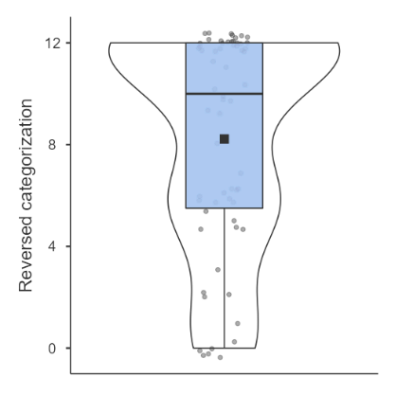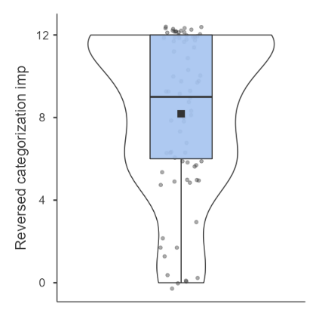
Beads
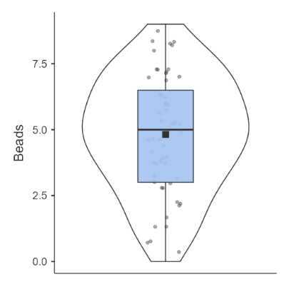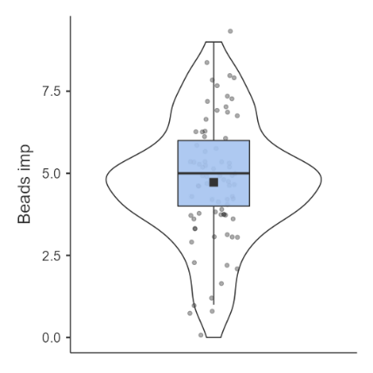
Stroop
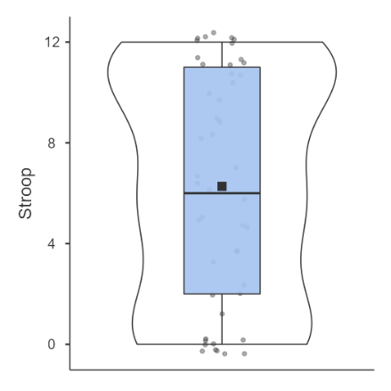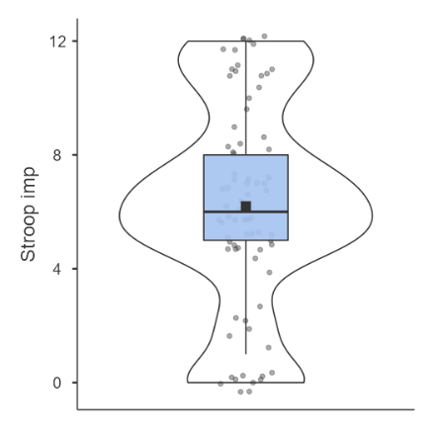

Spinning Pots
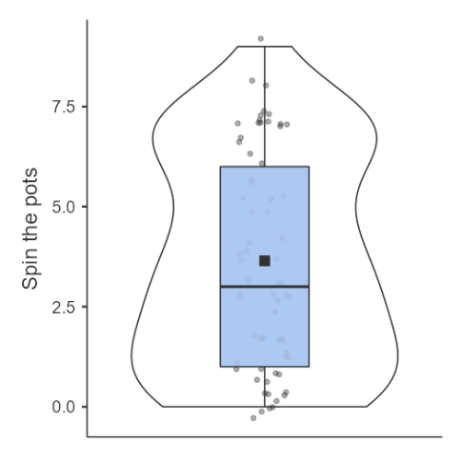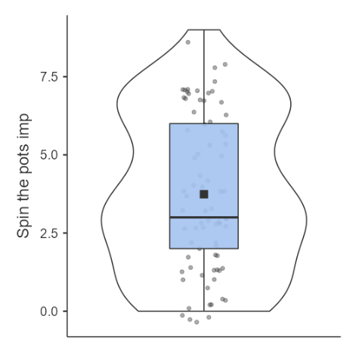

Delay of Gratification
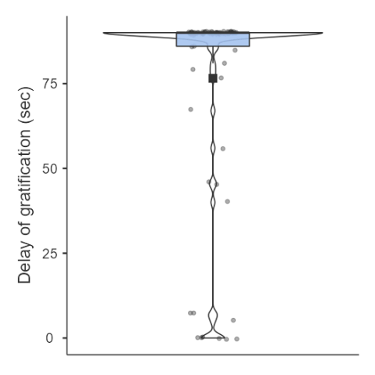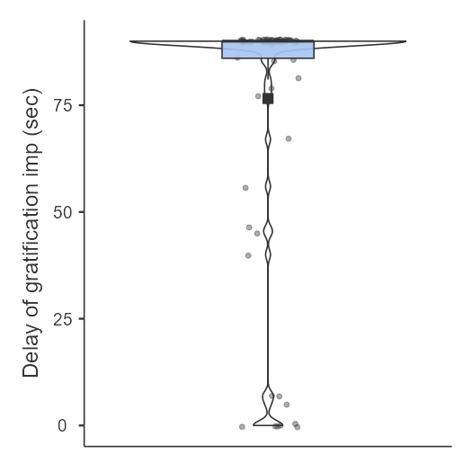
Prohibition task
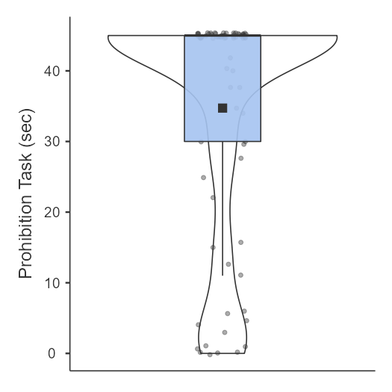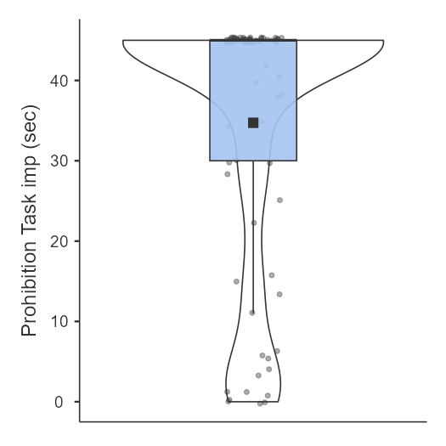

Table S3. EF-task scores after multiple imputation (complete sample)
 |  |  |  |  |  |  |  |  |  |  |  |  |  |  | Skewness |  |  |  |  |  |  | Kurtosis
 |  | N |  | Missing |  |  | Mean |  | SD |  | Min |  | Max |  | Skewness |  |  | SE |  |  | Kurtosis |  |  |  | SE
Reversed categorization |  | 77 |  |  | 0 |  | 8.18 |  | 3.90 |  | 0 |  | 12 |  |  | - 0.724 | 0.274 |  |  | -0.569 |  |  |  | 0.541
Beads |  | 77 |  |  | 0 |  | 4.75 |  | 1.88 |  | 0 |  | 9 |  |  | -0.150 | 0.274 |  |  | 0.034 |  |  |  | 0.541
Stroop |  | 77 |  |  | 0 |  | 6.20 |  | 3.64 |  | 0 |  | 12 |  |  | 0.141 | 0.274 |  |  | -0.708 |  |  |  | 0.541
Spinning Pots |  | 77 |  |  | 0 |  | 7.74 |  | 3.04 |  | 0 |  | 12 |  |  | -0.131 | 0.274 |  |  | -1.180 |  |  |  | 0.541
Delay of Gratification |  | 77 |  |  | 0 |  | 76.60 |  | 29.10 |  | 0 |  | 90 |  |  | -2.040 | 0.274 |  |  | 2.450 |  |  |  | 0.541
Prohibition task |  | 77 |  |  | 0 |  | 34.70 |  | 16.20 |  | 0 |  | 45 |  |  | -1.280 | 0.274 |  |  | -0.028 |  |  |  | 0.541

Correlations between EF-tasks using Spearman´s rho

Table S4
Spearmans´ rho between EF tasks
 |  |  |  |  | Reversed |  |  |  |  | Stroop |  |  | Spin |  |  | Beads |  |  |  | Prohibition |  |  |  |  | Delay
Reversed |  |  |  |  |  |  | —
Stroop |  |  |  |  |  | 0.376 |  | *** |  | —
Spin |  |  |  |  |  | 0.399 |  | *** |  | 0.257 |  | * | —
Beads |  |  |  |  |  | 0.372 |  | *** |  | 0.251 |  | * | 0.157 |  |  | —
Prohibition |  |  |  |  |  | 0.400 |  | *** |  | 0.412 |  | *** | 0.293 |  | ** | 0.283 |  |  | * | —
Delay |  |  |  |  |  | 0.095 |  |  |  | 0.096 |  |  | 0.228 |  | * | 0.113 |  |  |  | 0.469 |  | *** |  |  | —
Note. * p < .05, ** p < .01, *** p < .001

