Supplementary Materials

A. Qualitative Risk of Bias Assessment

Selection Bias
Selection bias was present across most studies, with it representing the second largest cause of RoB. Eleven (40.7%) studies were rated as having a high RoB, 11 (40.7%) were rated as unclear, and five (18.5%) were rated as having a low RoB. The main reason for studies achieving high or unclear ratings was the method of establishing autism diagnoses or traits. The completion of a comprehensive, in-study assessment of autism was infrequent, and whilst some studies accepted a self-reported autism diagnosis, there was often no independent or professional verification.

Performance Bias
The risk of performance bias was mainly unclear across studies. Seventeen (63%) achieved an unclear rating, nine (33.3%) were rated as having a low RoB, and one (3.7%) was rated as high. This was partly because of the clarity provided around participation incentives. For example, McKernan and Russo (2024) offered monetary incentives for autistic participants, but non-autistic people were automatically screened out once recruitment thresholds were reached. It could be argued that there was a risk of differentially motivating participants with this approach, hence the high rating.

Administration Fidelity
Out of all seven RoB categories, administration fidelity had the lowest RoB across studies. Sixteen studies (59.3%) were rated as having a low RoB, nine (33.3%) were rated as unclear, and two (7.4%) had a high RoB. Overall, studies recorded consistent administration procedures across participants. Where this was evidently not the case, studies were rated as having a high RoB. One example is Riedelbauch (2024): administration varied in how participants completed the measure (either online or at home via pencil and paper), so a high risk of administration bias could not be ruled out.

Detection Bias
The risk of detection bias was mainly unclear, with 15 studies receiving this rating (55.6%). Conversely, 11 studies (40.7%) were given a low RoB rating, and one (4.17%) received a high rating. Most papers were rated as having an unclear risk of detection bias because of a lack of clarity around scoring procedures. Where scoring was not reported, it was not possible to eliminate a potential source of bias. In contrast, studies that achieved a low RoB rating were clear on their adherence to measures’ original scoring procedures.

Statistical Bias
Statistical bias had the most unclear RoB across categories, with 21 papers (77.8%) receiving this rating. The main reason for this was a lack of reporting on missing data, particularly how missing data was handled and how it influenced the overall results. For example, Muniandy (2021) reported IC values appropriately, but did not state whether any data was missing from the overall dataset.

Reporting Bias
Reporting bias was the third highest RoB across studies. 17 studies (63%) were rated as unclear, six were rated as high (22.2%), and only four were rated as low (14.8%). The main reason for studies achieving high or unclear ratings was the level, or reporting, of attrition. Several studies also failed to report descriptive statistics for the completed anxiety measures, earning them a high RoB rating.

Generalisability
Generalisability had the second lowest RoB, with 13 studies (48%) being deemed as having a low RoB, and 14 as unclear (51.9%). Three studies had a sample size of less than 50 participants, whilst one study recruited less than 30 participants. However, the main risk to generalisability was the sampling method, with most studies being rated as unclear for recruiting from a single restricted or non-random sample.

Summary
Overall, the RoB across the included studies was variable. Over half of studies were rated as having an unclear or high RoB on all categories except administration fidelity. Statistical and selection bias were the categories with the biggest threats of bias because of how autism diagnoses and traits were established, alongside studies being unclear on their scoring procedures.

B. Data Extracted from All Studies
ID | Study | Scale | Alpha | Items | N | Alpha (VAR) | Alpha (SE) | Effect (ABT) | ABT.Var | ABT.SE | Design
1 | Aller et al., 2022 | Depression Anxiety and Stress Scales (DASS-21; Anxiety Subscale) | 0.8 | 21 | 461 | 0.0002 | 0.0135 | 1.6094 | 0.0046 | 0.0676 | Experimental
2A | Bemmer et al., 2021 | Liebowitz Social Anxiety Scale (LSAS) | 0.96 | 24 | 78 | <0.0001 | 0.0066 | 3.2189 | 0.0275 | 0.1657 | Experimental
2B | Bemmer et al., 2021 | Depression Anxiety Stress Scales (DASS-21) | 0.95 | 21 | 78 | 0.0001 | 0.0083 | 2.9957 | 0.0276 | 0.1662 | Experimental
2C | Bemmer et al., 2021 | Social Interaction Anxiety Scale (SIAS) | 0.86 | 20 | 78 | 0.0005 | 0.0233 | 1.9661 | 0.0277 | 0.1664 | Experimental
2D | Bemmer et al., 2021 | Social Phobia Scale (SPS) | 0.94 | 20 | 78 | 0.0001 | 0.0100 | 2.8134 | 0.0277 | 0.1664 | Experimental
3A | Bowri et al., 2021 | GAD-7 | 0.92 | 7 | 320 | <0.0001 | 0.0069 | 2.5257 | 0.0073 | 0.0857 | Experimental
3B | Bowri et al., 2021 | Liebowitz Social Anxiety Scale (LSAS) | 0.96 | 24 | 320 | <0.0001 | 0.0032 | 3.2189 | 0.0066 | 0.0810 | Experimental
4A | Bush et al., 2021 | GAD-7 | 0.91 | 7 | 247 | 0.0001 | 0.0088 | 2.4079 | 0.0095 | 0.0976 | Experimental
4B | Bush et al., 2021 | Mini-Social Phobia Inventory (MINI-SPIN) | 0.83 | 3 | 247 | 0.0004 | 0.0188 | 1.7720 | 0.0122 | 0.1107 | Experimental
5 | Capriola-Hall et al., 2021 | Adult Self Report (ASR; Anxiety Subscale) | 0.87 | 18 | 32 | 0.0012 | 0.0345 | 2.0402 | 0.0706 | 0.2657 | Experimental
6 | Carpita et al., 2023 | Social Anxiety Spectrum Short Version (SHY-SV) | 0.945 | 48 | 139 | <0.0001 | 0.0067 | 2.9957 | 0.0149 | 0.1221 | Experimental
7 | Cassidy et al., 2021 | Anxiety Scale for Autism (General Scale; ASA-A) | 0.921 | 20 | 308 | <0.0001 | 0.0066 | 2.5257 | 0.0069 | 0.0829 | Experimental
8A | Chew et al., 2021 | The Social Anxiety Questionnaire (SAQ) | 0.93 | 30 | 50 | 0.0002 | 0.0145 | 2.6593 | 0.0431 | 0.2076 | Psychometric and large sample
8B | Chew et al., 2021 | The Social Anxiety Questionnaire (SAQ) | 0.93 | 30 | 81 | 0.0001 | 0.0113 | 2.6593 | 0.0262 | 0.1618 | Psychometric and large sample
9A | Gaigg et al., 2020 | Becks Anxiety Inventory (BAI) | 0.92 | 21 | 54 | 0.0003 | 0.0161 | 2.5257 | 0.0404 | 0.2010 | Experimental
9B | Gaigg et al.,2020 | Liebowitz Social Anxiety Scale (LSAS) | 0.97 | 24 | 54 | <0.0001 | 0.0060 | 3.5066 | 0.0401 | 0.2003 | Experimental
9C | Gaigg et al., 2020 | GAD-7 | 0.93 | 7 | 54 | 0.0002 | 0.0148 | 2.6593 | 0.0449 | 0.2118 | Experimental
9D | Gaigg et al., 2020 | State-Trait Anxiety Inventory-Trait (STAI-T) | 0.94 | 20 | 54 | 0.0001 | 0.0121 | 2.8134 | 0.0405 | 0.2012 | Experimental
10A | Genova et al., 2023 | Personal Report of Public Speaking Apprehension (PRPSA) | 0.91 | 34 | 85 | 0.0002 | 0.0142 | 2.4079 | 0.0248 | 0.1576 | Psychometric and large sample
10B | Genova et al., 2023 | MOJO-iAnxiety | 0.85 | 11 | 85 | 0.0006 | 0.0244 | 1.8971 | 0.0265 | 0.1628 | Psychometric and large sample
11 | Hedley et al., 2019 | DSM-5 Dimensional Anxiety Scale (DSM-5 DAS) | 0.91 | 10 | 43 | 0.0004 | 0.0210 | 2.4079 | 0.0542 | 0.2328 | Experimental
12A | Hull et al., 2019 | GAD-7 | 0.92 | 7 | 354 | <0.0001 | 0.0065 | 2.5257 | 0.0066 | 0.0814 | Experimental
12B | Hull et al., 2019 | Liebowitz Social Anxiety Scale (LSAS) | 0.97 | 24 | 354 | <0.0001 | 0.0023 | 3.5066 | 0.0059 | 0.0770 | Experimental
13 | Kuzminskaite et al., 2020 | Dutch Hospital Anxiety and Depression Scale (Anxiety Scale; HADS-A) | 0.85 | 7 | 742 | 0.0001 | 0.0084 | 1.8971 | 0.0032 | 0.0562 | Experimental
14 | Mazurek, 2013 | GAD-7 | 0.88 | 7 | 108 | 0.0003 | 0.0178 | 2.1203 | 0.0220 | 0.1484 | Experimental
15 | McKernan & Russo, 2023 | DASS-21 (Anxiety Subscale) | 0.891 | 7 | 231 | 0.0001 | 0.0110 | 2.2073 | 0.0102 | 0.1009 | Psychometric and large sample
16A | McVey et al., 2016 | Liebowitz Social Anxiety Scale (LSAS) | 0.97 | 24 | 56 | <0.0001 | 0.0059 | 3.5066 | 0.0386 | 0.1966 | Experimental
16B | McVey et al., 2016 | SPIN (Social Phobia Inventory) | 0.94 | 17 | 56 | 0.0001 | 0.0119 | 2.8134 | 0.0394 | 0.1984 | Experimental
17 | Moseley et al., 2022 | GAD-7 | 0.91 | 7 | 314 | 0.0001 | 0.0078 | 2.4079 | 0.0075 | 0.0865 | Experimental
18 | Muniandy et al., 2021 | DSM-5 Generalised Anxiety Disorder Dimensional Scale (DSM-5 GAD-D) | 0.87 | 10 | 76 | 0.0005 | 0.0225 | 2.0402 | 0.0300 | 0.1733 | Experimental
19 | Nah et al., 2018 | Depression Anxiety Stress Scales (DASS-21; Anxiety Subscale) | 0.83 | 7 | 149 | 0.0005 | 0.0214 | 1.7720 | 0.0159 | 0.1260 | Experimental
20 | Pahnke et al., 2023 | Swedish Beck Anxiety Inventory (BAI) | 0.95 | 21 | 16 | 0.0004 | 0.0194 | 2.9957 | 0.1500 | 0.3873 | Experimental
21 | Park et al., 2020 | Depression Anxiety Stress Scales (DASS-21; Anxiety Scale) | 0.84 | 7 | 123 | 0.0005 | 0.0222 | 1.8326 | 0.0193 | 0.1389 | Psychometric and large sample
22A | Riedelbauch et al., 2024 | German Liebowitz Social Anxiety Scale (LSAS) | 0.96 | 24 | 86 | <0.0001 | 0.0063 | 3.2189 | 0.0248 | 0.1576 | Experimental
22B | Riedelbauch et al., 2024 | German Hospital Anxiety and Depression Scale (Anxiety Subscale) | 0.8 | 7 | 86 | 0.0011 | 0.0333 | 1.6094 | 0.0278 | 0.1667 | Experimental
23 | Robeson et al., 2024 | GAD-7 | 0.91 | 7 | 477 | 0.0000 | 0.0063 | 2.4079 | 0.0049 | 0.0701 | Psychometric and large sample
24A | Rodgers et al., 2020 | Anxiety Scale for Autism-Adults (ASA; General Scale) | 0.899 | 20 | 505 | <0.0001 | 0.0065 | 2.3026 | 0.0042 | 0.0647 | Psychometric and large sample
24B | Rodgers et al., 2020 | Hospital Anxiety and Depression Scale (HADS; Anxiety Subscale) | 0.819 | 7 | 505 | 0.0002 | 0.0123 | 1.7148 | 0.0046 | 0.0681 | Psychometric and large sample
25 | Rumball et al., 2021 | Hospital Anxiety and Depression Scale (Anxiety Scale; HADS-A) | 0.87 | 7 | 59 | 0.0007 | 0.0263 | 2.0402 | 0.0409 | 0.2023 | Experimental
26A | Schiltz et al., 2021 | SPIN (Social Phobia Inventory) | 0.93 | 17 | 69 | 0.0002 | 0.0125 | 2.6593 | 0.0317 | 0.1781 | Experimental
26B | Schiltz et al., 2021 | Liebowitz Social Anxiety Scale (LSAS) | 0.96 | 24 | 69 | <0.0001 | 0.0071 | 3.2189 | 0.0311 | 0.1765 | Experimental
27A | Spain et al., 2016 | Liebowitz Social Anxiety Scale (LSAS) | 0.96 | 24 | 50 | 0.0001 | 0.0083 | 3.2189 | 0.0426 | 0.2064 | Experimental
27B | Spain et al., 2016 | Brief Fear of Negative Evaluation Scale (BFNE) | 0.9 | 12 | 50 | 0.0004 | 0.0211 | 2.3026 | 0.0445 | 0.2110 | Experimental
27C | Spain et al., 2016 | Social Phobia Scale (SPS) | 0.93 | 20 | 50 | 0.0002 | 0.0145 | 2.6593 | 0.0430 | 0.2073 | Experimental
27D | Spain et al., 2016 | Social Interaction Anxiety Scale (SIAS) | 0.92 | 20 | 50 | 0.0003 | 0.0166 | 2.5257 | 0.0430 | 0.2073 | Experimental
Supplementary Materials A. Table showing the data extracted from each of the included studies.

C. QQ Plots for Individual Measures
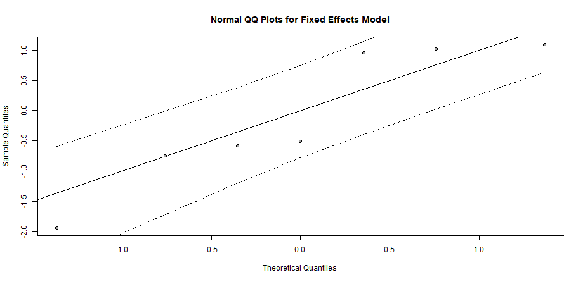
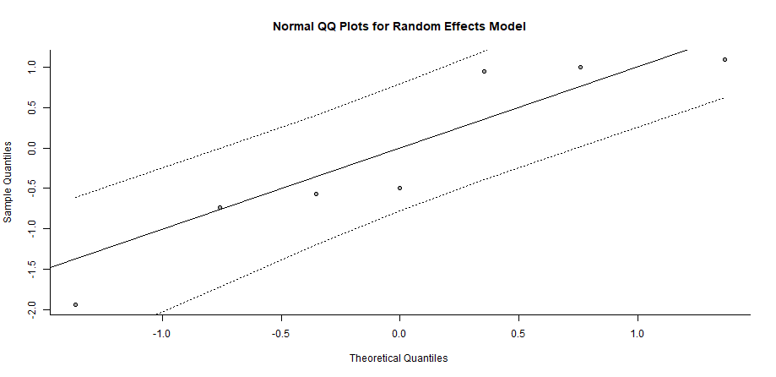
GAD-7
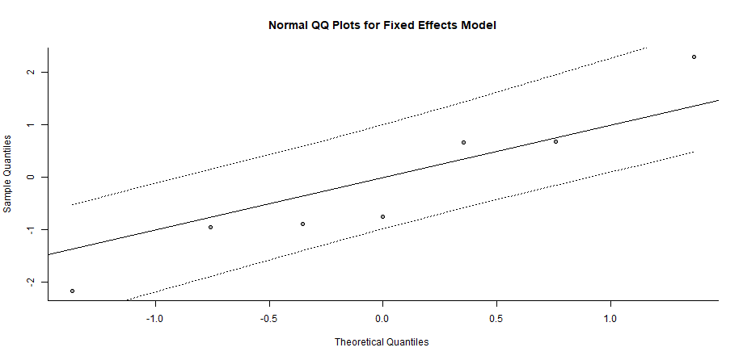
LSAS 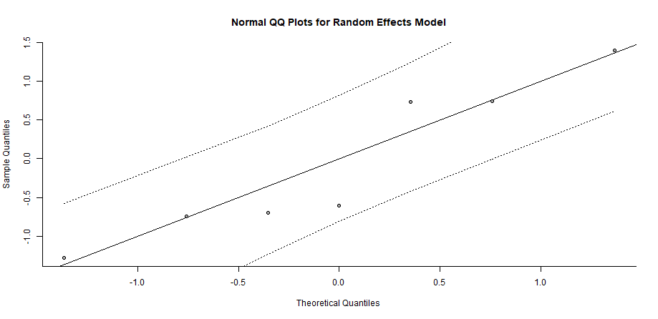
DASS-21 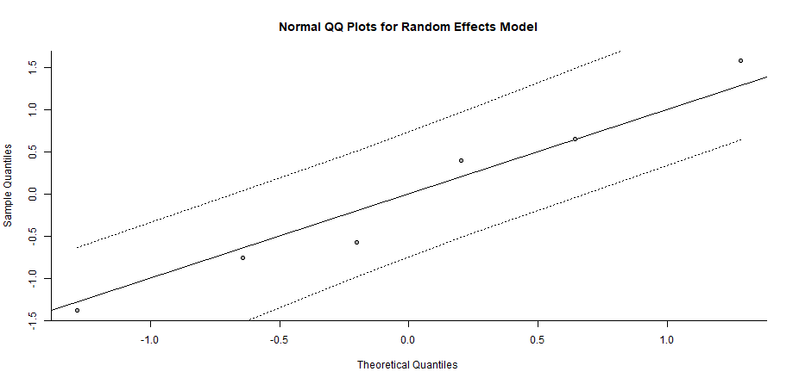

D. Study Level Effects for GAD-7, LSAS, and DASS-21
Measure | Study | Effect | Std.Er | CI
GAD-7 | Bowri (2021).A | 0.92 | 0.01 | 0.91-0.93
GAD-7 | Bush (2021).A | 0.91 | 0.01 | 0.89-0.93
GAD-7 | Gaigg (2020).C | 0.93 | 0.02 | 0.90-0.96
GAD-7 | Hull (2019).A | 0.92 | 0.01 | 0.91-0.93
GAD-7 | Mazurek (2013) | 0.88 | 0.02 | 0.85-0.91
GAD-7 | Moseley (2022) | 0.91 | 0.01 | 0.89-0.93
GAD-7 | Robeson (2024) | 0.91 | 0.01 | 0.9-0.92
LSAS | Bemmer (2021).A | 0.96 | 0.01 | 0.95-0.97
LSAS | Bowri (2021).B | 0.96 | 0.01 | 0.95-0.97
LSAS | Gaigg (2020).B | 0.97 | 0.01 | 0.96-0.98
LSAS | Hull (2019).B | 0.97 | <0.01 | 0.97-0.97
LSAS | McVey (2016).A | 0.97 | 0.01 | 0.96-0.98
LSAS | Schiltz (2021).B | 0.96 | 0.01 | 0.95-0.97
LSAS | Spain (2016).A | 0.96 | 0.01 | 0.94-0.98
DASS-21 | Aller (2022) | 0.8 | 0.01 | 0.78-0.83
DASS-21 | Bemmer (2021).B | 0.95 | 0.01 | 0.93-0.97
DASS-21 | McKernan (2023) | 0.89 | 0.01 | 0.87-0.91
DASS-21 | Nah (2018) | 0.83 | 0.02 | 0.79-0.87
DASS-21 | Park (2020) | 0.84 | 0.02 | 0.8-0.88
Supplementary Materials C. Table of Study Level Effects for the GAD-7, LSAS, and DASS-21.

E. Supplementary Analysis for GAD-7 and LSAS
GAD-7
The ‘leave-one-out’ analysis showed that one study was disproportionately influential and discrepant with the rest of the literature: Mazurek (2013; see Figure 9).
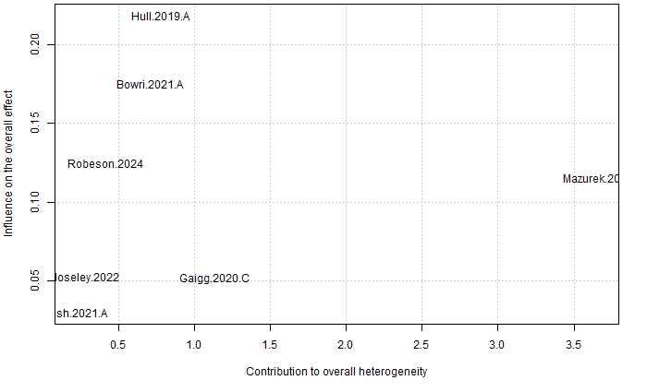

The random effects model was recalculated with the study showing disproportionate influence removed. A corrected random effects model showed minimal to no differences, with a reported synthesis of α = .92 (95% CI 0.91-0.92), a 1% increase from the original calculation (see Figure 10).
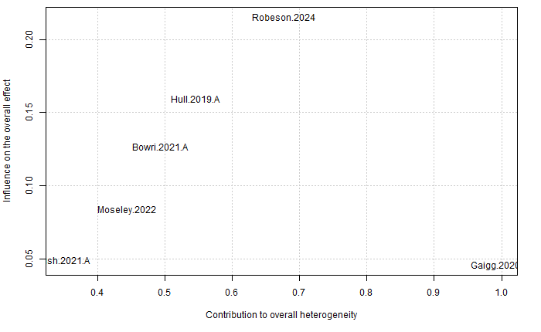
LSAS
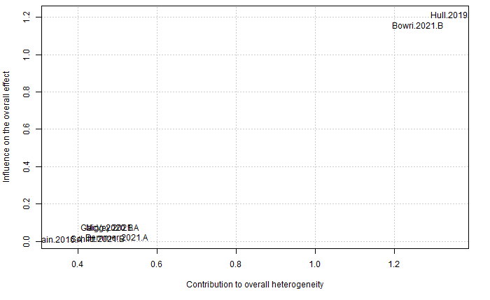
The ‘leave-one-out’ analysis showed that two studies were disproportionately influential and discrepant with the bulk of the literature: Bowri (2021) and Hull (2019; see Figure 11).

The random effects model was recalculated with the four studies showing disproportionate influence removed (see Figure 11). A corrected random effects model showed minimal to no differences, with a reported synthesis of α=.97 (95% CI 96.5-97.09%), the same as the original calculation.

F. Sensitivity Analysis using ABT Values (Bonett, 2002)
Compared to the raw alpha values which had 17.8% heterogeneity, the transformed values showed slightly higher heterogeneity. However, it remained at an acceptable level. The back-transformed confidence intervals were between 0.91-0.92, the same as the raw alpha values.
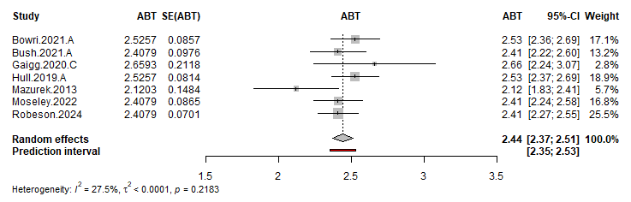
There was a difference of 1.1% in heterogeneity compared to the raw alpha values, with the transformed values still falling at an acceptable level. Similar to the GAD-7, the back-transformed confidence intervals (0.96-0.97) were the same as those for the raw alpha values.
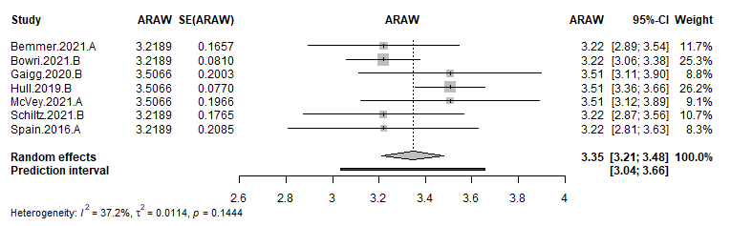
The heterogeneity is the same as raw alpha values, for which a further analysis has been carried out. The back-transformed confidence intervals were 0.80-0.92, which was a slightly smaller lower confidence interval than for the raw alpha values (0.83-0.92).
