Supplementary Information

Figures

Figure S1. Distribution of Latent Autism Trait by Sex

Tables

Table S1. Autism Measure Correlations

Table S2. Confusion Matrix of ADO Classification and Clinician-Determined Autism Diagnosis.

Table S3. Confusion Matrix by Sex of ADOS Classification and Clinician-Determined Autism Diagnosis.

Table S4. ADOS Item Response Frequencies by Sex.

Table S5. Test-Level Effect of Differential Item Functioning

Figure S1. Distribution of Latent Autism Trait by Sex

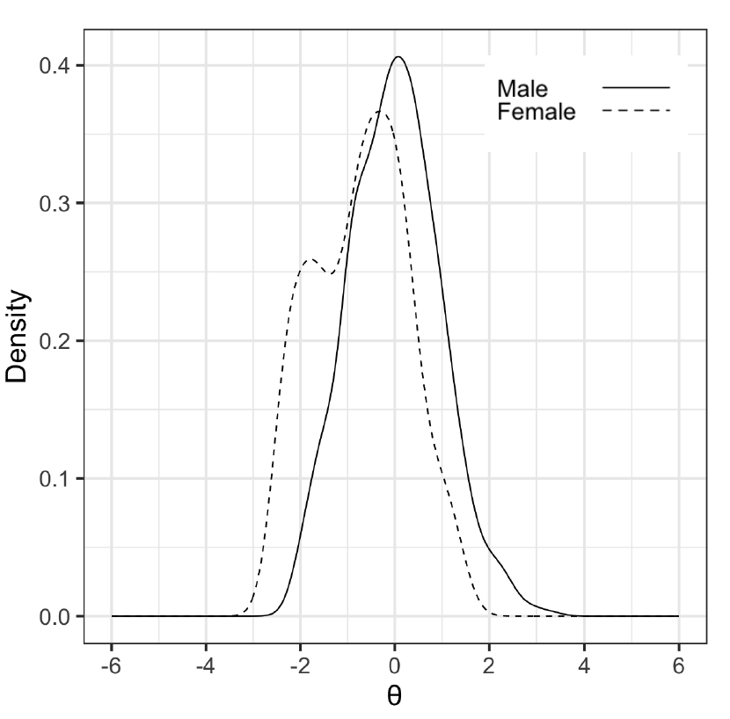

Figure S1. Density plots of female and male latent autistic traits in this sample,Theta reflects the level of latent autistic traits for this sample, standardized to a mean of 0 and standard deviation of 1 for the reference sample (males).

Table S1. Autism Measure Correlations
 |  | Correlation
 |  | Pearson | Spearman
ADOS-2 Overall CSS | SCQ Total Score | 0.473* | 0.458*
ADOS-2 Overall CSS | SRS-2 T-Score | 0.406* | 0.397*
SCQ Total Score | SRS-2 T-Score | 0.780* | 0.742*
Note: Asterisks denote significant correlations between scores.
Abbreviations: Overall CSS, Overall comparison score; SCQ, Social Communication Questionnaire; SRS-2, Social Responsive Scale, Second Edition.

Table S2. Confusion Matrix of ADOS Classification and Clinician-Determined Autism Diagnosis.
 | ASD DSM-5 Diagnosis
ADOS Classification | ASD | No ASD
Autism/Autism Spectrum | 420 (53.4%) | 58 (7.4%)
Non-Spectrum | 53 (6.7%) | 255 (32.5%)
Total | 473 (60.2%) | 313 (39.8%)
Note. Comparison of ADOS-2 classification and ASD diagnosis as confirmed by an expert clinician using DSM-5 diagnostic criteria. Participants without diagnosis information (n = 27) were excluded. All ADOS classifications were determined by applying cut-offs to the raw ADOS-2 score to classify scores as “autism,” “autism spectrum,” or “non-spectrum” (Lord et al., 2012). Accuracy was 0.859 (95% CI [0.833, 0.882]); sensitivity and specificity were 0.888 and 0.815, respectively.
Abbreviations: ADOS, Autism Diagnostic Observation Schedule; ASD, Autism Spectrum Disorder; DSM-5, Diagnostic and Statistical Manual 5th Edition.

Table S3. Confusion Matrix by Sex of ADOS Classification and Clinician-Determined Autism Diagnosis.
 | ASD DSM-5 Diagnosis
 | Female |  |  | Male
ADOS Classification | ASD | No ASD |  | ASD |  | No ASD
Autism/Autism Spectrum | 65 (34.2%) |  | 17 (8.9%) |  | 355 (51.0%) |  | 41 (5.9%)
Non-Spectrum | 12 (6.3%) |  | 96 (50.5%) |  | 41 (5.9%) |  | 159 (22.8%)
Total | 77 (40.5%) |  | 113 (59.5%) |  | 496 (71.3%) |  | 200 (28.7%)
Note. Comparison of ADOS-2 classification and ASD diagnosis as confirmed by an expert clinician using DSM-5 diagnostic criteria. Participants without diagnosis information (9 females, 18 males) were excluded. All ADOS classifications were determined by applying cut-offs to the raw ADOS-2 score to classify scores as “autism,” “autism spectrum,” or “non-spectrum” (Lord et al., 2012). For females, accuracy was 0.847 (95% CI [0.788, 0.895]); sensitivity and specificity were 0.844 and 0.850, respectively. For males, accuracy was 0.862 (95% CI [0.832, 0.889]); sensitivity and specificity were 0.897 and 0.795, respectively.
Abbreviations: ADOS, Autism Diagnostic Observation Schedule; ASD, Autism Spectrum Disorder; DSM-5, Diagnostic and Statistical Manual 5th Edition.

Table S4. ADOS Item Response Frequencies by Sex
 | Female |  |  | Male
Score on ADOS item | 0 | 1 | 2 | 0 | 1 | 2
A-1 Overall Level of Non-Echoed Spoken Language | 178 | 20 | 1 | 472 | 134 | 8
A-2 Speech Abnormalities Associated with Autism (Intonation/Volume/Rhythm/Rate) | 104 | 67 | 28 | 204 | 249 | 161
A-3 Immediate Echolalia | 192 | 5 | 2 | 568 | 40 | 6
A-4 Stereotyped/Idiosyncratic Use of Words or Phrases | 124 | 59 | 16 | 269 | 244 | 101
A-5 Offers Information | 180 | 14 | 5 | 478 | 99 | 37
A-6 Asks for Information | 66 | 70 | 63 | 214 | 217 | 183
A-7 Reporting of Events | 143 | 52 | 4 | 329 | 216 | 69
A-8 Conversation | 115 | 75 | 9 | 226 | 269 | 119
A-9 Descriptive, Conventional, Instrumental or Informational Gestures | 135 | 58 | 6 | 379 | 205 | 30
B-1 Unusual Eye Contact | 124 | NA | 75 | 262 | NA | 352
B-2 Facial Expressions Directed to Examiner | 111 | 82 | 6 | 253 | 299 | 62
B-3 Language Production and Linked Nonverbal Communication | 176 | 23 | 0 | 523 | 87 | 4
B-4 Shared Enjoyment in Interaction | 132 | 50 | 17 | 311 | 191 | 112
B-5 Comments on Others' Emotions/Empathy | 104 | 64 | 31 | 163 | 230 | 221
B-6 Insight Into Typical Social Situations and Relationships | 99 | 58 | 42 | 109 | 202 | 303
B-7 Quality of Social Overtures | 116 | 76 | 7 | 214 | 323 | 77
B-9 Quality of Social Response | 89 | 100 | 10 | 143 | 400 | 71
B-10 Amount of Reciprocal Social Communication | 147 | 43 | 9 | 338 | 200 | 76
B-11 Overall Quality of Rapport | 115 | 70 | 14 | 256 | 254 | 104
D-1 Unusual Sensory Interest In Play Material/Person | 161 | 23 | 15 | 399 | 131 | 84
D-2 Hand and Finger and Other Complex Mannerisms | 177 | 7 | 15 | 483 | 70 | 61
D-3 Self-Injurious Behavior | 199 | 0 | 0 | 610 | 4 | 0
D-4 Excessive Interest in or References to Unusual or Highly Specific Topics or Objects or Repetitive Behaviors | 148 | 36 | 15 | 324 | 180 | 110
D-5 Compulsions or Rituals | 170 | 25 | 4 | 480 | 114 | 20
Abbreviations: ADOS, Autism Diagnostic Observation Schedule

Table S5. Test-Level Effect of Differential Item Functioning
 | STDS | UTDS | UETSDS | ETSSD
Males as reference group | -0.413 | 1.066 | 0.412 | -0.067
Note. Males served as the reference group
Abbreviations: ETSSD, Expected Test Standardized Score Difference; STDS, Signed Test Difference; UETSDS, Unsigned Expected Test Score Differences in the Sample; UTDS,
unsigned test difference

