Supplementary Figure 1. Bivariate Correlation of Primary Variables
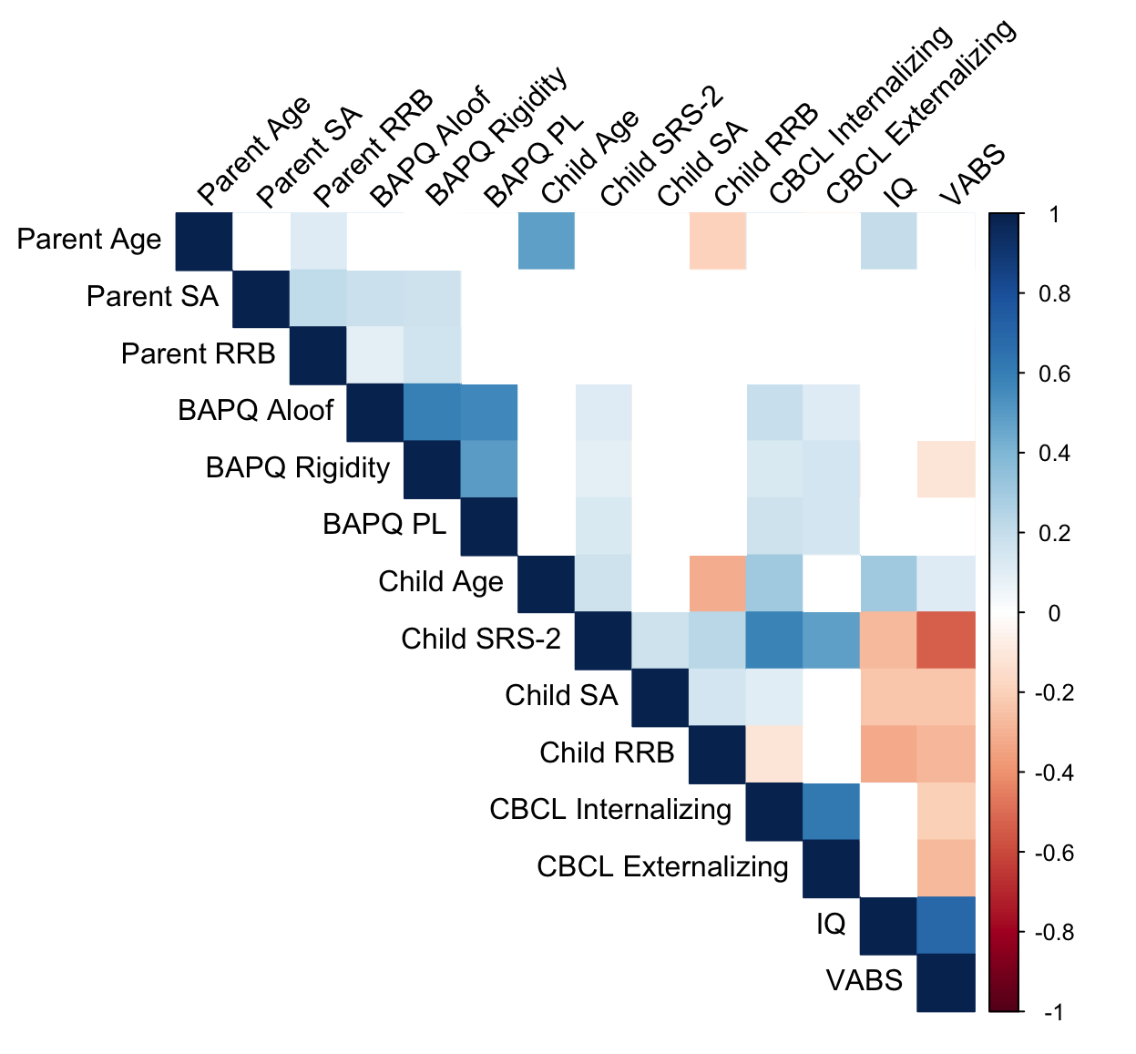
BAPQ: Broad Autism Phenotype Questionnaire; CBCL: Child Behavior Checklist; IQ: Intelligence Quotient; RRB: Restricted and Repetitive Behaviors; SA: Social Affect; SRS-2: Social Responsiveness Scale-2; PL: Pragmatic Language; VABS: Vineland Adaptive Behavior Schedule

Supplementary Figure 2. Parallel Analysis Scree Plot for Fathers
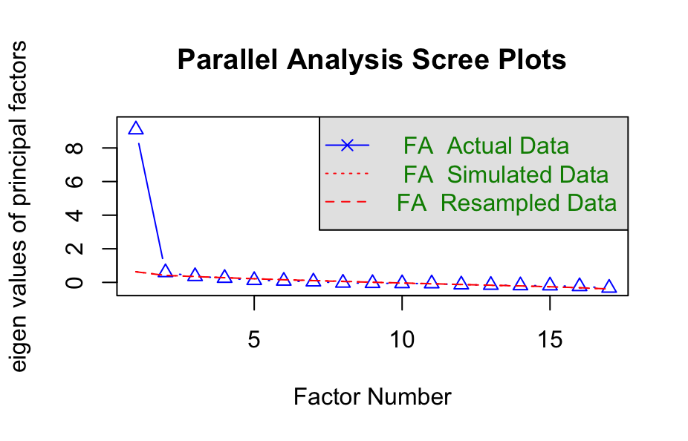

Supplementary Figure 3. Parallel Analysis Scree Plot for Mothers
