Article title: Peer victimisation but not parental mental health shape trajectories of emotional problems across childhood and adolescence in autism
Journal name: Journal of Autism and Developmental Disorders

Online Resource 2 – Further diagrammatic representations of CLPMs and RI-CLPMs

Figure 3 illustrates the basic structure of a CLPM, constructed using the observed scores for both variables at each timepoint.

Figure 3
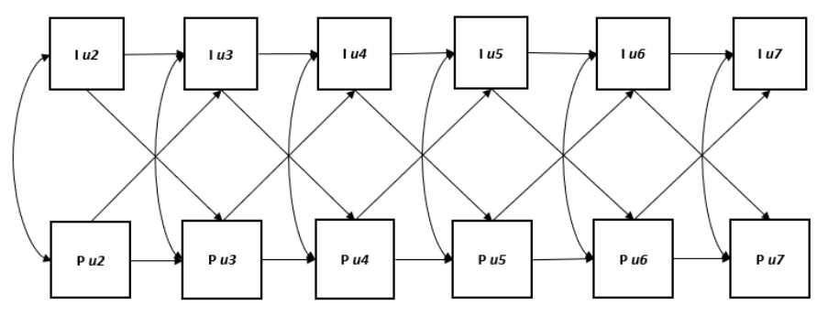
Six-wave Cross-Lagged Panel Model. In this example, Iut denotes the observed internalising symptoms, and Put denotes the parental mental health problems for individual u at timepoint t.
As described in the main text, the RI-CLPM has been proposed as an extension of the CLPM in order to separate out the within- and between-person variation, using the construction of latent variables based on the observed data.
In this study, two RI-CLPMs were used to investigate the two separate research questions. Each RI-CLPM is constructed based on observed scores, in this case consisting of internalising symptoms and peer victimisation measured by the SDQ, and parental mental health measured by the K6. The observed scores are represented in the model by three components; 1) the grand means (the mean across all individuals at each time point), 2) a stable between-person component, and 3) a variable within-person component (see Figure 4). The stable between-person component is represented in the model by random intercepts (BIu and BPu) – accounting for each person’s difference from the grand means, and therefore separating out the effect of stable between-person variation in the data. In the RI-CLPM this is specified by creating a latent variable associated with the observed repeated measures, with all factor loadings fixed at 1. The final component of the observed scores in the RI-CLPM accounts for within-person variation, based on the difference between the observed score and expected score given the grand mean and random intercepts. In the RI-CLPM this is specified by creating latent variables for each observed repeated measure (WIu2-Wlu7 and WPu2-WPu7), and constraining measurement error variances to 0.
Next, structural relations in the CLPM are specified between the within-person latent variables. The auto-regressive effects (e.g. from WIu2 to WIu3) represent the predictive relationship between, for example, a person’s internalising symptoms at timepoint 2, to their internalising symptoms at the timepoint 3. The cross-lagged effects in the model therefore represent the predictive relationship between one variable on another. For example, the predictive effect of parental mental health at timepoint 3, on internalising symptoms at timepoint 4.
Finally, the model also includes the covariances between the within-person latent variables at each timepoint. In this RI-CLPM, the covariance between the random-intercepts (BIu and BPu) was not constrained, allowing it to be freely estimated. Allowing this to be freely estimated, rather than constrained at 0, is chosen in order to be most representative of the data, where we might expect that the stable, within-person component of internalising symptoms relates to the stable, within-person component of parental mental health.
Figure 4
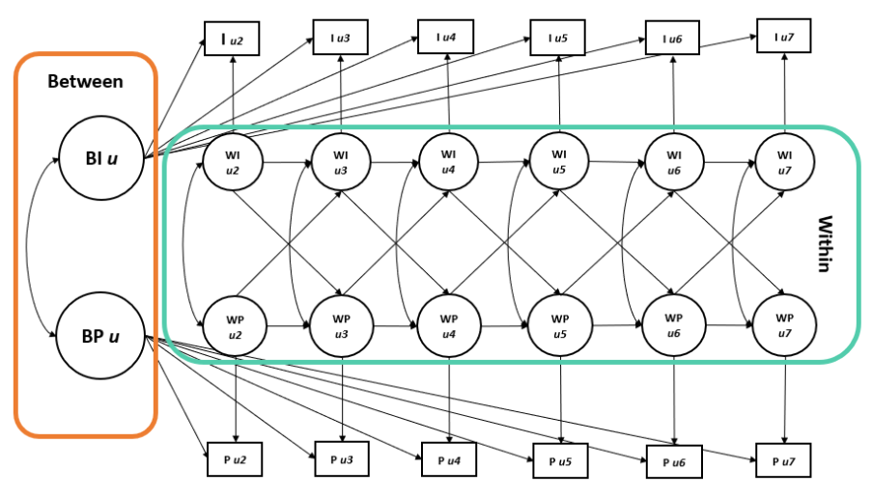
Six-wave Random-Intercept Cross-Lag Panel Model. To illustrate the model, this is based on the relationships between autistic young person internalising symptoms and parental mental health only. Iut denotes the observed internalising symptoms, and Put denotes the parental mental health problems for individual u at timepoint t. W represents latent variables accounting for within-person variation, and B represents the random intercept latent variables accounting for between-person variation.

